GREENFUTURES
Lesson 4: Climate Justice, Futures Thinking and Green Innovation
Teacher Guide

This is the final GreenFutures lesson and it is deliberately framed differently from the first three. Where earlier lessons covered difficult material such as climate change, AI risk, hard trade-offs, this lesson pivots toward fairness, future possibility and the students' own sense of capability.
Time | ~65 minutes (flex to a 40-minute class by trimming discussion time and one activity, as noted in the walkthrough below)
Background | Builds directly on all three previous lessons and draws on each lesson's climate journal entries for the closing capstone task. Allow extra time if possible, this is the longest and most important session to run in full.
Materials Needed | PowerPoint presentation, laptop, screen, timer, students' climate journals from Lessons 1–3, worksheet or slide template for the climate action proposal, certificates of completion (can be also presented at the follow-up celebration event, per the module's NCCA-aligned design).
Curriculum Links
GreenFutures is designed as an NCCA-compliant, cross-curricular Transition Year module (Science, Geography, CSPE, Digital Media). Its interactive and reflective activities build the five key skills central to Transition Year:
- Information processing
- Critical and creative thinking
- Communicating
- Working with others
- Being personally effective
Leaving Certificate subject links: Geography, Politics and Society, Technology, Computer Science, Business, Economics.

Learning Intentions
By the end of this lesson, students will be able to:
- Explain the concept of climate justice
- Discuss how climate change affects different communities differently, including within Ireland
- Evaluate the role of technology, policy and behaviour in climate action
- Reflect on possible future climate scenarios
- Identify emerging green careers, and complete a personal climate action proposal

Module Overview
Framing and Introduction (~6 mins)
Deliberately open with acknowledgement and hope, before outcomes.
Climate Justice (~11 mins)
Global and Irish inequality, and a reflective discussion with no single right answer.
Futures Thinking (~11 mins)
Possible climate scenarios and a scenario-choice activity.
Reasons for Hope and Green Futures (~9 mins)
Innovation, collective action, green careers and the honest AI/jobs conversation.
Capstone: Climate Action Proposal (~20 mins)
The module's assessable culmination, followed by closing reflection prompts.
Recap and Close (~3 mins)
Full-module recap and celebration-event bridge.

Lesson 4 Module Walkthrough
Each row below shows the slide alongside facilitation notes. Timings are approximate and add up to the total above; trim discussion prompts first if running short on time.

Introduction (~3 mins)
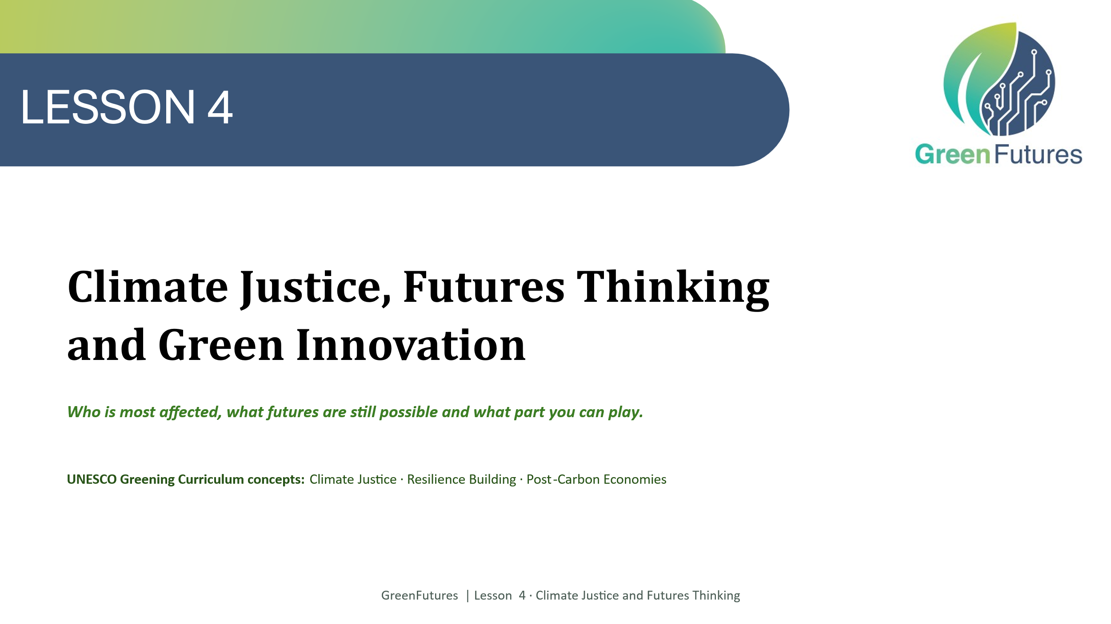 | LECTURE (~1 min)  Title slide, keep this brief; the framing happens on the next slide.
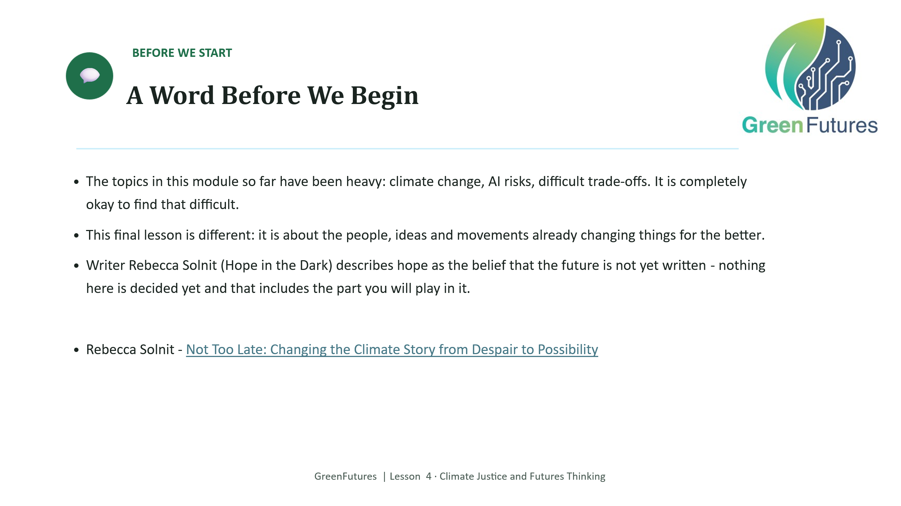 | LECTURE, FRAMING, READ CAREFULLY (~3 mins)  This slide matters more than its short time allocation suggests. Acknowledge openly that the module's content has been heavy, and that it's okay to have found it difficult.  Pivot explicitly: this final lesson is about the people, ideas and movements already changing things. The Rebecca Solnit idea of hope as the belief that the future is not yet written is offered here as a framing thought, not a quotation to read verbatim from a text, put it in your own words to the class.  Rebecca Solnit - Not Too Late: Changing the Climate Story from Despair to Possibility
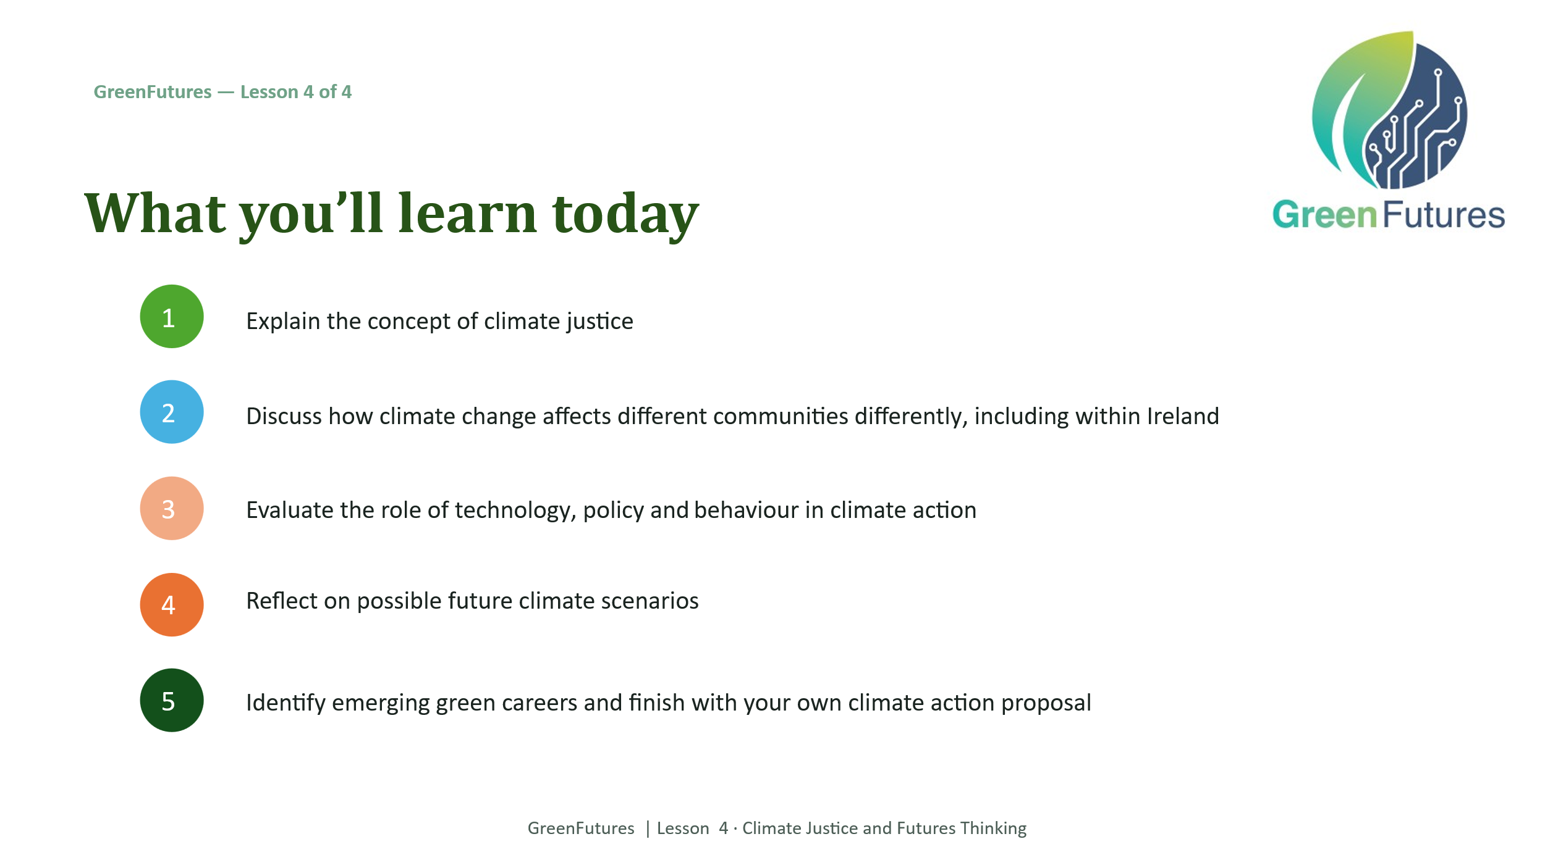 | LECTURE (~2 mins)  Walk through today's five learning outcomes.
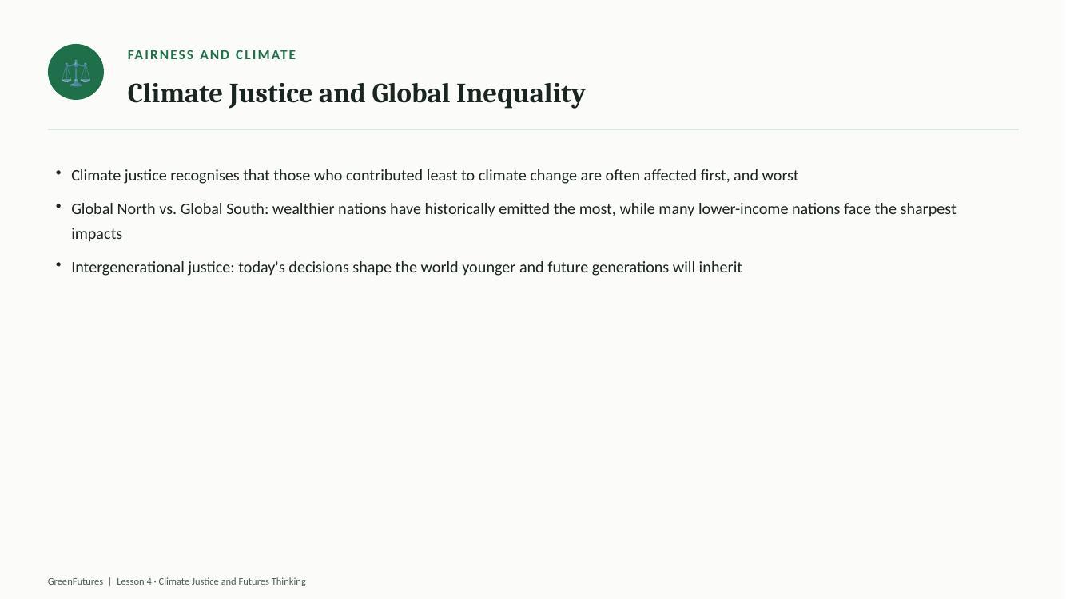 | LECTURE (~3 mins)  Present the Irish wind-energy example and Bord na Móna's shift from peat to wind, framed as a real ‘just transition’ story.  LECTURE (~4 mins)  Introduce climate justice: those who contributed least are often affected first and worst. Cover Global North/South responsibility and intergenerational justice.  Mary Robinson hosted a major climate justice conference in her hometown in June 2026, on the theme of communities working together. What do you think that has to do with fairness?  Her YouTube Channel on Climate Justice https://www.youtube.com/@MRFCJorg
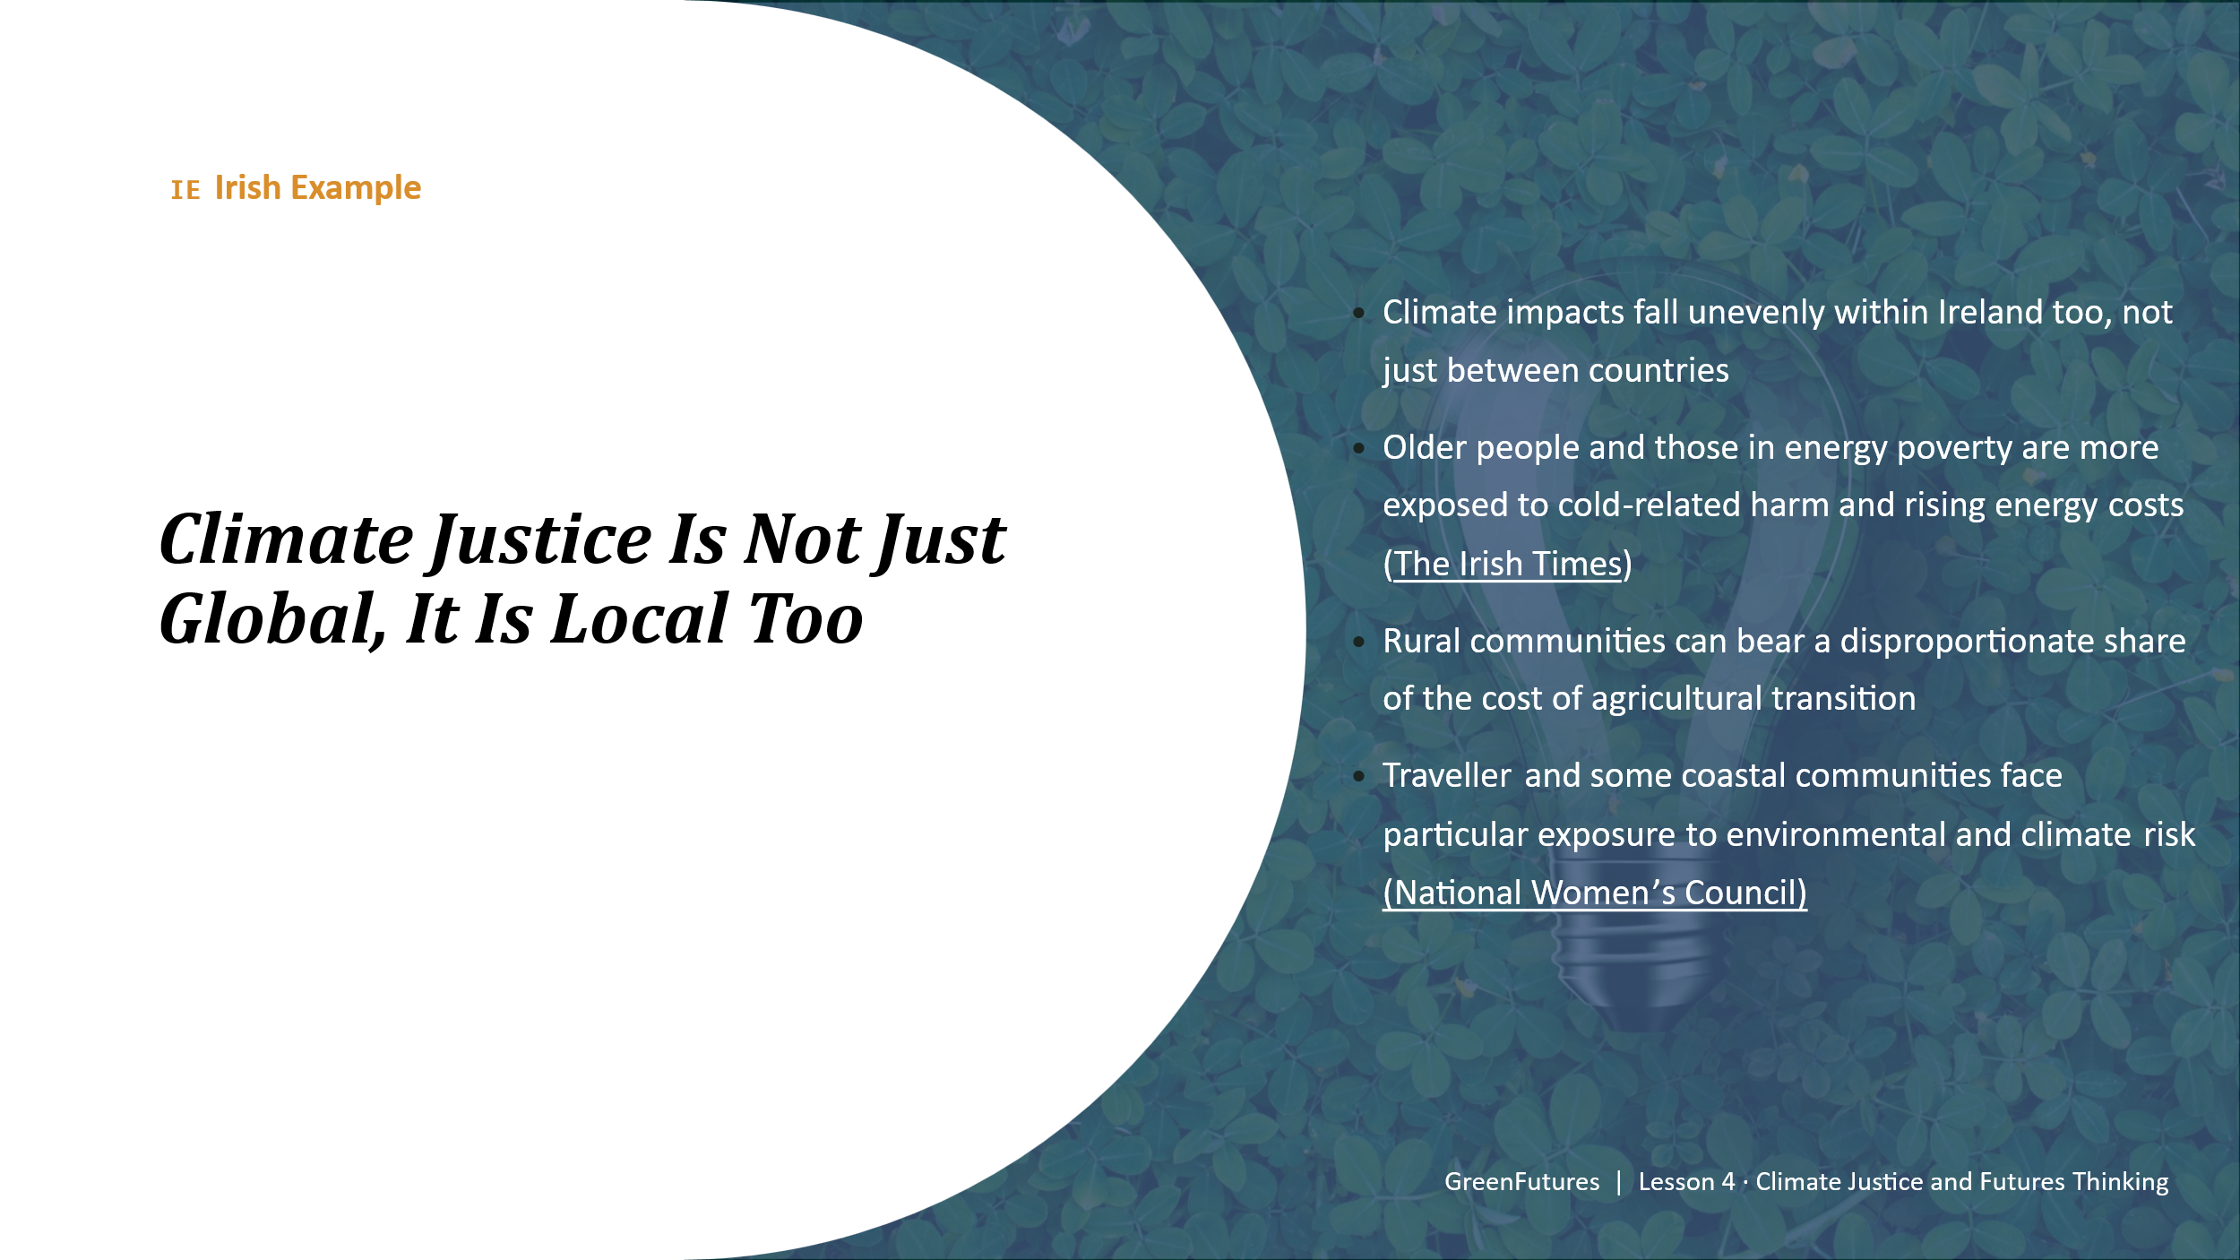 | LECTURE (~3 mins)  Bring climate justice home: older people and energy poverty, rural communities and agricultural transition, Traveller and coastal communities. This shows justice isn't only a global-scale issue.  https://www.nwci.ie/learn/article/new_report_shows_irelands_climate_policy_is_failing_women_and_marginalised  https://www.irishtimes.com/news/environment/ireland-s-poorest-communities-are-not-sufficiently-heard-on-climate-major-report-finds-1.4834574
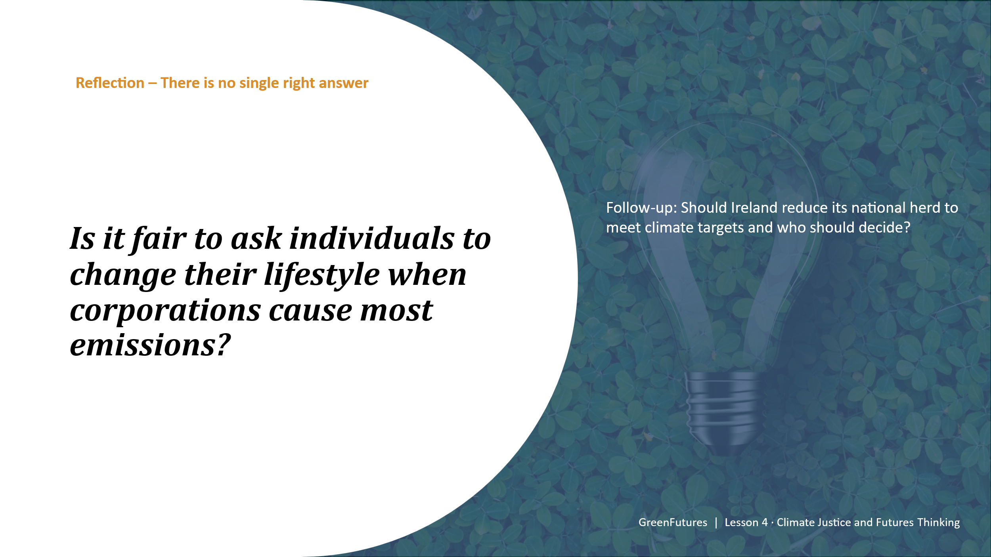 | DISCUSSION - NO SINGLE RIGHT ANSWER (~4 mins)  Pose the fairness question and the national-herd follow-up question. Let the discussion run without steering toward a ‘correct’ answer. The value is in the reasoning, not a resolution.  Keep this discussion time-boxed; it can run long given how open-ended it is.  https://www.rte.ie/news/ireland/2025/1117/1544305-irish-ai-climate/
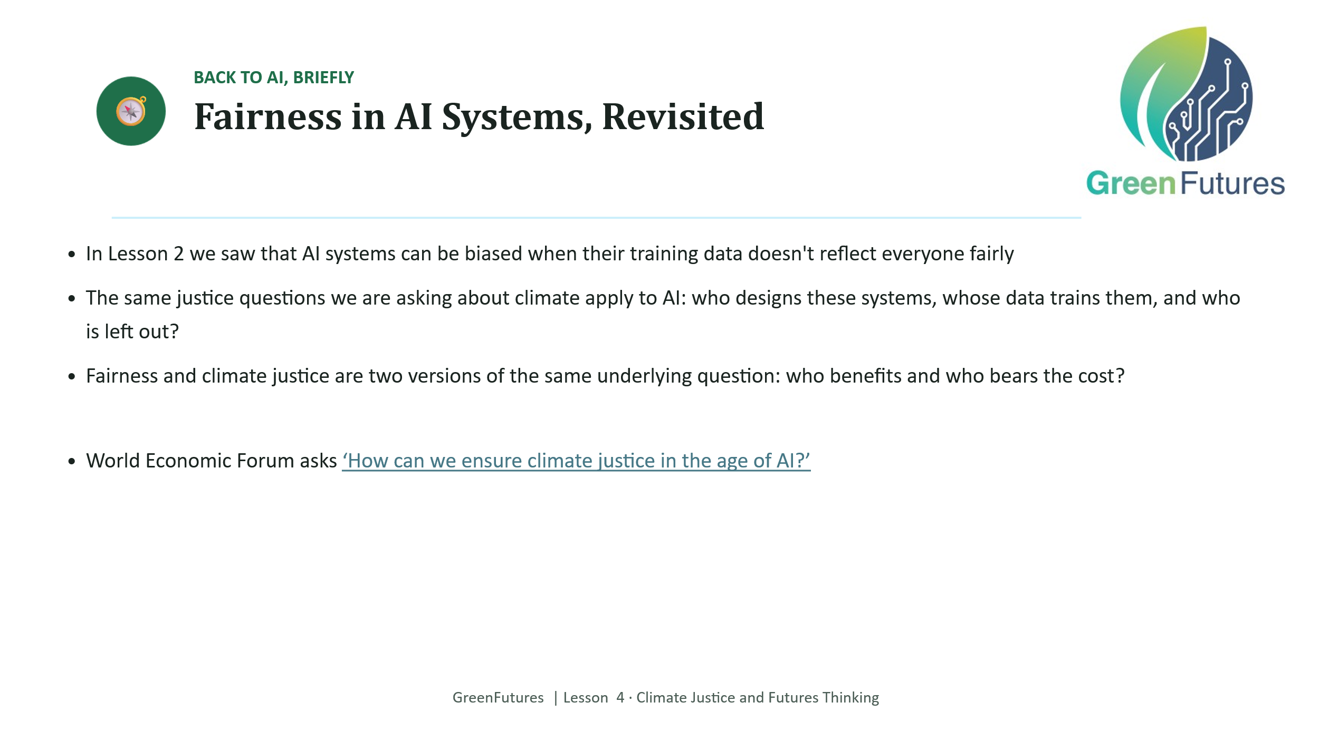 | LECTURE (~3 mins)  Briefly connect back to Lesson 2's bias discussion: the same ‘who benefits, who bears the cost’ question applies to AI systems as much as to climate policy.  WEF: https://www.weforum.org/stories/sustainable-development/climate-justice-in-the-age-of-ai/
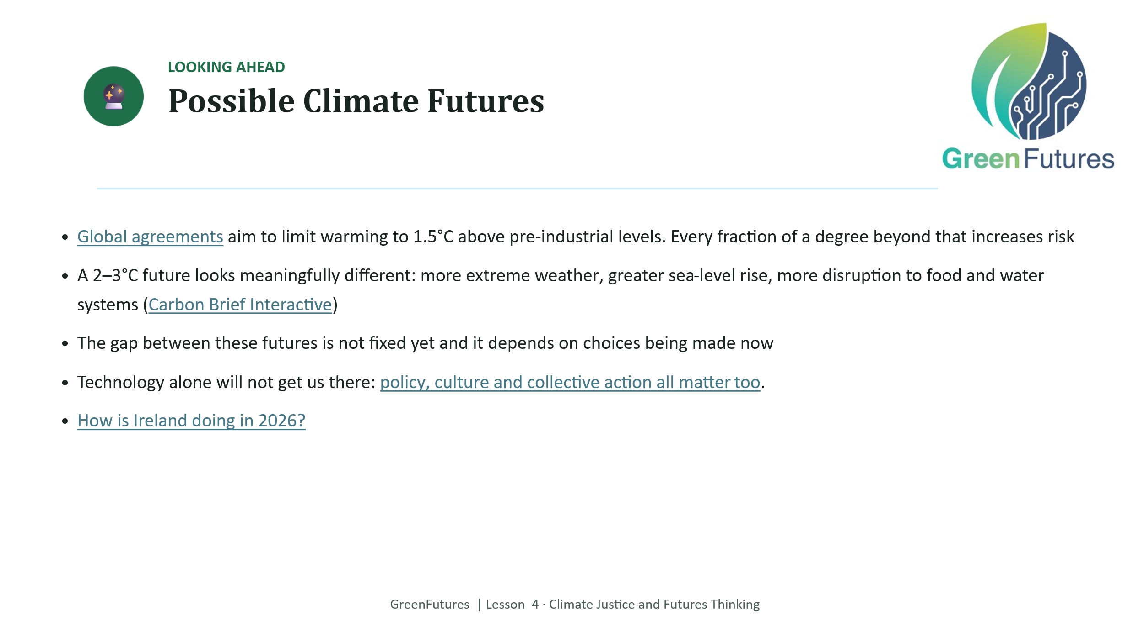 | LECTURE (~4 mins)  Cover the 1.5°C vs. 2–3°C scenario contrast.  Carbon Brief Interactive: Useful tool to explore with the students  International Panel on Climate Change Report (https://www.ipcc.ch/2023/03/20/press-release-ar6-synthesis-report/)  Policy, culture and collective action all matter too. (EU Climate Days)  How is Ireland doing in 2026?
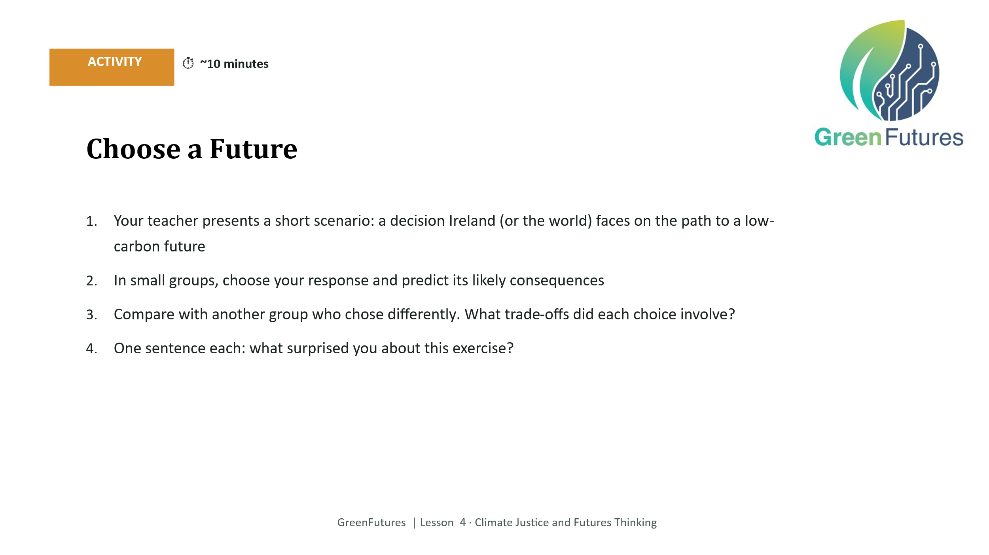 | 3-NOP Winter Milk Trial https://teagasc.ie/animals/dairy/dairy-levy-research/winterliquid-milk-production/  GreenFeed Research Update: https://teagasc.ie/environment/climate-change-air-quality/signpost-programme/research-updates/  ICBF Methane https://www.icbf.com/methane/  Present a scenario (decision on the path to a low-carbon future). Groups choose a response, predict consequences, then compare with a group that chose differently.  Example of a scenario:  With the explosion in AI and digitisation, computing demand is rising, and so is power consumption. In the backdrop of an energy crisis caused by the wars between Ukraine and Russia, and Iran blocking the Strait of Hormuz, energy costs are going up, and there may be a situation where energy needs to be prioritised between data centres and residential users.  Should the Irish Government bring in laws / regulations to limit the total energy consumed by Data Centres to 25%.  https://www.rte.ie/news/business/2026/0707/1582175-cso-data-centre-energy-figures/  https://www.iiea.com/blog/data-centres-in-ireland-the-state-of-play
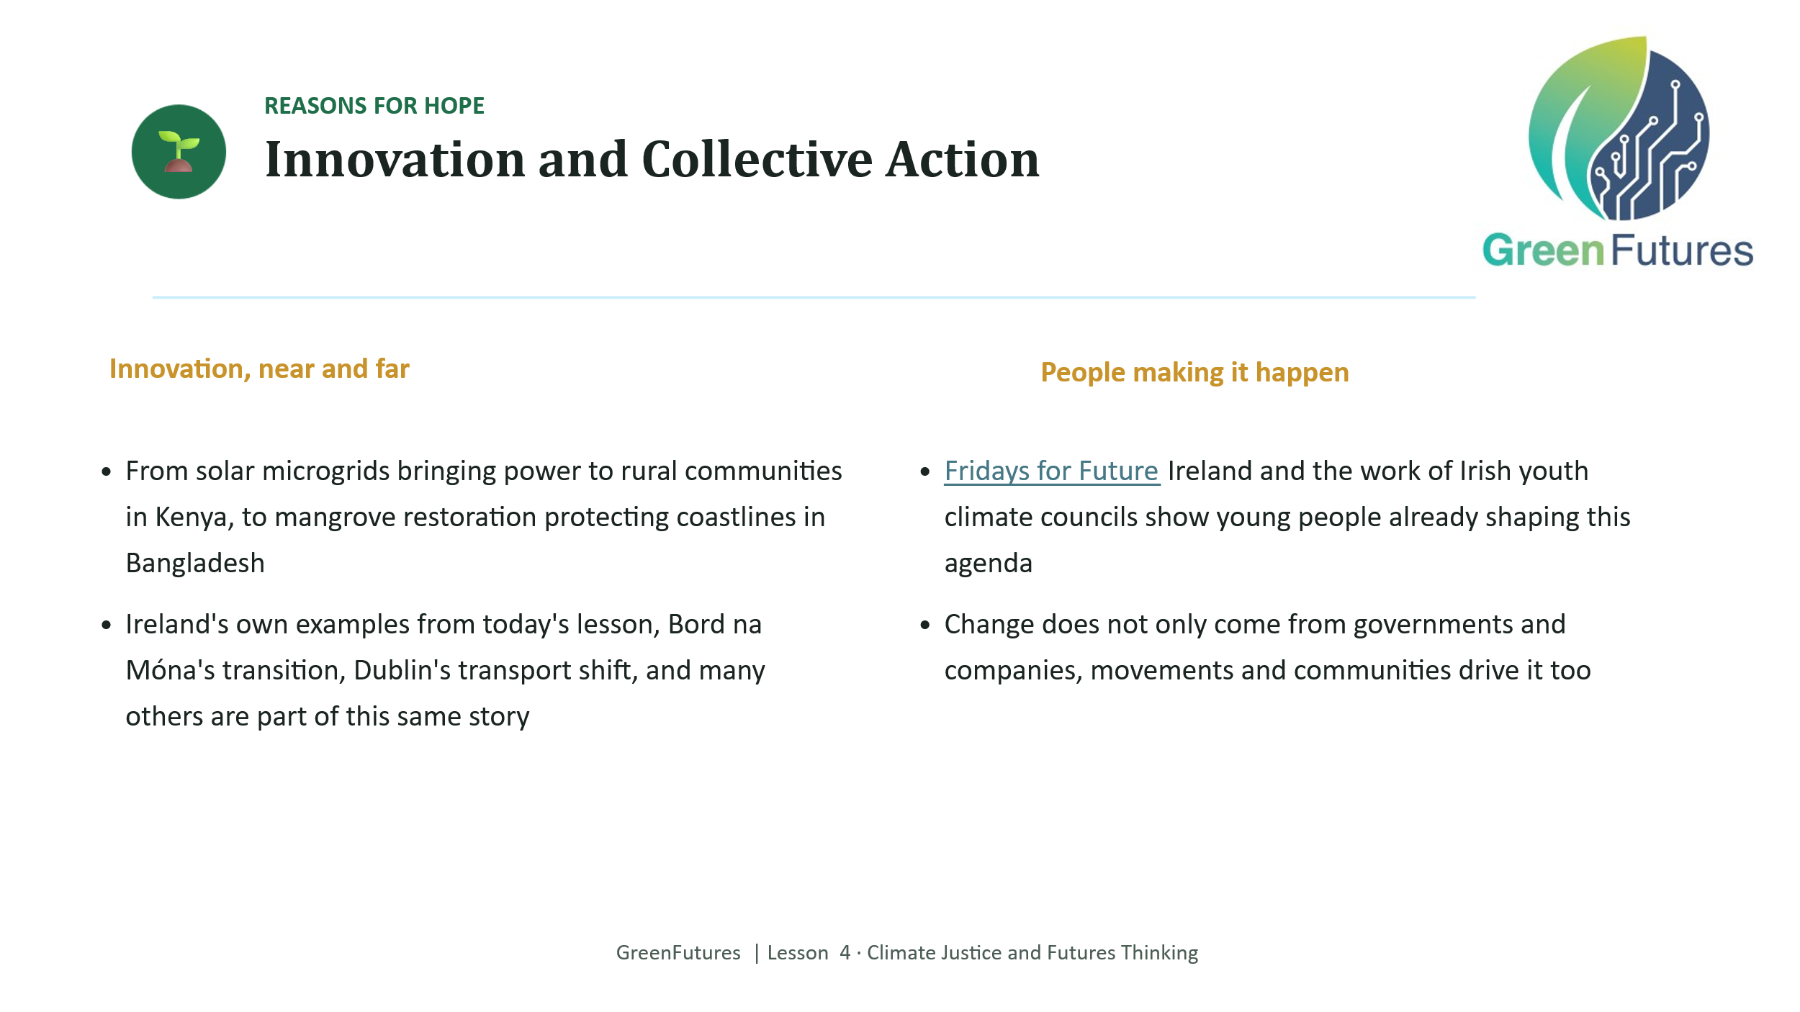 | LECTURE (~3 mins)  Cover global innovation examples (solar microgrids in Kenya, mangrove restoration in Bangladesh) alongside Ireland's own examples from Lesson 3, and youth-led collective action (Fridays for Future Ireland, Irish youth climate councils).
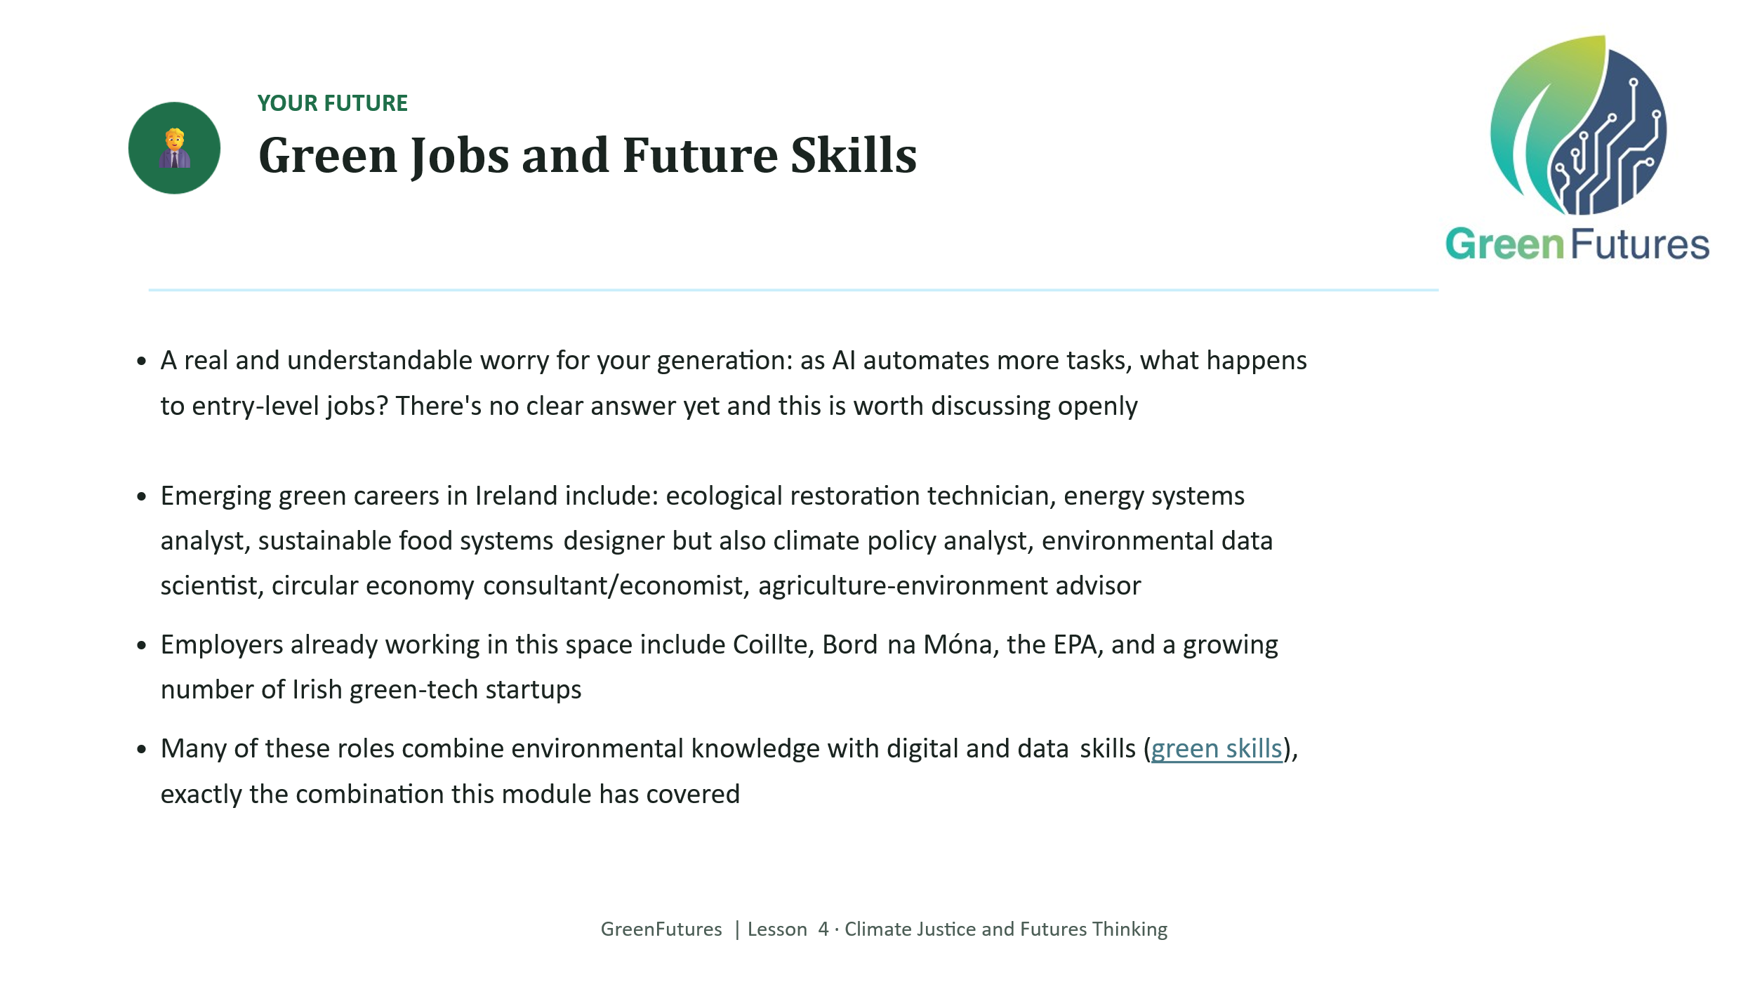 | LECTURE (~3 mins)  Cover Irish green career examples and employers. This is a good moment to invite questions about what skills or subjects lead toward these careers.  Trades and hands-on roles:  - Solar PV installer  - Wind turbine technician  - Retrofit installer (insulation, heat pumps)  - EV charging infrastructure electrician  - Farm technician (Teagasc apprenticeship route)  Professional and technical roles:  - Offshore wind engineer  - ESG (Environmental, Social, Governance) analyst  - BER assessor/energy auditor  - Battery storage/grid technician  - Sustainability consultant  More employers to add:  - SSE Airtricity/SSE Renewables  - ESB and ESB Networks  - EirGrid  - Uisce Éireann  - Teagasc  - GridBeyond — Dublin-founded AI energy company  Social science-friendly green job titles:  - Climate policy analyst  - Environmental/climate economist  - ESG (Environmental, Social, Governance) analyst, a genuinely fast-growing finance-sector role  - Sustainability/CSR manager  - Climate communications or campaigns officer  - Environmental or climate lawyer  - Local authority climate action officer / environmental planner  - Behavioural scientist for sustainable behaviour change  Irish employers for these:  - ESRI (Economic and Social Research Institute)  - Central Bank of Ireland has a climate risk unit  - Local authority Climate Action Regional Offices (e.g. Codema, Dublin's energy agency); local, relatable, hires planners/communications people  - An Taisce and Friends of the Earth Ireland; environmental NGOs with policy/campaigns roles  - Big firms like KPMG, Deloitte, PwC all now have dedicated ESG/sustainability advisory teams  - Banks like AIB and Bank of Ireland growing sustainable finance teams
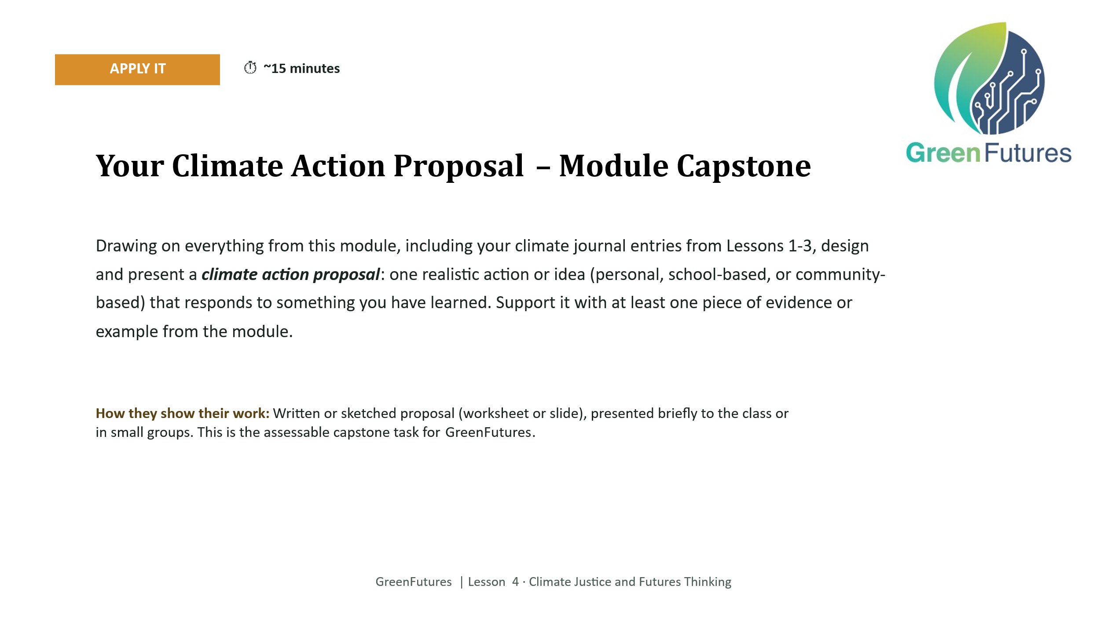 | APPLY - MODULE CAPSTONE (~15 mins)  Students design a climate action proposal drawing on their climate journal entries from all three previous lessons, supported by at least one piece of evidence from the module.  This is the assessable culmination of GreenFutures. Do not compress this into a take-home handout. A shared moment of presenting (to the class or in small groups) is what builds the sense of capability the whole module has been working toward.
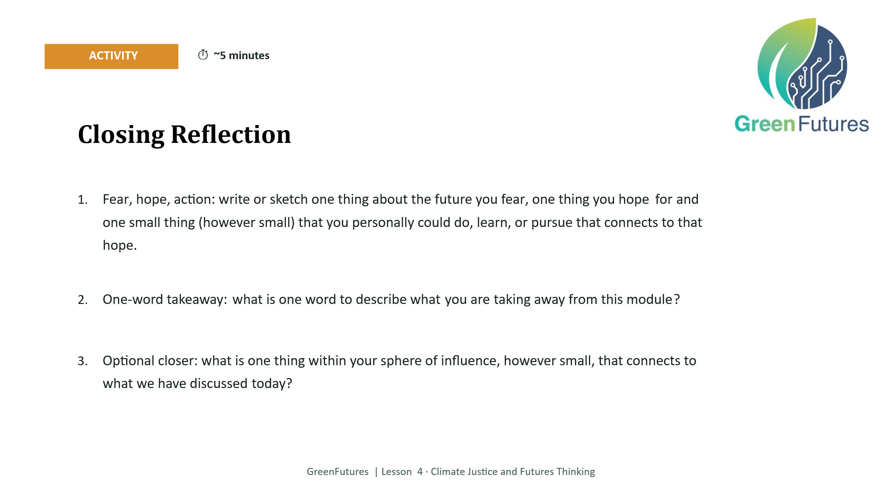 | ACTIVITY, CHOOSE 1-2 PROMPTS (~5 mins)  Offer the fear/hope/action sketch, the one-word takeaway, and the sphere-of-influence question. Choose one or two based on time remaining rather than running all three.
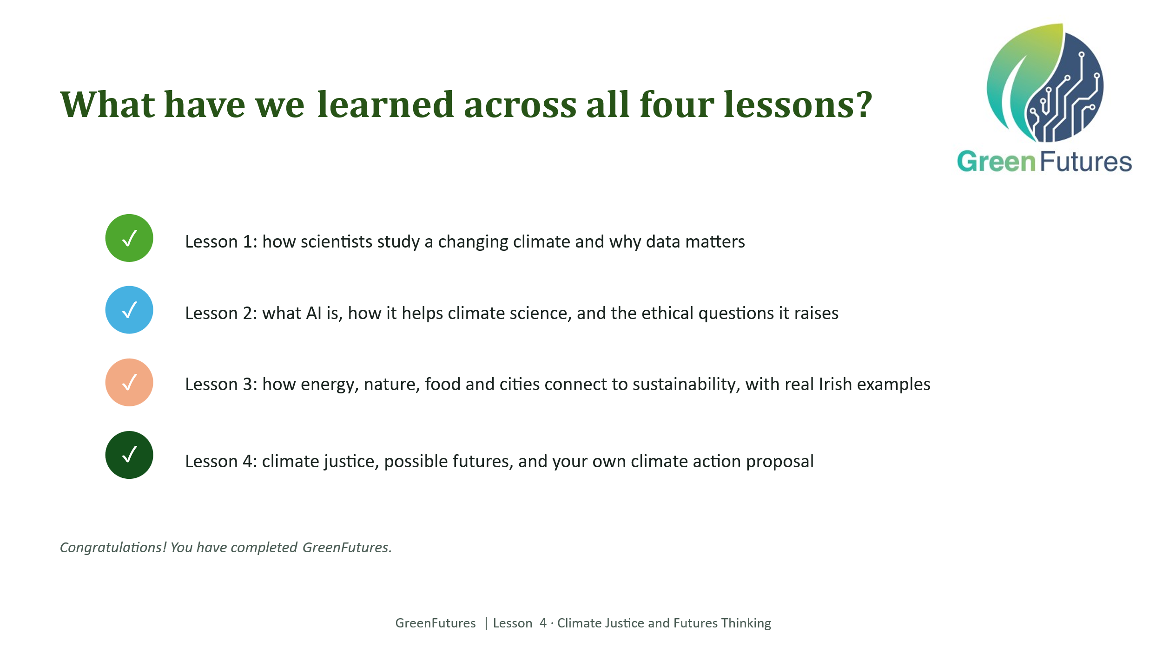 | LECTURE (~2 mins)  Recap across all four lessons, not just today. This is the module's full-arc summary.
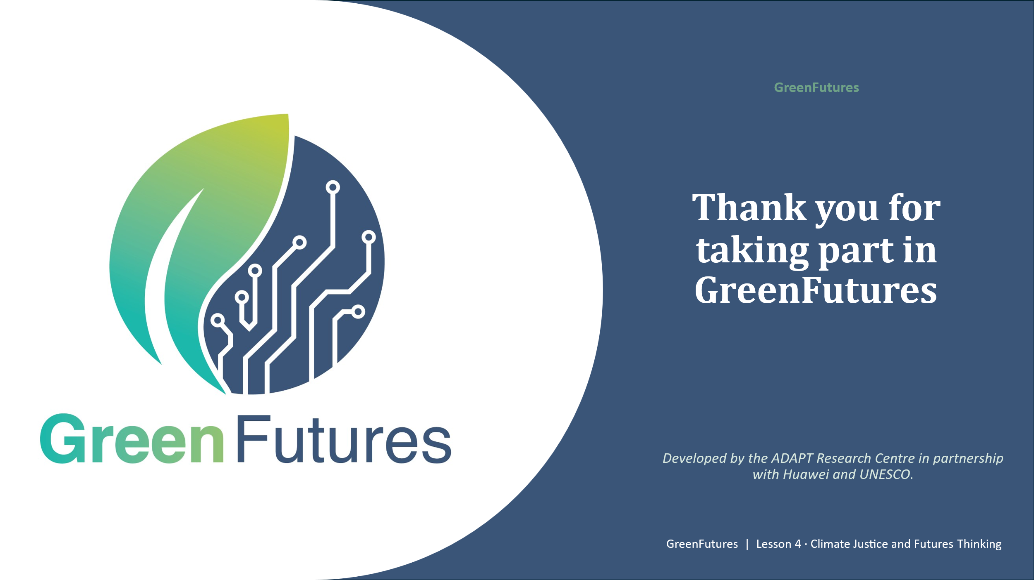 | LECTURE (~1 min)  Close by confirming the certificate of completion will be given, a template can be requested from ADAPT Research Centre. Possibility of presenting a number of certificates at the module's celebration event TBC.

