GREENFUTURES
Lesson 3: Sustainable Systems: Energy, Nature, Food and Cities
Teacher Guide

This is the third of four GreenFutures lessons. Having covered climate science and AI, this lesson turns to the physical systems - energy, nature, food, cities - that climate action must ultimately change, always grounded in a real Irish example.
Time | ~55 minutes (flex to a 40-minute class by trimming discussion time and one activity, as noted in the walkthrough below)
Background | Builds on Lessons 1 and 2. No new technical prerequisites, though the AI vocabulary from Lesson 2 (bias, pattern recognition) is referenced briefly when discussing AI-supported systems.
Materials Needed | PowerPoint presentation, laptop, screen, timer, students' climate journals.
Curriculum Links
GreenFutures is designed as an NCCA-compliant, cross-curricular Transition Year module (Science, Geography, CSPE, Digital Media). Its interactive and reflective activities build the five key skills central to Transition Year:
- Information processing
- Critical and creative thinking
- Communicating
- Working with others
- Being personally effective

Leaving Certificate subject links: Geography, Politics and Society, Technology, Computer Science, Business, Economics.
Learning Intentions
By the end of this lesson, students will be able to:
- Describe how energy, nature, food and cities each contribute to climate change
- Compare renewable and non-renewable energy systems
- Explain why biodiversity and healthy ecosystems matter, as a crisis connected to but distinct from climate change
- Identify sustainable approaches to food, transport and everyday consumption
- See how AI supports smarter, more sustainable infrastructure

Module Overview
Introduction (~3 mins)
Recap and preview today's four systems.
Energy and Nature (~14 mins)
Cover renewable energy and biodiversity, each with a grounding Irish example.
Food and Cities (~14 mins)
Cover agriculture and urban sustainability, each with a grounding Irish example - handle the farming example with care.
Weigh the Trade-Off and Apply (~18 mins)
Students debate a real trade-off, then propose one improvement to a system close to home.
Recap and Close (~3 mins)
Consolidate and preview Lesson 4.

Lesson 3 Module Walkthrough
Each row below shows the slide alongside facilitation notes. Timings are approximate and add up to the total above; trim discussion prompts first if running short on time.

Introduction (~3 mins)
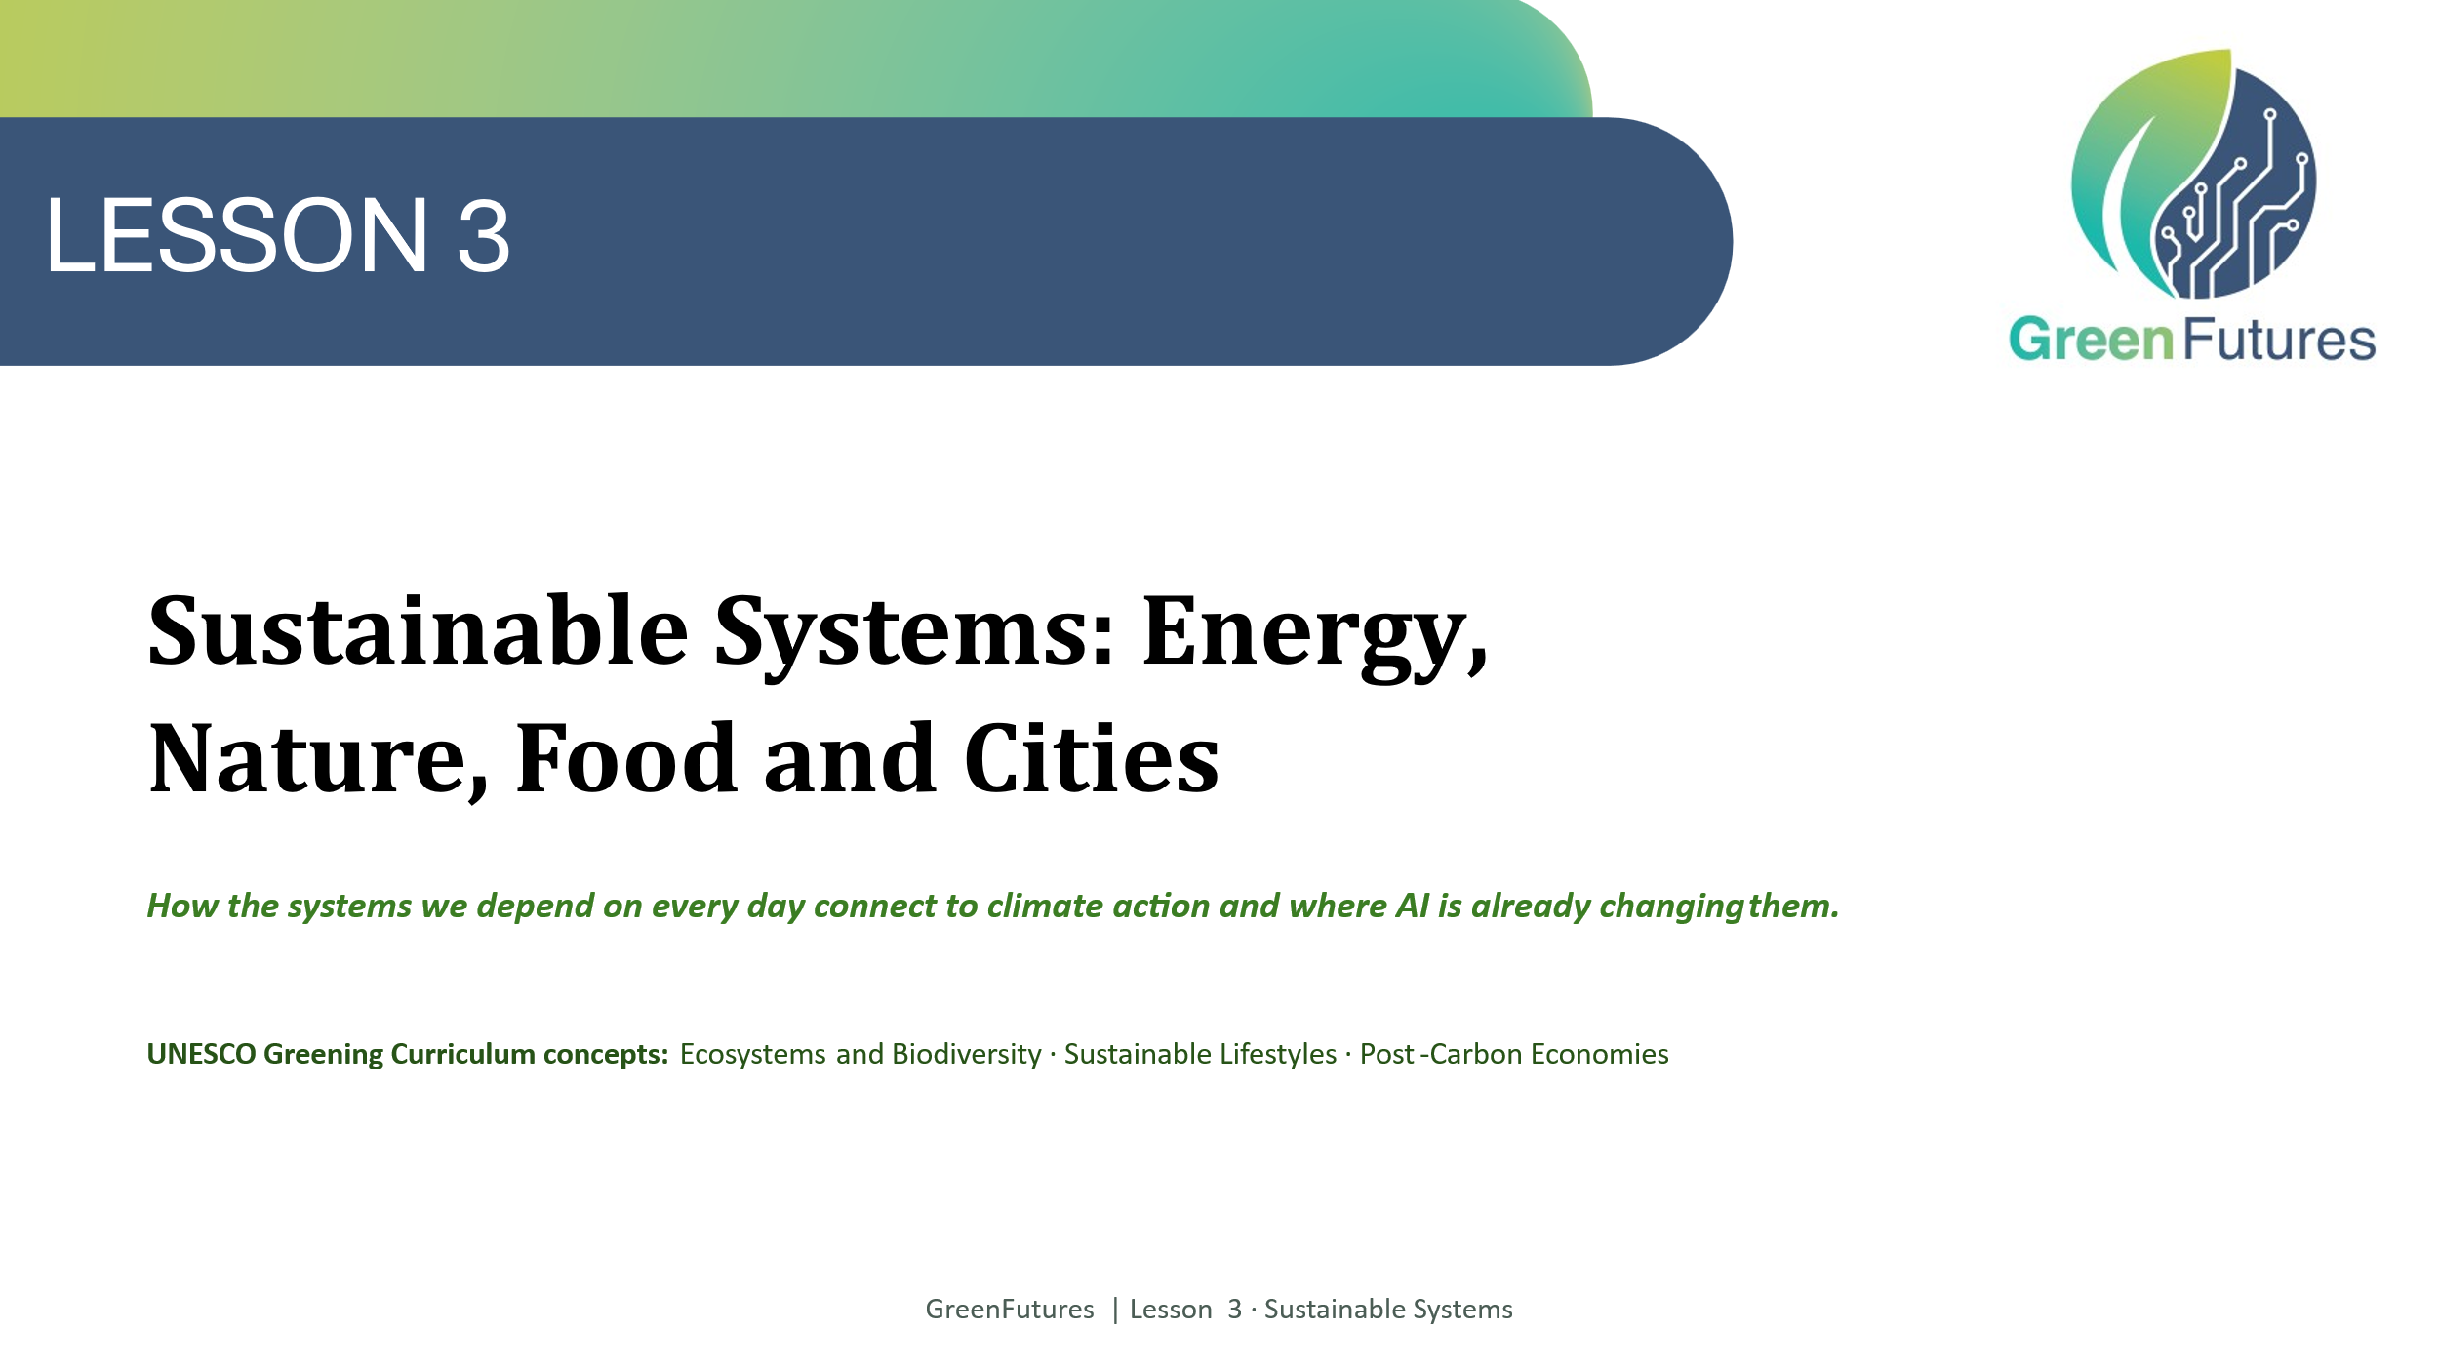 | LECTURE (~1 min)  Briefly recap Lessons 1 and 2. Tell students today connects everything so far to four everyday systems: energy, nature, food and cities.
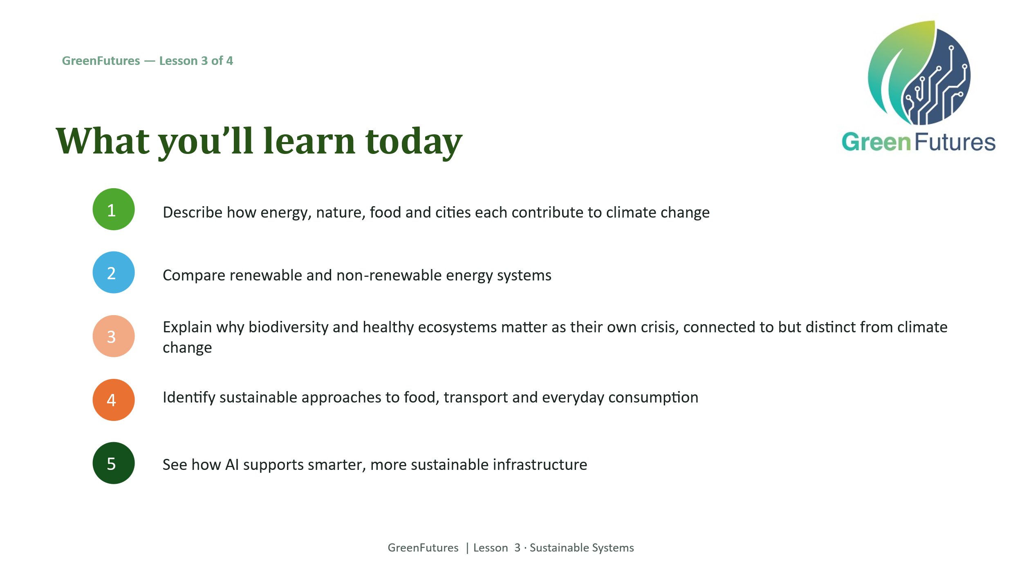 | LECTURE (~2 mins)  Walk through today's five learning outcomes.
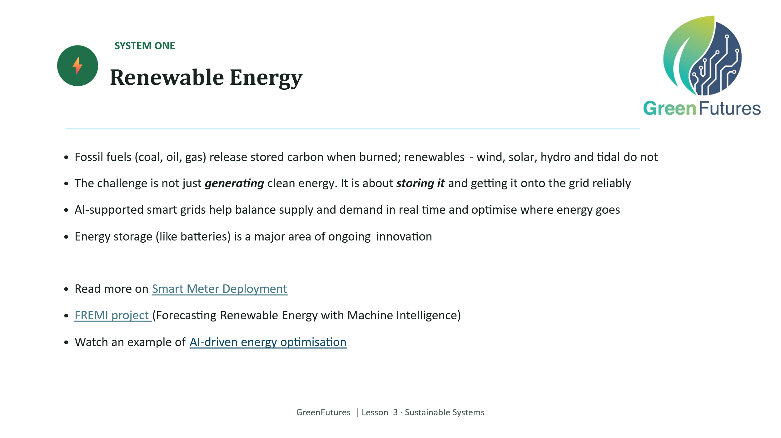 | LECTURE (~4 mins)  Cover fossil fuels vs. renewables, and the storage/grid challenge. Introduce AI-supported smart grids as a real application.  ESB: Smart Meter Deployment  FREMI project (Forecasting Renewable Energy with Machine Intelligence)  ESB and GridVision  AI-driven energy optimisation by GridBeyond:  https://www.youtube.com/watch?v=qMXm-xkToAM  https://gridbeyond.com/about-us-2/
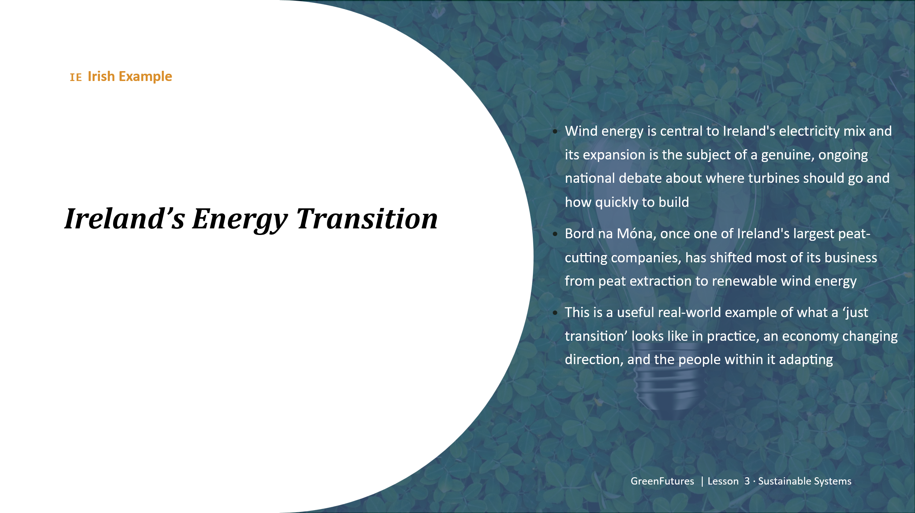 | LECTURE (~3 mins)  Present the Irish wind-energy example and Bord na Móna's shift from peat to wind, framed as a real ‘just transition’ story.
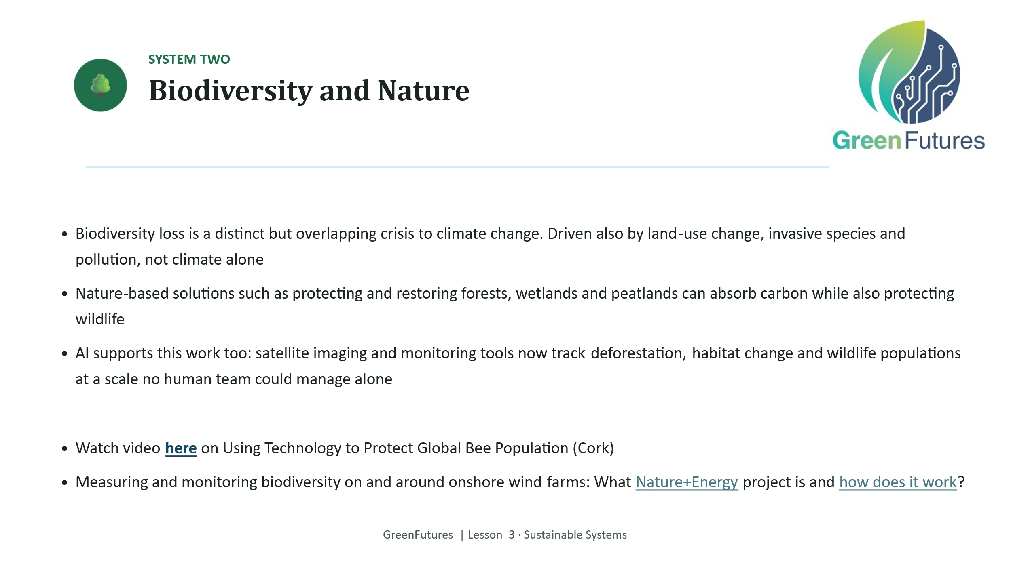 | LECTURE (~4 mins)  Introduce biodiversity loss as a distinct but overlapping crisis to climate change, driven also by land-use change, invasive species and pollution. Cover nature-based solutions and AI-supported monitoring.  AvisProtect (Cork) video on bee population  Measuring and monitoring biodiversity on and around onshore wind farms: What Nature+Energy project is and how does it work?  https://www.irishtimes.com/news/environment/nature-energy-project-to-benefit-vicinities-of-wind-farms-1.4612421
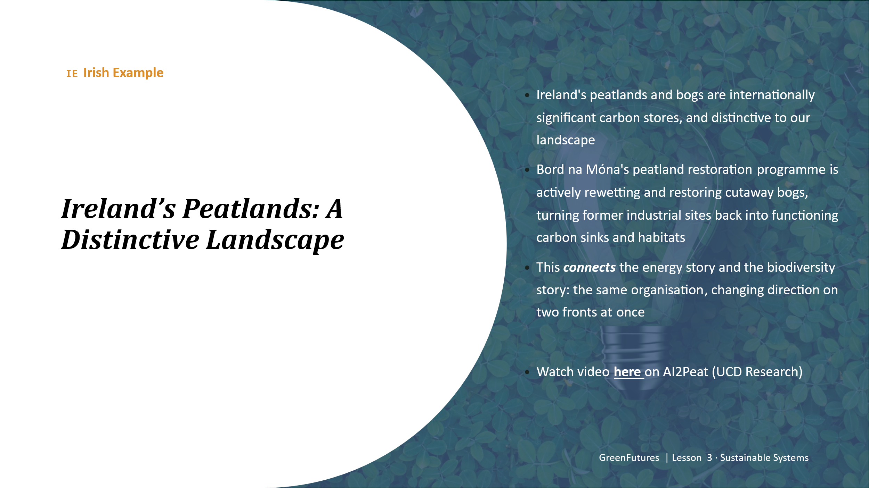 | LECTURE (~3 mins)  Present Ireland's peatlands as a distinctive landscape and Bord na Móna's peatland restoration programme, this deliberately echoes back to the wind-energy slide, showing one organisation changing direction on two fronts.  AI2Peat (UCD Research) video  More on the project:  https://www.ucd.ie/research/impact/casestudies/ai2peattheall-irelandaiplatformpoweringsmarterpeatlandmanagement/  https://www.rte.ie/news/ireland/2025/1117/1544305-irish-ai-climate/
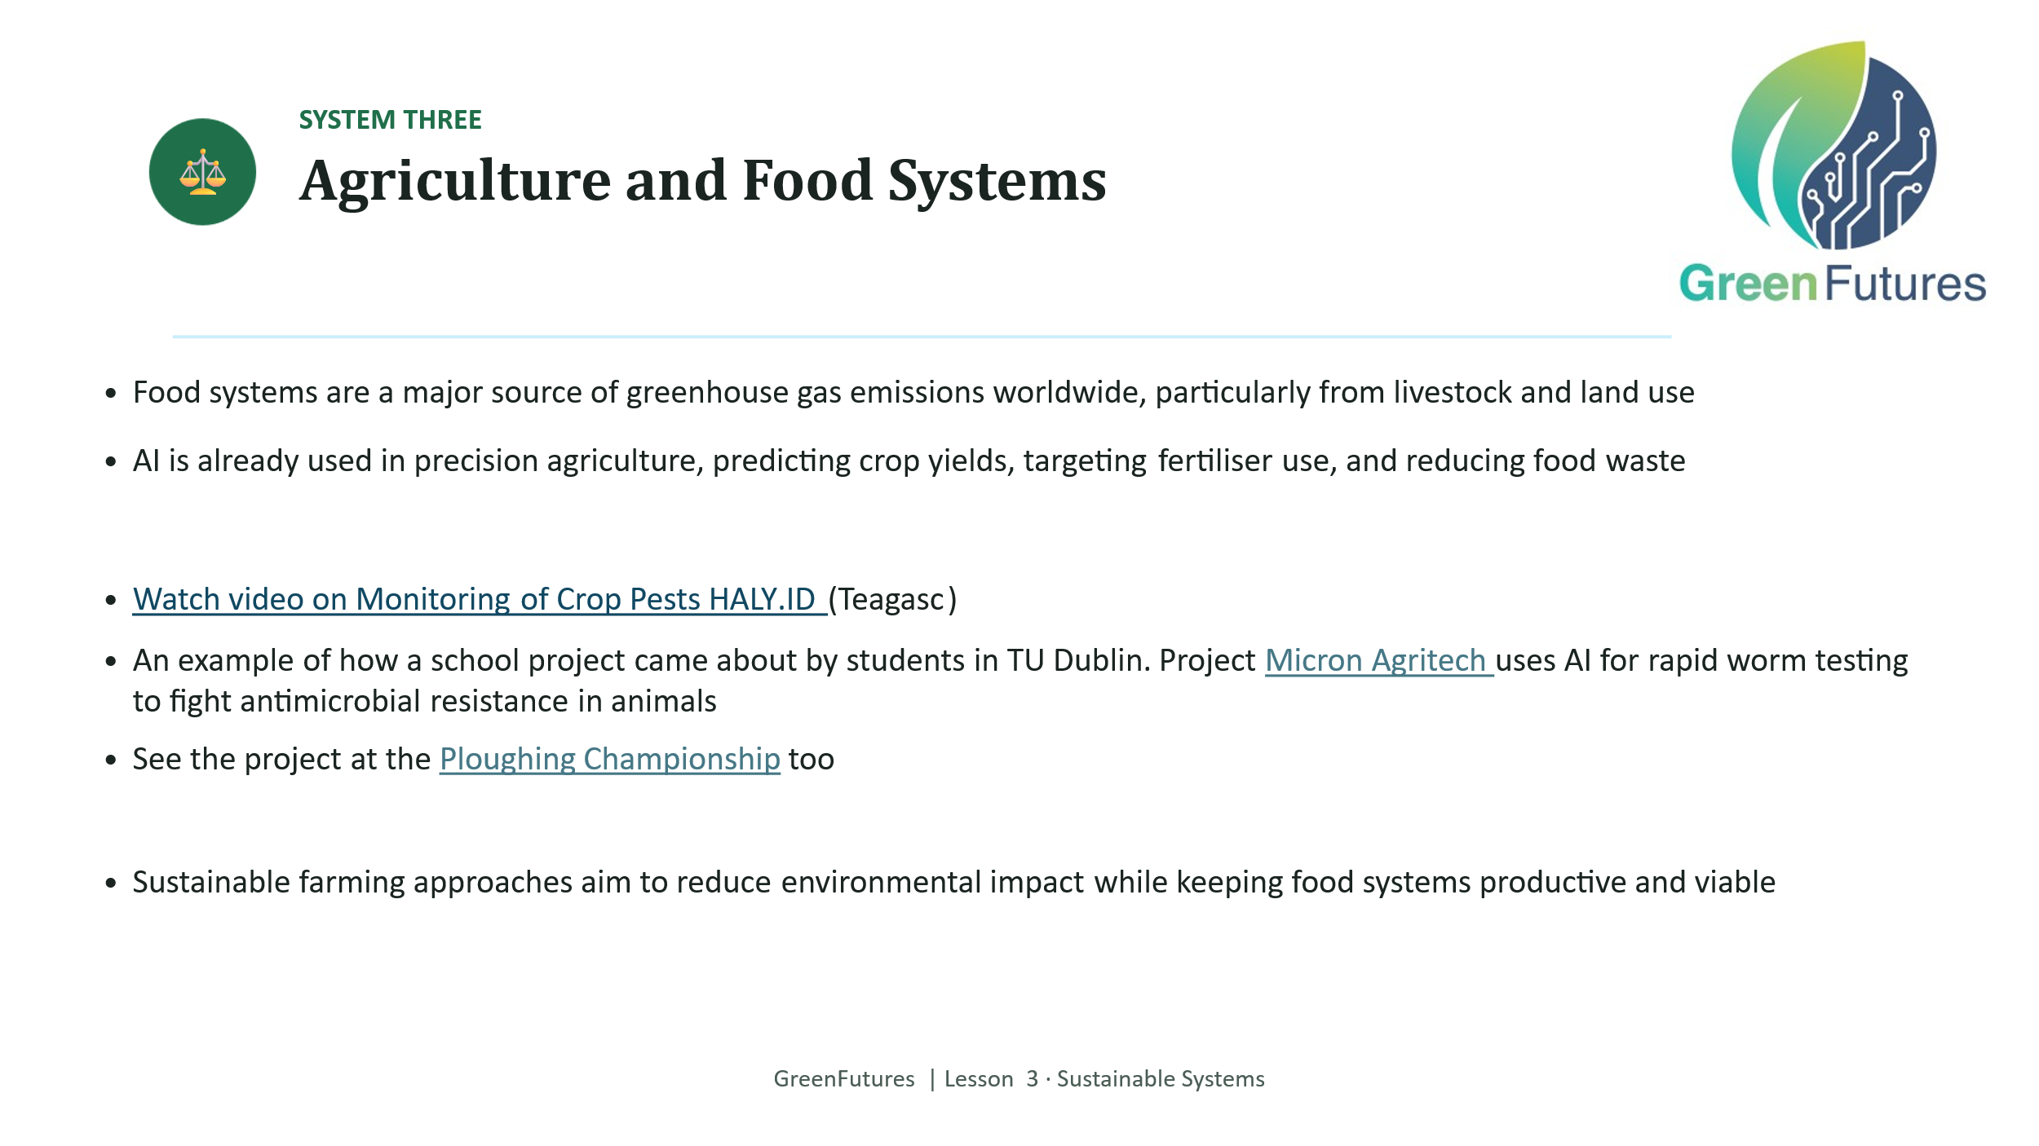 | LECTURE (~4 mins)  Cover food systems' emissions, AI in precision agriculture, and reducing fertiliser use and food waste.  - Monitoring of crop pests (Teagasc)  Ploughing: How Micron Agritech uses rapid worm testing to fight antimicrobial resistance.  The project was developed as part of a school project by TU Dublin students, great example and inspiration for the TY students: https://www.youtube.com/watch?v=vvrklQxxyaw
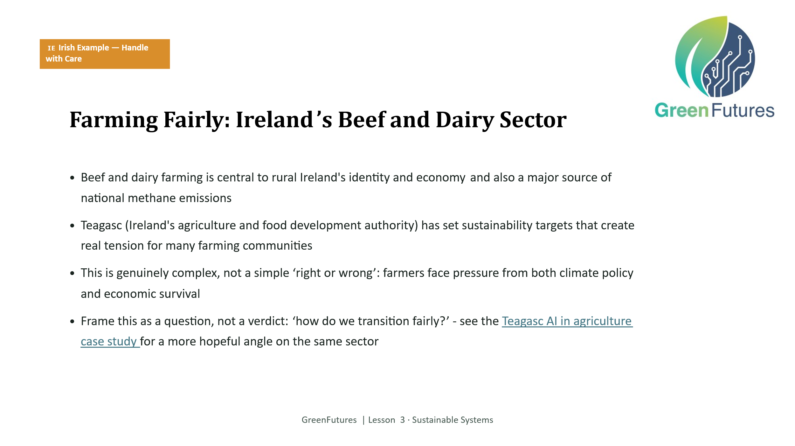 | LECTURE/DISCUSSION - HANDLE WITH CARE (~4 mins)  Present the beef and dairy example. This is the most sensitive slide in the module - read the framing note aloud if useful: the aim is to present real complexity and pressure on farming communities, not to hand down a verdict.  https://teagasc.ie/news--events/daily/how-artificial-intelligence-is-shaping-the-future-of-irelands-food-industry/
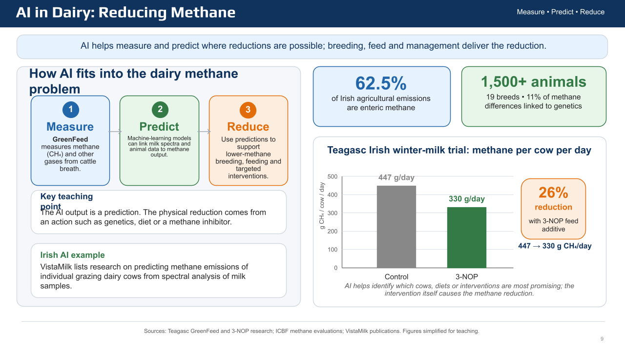 | 3-NOP Winter Milk Trial https://teagasc.ie/animals/dairy/dairy-levy-research/winterliquid-milk-production/  GreenFeed Research Update: https://teagasc.ie/environment/climate-change-air-quality/signpost-programme/research-updates/  ICBF Methane https://www.icbf.com/methane/
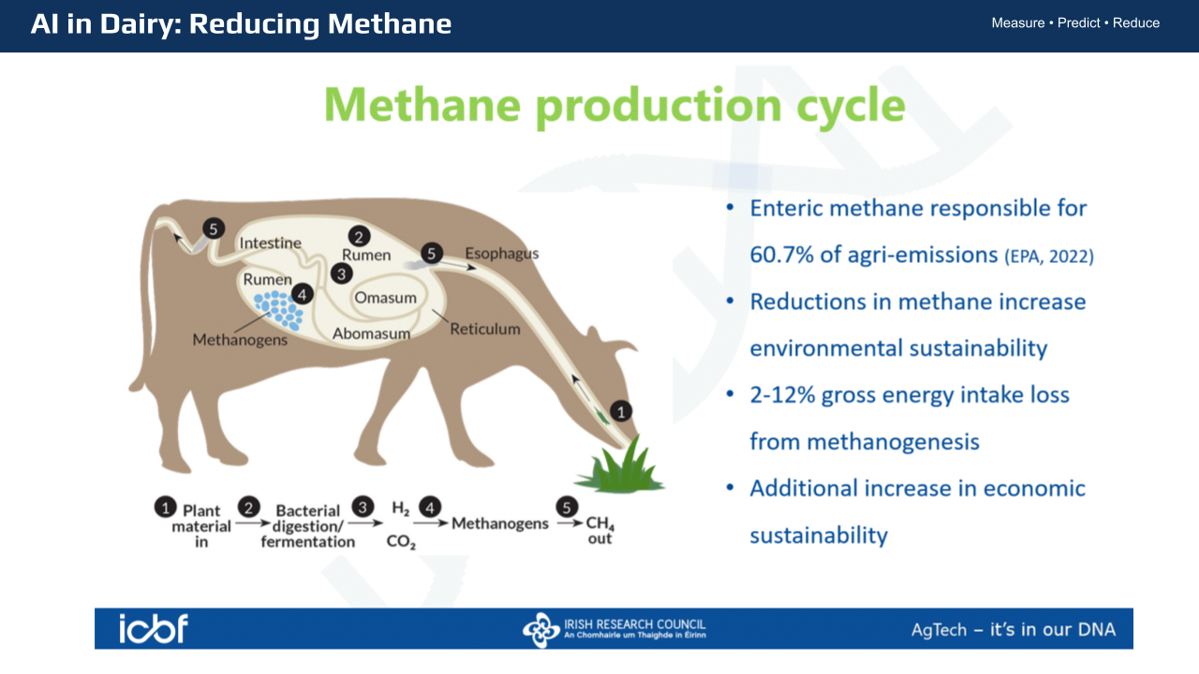
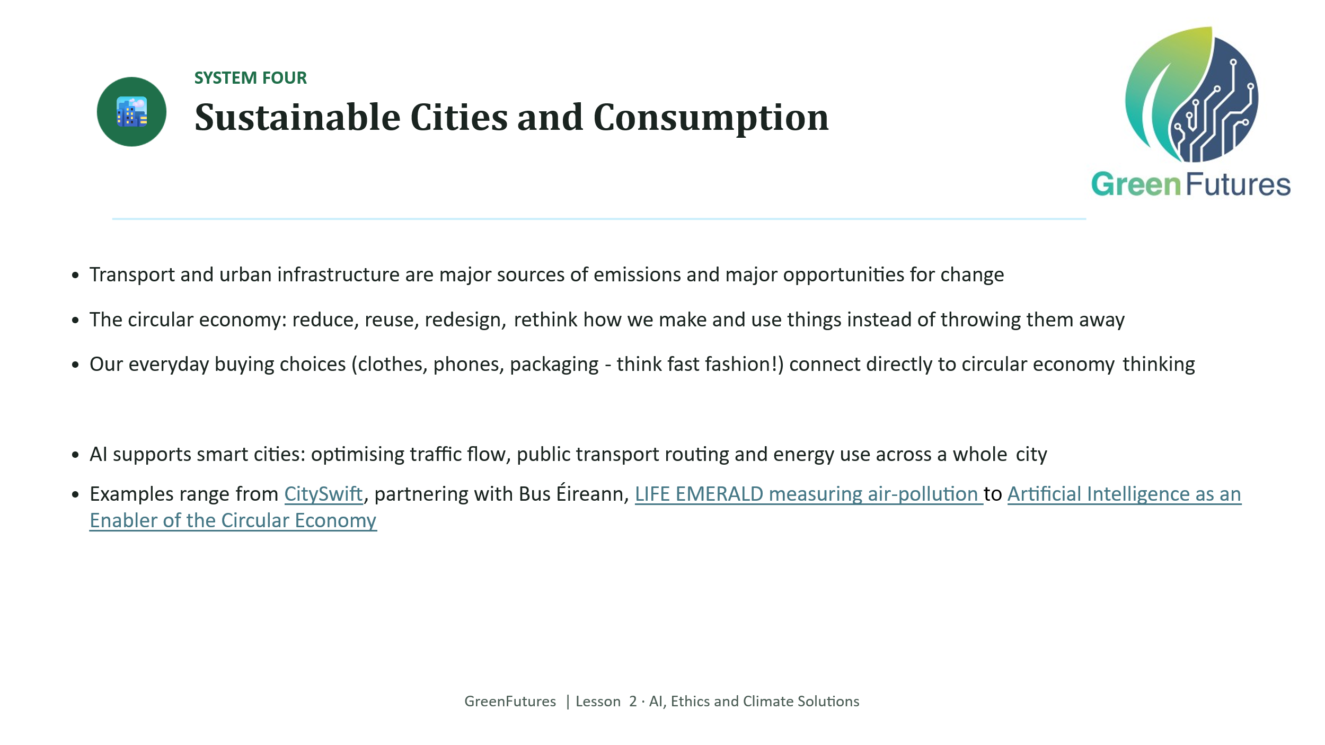 | LECTURE (~4 mins)  Cover urban emissions, the circular economy (reduce/reuse/redesign), everyday consumption choices (fast fashion, overconsumption!) and AI-supported smart cities.  Examples range from CitySwift, partnering with Bus Éireann  LIFE EMERALD measuring air-pollution  https://airquality.ie/  Circular Economy (EPA):  Artificial Intelligence as an Enabler of the Circular Economy  https://www.epa.ie/publications/research/reports/Research_Report-492.pdf  Potential question for discussion: why do you think adoption lags here, when Ireland is otherwise ahead on AI?
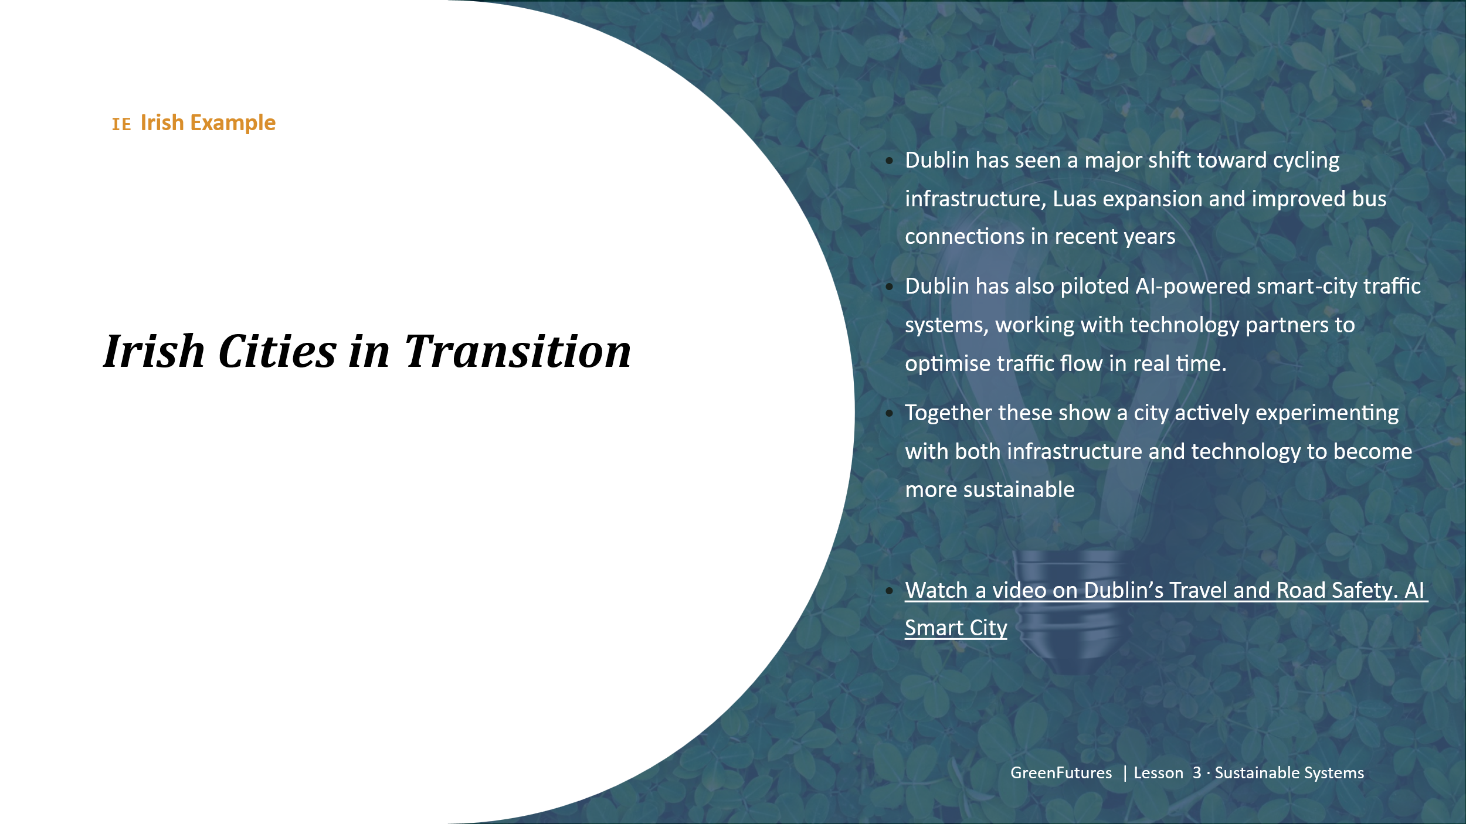 | LECTURE (~3 mins)  Present Dublin's cycling infrastructure, Luas expansion and bus network as a transport example, and the Dublin smart-city traffic pilot as the AI-supported example. Other examples from around the country?  Watch a video: https://vivacitylabs.com/smart-city-dublin-using-nvidia-bentley-systems/
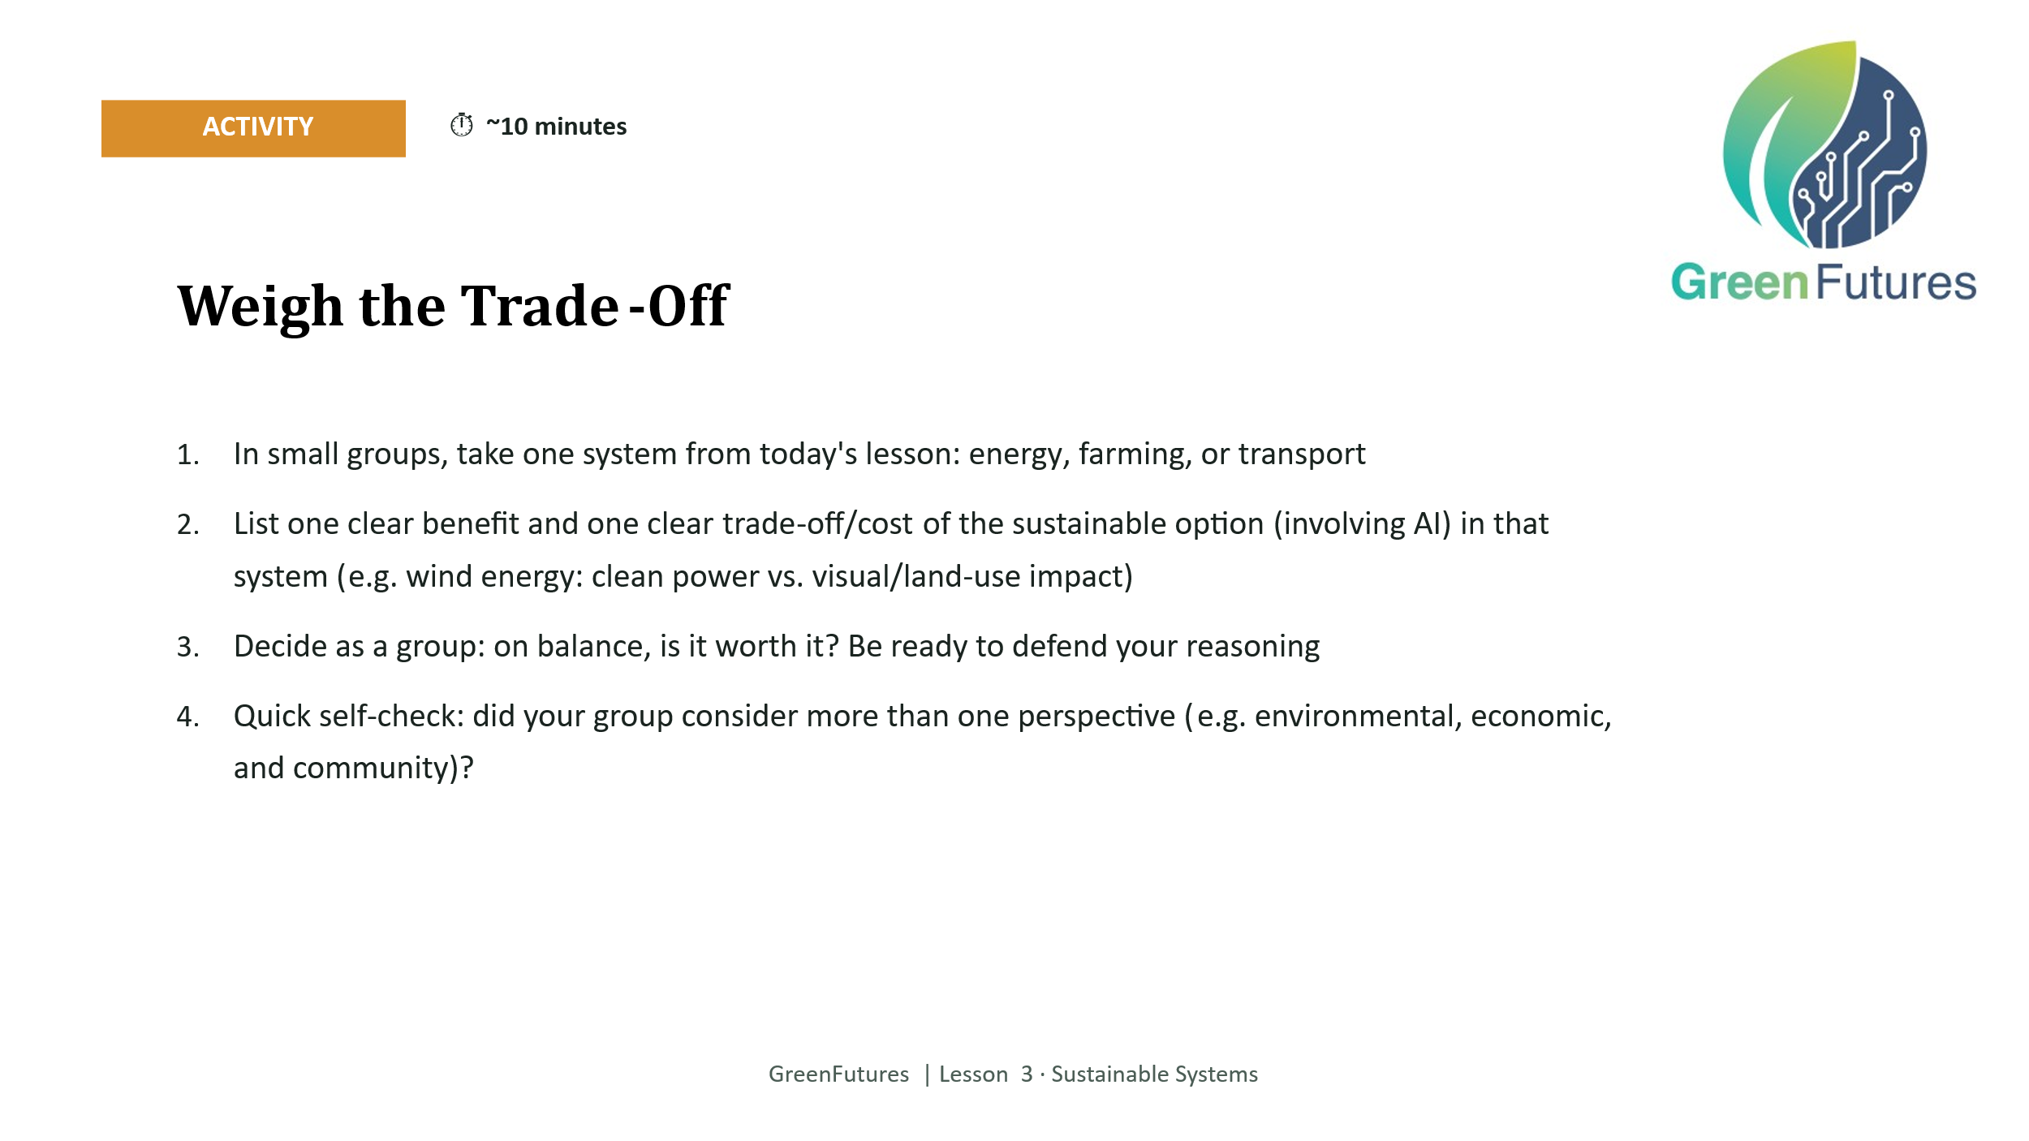 | ACTIVITY (~10 mins)  Small groups take one system (energy, farming or transport), list one benefit and one trade-off of the sustainable option involving AI and decide as a group whether it is worth it.  Prompt groups to check they have considered more than one perspective (environmental, economic, community) before deciding.
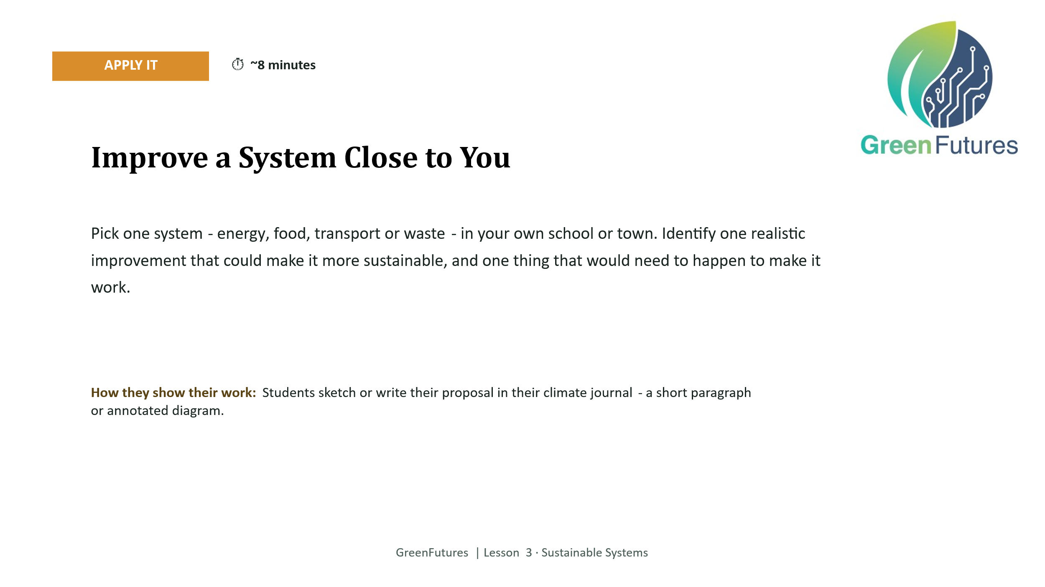 | APPLY (INDIVIDUAL, CAPTURED) (~8 mins)  Students pick one system in their own school or town and propose one realistic improvement, sketched or written in their climate journal.  Keep this grounded and local (their own canteen, bus route, bin system) rather than abstract. It feeds into the bigger Lesson 4 action proposal.
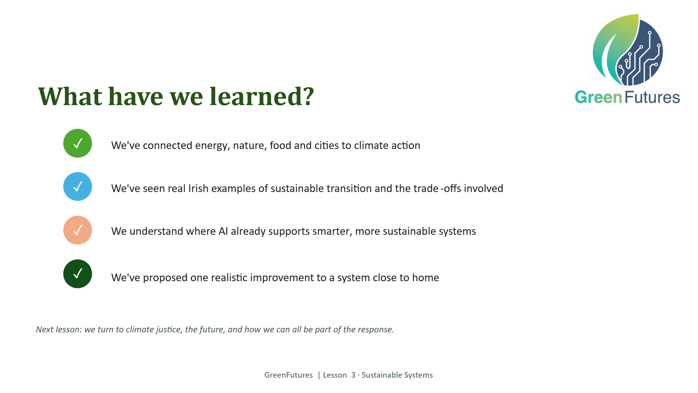 | LECTURE (~2 mins)  Revisit the five learning outcomes.
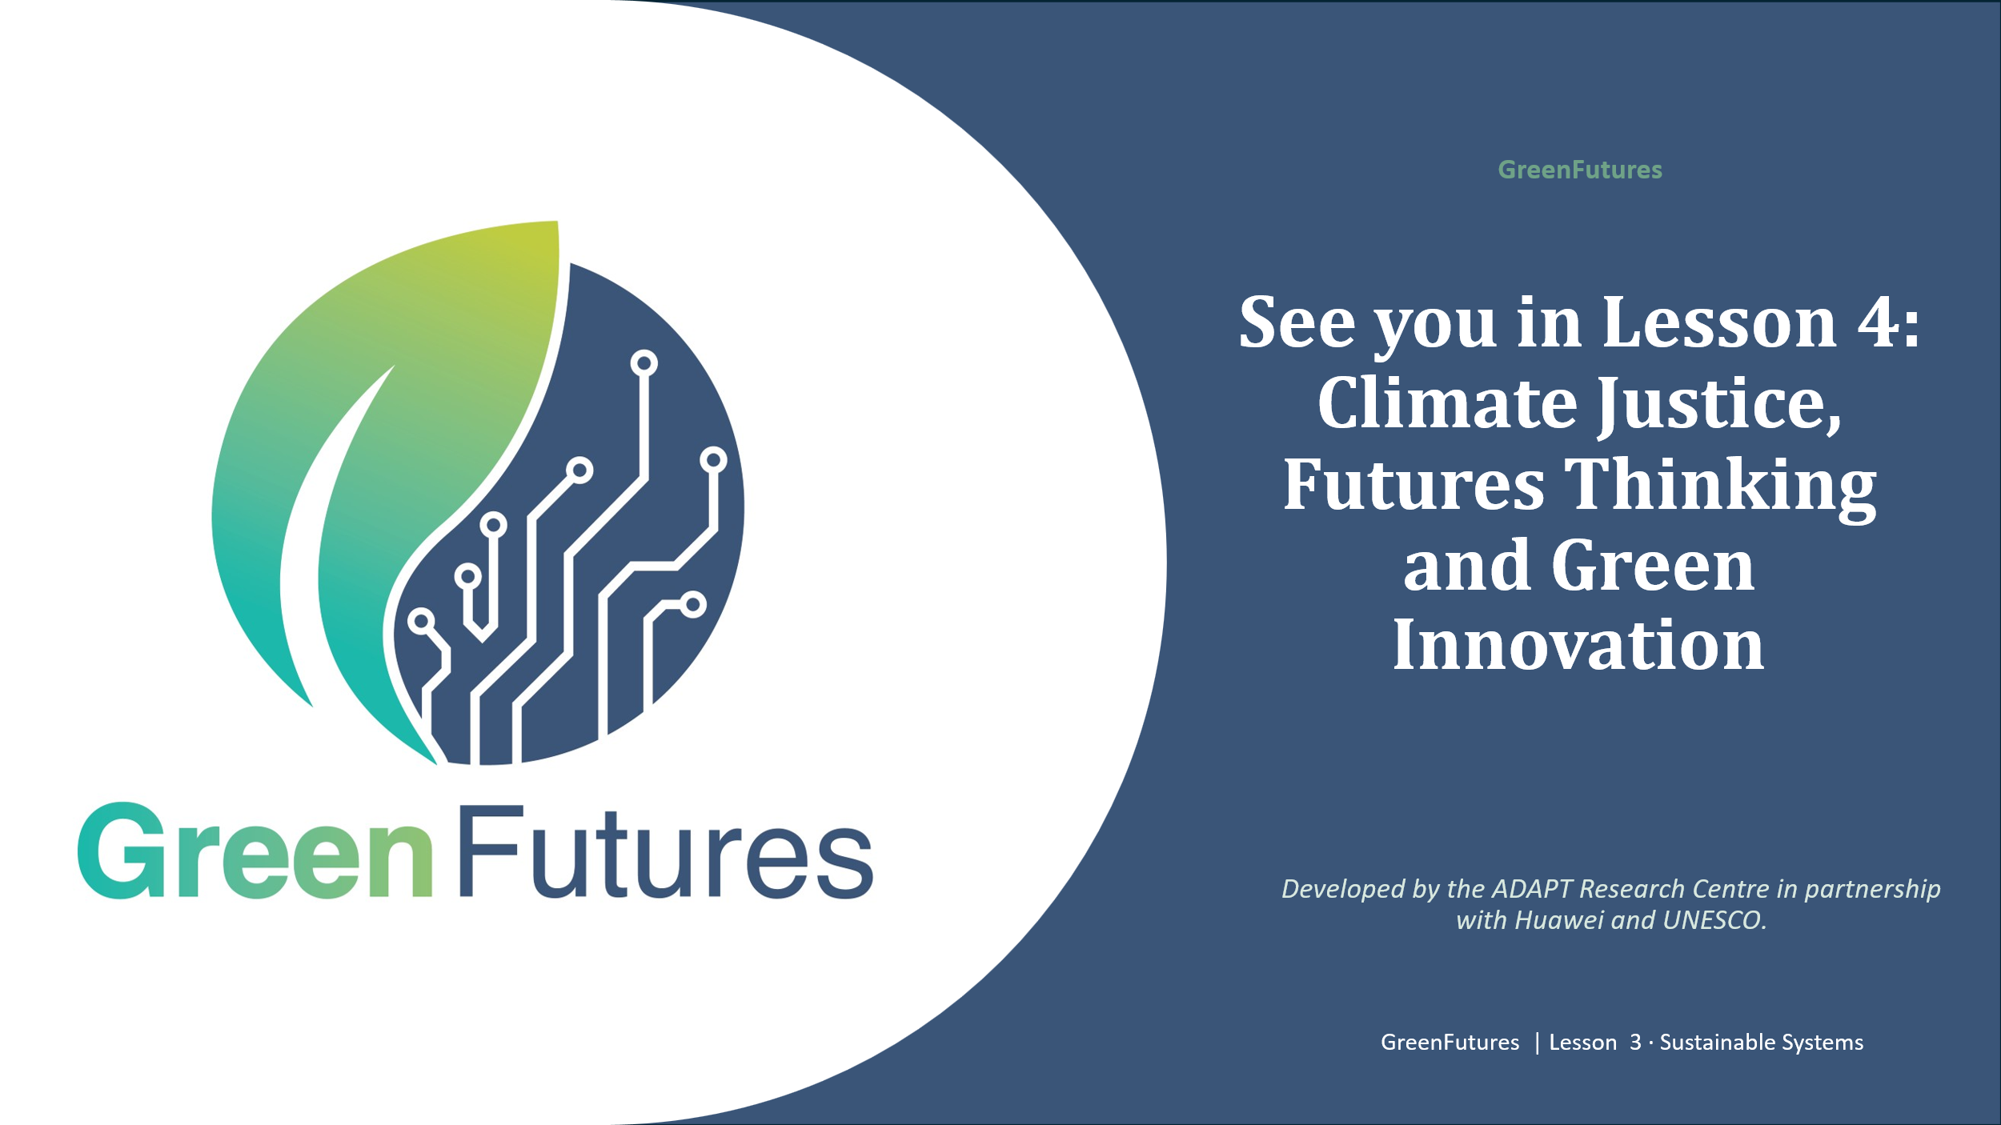 | LECTURE (~1 min)  Preview Lesson 4: Climate Justice, Futures Thinking and Green Innovation.

