GREENFUTURES
Lesson 2: Artificial Intelligence, Ethics and Climate Solutions
Teacher Guide

This is the second of four GreenFutures lessons. It builds directly on Lesson 1's introduction to climate data by asking: what actually is the AI behind these tools, how is it used in climate work, and what are its limits and risks?
Time | ~55 minutes (flex to a 40-minute class by trimming discussion time and one activity, as noted in the walkthrough below)
Background | Builds on Lesson 1 (climate data and the introduction of AI's role in it). No technical AI background is assumed. The lesson deliberately keeps explanations grounded in everyday, non-technical examples.
Materials Needed | PowerPoint presentation, laptop, screen, internet access, timer, students' climate journals from Lesson 1, a small pre-vetted bank of real AI/climate headlines or social posts for the two evaluation activities (teacher to prepare in advance).
Curriculum Links
GreenFutures is designed as an NCCA-compliant, cross-curricular Transition Year module (Science, Geography, CSPE, Digital Media). Its interactive and reflective activities build the five key skills central to Transition Year:
- Information processing
- Critical and creative thinking
- Communicating
- Working with others
- Being personally effective

Leaving Certificate subject links: Geography, Politics and Society, Technology, Computer Science, Business, Economics.
Learning Intentions
By the end of this lesson, students will be able to:
- Explain basic AI concepts and terminology in plain language
- Identify real ways AI is used in climate and environmental work
- Evaluate the benefits and risks of AI systems, including bias
- Reflect on ethical questions around technology and sustainability

Module Overview
Recap and Warm-Up (~6 mins)
Recap Lesson 1 and open with a quick, energising discussion.
What AI Is and How It Works (~8 mins)
Demystify AI in accessible, everyday terms.
AI in Climate Science and Its Limits (~16 mins)
See real applications, then interrogate bias directly through an activity.
Ethics and the Environmental Cost of AI (~17 mins)
Cover responsible AI principles, misinformation, and AI's own environmental footprint.
Apply, Recap and Close (~11 mins)
Students judge a real claim, then the class consolidates and previews Lesson 3.

Lesson 2 Module Walkthrough
Each row below shows the slide alongside facilitation notes. Timings are approximate and add up to the total above; trim discussion prompts first if running short on time.

Recap and Warm-Up (~6 mins)
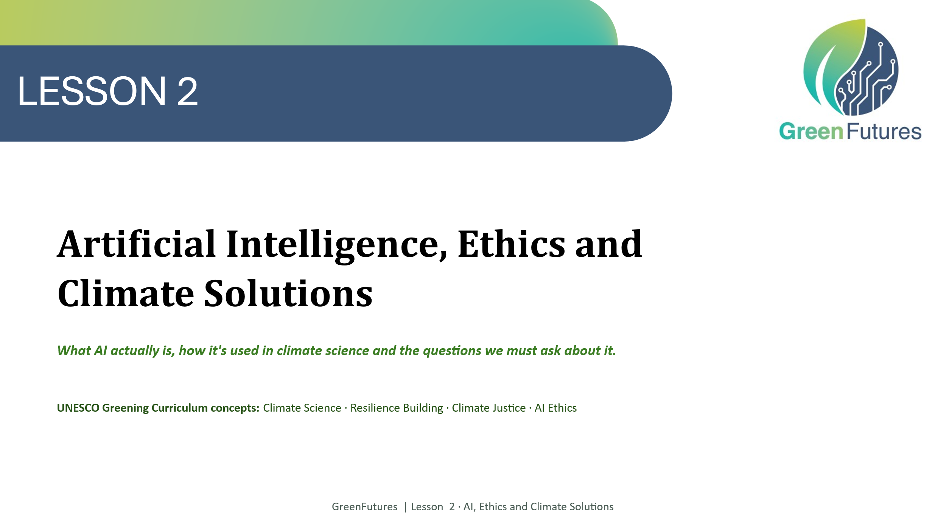 | LECTURE (~1 min)  Briefly recap Lesson 1's key idea: climate science depends on huge datasets and AI helps make sense of them.
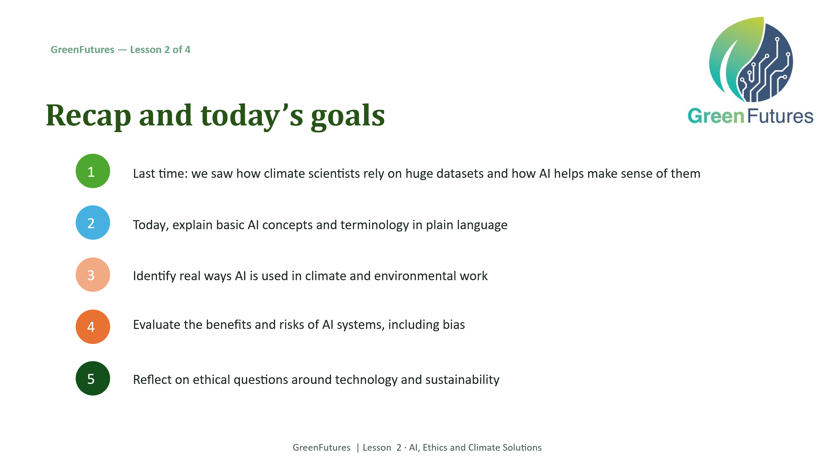 | LECTURE (~2 mins)  Walk through today's learning outcomes.
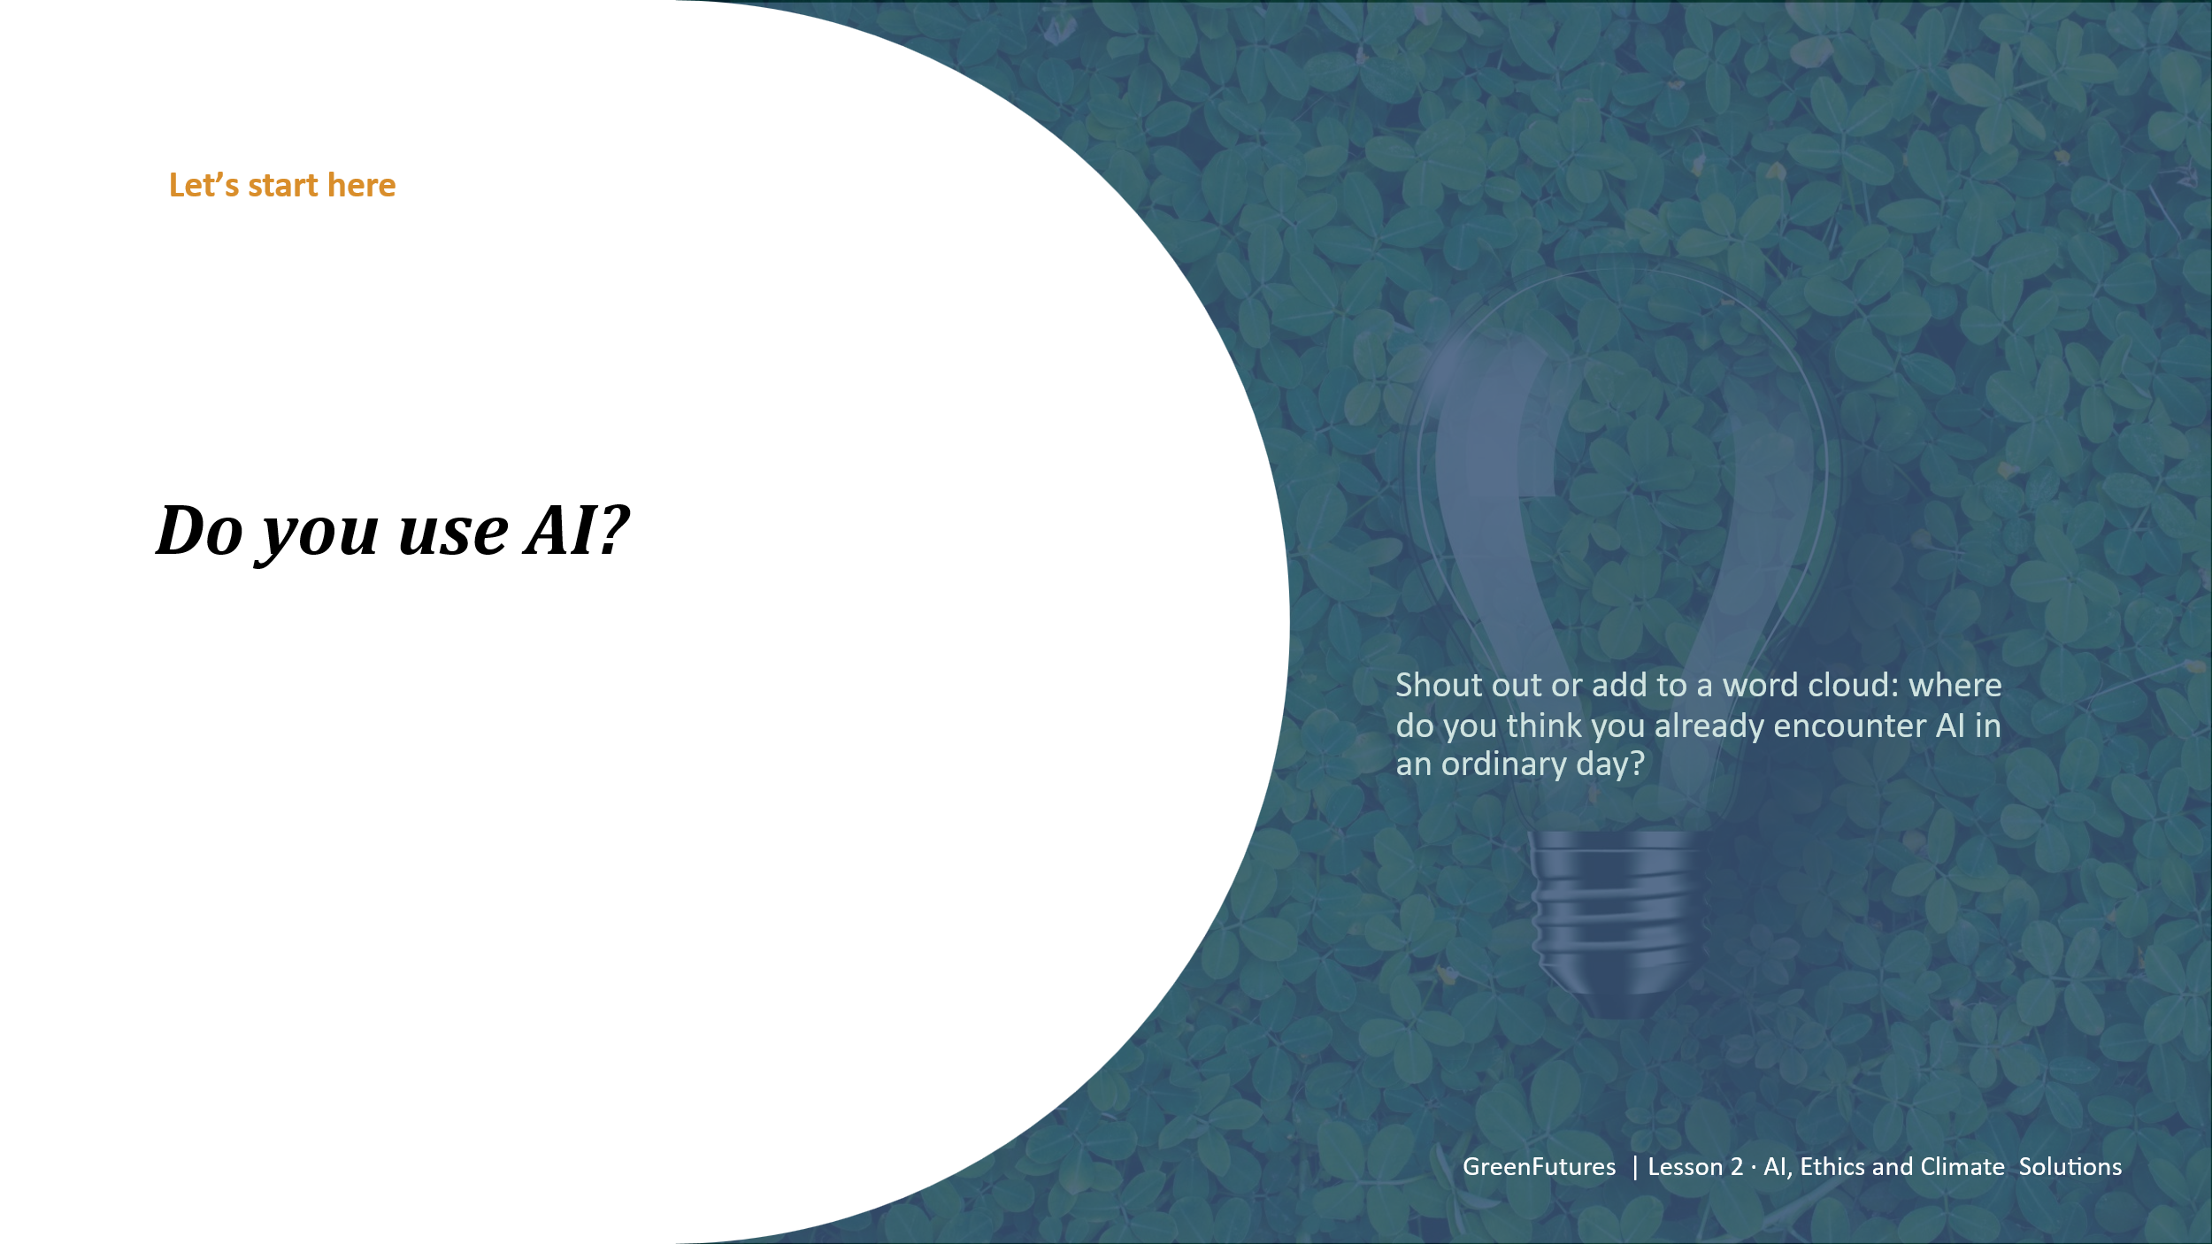 | DISCUSSION (~3 mins)  ‘Do you use AI?’ - take open answers or use a word-cloud tool. Works well as a low-stakes opener.  ‘Do you use AI and where do you see AI used in every day life?’
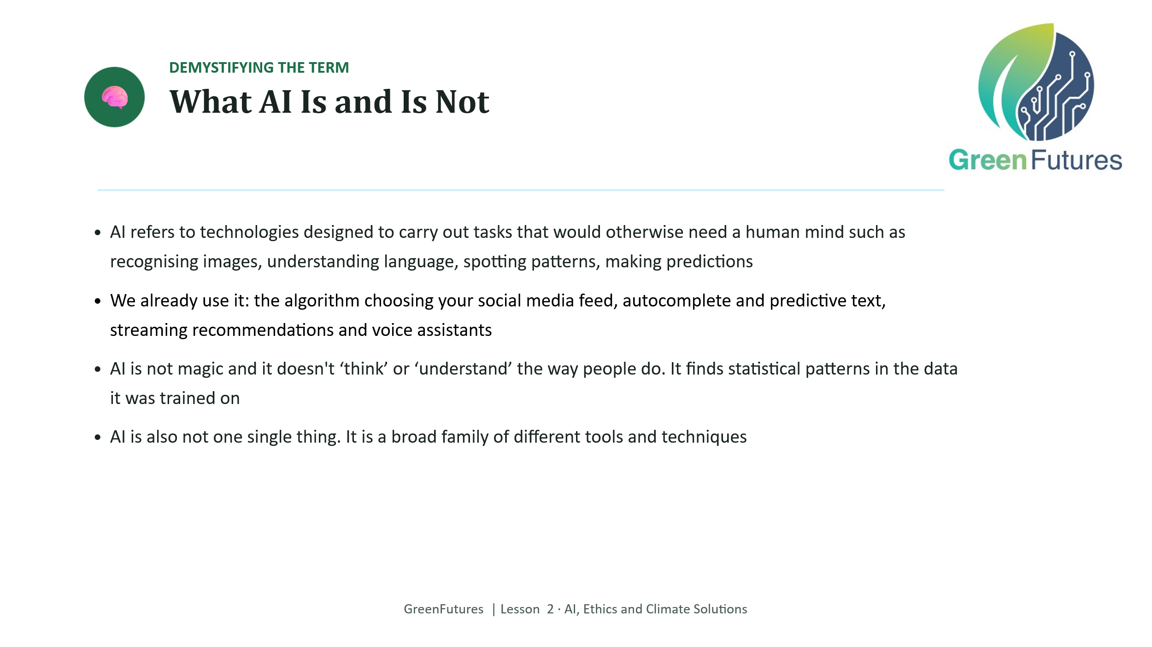 | LECTURE (~4 mins)  Define AI in plain terms and immediately ground it in everyday examples - social media algorithms, autocomplete/predictive text, streaming recommendations, voice assistants.  Be explicit that AI finds statistical patterns, it doesn't ‘understand’. This distinction matters for the ethics discussion later.  We strongly encourage to take a free, 90-minutes course on AI, specifically designed by ADAPT Research Centre for secondary school teachers: https://ailiteracyintheclassroom.ie/course/
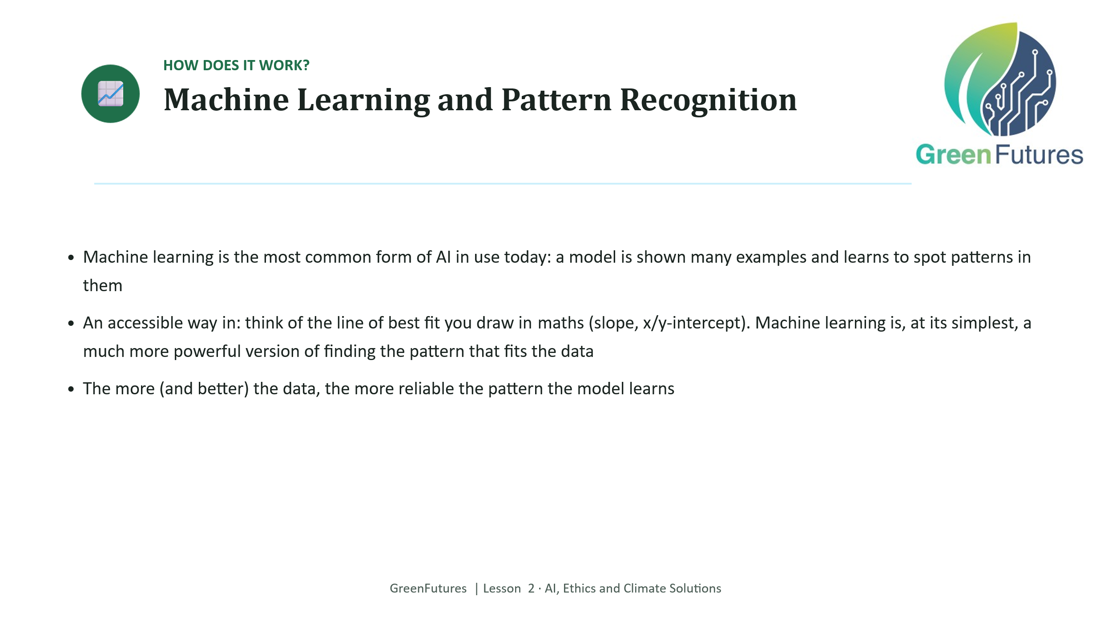 | LECTURE (~4 mins)  Introduce machine learning as pattern-finding, using the line-of-best-fit/coordinate geometry analogy so it connects to students' maths course.
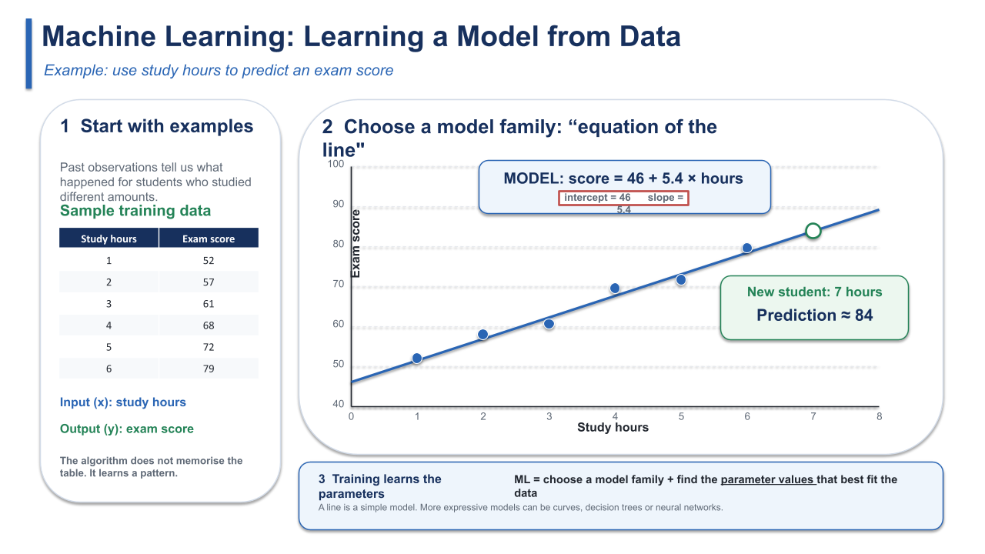 | A short, worked example or visual that makes this concrete, lands better than the analogy alone.  Here we demonstrate that Machine Learning comprises of two aspects. 1) Samples of data from previous examples 2) A “Model” where parameters need to be tuned based on the examples.  We illustrate this using the Equation of the line [Y = Slope * X + Intercept]. Here the parameters are Slope and Intercept. Machine Learning algorithms try to find the best Slope and Intercept parameter values so that the model can make the best prediction for new data.  We ask the model to predict the results a student will get (Y value) if they study for 6 hours (X value).
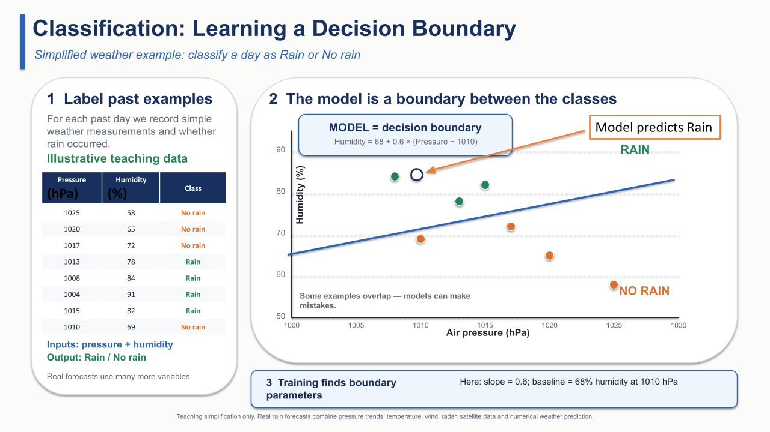 | There are many “Model” types. Using the line is a very trivial approach where there are 2 parameters. Modern AI / ML models may have hundreds, thousands, or even billions of parameters.  Here we provide another example where historical data was collected, about pressure and humidity, and whether it rained. Here we can see if we can “Classify” the prediction or new data into Rain or No Rain depending on where the new point lies in reference to the learned model.
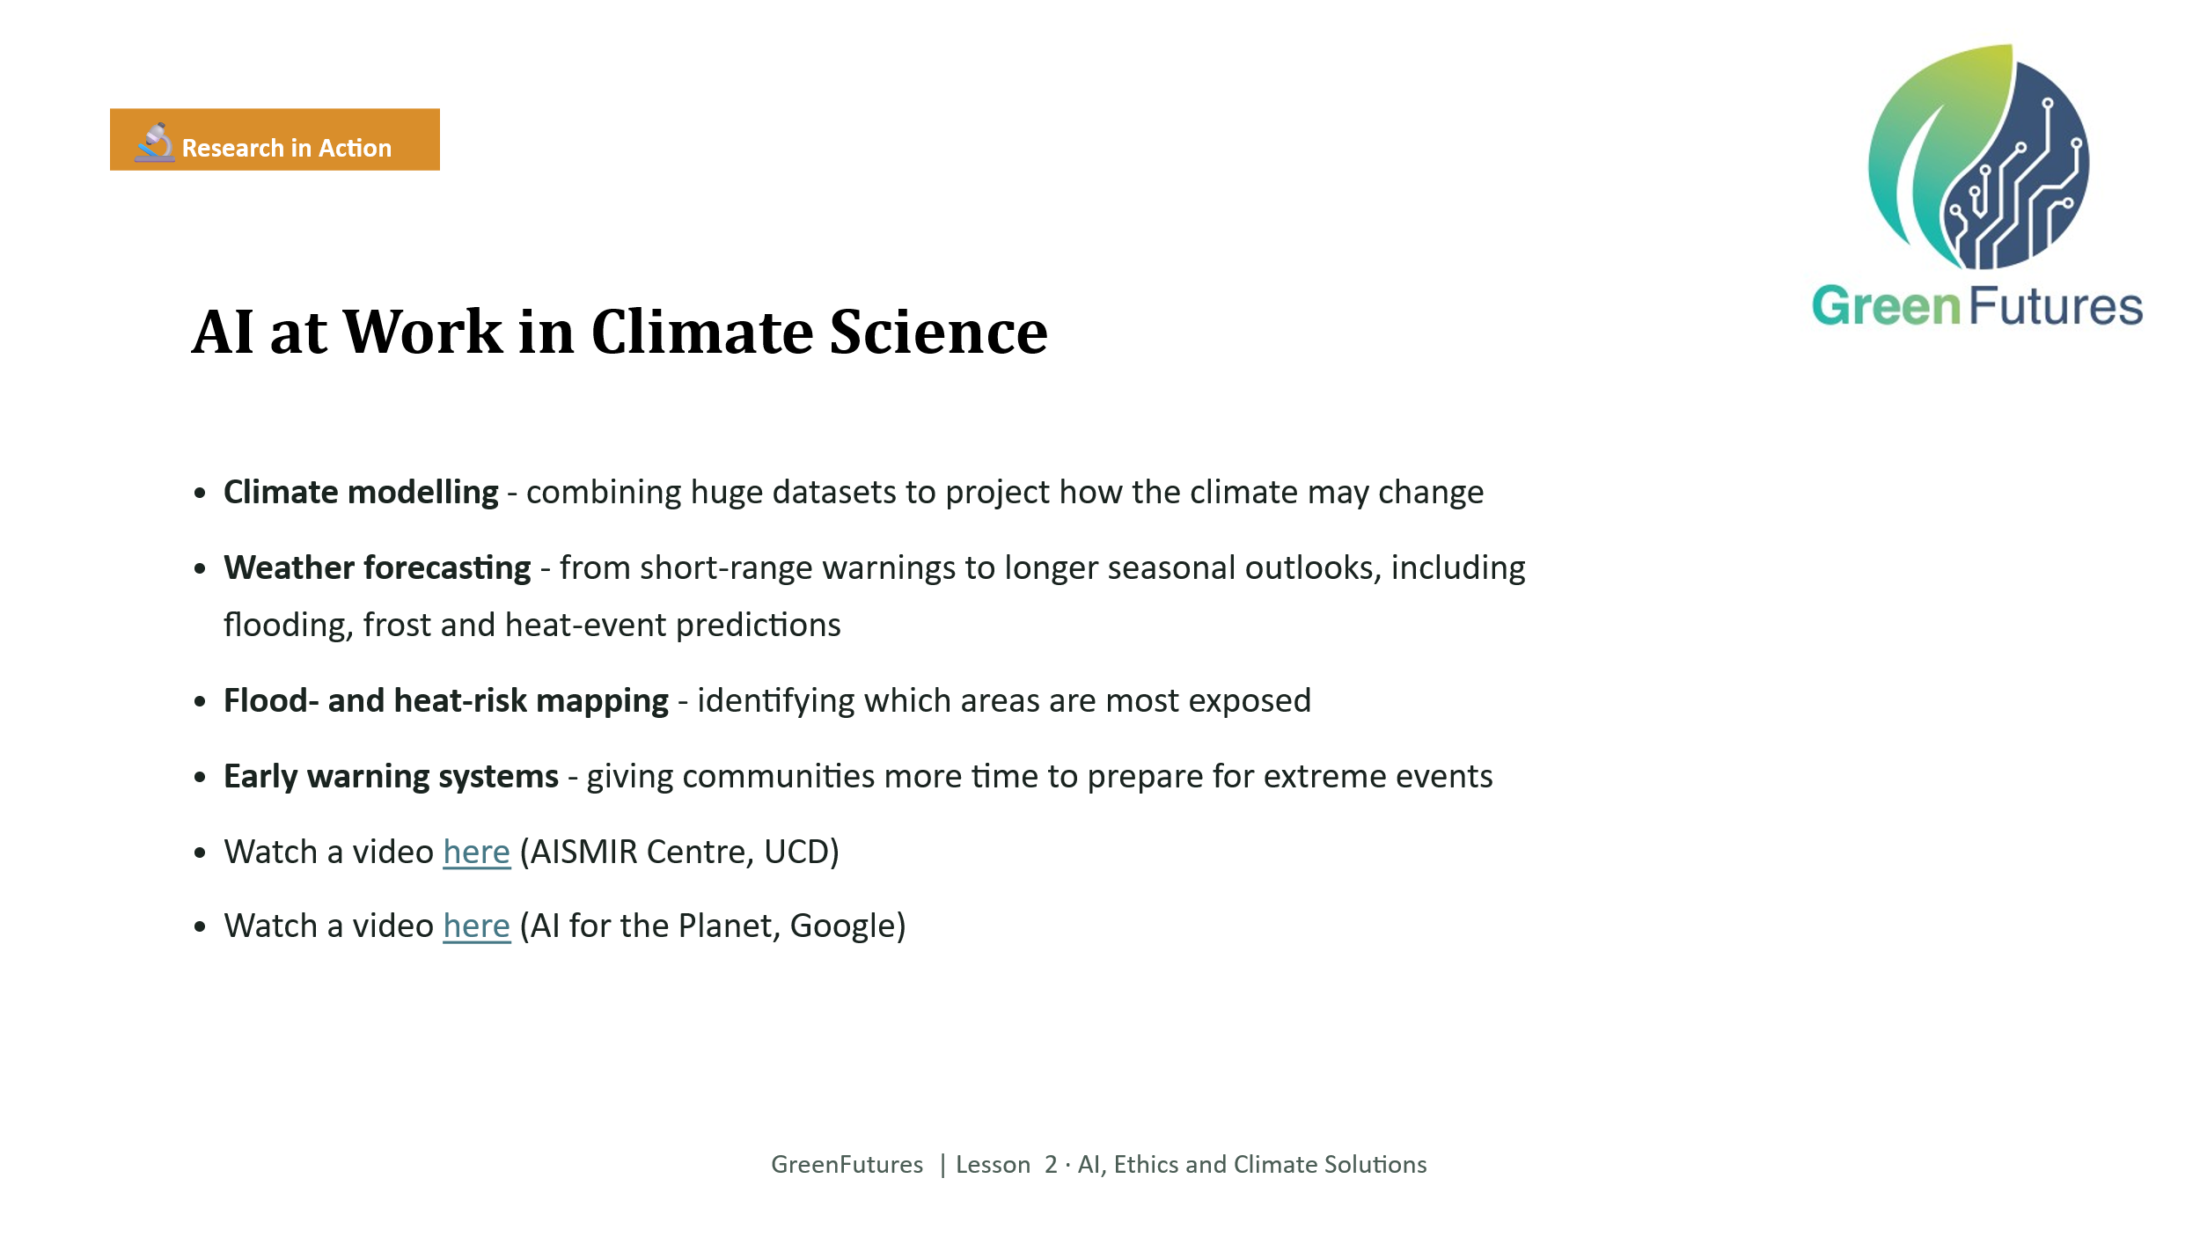 | LECTURE (~4 mins)  Cover the four real applications of AI in climate science: modelling, forecasting, risk mapping, early warning systems.  How will AI transform how we forecast the weather in Ireland? (AIMSIR Centre at UCD)  AI for the Planet | Google Research
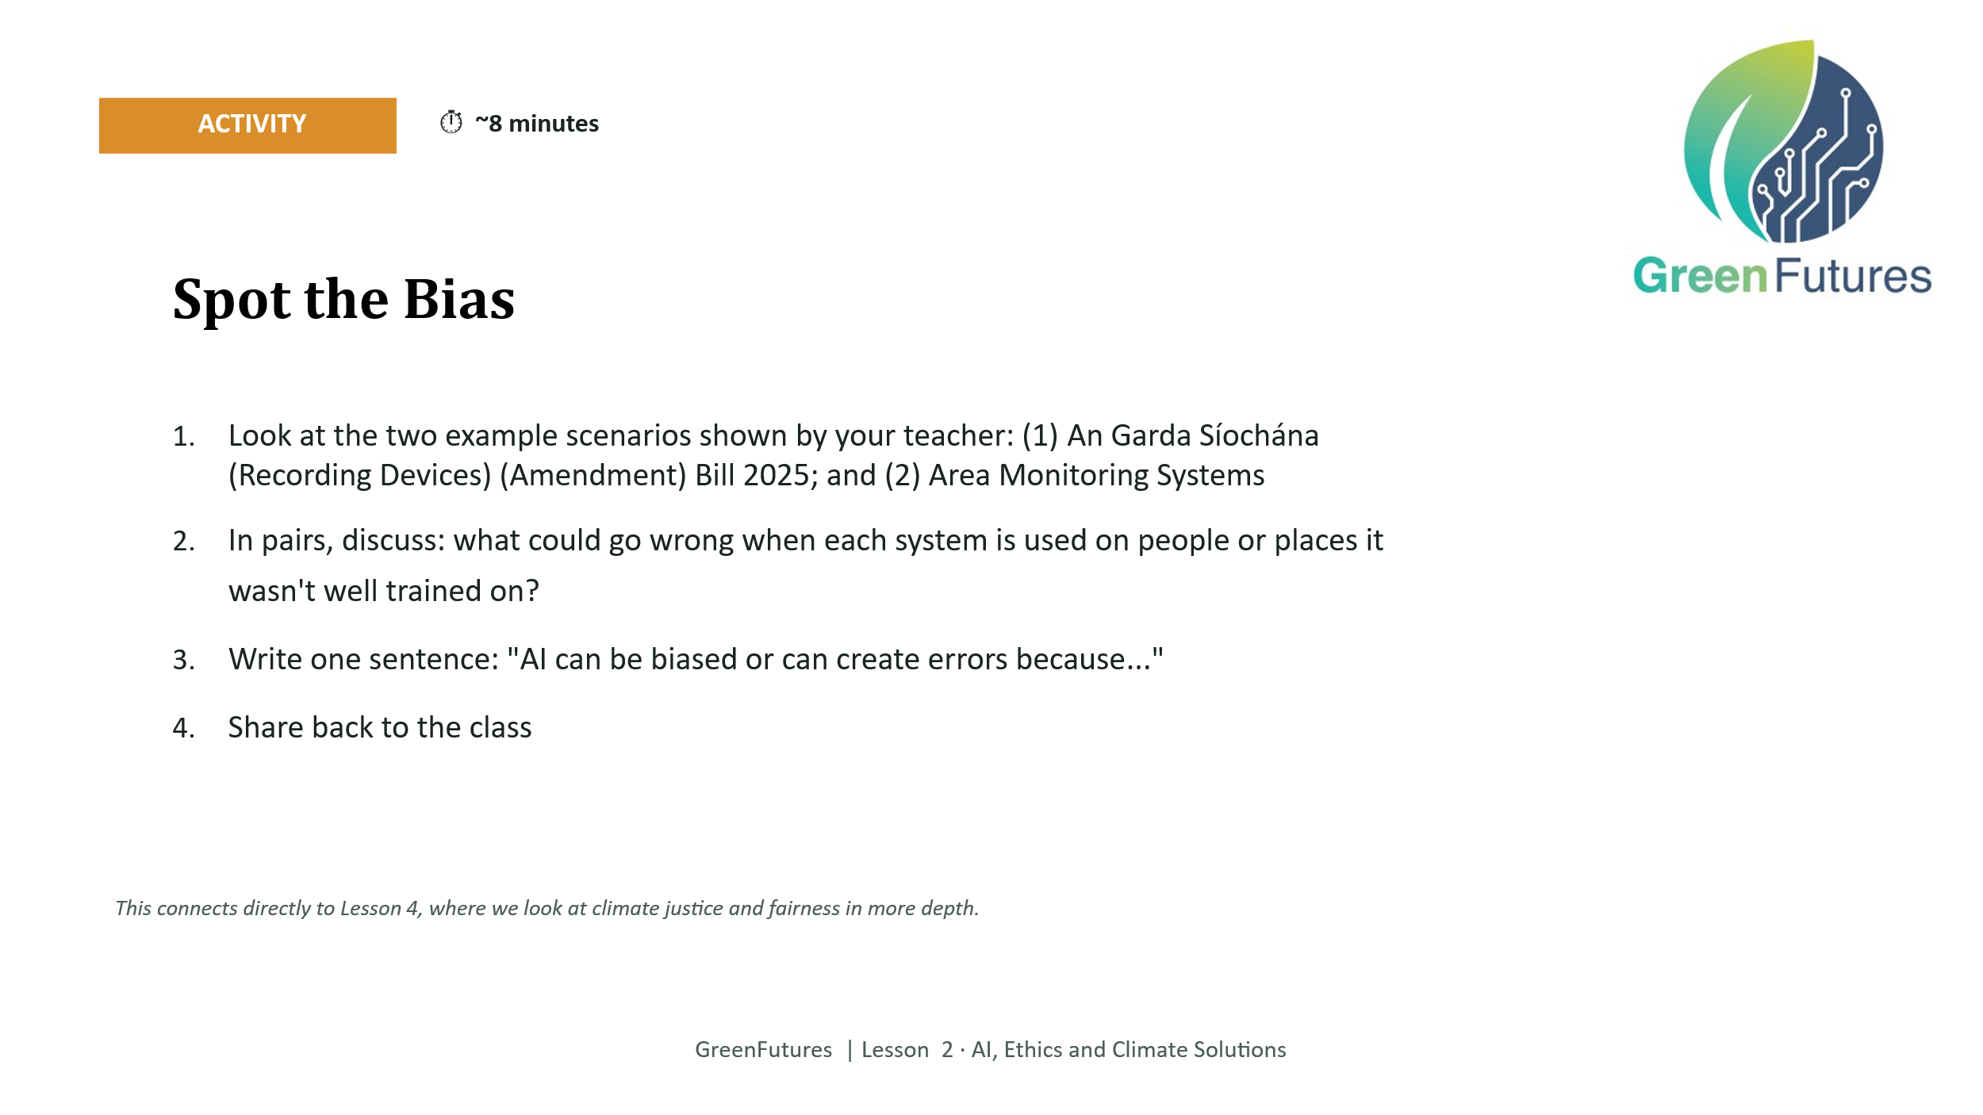 | ACTIVITY (~8 mins)  Present the two scenarios (An Garda Síochána (Recording Devices) (Amendment) Bill 2025; Area Monitoring Systems.  Pairs discuss what could go wrong, then write one ‘AI can be biased because...’ sentence.  Flag explicitly that this connects to Lesson 4's deeper look at climate justice and fairness.  Ensure most up-to-date information. (Links below from August 2026)  ----Discussion links for An Garda Síochána (Recording Devices) (Amendment) Bill 2025:  https://president.ie/en/media-library/news-releases/connolly-signs-the-garda-siochana-recording-devices-amendment-bill-2025  https://www.iccl.ie/news/garda-ai-bill-iccl-trinity/  https://www.rte.ie/news/primetime/2023/0614/1389207-how-would-facial-recognition-technology-work-in-ireland/  ---- Discussion links for Area Monitoring Systems:  https://www.irishexaminer.com/farming/arid-41506511.html  https://www.gov.ie/en/department-of-agriculture-food-and-the-marine/publications/area-monitoring-system-ams/  https://www.agriland.ie/farming-news/dafm-additional-acres-actions-to-be-satellite-monitored/
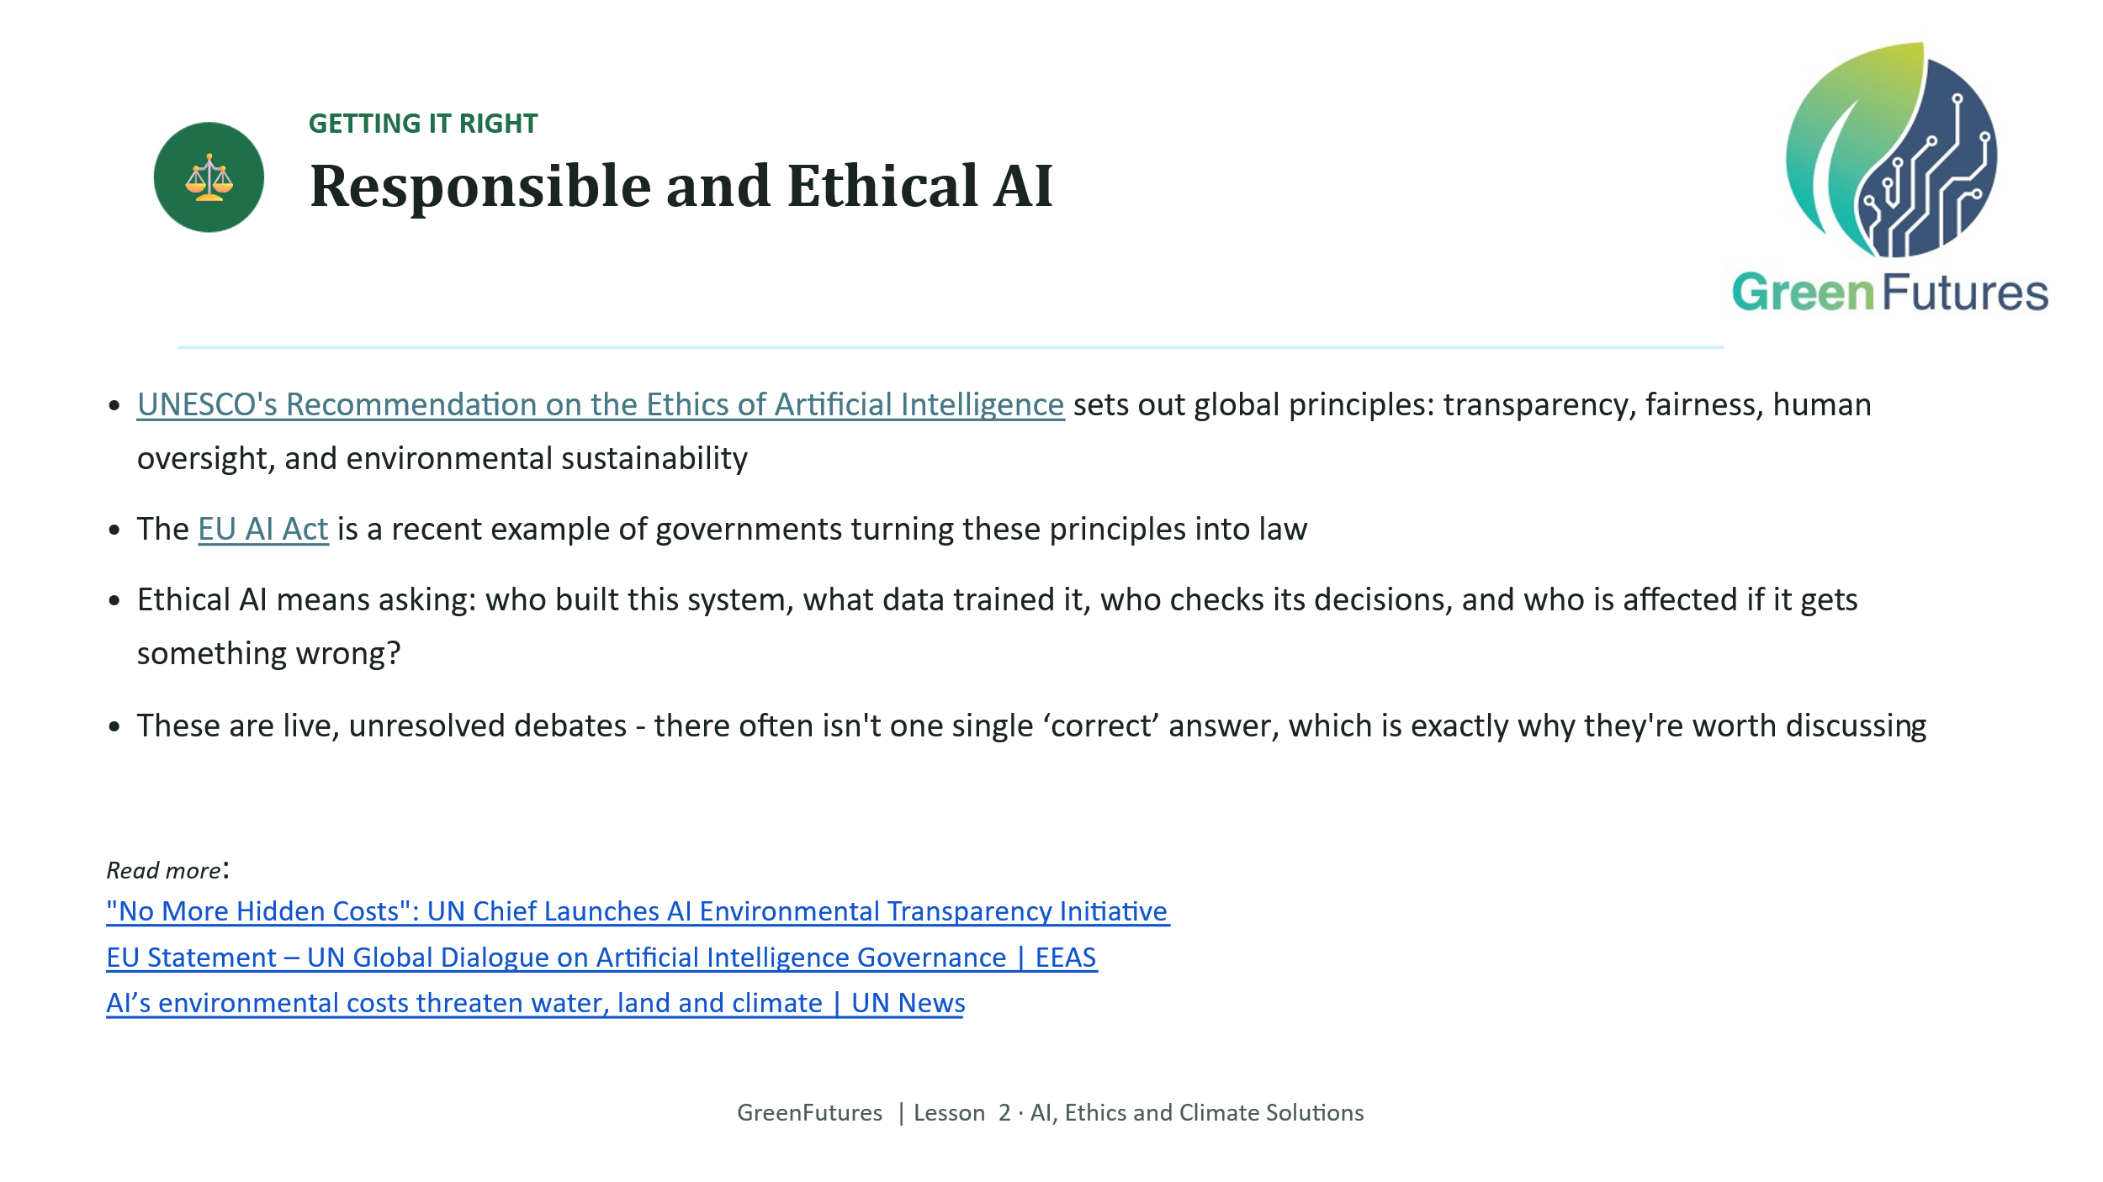 | LECTURE (~4 mins)  Introduce UNESCO's Recommendation on the Ethics of Artificial Intelligence (transparency, fairness, human oversight, environmental sustainability) and the EU AI Act as a real-world example of these principles becoming law.  Keep this as an open question – ‘who checks these systems, and who is affected if they get it wrong?’ - rather than a settled answer.
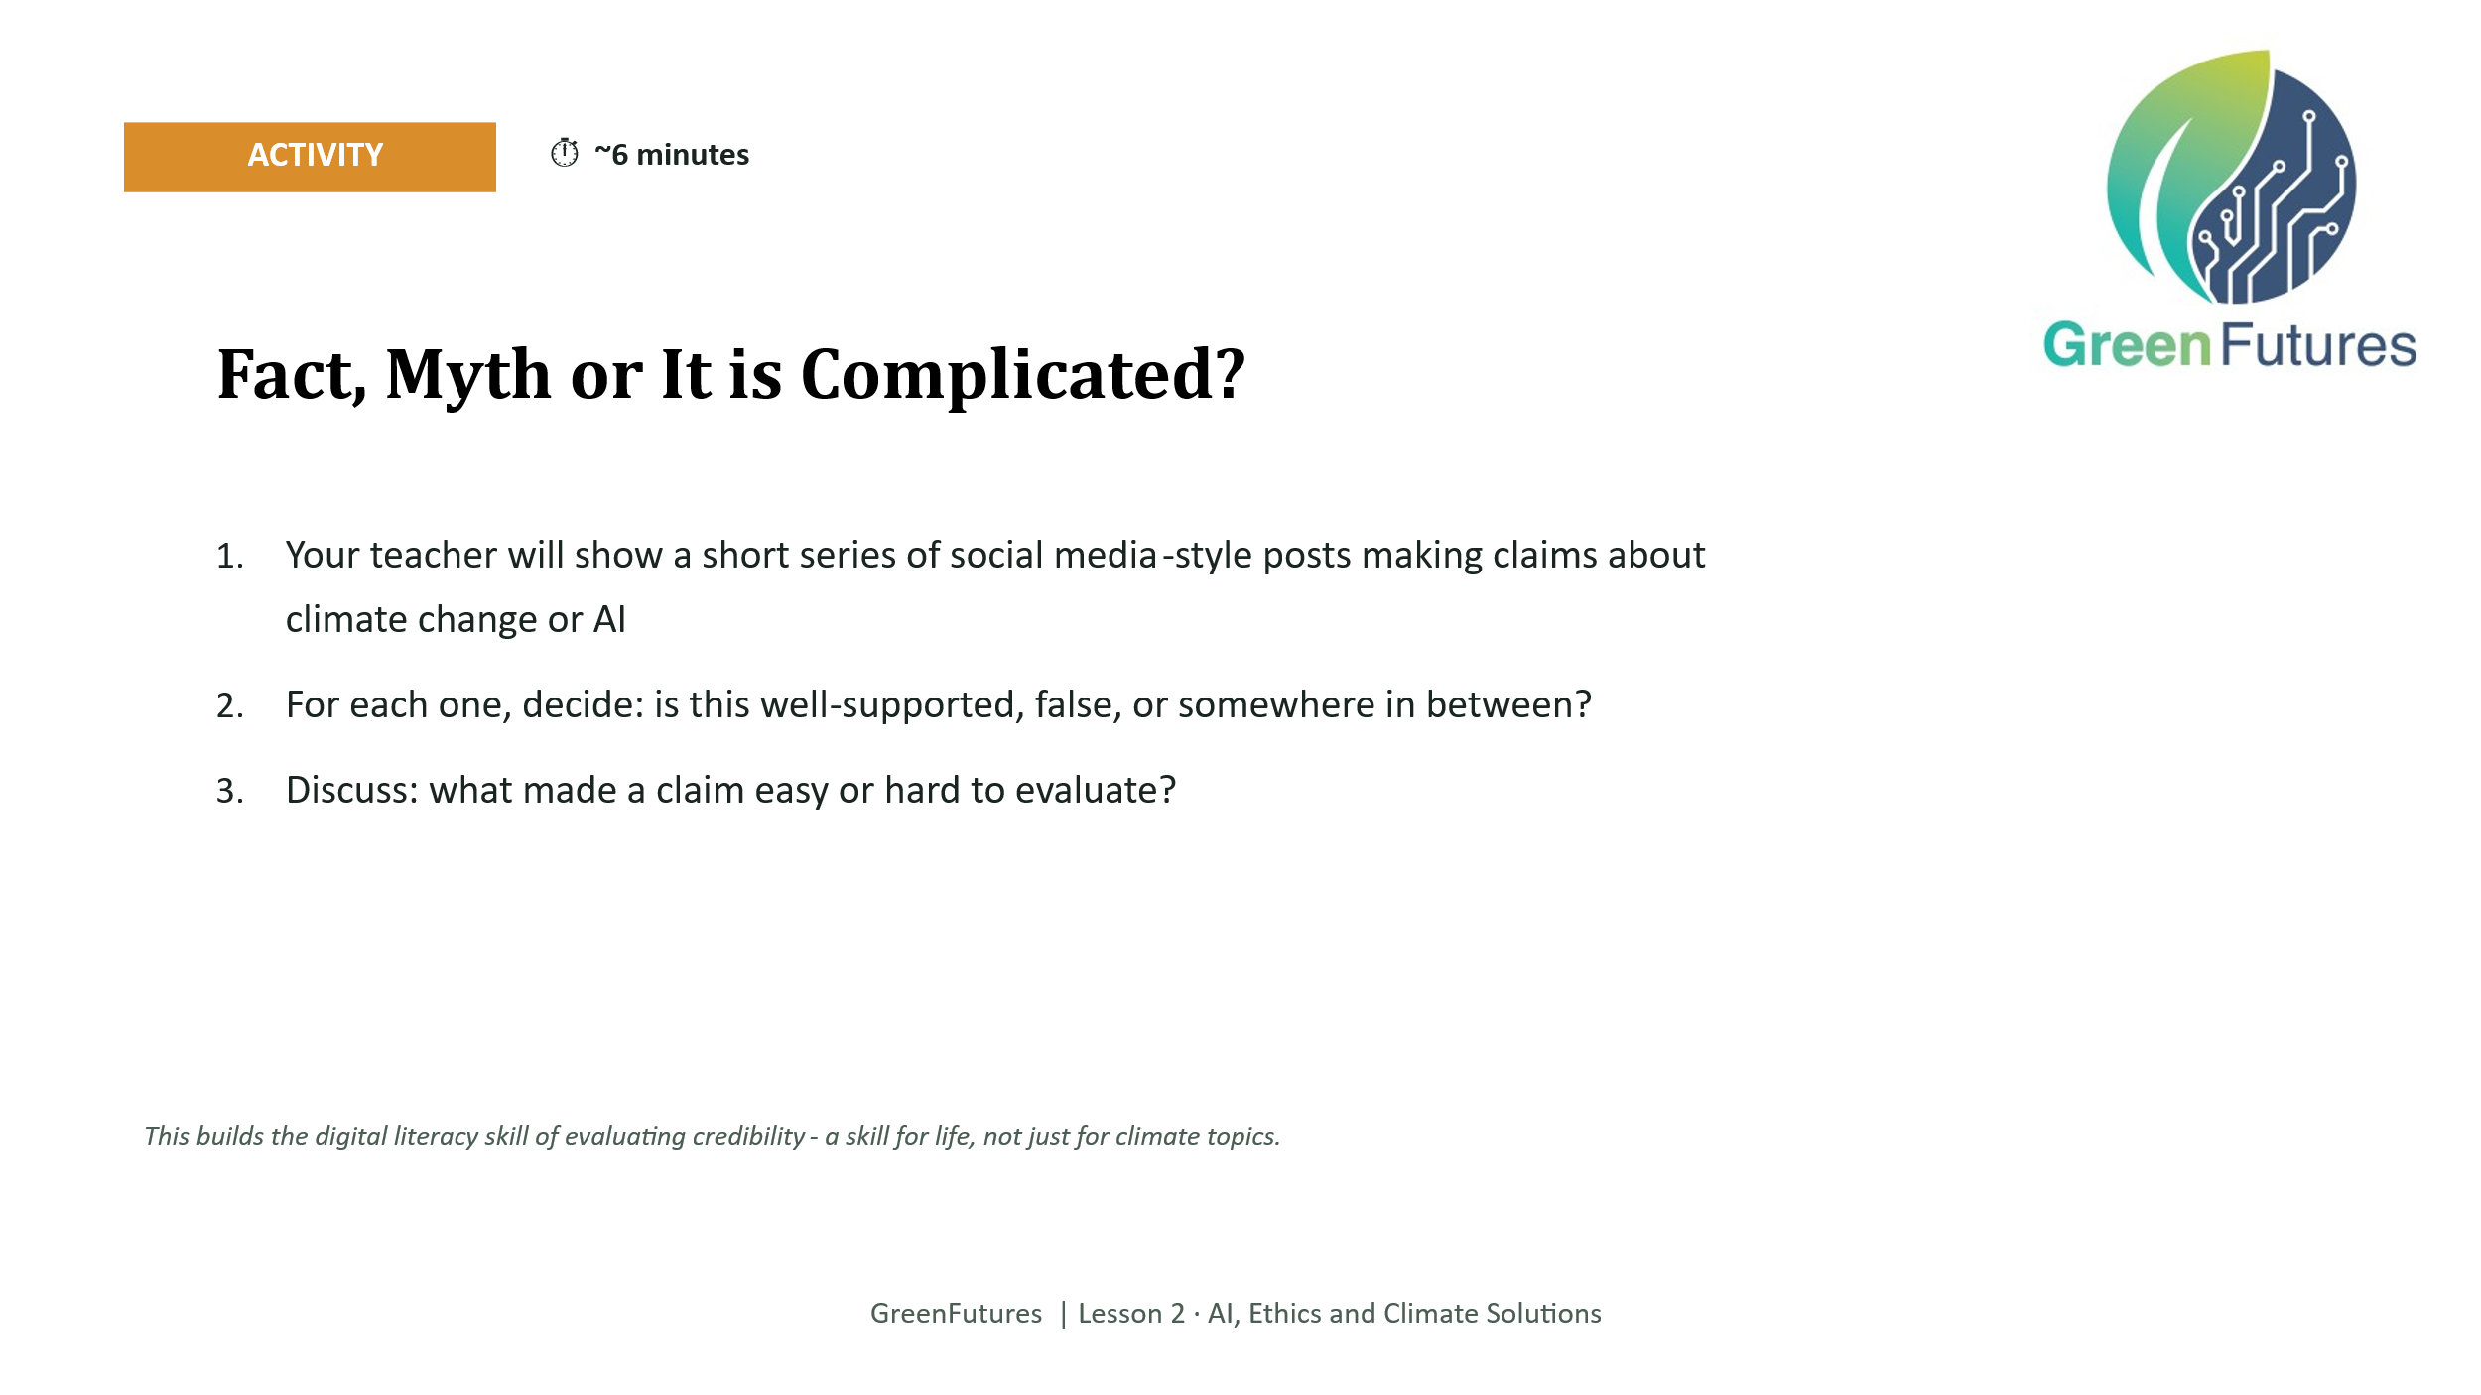 | ACTIVITY (~6 mins)  Show a short series of pre-vetted social-media-style posts making claims about climate or AI. Students judge: well-supported, false, or somewhere in between.  Prepare this bank of examples in advance rather than searching live.  Examples:  (Ireland)  "Data centres now use almost a quarter of ALL the electricity in Ireland."  (https://www.rte.ie/news/business/2026/0707/1582175-cso-data-centre-energy-figures/)  "That cold, frosty week we just had? Kind of hard to believe in 'global warming' now, isn't it?"  (https://www.thejournal.ie/factcheck-debunked-graph-hottest-springs-climate-change-global-warming-chart-met-eireann-hottest-springs-7064300-Jun2026/)  "Video going around of a well-known Irish businessman telling people to invest in a new trading platform, is it really him?"  https://www.thejournal.ie/debunked-michael-oleary-financial-software-ai-deepfake-6644169-Mar2025/)  (International)  "Volcanoes pump out more CO2 every year than all of humanity combined, so why blame cars and factories?"  (https://www.climate.gov/news-features/climate-qa/which-emits-more-carbon-dioxide-volcanoes-or-human-activities)  "Every time you ask ChatGPT a question, it uses a full bottle of drinking water."  (https://findskill.ai/blog/does-chatgpt-use-water/)
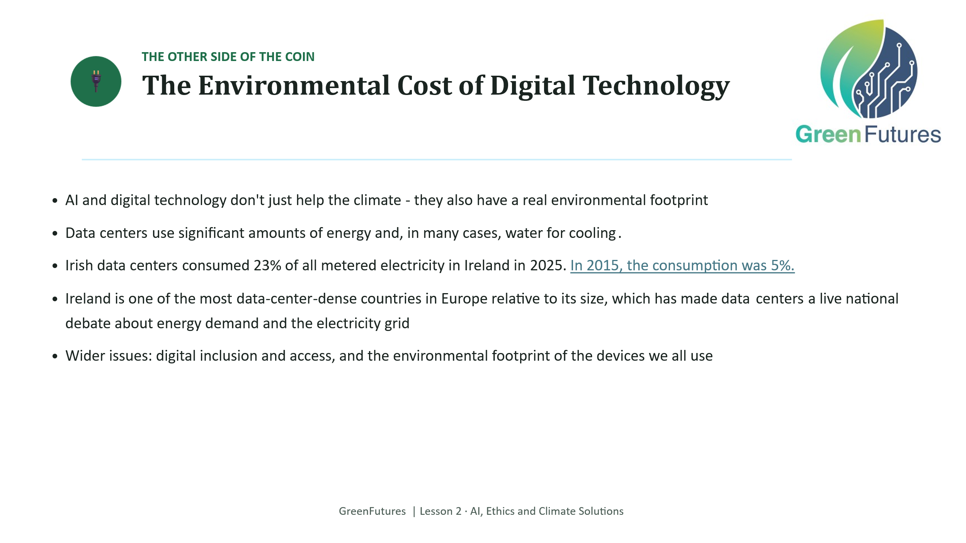 | LECTURE (~4 mins)  Cover the environmental footprint of digital technology: data-centre energy and water use, and Ireland's position as one of Europe's most data-centre-dense countries relative to its size.  https://www.cso.ie/en/releasesandpublications/ep/p-dcmec/datacentresmeteredelectricityconsumption2025/  https://www.rte.ie/news/business/2026/0707/1582175-cso-data-centre-energy-figures/
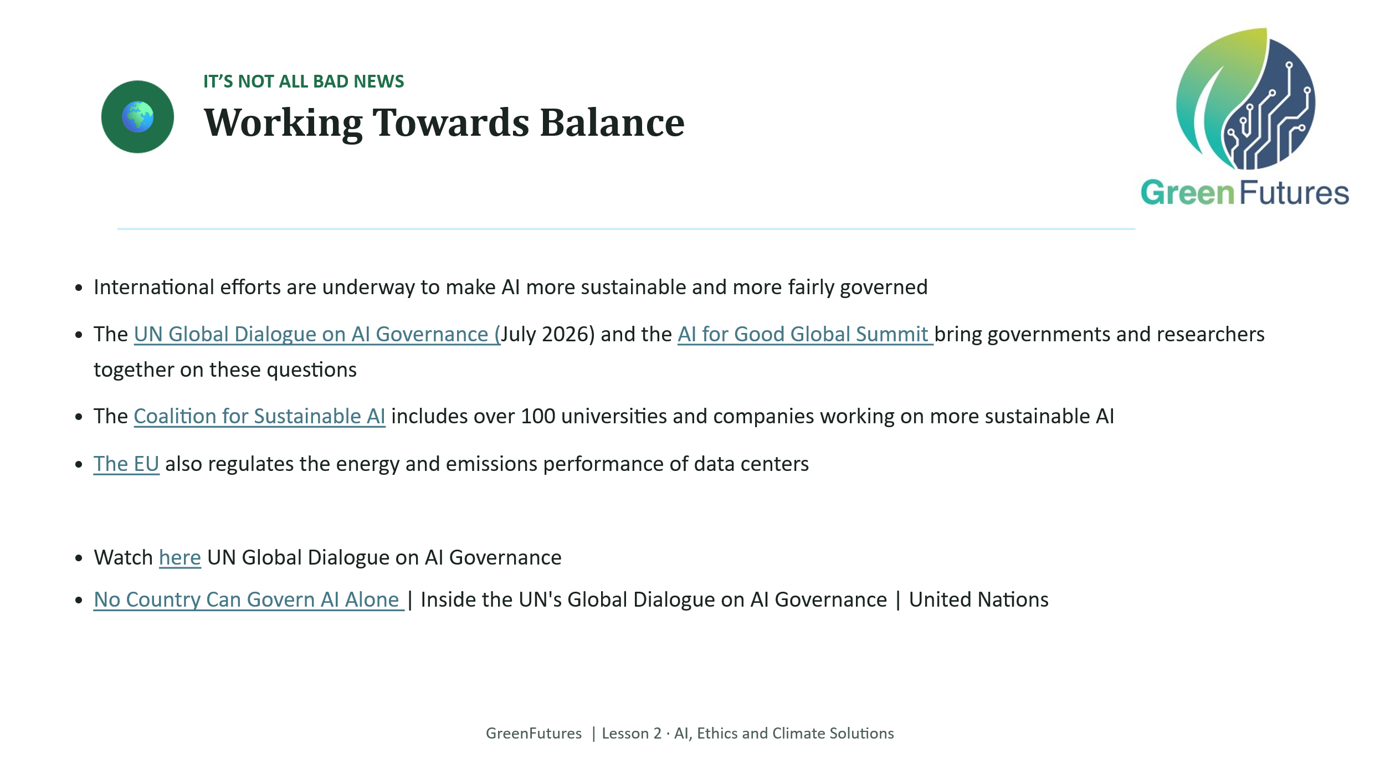 | LECTURE (~3 mins)  Present the balancing international efforts, so the lesson doesn't end on a purely negative note about AI's footprint.  Note the Irish Presidency (July-Dec 2026) and a number of events organised on AI across Ireland.  Further reading:  https://knowledgegov.org/reflections-on-the-ai-for-good-global-summit-2026/  https://www.europarl.europa.eu/RegData/etudes/BRIE/2025/775859/EPRS_BRI(2025)775859_EN.pdf
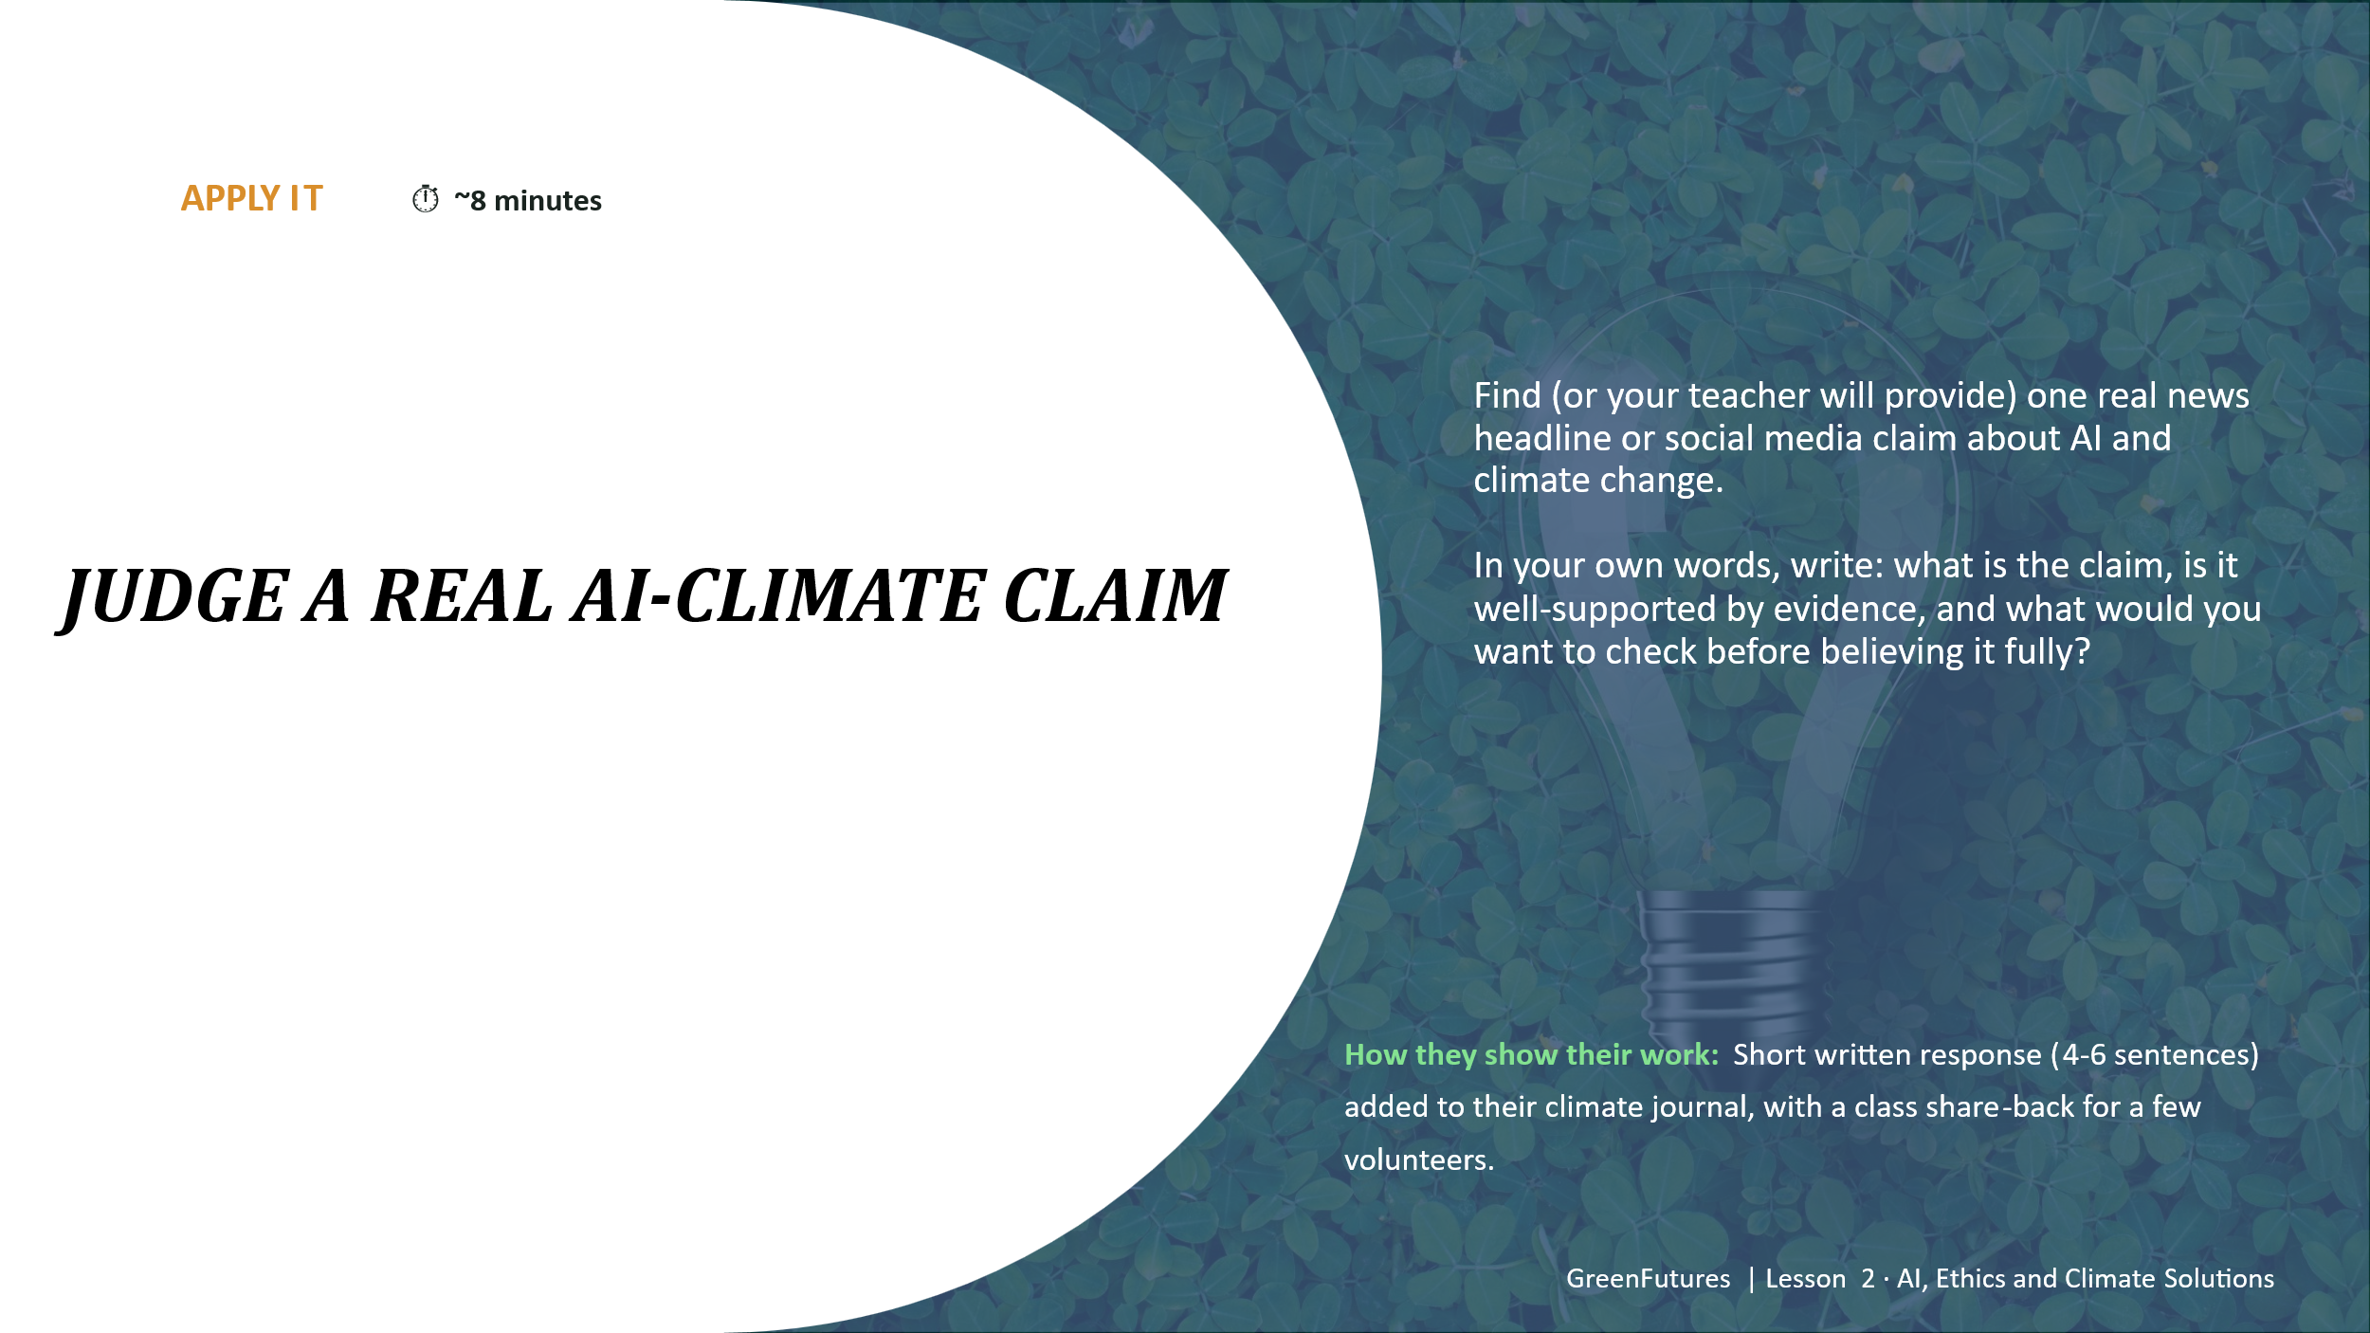 | APPLY (INDIVIDUAL, CAPTURED) (~8 mins)  Students evaluate one real AI/climate headline or claim (teacher-supplied) and write 4–6 sentences: what's the claim, is it supported, what would they check?  A few volunteers share back. Add to the climate journal.  Teacher note: keep a small bank of pre-vetted real headlines ready, so students aren't searching open-ended and encountering unsuitable content.  Examples:  Why AI is the biggest threat to sustainability — and what you can do about it | by Raz Godelnik | HumanAI | Medium  Golf Drinks More Than Every Data Center Combined
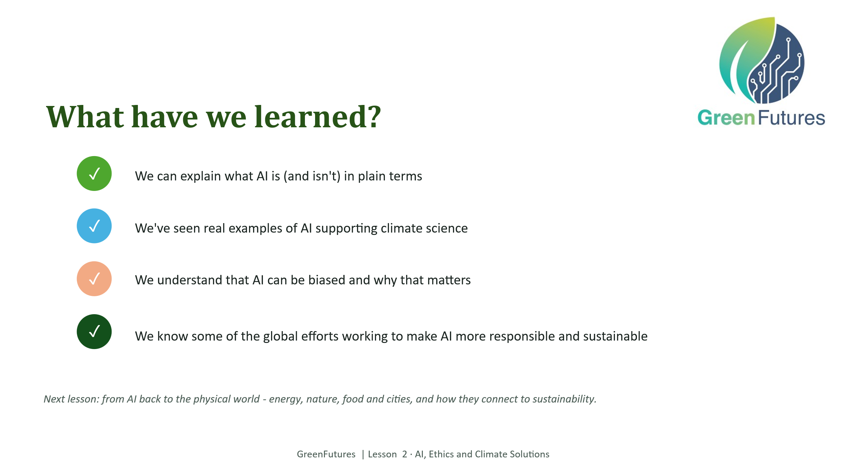 | LECTURE (~2 mins)  Revisit the four learning outcomes.
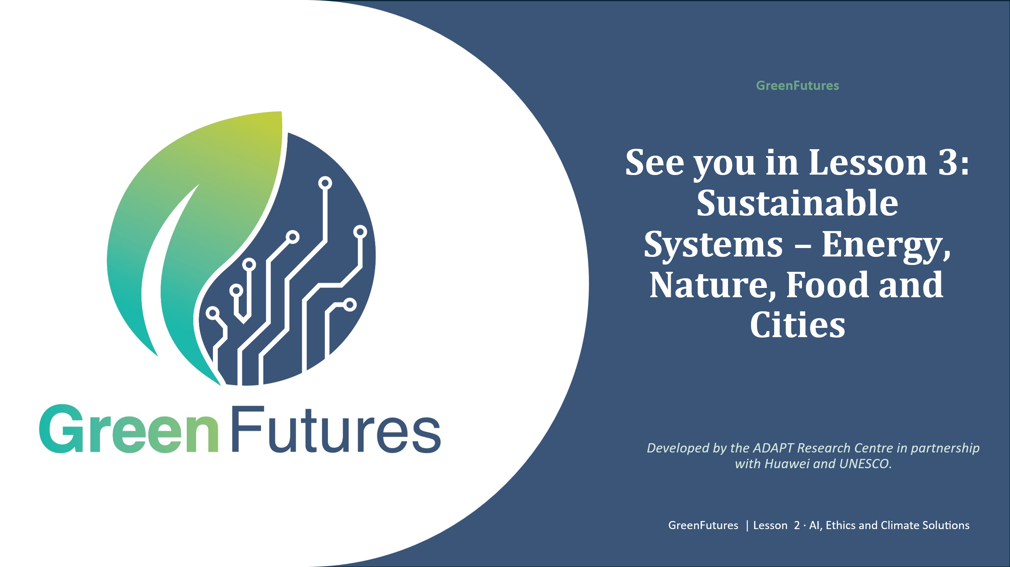 | LECTURE (~1 min)  Preview Lesson 3: Sustainable Systems - Energy, Nature, Food and Cities.

