GREENFUTURES
Lesson 1: Understanding Our Changing Planet: Climate, Environment and Data
Teacher Guide

GreenFutures is a four-lesson Transition Year module on AI, sustainability, climate action and digital transformation, developed by the ADAPT Research Centre in partnership with Huawei and UNESCO. This first lesson introduces students to the science of climate change and shows how digital tools and AI are used to study it.
Time | ~55 minutes (flex to a 40-minute class by trimming discussion time and one activity, as noted in the walkthrough below)
Background | There are no prerequisites for this lesson. It assumes only the general climate awareness students will already have from Junior Cycle Science, Geography and CSPE.  We strongly encourage the teachers to take a free, 90-minutes course on AI literacy, specifically designed by ADAPT Research Centre for secondary school teachers: https://ailiteracyintheclassroom.ie/course/
Materials Needed | PowerPoint presentation, laptop, screen, internet access (for the data-dashboard activity - a low-bandwidth alternative is provided), timer, printed or digital journal/worksheet for each student.
Curriculum Links
GreenFutures is designed as an NCCA-compliant, cross-curricular Transition Year module (Science, Geography, CSPE, Digital Media). Its interactive and reflective activities build the five key skills central to Transition Year:
- Information processing
- Critical and creative thinking
- Communicating
- Working with others
- Being personally effective

Leaving Certificate subject links: Geography, Politics and Society, Technology, Computer Science, Business, Economics.

Learning Intentions
By the end of this lesson, students will be able to:
- Explain the difference between weather and climate
- Describe the major causes and impacts of climate change, in Ireland and globally
- Understand how scientists collect and interpret climate data and where AI fits in
- Read evidence for themselves in graphs, maps and datasets
- Recognise why reliable data matters for good decisions
Module Overview
Introduction (~3 mins)
Introduce the GreenFutures series and this lesson's goals.
Weather, Climate and Causes (~14 mins)
Establish core vocabulary, then explore the causes of climate change and ground it with Irish examples.
Climate Systems and Data (~19 mins)
Explain how climate data is gathered and why AI is essential to making sense of it, with a hands-on data-exploration activity.
Why This Matters, and Apply (~13 mins)
Connect data to decisions, then have students capture a personal observation in their climate journal.
Recap and Close (~3 mins)
Consolidate learning and preview Lesson 2.

Lesson 1 Module Walkthrough
Each row below shows the slide alongside facilitation notes. Timings are approximate and add up to the total above; trim discussion prompts first if running short on time.

Introduction (~3 mins)
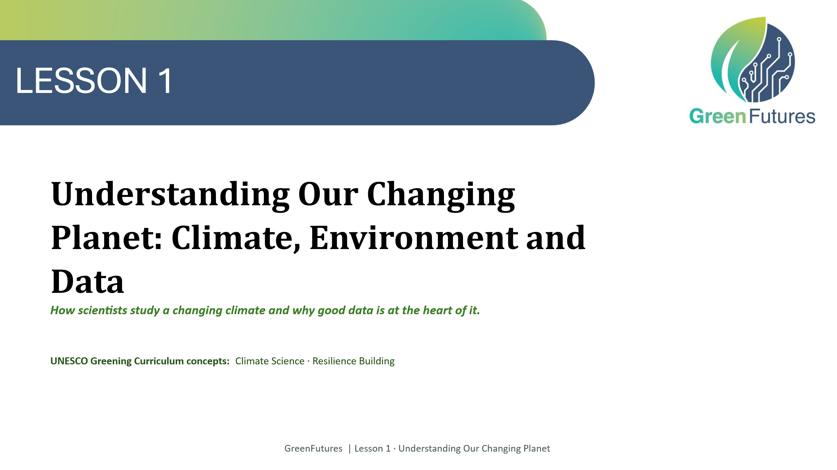 | LECTURE (~1 min)  Introduce GreenFutures: a four-lesson Transition Year module on AI and sustainability developed by the ADAPT Research Centre with Huawei and UNESCO.  Tell students this first lesson looks at how scientists study a changing climate, and why good data, including AI, is central to that work.
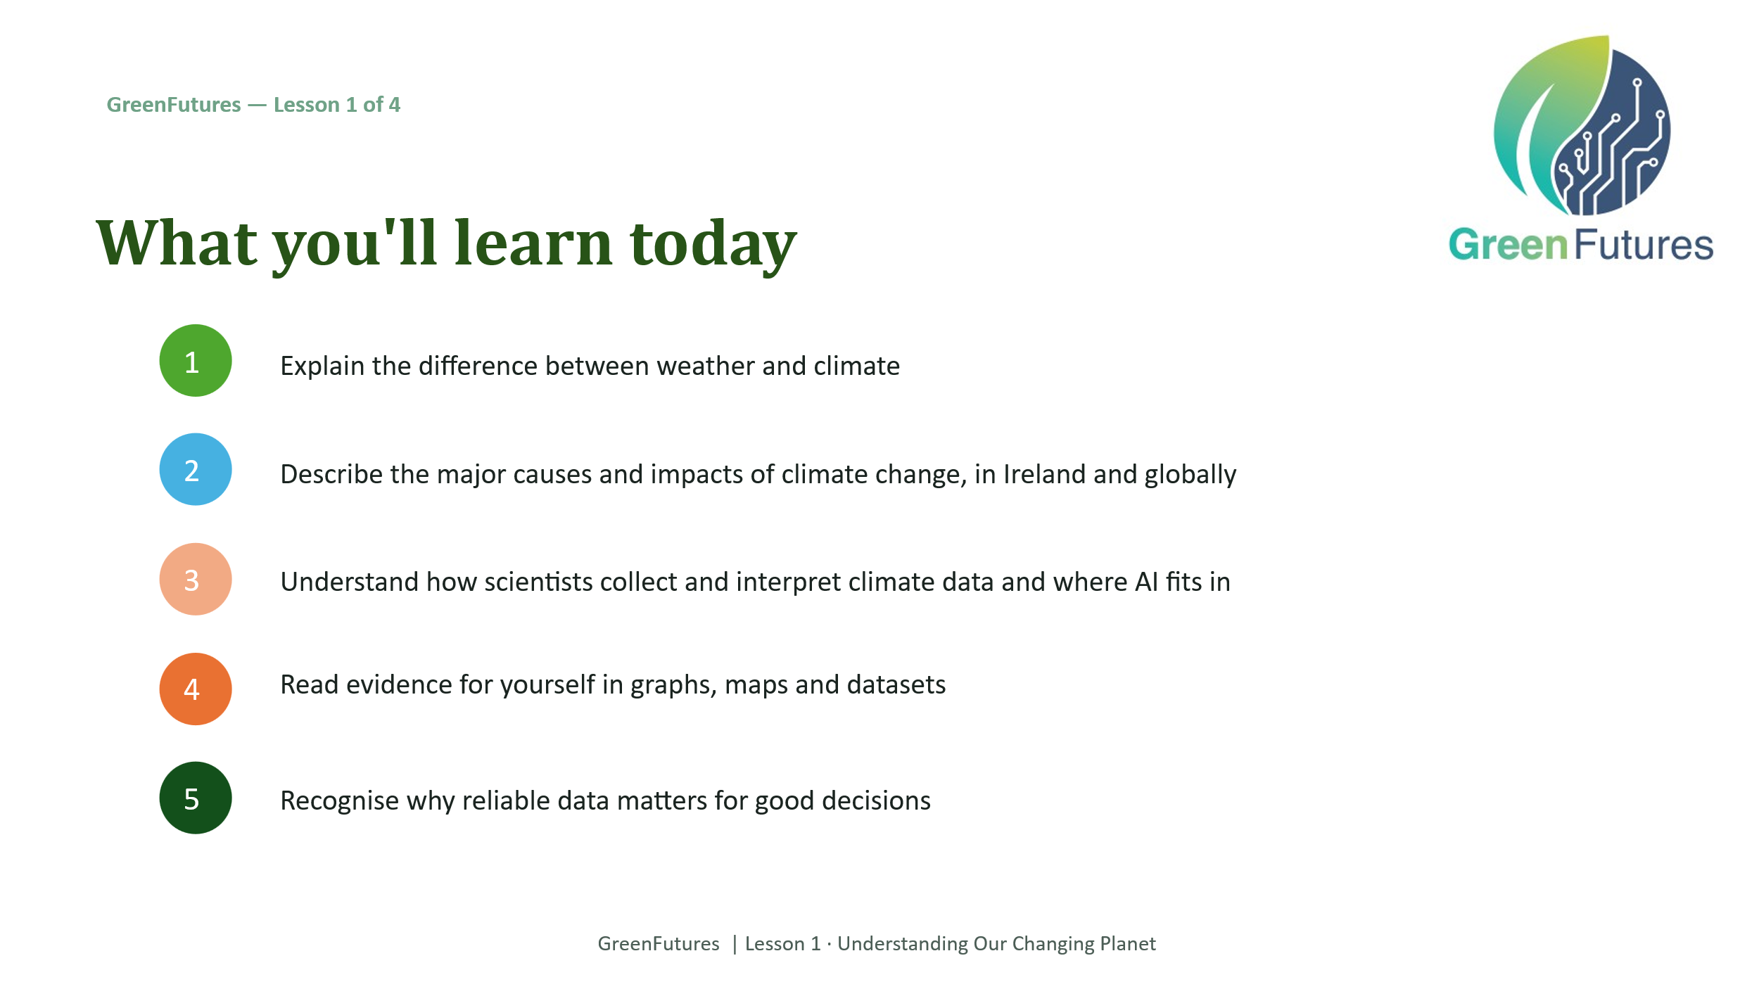 | LECTURE (~2 mins)  Walk through the five learning outcomes on screen so students know what to expect from the session.  Consider a very short pre-learning check here if running Lesson 1 as the pilot's opening session - a one-question sentiment check (‘how do you feel about climate change right now?’) gives a useful baseline to revisit at the end of Lesson 4.
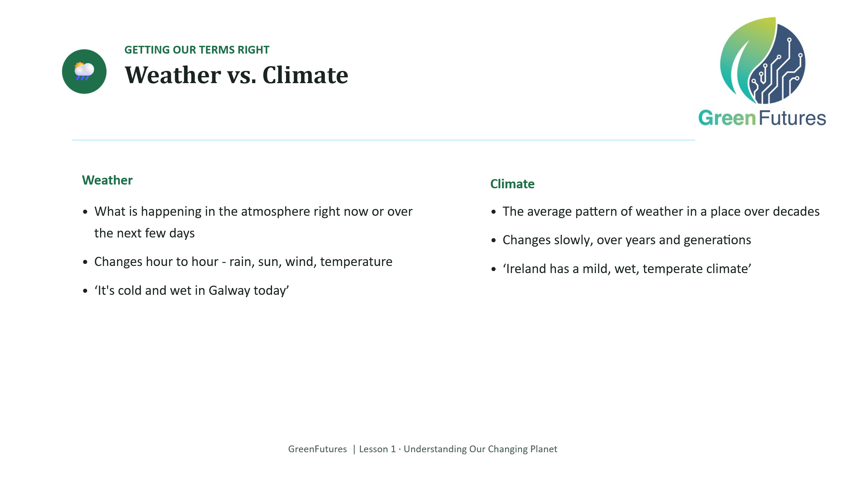 | LECTURE (~4 mins)  Present the weather vs. climate distinction. Use the two example sentences on the slide as a quick check for understanding before moving on.
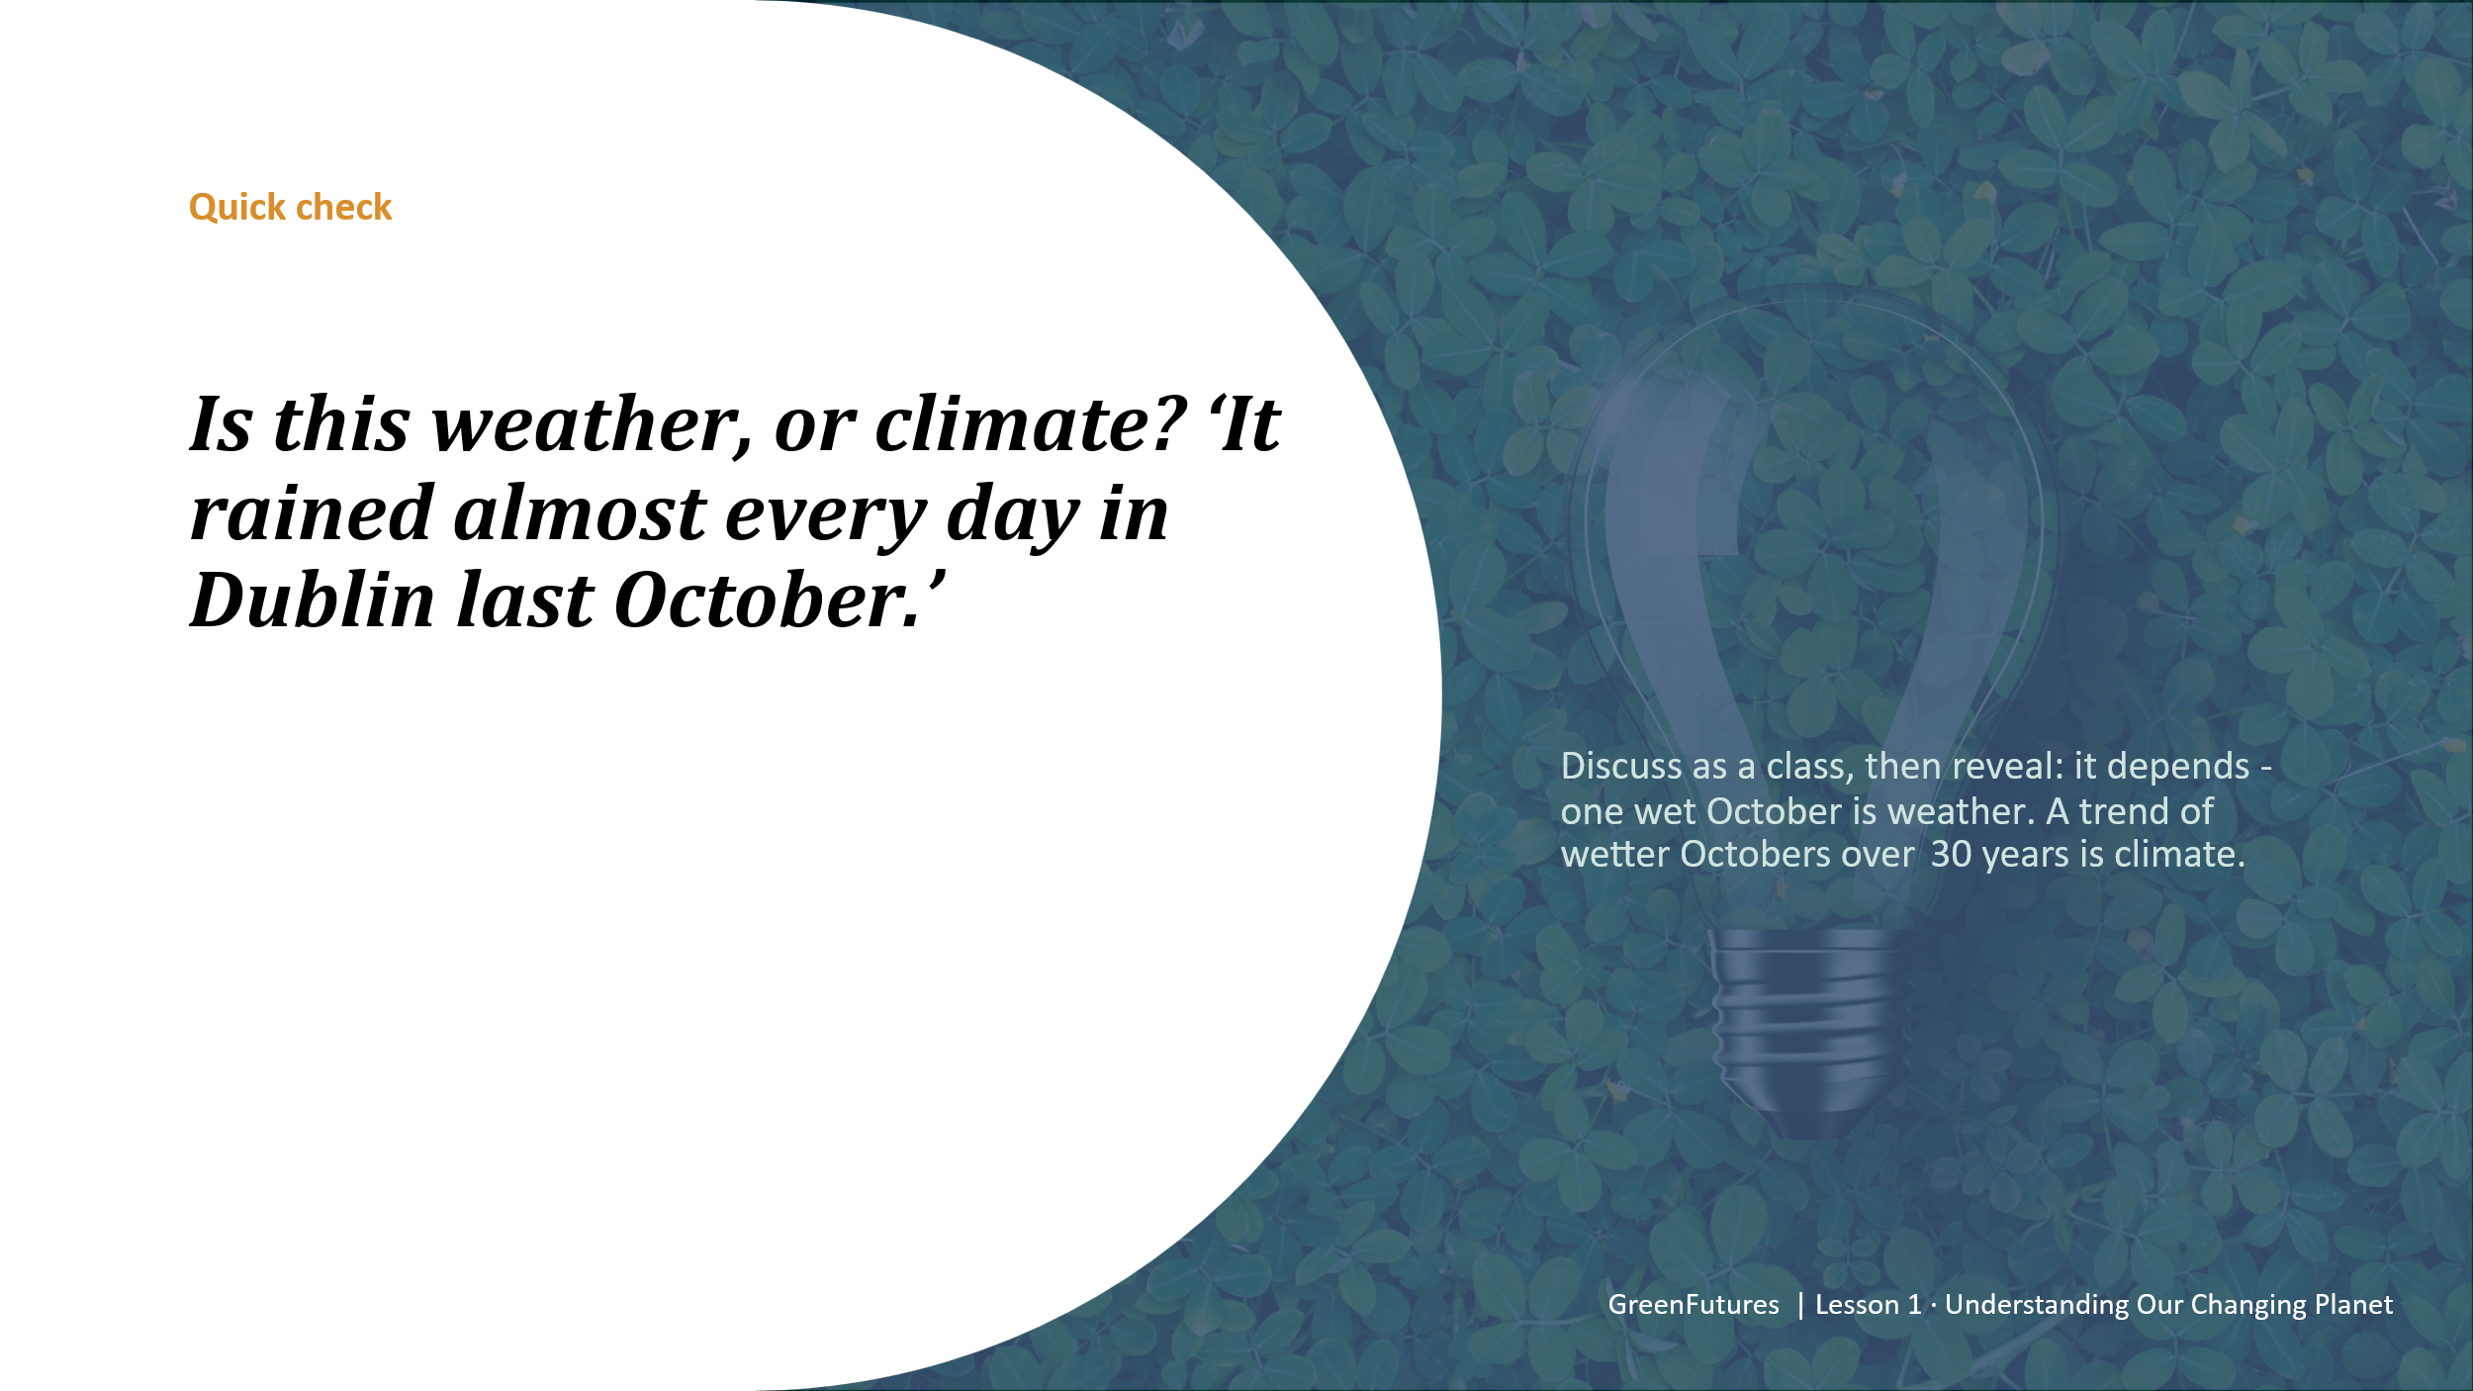 | DISCUSSION (~3 mins)  Pose the discussion question and take a few answers before revealing the explanation.  Keep this brief and light. It's a warm-up, not a debate.
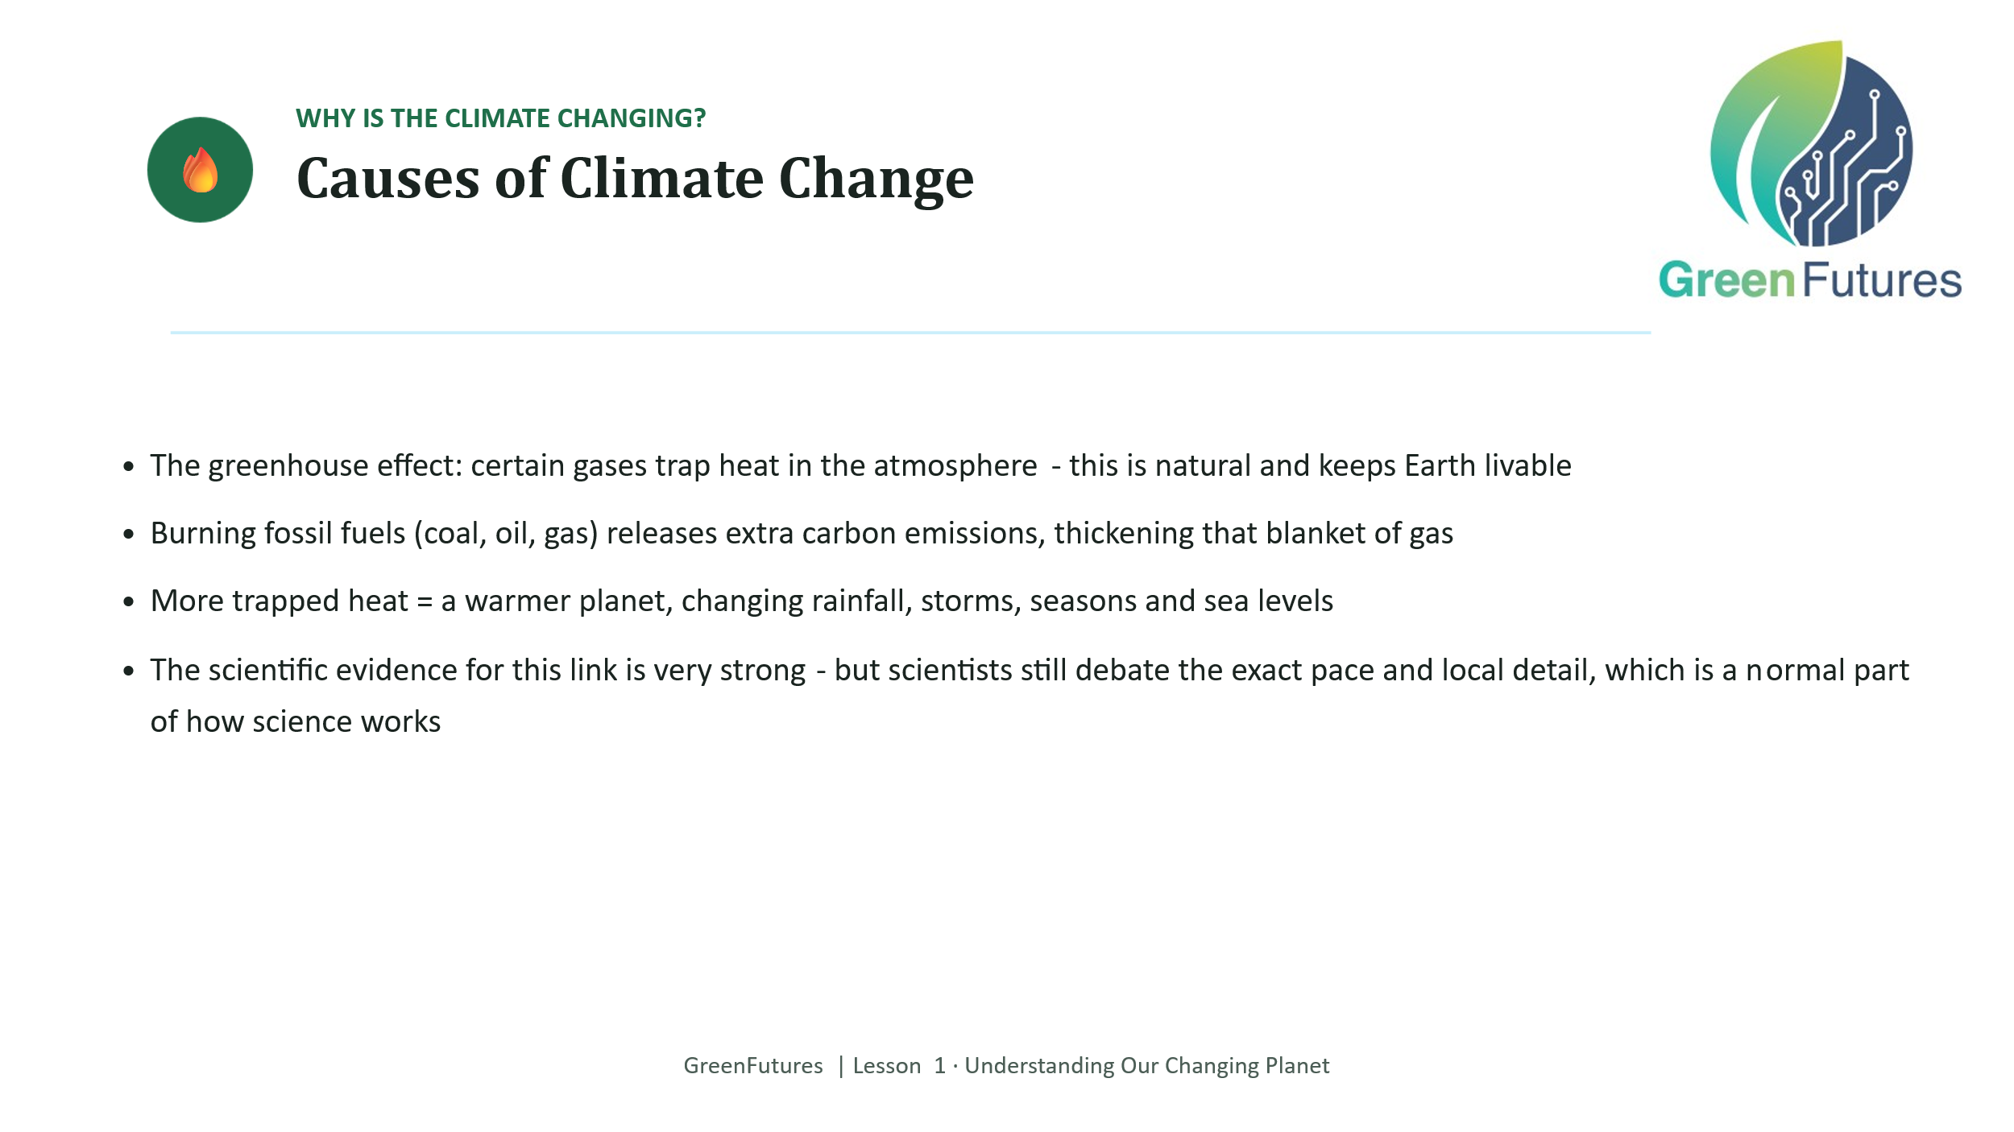 | LECTURE (~4 mins)  Cover the greenhouse effect, carbon emissions and fossil fuels as the core causes of climate change.  Be explicit that near-total scientific consensus exists on the core cause, even though some detail (pace, local impact) is still actively researched. This distinction matters and comes up again later in the lesson.
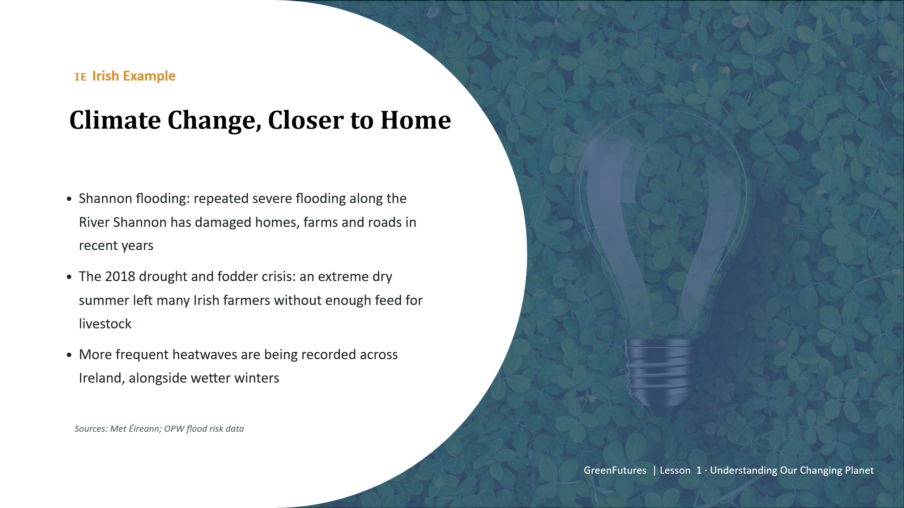 | LECTURE (~4 mins)  Present the Irish examples of climate impact: Shannon flooding, the 2018 drought and fodder crisis, and increasing heatwave frequency.  These are specific Met Éireann/OPW flood data or trend figures so students see real numbers, not just anecdote.  HEATWAVES -  https://www.met.ie/new-study-shows-impact-of-climate-change-on-record-breaking-summer  “Summer 2025 was provisionally the warmest summer on record nationally with a mean temperature of 16.19°C”  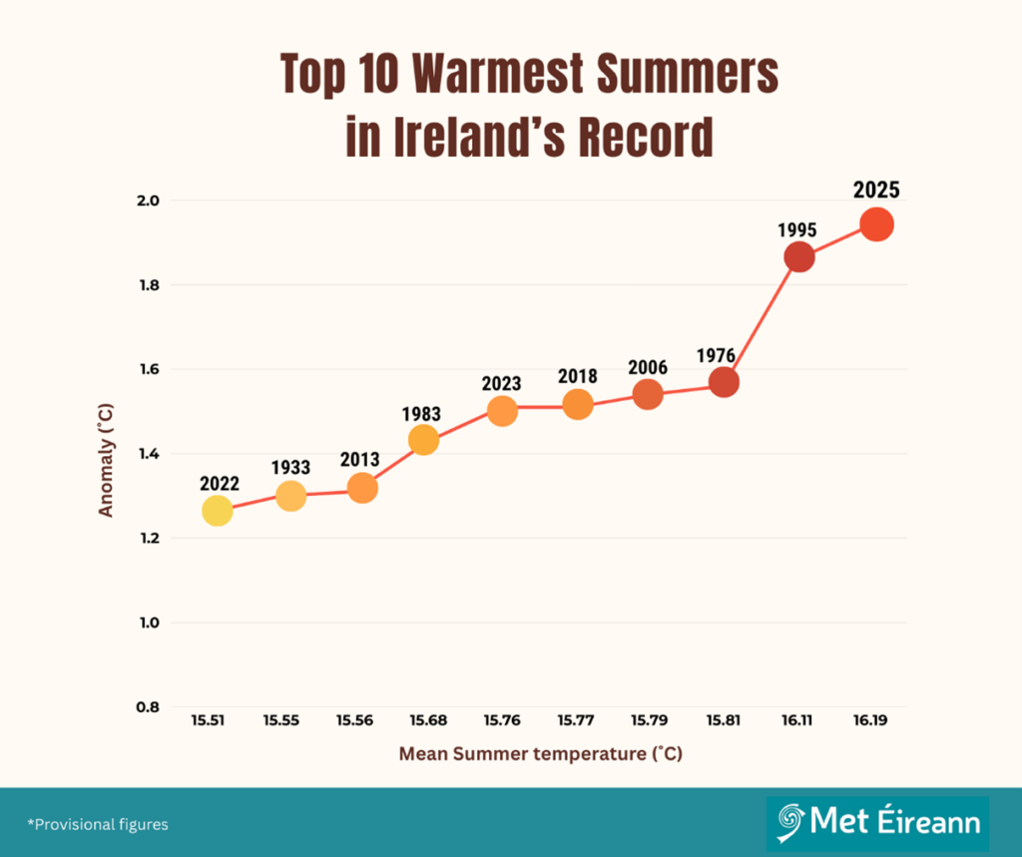  https://www.met.ie/cms/assets/uploads/2023/10/A4_heatsheet_updated.pdf - Shows trends of hotter weather in Ireland  Summer Centre - Heatwaves “5 consecutive days of pf +25C in the shade” there were heatwaves in Ireland May, June, July 2026!
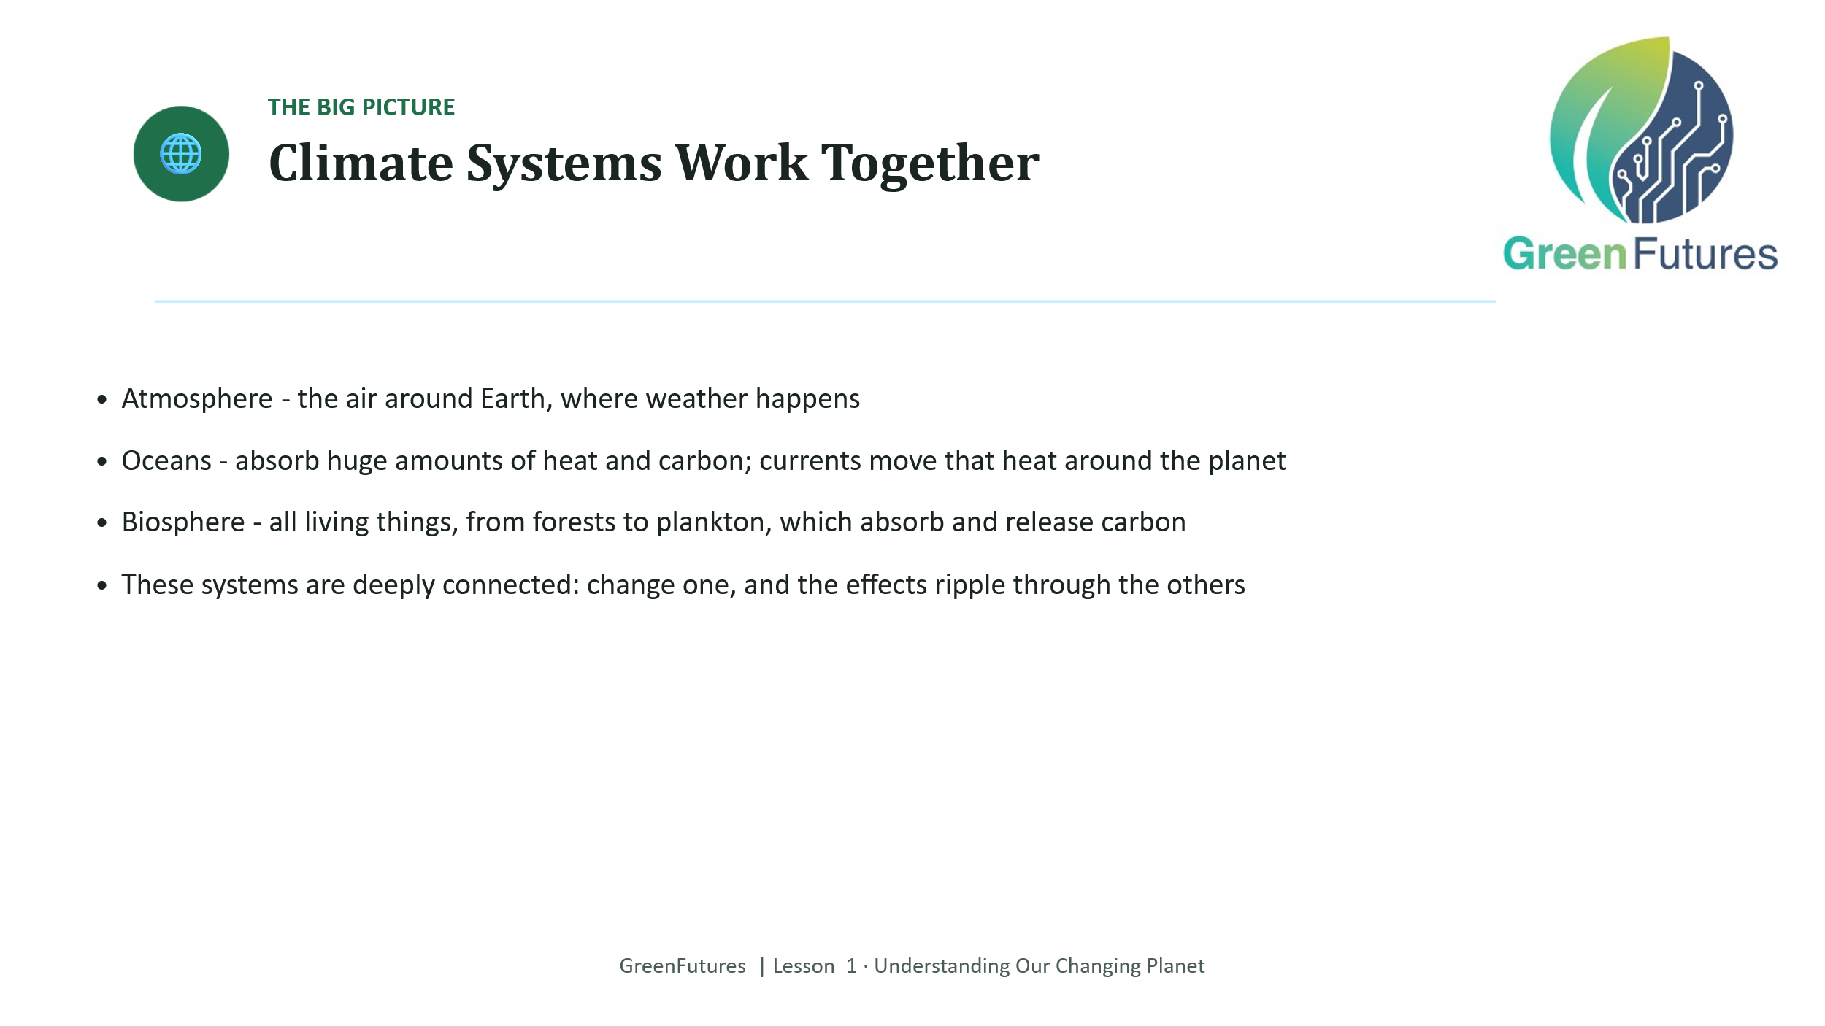 | LECTURE (~3 mins)  Briefly cover the three climate systems (atmosphere, oceans, biosphere) and how they interact. Keep this short, it's context for the data section that follows.
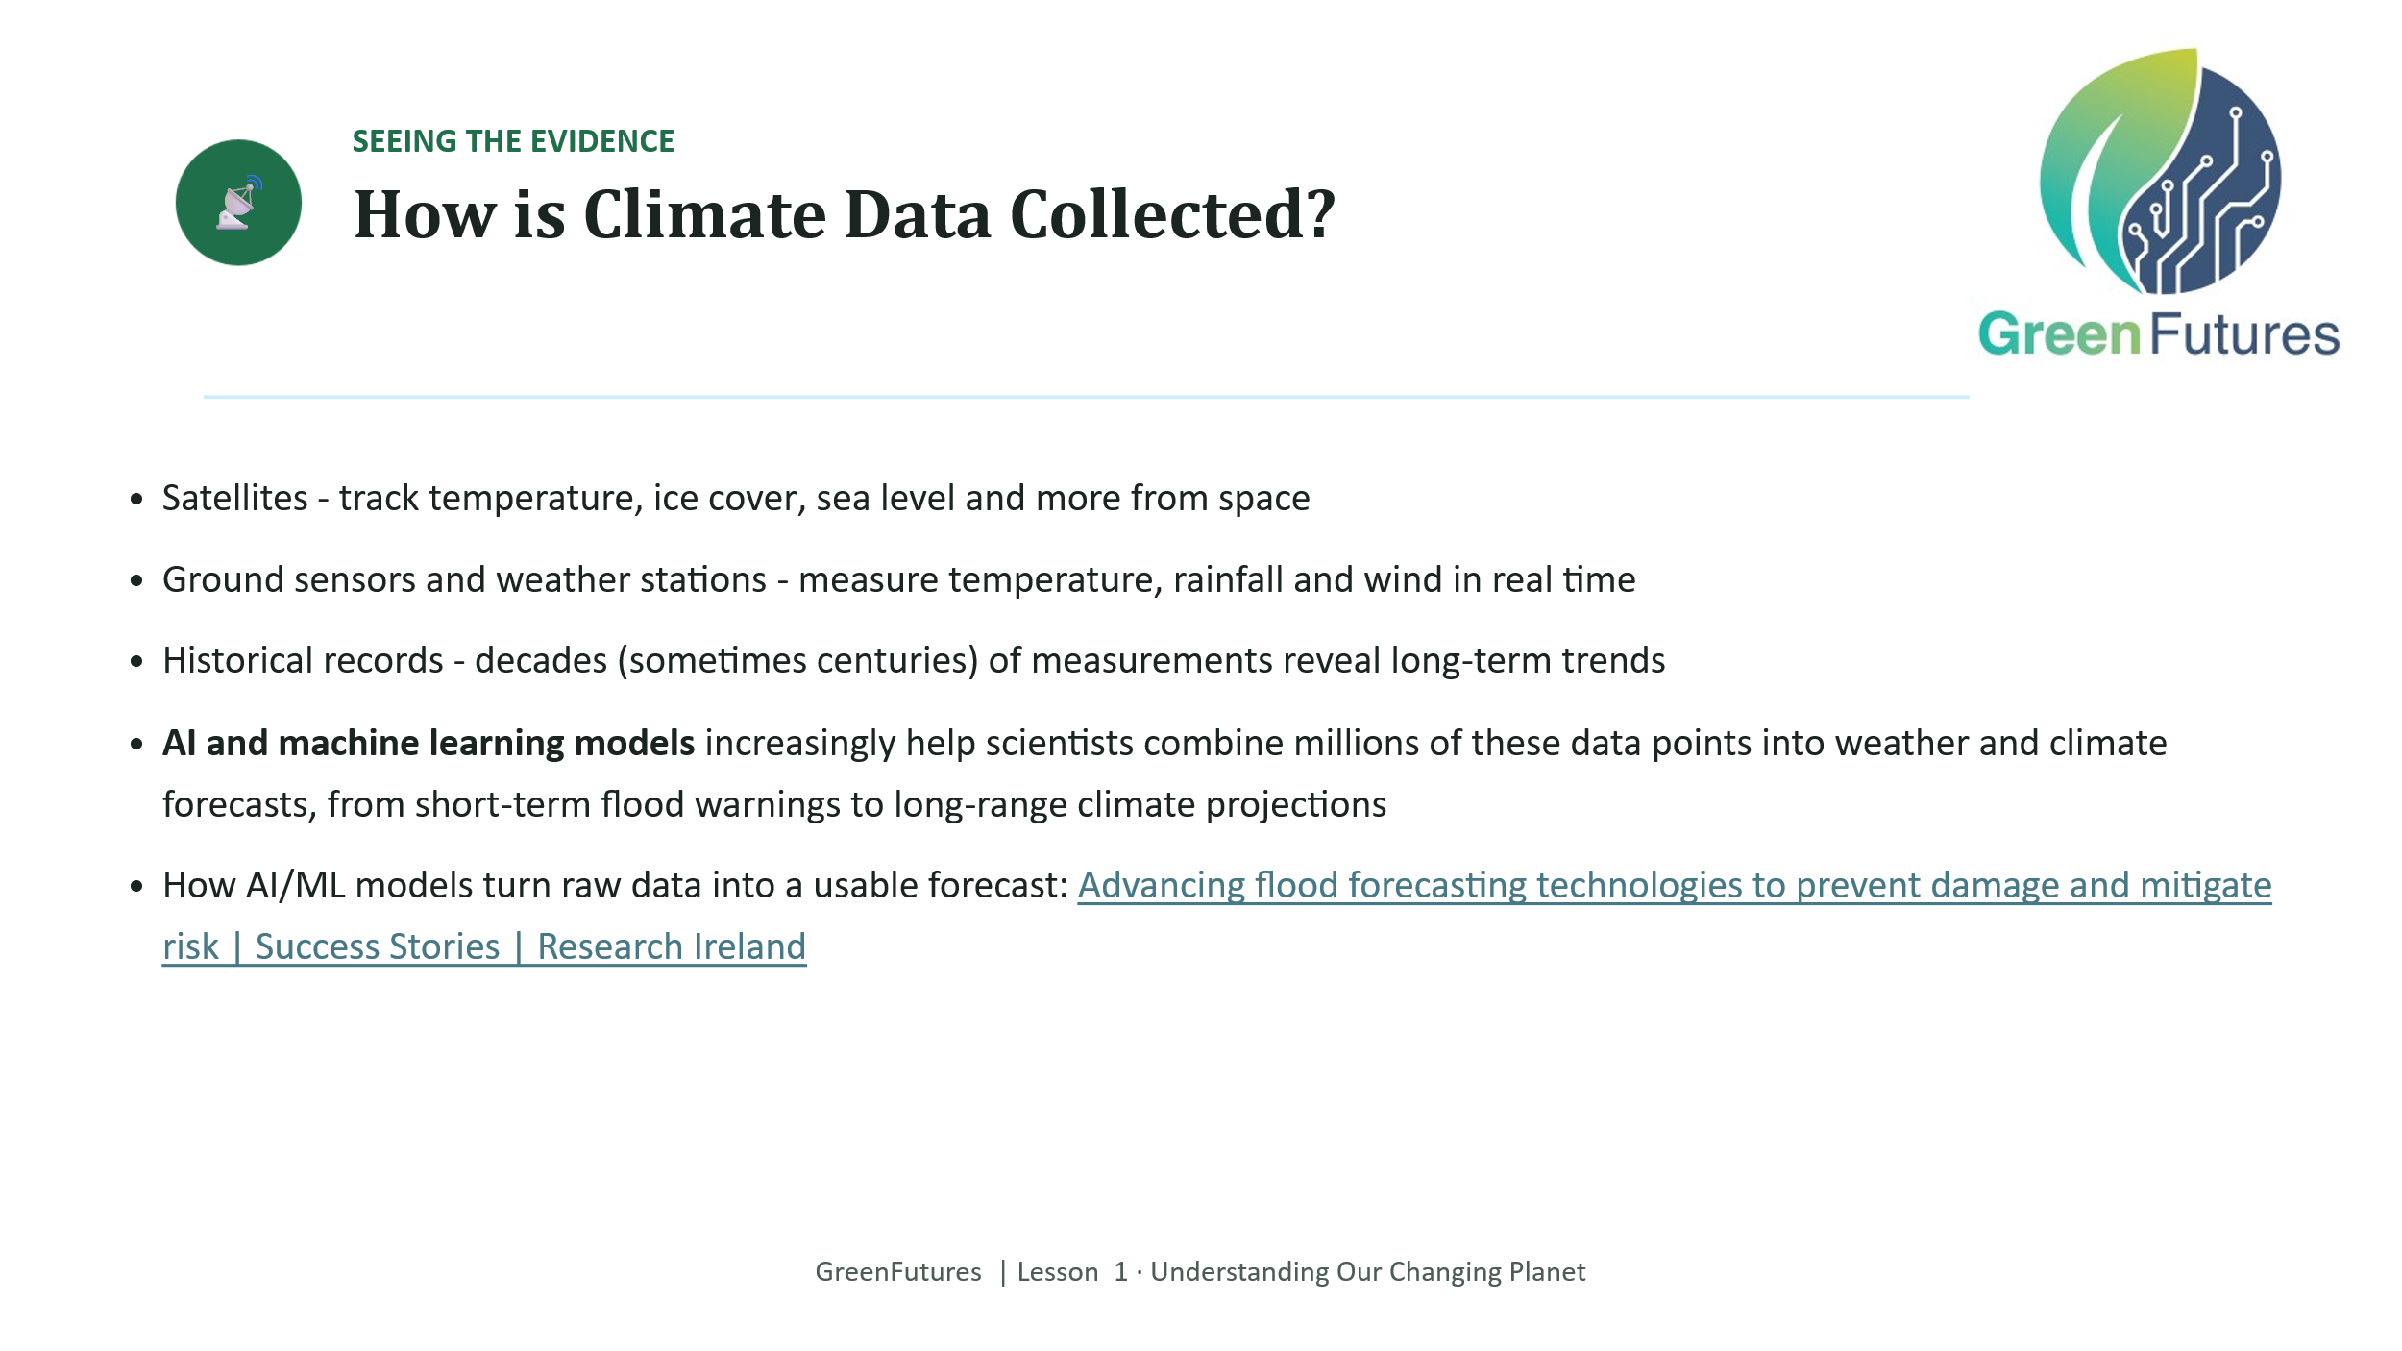 | LECTURE (~4 mins)  Cover the three traditional data sources (satellites, sensors, historical records), then introduce AI/ML's growing role in combining them into forecasts.  This is the natural home for weather-prediction examples. Flooding, frost and heat-event forecasting, and the idea that data has ‘5 Vs’ (volume being a key one).  Here is an example: https://www.farmersjournal.ie/news/news/early-warning-system-for-flooding-in-ireland-being-developed-802858  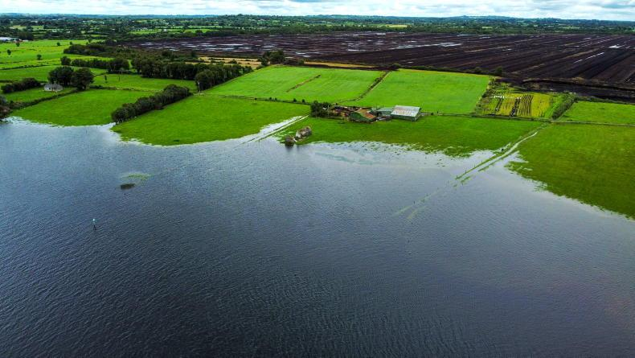  “The maps were fed into an artificial intelligence model designed to predict the extent of future flooding events in these areas, which researchers say is accurate up to approximately 20 metres “  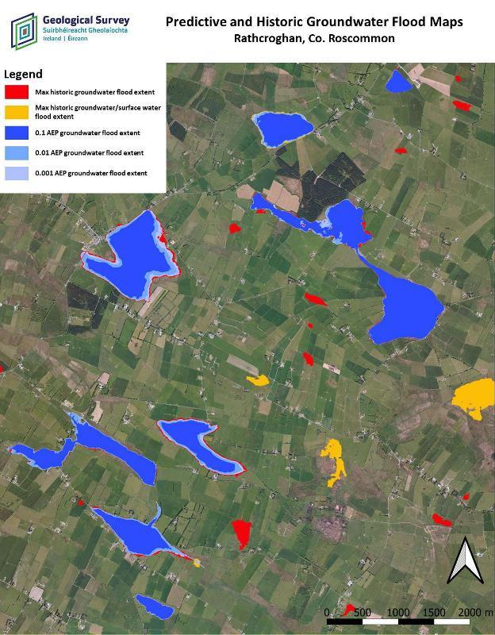  Predicted groundwater flood extent, Rathcroghan, Co. Roscommon. Satellite observations from Copernicus Sentinel-1 were combined with field measurements and hydrological modelling to estimate flood extents for different probabilities.  Source: Geological Survey Ireland, GWFlood.  StopFlood project video is useful Advancing flood forecasting technologies to prevent damage and mitigate risk | Success Stories | Research Ireland  https://www.youtube.com/watch?v=gtqW1-ccblc
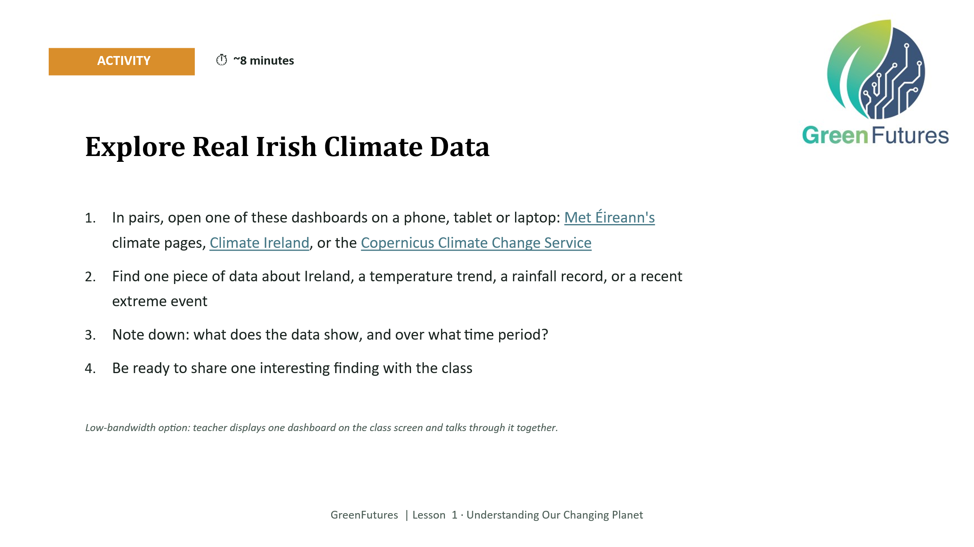 | ACTIVITY (~8 mins)  Pairs open one of: Met Éireann's climate pages, Climate Ireland, or the Copernicus Climate Change Service, and find one Irish data point (temperature trend, rainfall record, or extreme event).  Low-bandwidth option: display one dashboard on the class screen and walk through it together rather than pairs working independently.  Circulate and prompt pairs to note the time period covered by their data point. This reinforces the weather-vs-climate distinction from earlier.
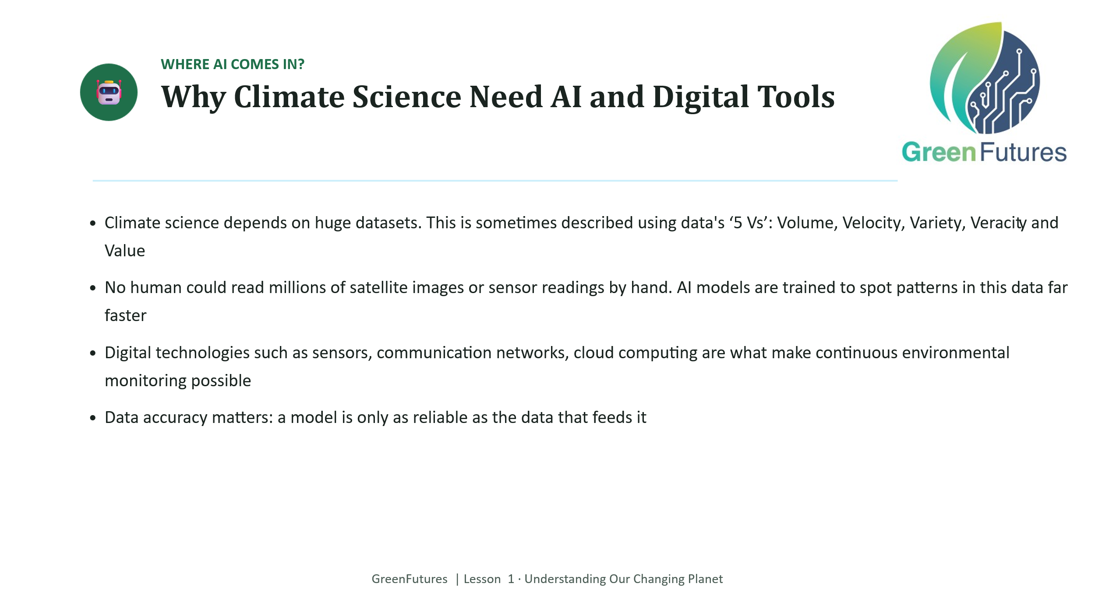 | LECTURE (~4 mins)  Explain why AI is essential at this scale. No human team could review this volume of data by hand. Introduce the idea of data accuracy as a live issue (evaluating the reliability of climate data), which previews Lesson 2's discussion of AI limitations and bias.
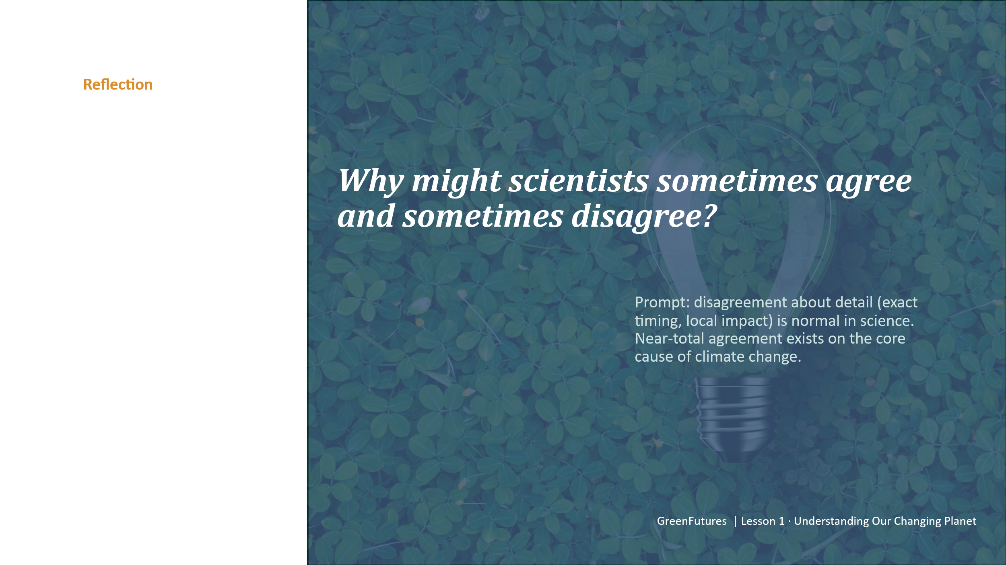 | DISCUSSION (~3 mins)  Ask why scientists sometimes agree or disagree. Steer toward: disagreement about detail is a normal, healthy part of the scientific process, not evidence that the underlying science is shaky.
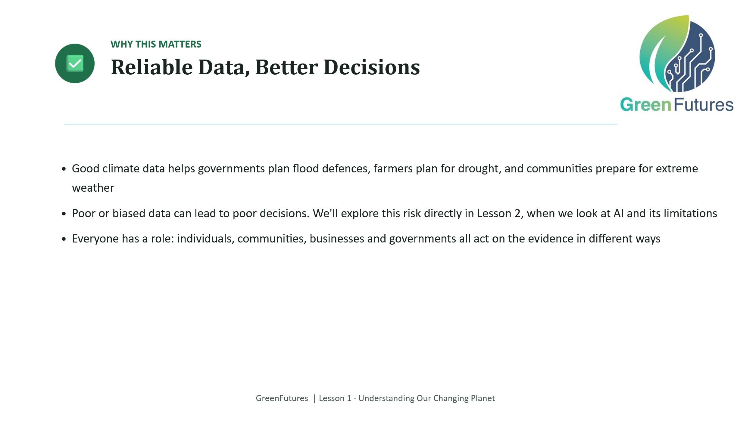 | LECTURE (~3 mins)  Connect good data to good decisions: flood defences, drought planning, community preparedness.  Flag explicitly that Lesson 2 will look at what happens when data or AI systems go wrong.
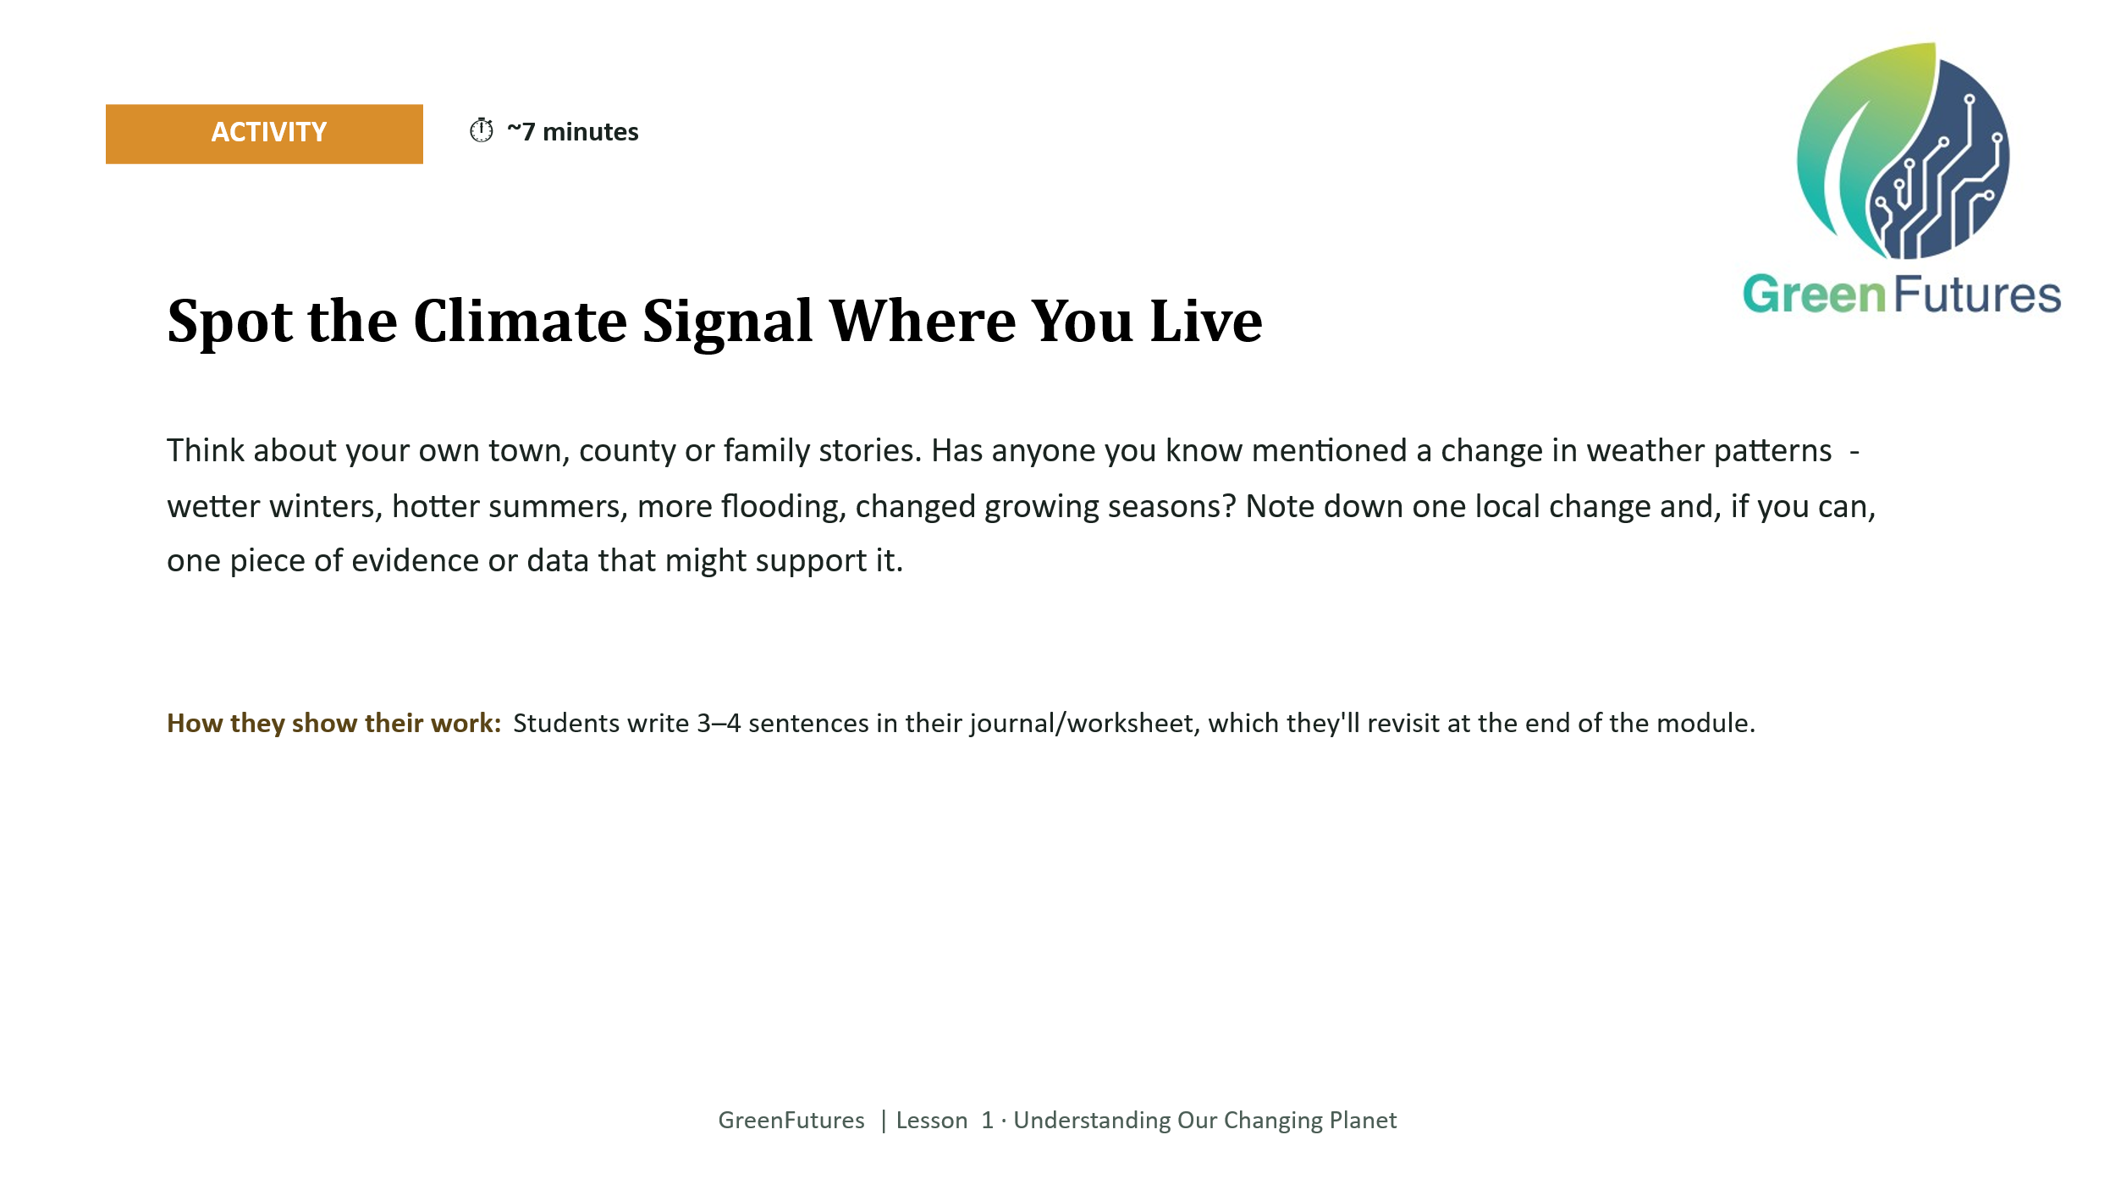 | APPLY (INDIVIDUAL, CAPTURED) (~7 mins)  Students write 3-4 sentences noting one change in weather patterns they, or someone they know, has observed locally, with evidence if possible.  This is the first entry in a running ‘climate journal’ that continues through all four lessons and feeds into the Lesson 4 climate action proposal. Keep it, don't let it be a one-off worksheet that gets lost.
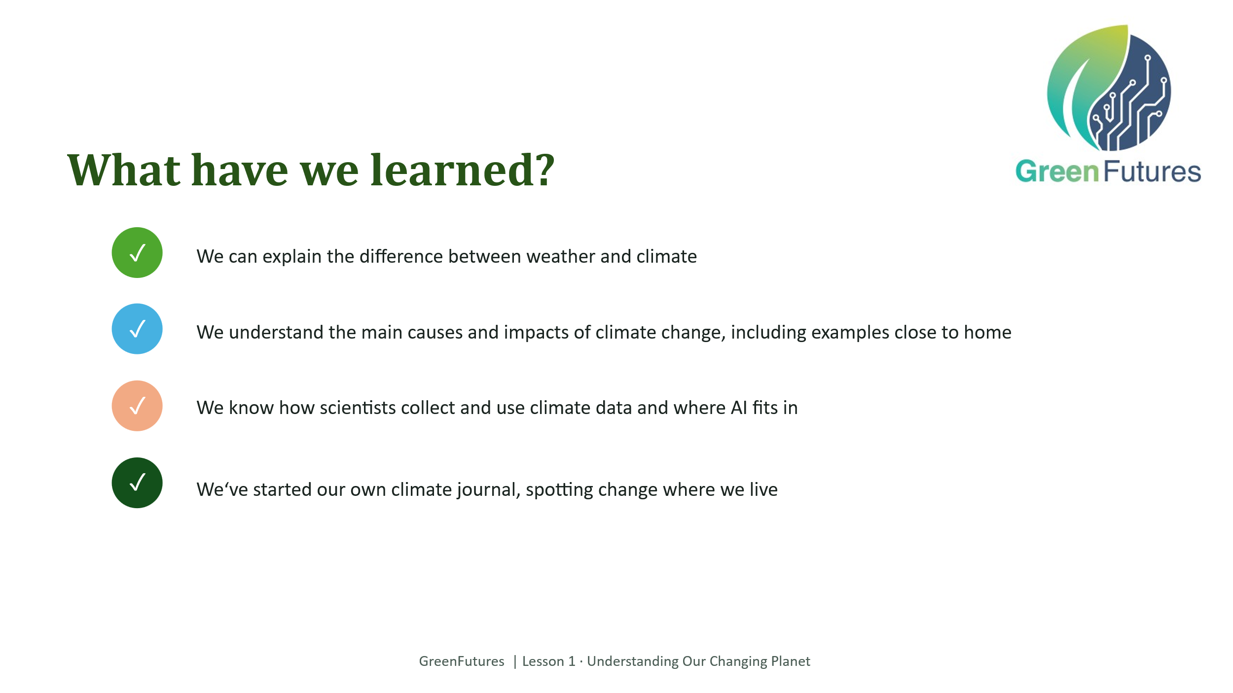 | LECTURE (~2 mins)  Revisit the five learning outcomes and confirm the class can speak to each one.
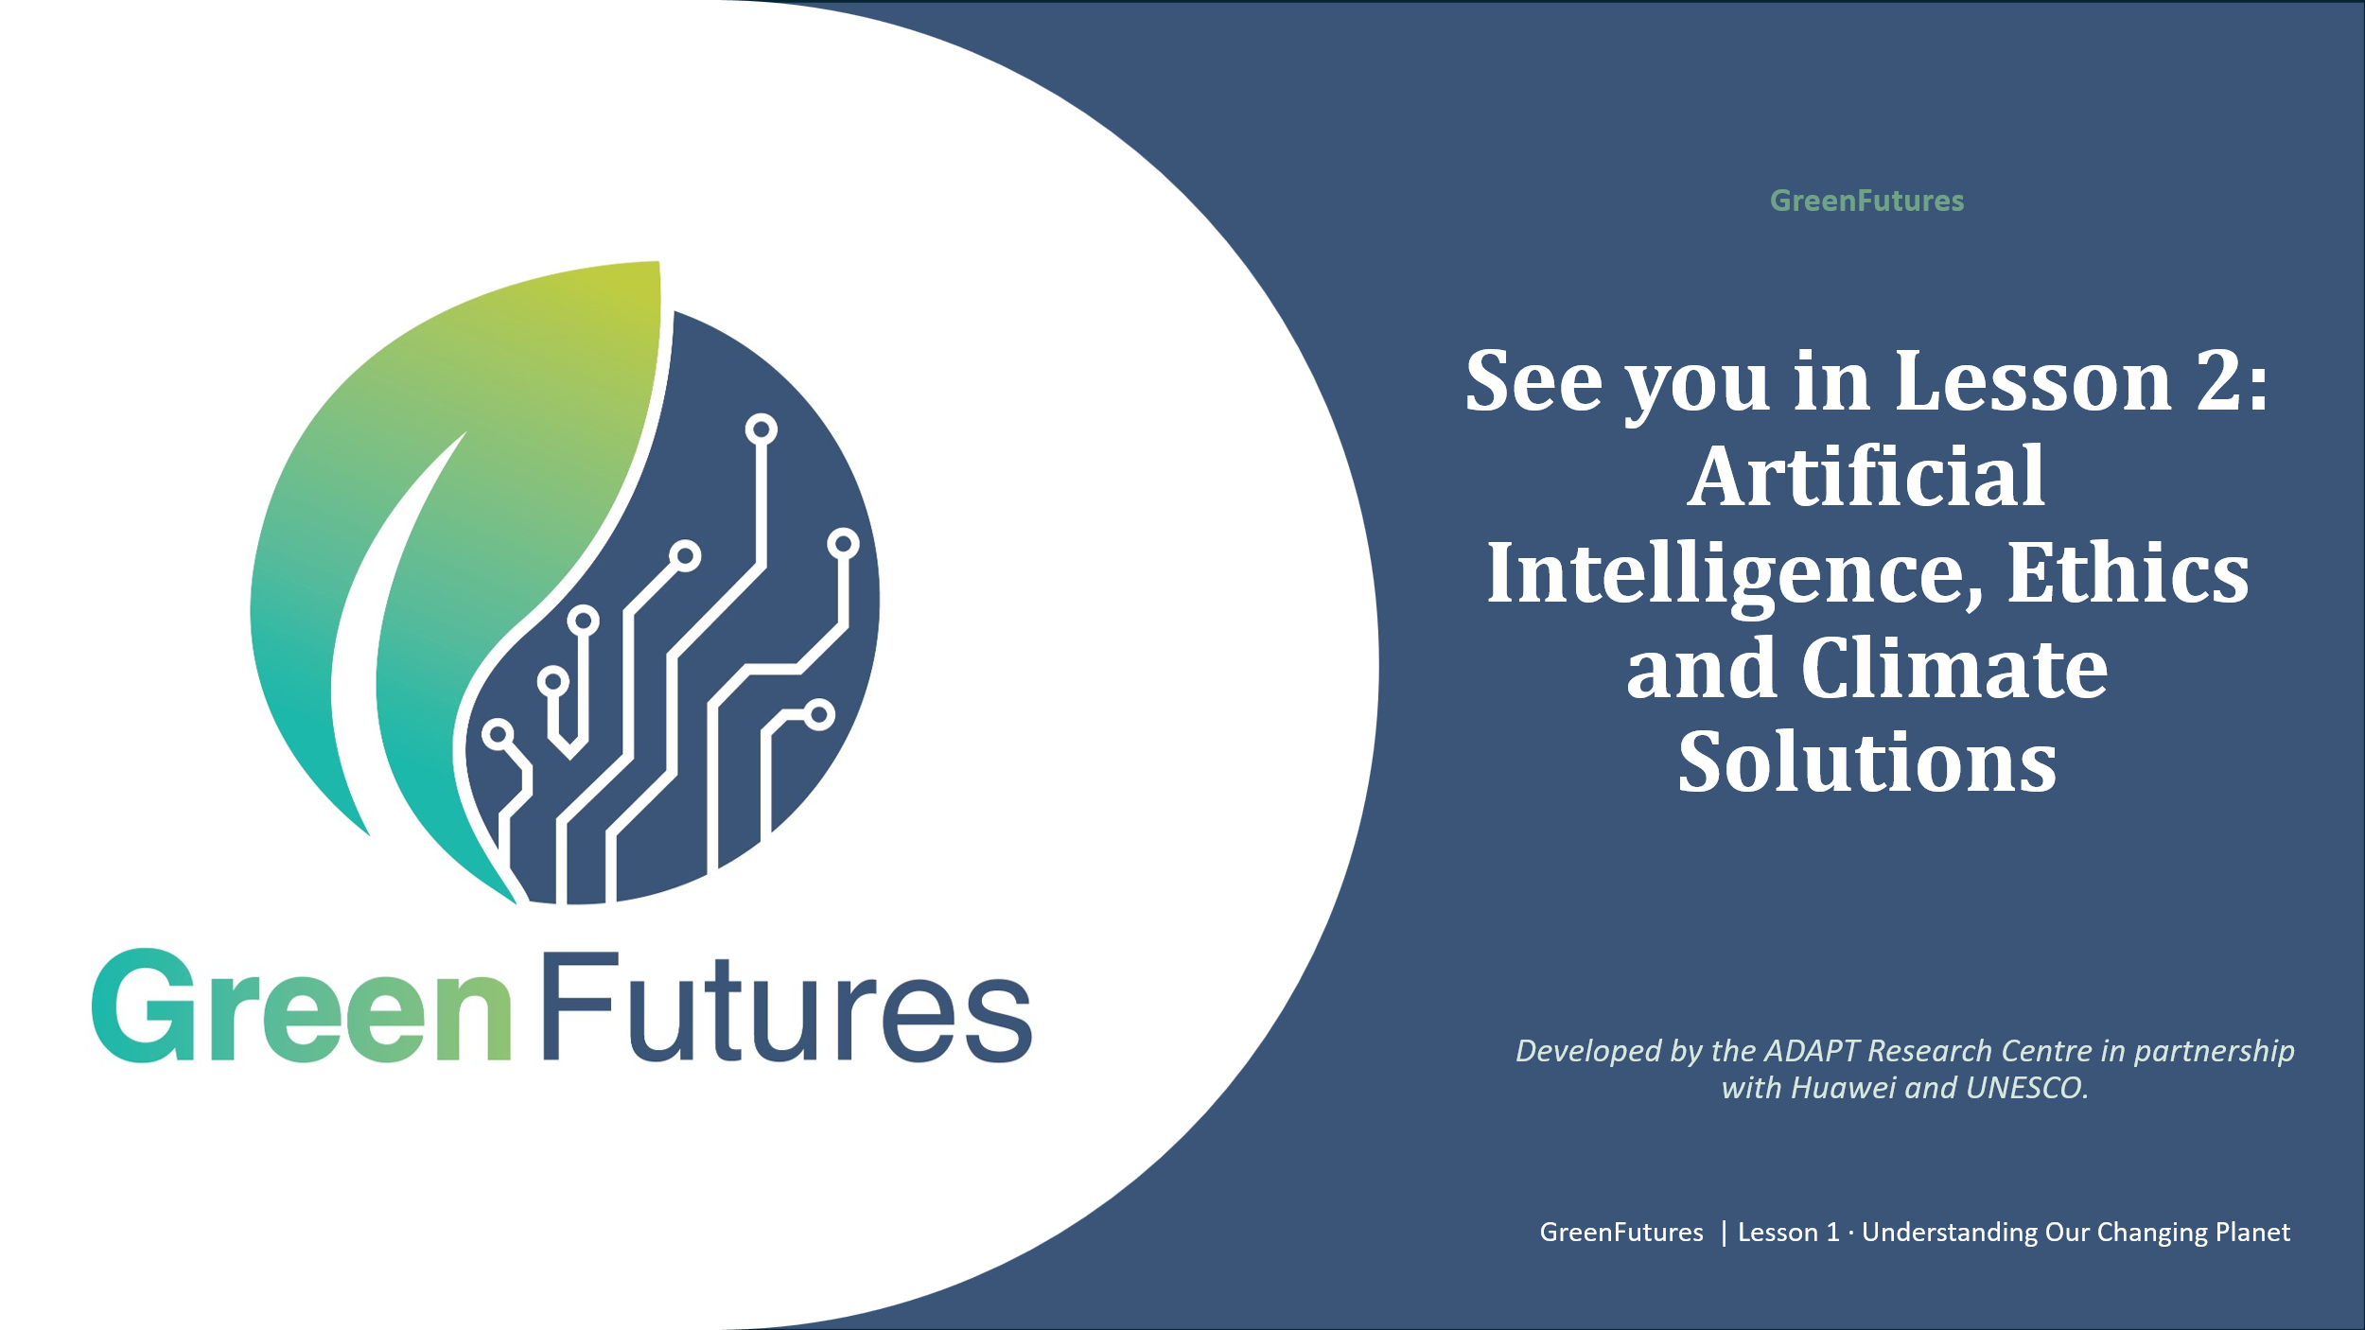 | LECTURE (~1 min)  Preview Lesson 2: Artificial Intelligence, Ethics and Climate Solutions.

