AI in My Life Taster Module
Teacher Guide
Version 2.1 | Last Updated: 21st August 2026
This guide accompanies the ‘AI in My Life Taster Workshop’ presentation slide deck of the AI in My Life workshop series, which is available at www.adaptcentre.ie/courses/ai-in-my-life-taster-lesson/ The programme was developed by the Education and Public Engagement team at the Research Ireland ADAPT Centre at Dublin City University. Note that no previous knowledge of AI by students or teachers is required.

This 90-minute AI in My Life Taster Module introduces students to artificial intelligence in everyday life, exploring AI and machine learning, facial and emotion recognition, AI-generated content, data privacy, bias and ethical decision-making through discussion and interactive activities. Students develop critical AI literacy by examining AI’s benefits and risks and learning to question, evaluate and use AI technologies safely and responsibly.
Learning Intentions
By the end of this workshop, students will be able to:
- Explain AI Basics: Explain in simple terms what Artificial Intelligence (AI) and Machine Learning (ML) are.
- Identify AI in Daily Life: Identify where AI applications show up in their daily lives.
- Recognise Ethical & Privacy Risks: List and discuss ethical, privacy, bias, and deepfake concerns related to AI.
- Think Critically: Critically evaluate AI-generated content (e.g., image/emotion detection, deepfakes, data usage).

Overview & Setup
- Target Audience: Primary audience is Transition Year (TY) students, but content is suited all Second Level students with a little tweaking.
- Module Duration: 90 Minutes
- Curriculum & Competency Alignment: Includes Media & Digital Literacy, Critical Thinking, Ethical Awareness, and Active Citizenship (see details on Pages 2-3).
- Materials Needed: Laptop with Google Slides or PowerPoint and audio, screen, WiFi access, student devices (for interactive activities). If devices are limited, activities can be done in pairs / small groups.
- Prerequisites: There are no prerequisites for this workshop. Students do not need any previous knowledge of AI.
- Key Vocabulary: Artificial Intelligence, Machine Learning, Deepfakes, Misinformation vs. Disinformation, AI and Bias, Training Data.

Curriculum Links
This module aligns with the overarching mission of Transition Year in Ireland: to promote personal, social, educational, and vocational development, preparing students to become autonomous, participative, and responsible members of society.
1. Senior Cycle Key Competencies Alignment (NCCA)
- Thinking and Solving Problems: Students question how AI works, evaluate AI-generated content, identify bias and misinformation, and weigh competing ethical choices. (Slides 5-13, 15-20, 28-31)
- Being Creative: Students explore creative applications of AI and engage with AI-generated imagery, considering how technology can be used imaginatively and responsibly. (Slides 10, 14, 17-20)
- Communicating: Students discuss AI applications, privacy, bias and ethical issues, explaining their views and responding to different perspectives. (Slides 8, 11-13, 20-23, 28-31)
- Working with Others: Interactive activities and group discussions encourage students to collaborate, listen to others and reach reasoned conclusions. (Slides 11, 13, 20, 28-31)
- Participating in Society: Students consider how AI affects individuals and society, including issues of fairness, privacy, misinformation, human rights and responsible technology use. (Slides 14-16, 21-31)
- Cultivating Wellbeing: Students develop awareness of digital safety, privacy and the potential effects of AI and misinformation on individuals and communities. (Slides 15-27)
- Managing Learning and Self: Students reflect on their own use of AI, personal data and digital tools, developing informed and responsible habits for navigating an AI-enabled world. (Slides 5-10, 21-27, 32)
2. Core Leaving Certificate Subject Alignment
- Computer Science: Supports understanding of AI, machine learning, data, automated systems and the ethical and societal implications of computing. (Slides 5-13, 21-31)
- Politics and Society: Explores privacy, equality, bias, ethics, human rights and the societal consequences of emerging technologies. (Slides 5-16, 20-23, 28-32)
- Business: Examines how organisations use AI and personal data, including recommendation systems, targeted advertising, automation and ethical responsibility. (Slides 7-9, 14, 29-31)
- English: Develops critical literacy through analysing misinformation, disinformation, deepfakes and AI-generated media. (Slides 15-20)
- Science subjects: Connects scientific and technological developments with real-world applications, limitations and ethical consequences. (Slides 5-14, 28-31)
- SPHE: Supports informed decision-making, privacy awareness, online safety, and responsible engagement with technology. (Slides 15-27)

3. Cross-Curricular Themes
- Digital and Media Literacy: Evaluating AI-generated images, deepfakes, misinformation and the credibility of online content. (Slides 15-20)
- AI and Digital Citizenship: Understanding where AI appears in everyday life and developing informed, responsible approaches to its use. (Slides 5-14, 32)
- Privacy and Data Protection: Exploring personal data, digital footprints, privacy policies, settings and safer use of AI tools. (Slides 21-27)
- Ethics and Human Rights: Considering bias, fairness, accountability and the consequences of automated decision-making. (Slides 11-13, 28-32)
- Critical Thinking and Problem-Solving: Questioning AI outputs, testing assumptions and weighing competing arguments and consequences. (Slides 17-20, 28-31)
- Wellbeing and Online Safety: Encouraging safer and more reflective participation in digital environments. (Slides 15-27)
- Sustainability and AI for Good: Exploring positive applications of AI in healthcare, climate and the environment, accessibility, education and agriculture. (Slide 14)
- Active Citizenship: Encouraging students to consider how AI shapes society and how people can contribute to fair, ethical and responsible uses of technology. (Slides 14 -16, 21-31)

Suggested Lesson Timing Matrix

90 Minutes (Recommended)
Topic / Section | Slide No. | Time
Introduction & Learning Intentions | Slides 1–3 | 3 mins
Opening Survey (Mentimeter) | Slide 4 | 5 mins
What is AI? (Definition & Royal Society Video) | Slides 5–6 | 6 mins
Machine Learning & Daily Examples | Slides 7–9 | 8 mins
Interactive Activity: Quick, Draw! | Slide 10 | 6 mins
Facial Recognition & Emotion Detection | Slides 11–13 | 12 mins
AI for Good vs. AI Unethical Use (Deepfakes) | Slides 14–16 | 7 mins
Spotting AI: Art or AI? Quiz & Detection Tips | Slides 17–20 | 12 mins
Data Privacy & Protecting Your Data | Slides 21–23 | 11 mins
Bias, Ethics & The Moral Machine | Slides 24–26 | 15 mins
Wrap-up & Post-Workshop Survey (Mentimeter) | Slides 27–28 | 5 mins

Teacher Notes & Scripting

Important Note for Teachers: Detailed suggested presenter scripts are built directly into the Presenter Notes section of the slide deck for your convenience.
- If you want a ready-to-read script: Feel free to use or adapt the built-in slide notes directly during your delivery. Best for teachers with limited existing knowledge of AI.
- If you prefer a conversational approach: Use the key concepts and talking points outlined in this guide to lead the discussion naturally in your own voice.

Tip: To view the built-in scripts while presenting, use Presenter View in PowerPoint or Google Slides.

Slide Deck Walkthrough

Introduction (~3 mins.)

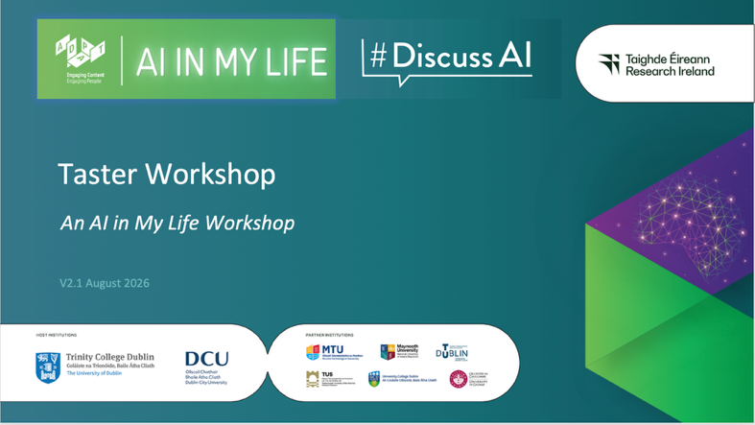 | Lecture (~1 min.)  Welcome to AI in My Life! This taster workshop provides a flavour of the main topics covered in the wider AI in My Life programme.
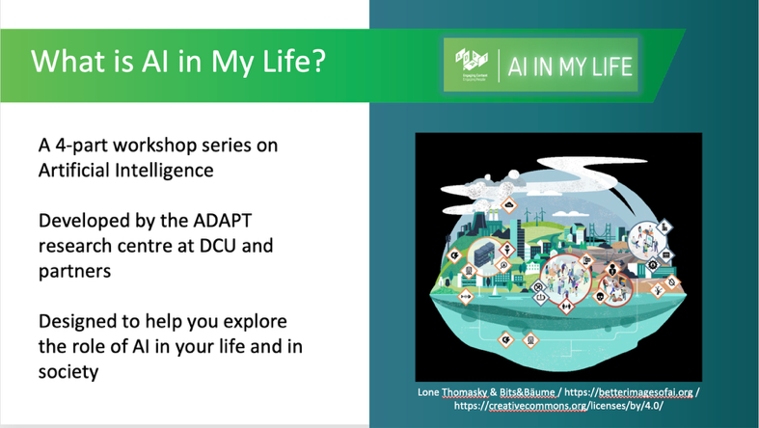 | Lecture (~1 min.)  AI in My Life is a modular workshop series on Artificial Intelligence (AI). It was developed by the Research Ireland ADAPT Centre. ADAPT is a major academia-industry research centre with more than 400 researchers from 8 Irish universities producing research and innovations in many aspects of AI.  AI is transforming life as we know it. While AI offers substantial benefits to individuals and society, it has major implications for privacy, ethics and security. AI in My Life aims to help students navigate this so-called ‘Age of AI’ safely and successfully.
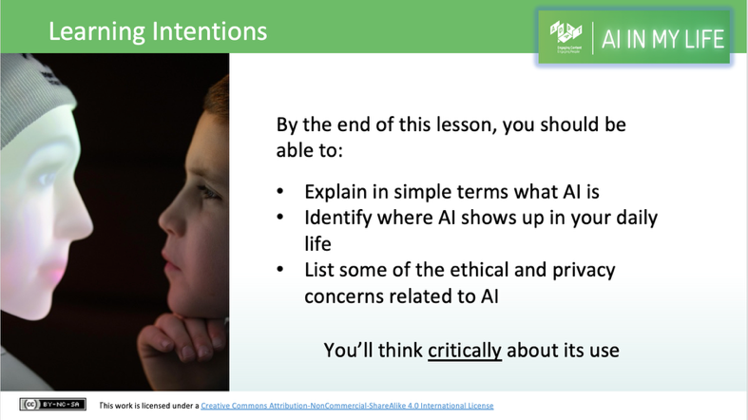 | Lecture (~1 min.)  Outline to students what they’ll be able to do by the end of this module:  - Explain in simple terms what AI and Machine Learning are.  - Identify everyday examples of AI in their lives.  - Uncover some of the ethical and privacy implications of AI.  - Think critically about the role of AI in society, weighing up the benefits and risks.
Opening Survey (~5 mins.)
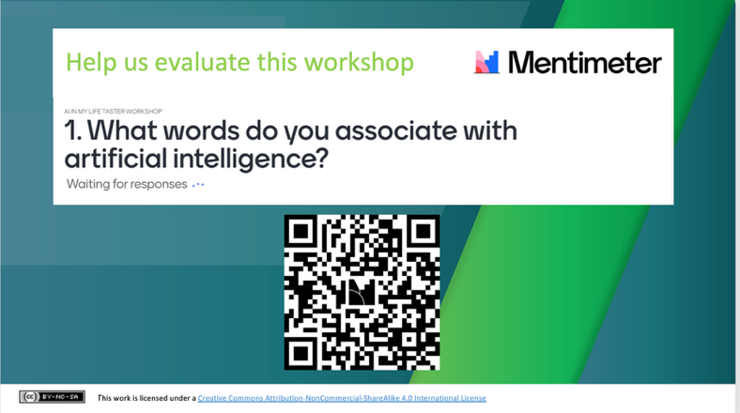 | Activity (~5 mins. for survey)  We’ll start by asking students four short questions designed to help us understand their current level of understanding and interest in AI. The survey is anonymous, and the answers will help us to evaluate the course and improve it.  Explain to students that their answers will not appear on the classroom screen (we’ve decided on this approach so that students won’t be swayed by answers they see others give).  Ask students to use their mobile phones or tablets to access the short survey on Mentimeter via the QR code.  Highlight that their answers will go (anonymously) to the AI in My Life evaluation team and will only be used to help us evaluate and improve the course.
What is AI? (~6 mins.)

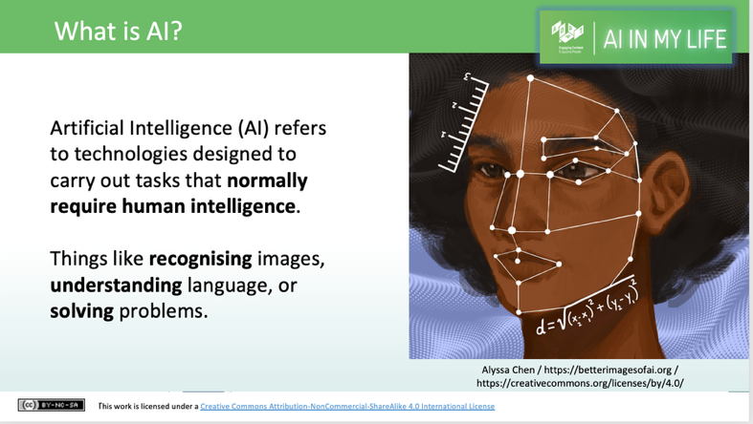 | Lecture (~2 mins.)  Explain what AI is. Go through the following definition, checking that students understand:  Artificial intelligence refers to many different technologies that are designed to accomplish tasks that can otherwise be only carried out by human minds, for example identifying patterns, recognising images, understanding languages or solving problems.
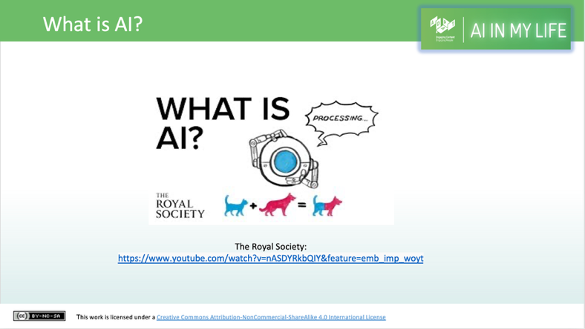 | Activity (~4 mins.)  This 2.5 minute video from the Royal Society in the UK explains some of the benefits of AI and ways in which it’s being used currently.  It also encourages us to reflect on whether AI development and use can have potentially negative effects on individuals and society and what we can do to address this issue.  Let’s take a look.  Ask students to note some of the beneficial uses of AI that the video mentions.
Machine Learning (~14 mins.)

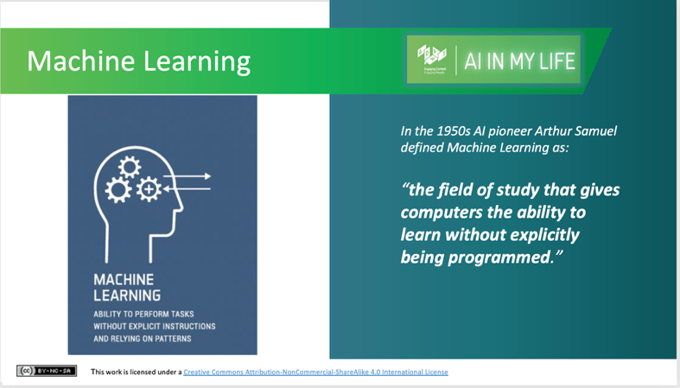 | Lecture (~1 min.)  Many AI applications are based on Machine Learning – so much so, that the terms AI and Machine Learning are often used interchangeably.  Machine Learning is an application (or subset) of AI that focuses on developing computer programmes that can access data and use it to learn and improve from experience.  In the 1950s AI pioneer Arthur Samuel defined Machine Learning as “the field of study that gives computers the ability to learn without explicitly being programmed.”
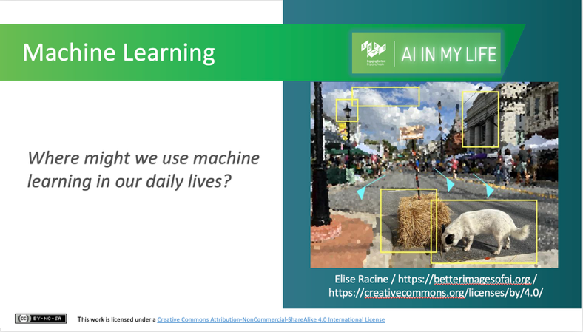 | Activity (~3 mins.)  Where might we use Machine Learning in our everyday lives?  Ask students to call out some examples.  - Netflix, for example, learns from your browsing and watching history to present you with recommended content based on what it has learned about you and your preferences.  - Email accounts classify spam into a separate folder from your inbox.  - Personal assistants such as Siri or Alexa also use Machine Learning to function.
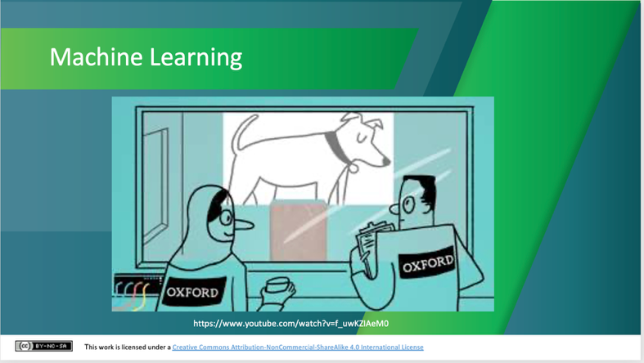 | Activity (~4 mins.)  Watch the short video (2.41 mins) from the University of Oxford, U.K. (https://www.youtube.com/watch?v=f_uwKZIAeM0). Ask students to note additional examples of Machine Learning applications.  Encourage students to listen out for what machine learning needs to work and improve (i.e., data).
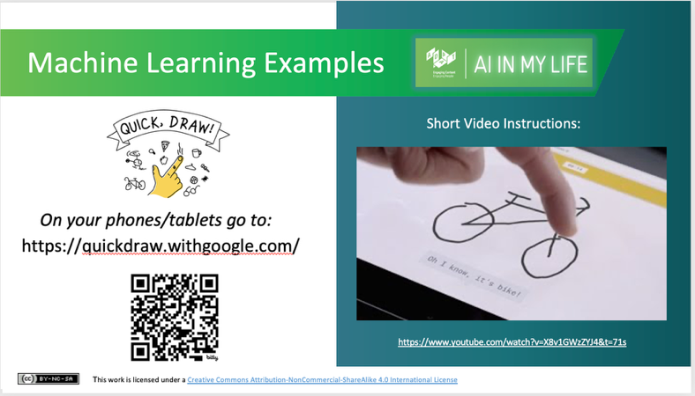 | Activity (~6 mins.)  Google’s ‘Quick, Draw!’ is a game built with machine learning. Students draw, and a neural network (a type of Machine Learning, modelled on the human brain, that learns to perform tasks by analysing examples) tries to guess what they’re drawing. Of course, it doesn’t always work, but the more people play with it, the more it will learn. The short explainer video (https://www.youtube.com/watch?v=X8v1GWzZYJ4&t=71s) will give you an overview of the game and how it works.  [Ask students to visit the link https://quickdraw.withgoogle.com/ on their mobile phone or tablet. Tell them to click on ‘Let’s Draw’ and try out the game themselves. When they get their doodle score, encourage them to click on one of the doodle items to see how the neural network figured it out, and visit the data to see 50 million drawings made by other real people on the internet.  If students don’t have access to devices, you can play the video explainer and ask them to note the web link to try out later).

Facial Recognition and Emotion Detection (~12 mins.)
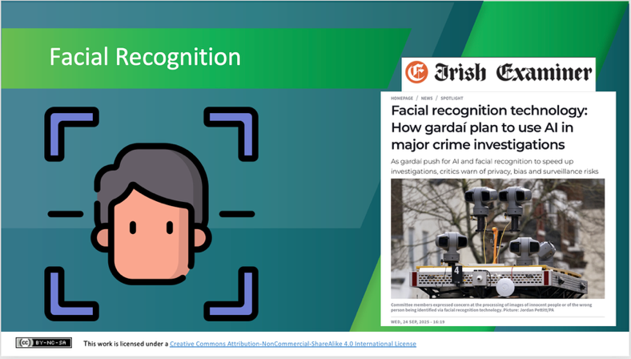 | Lecture (~1 min.)  Facial recognition systems are also built on Machine Learning and trained with large amounts of data. The more data they are provided with, the more accurate they become at recognising faces.  Discussion (~2 mins.)  Ask students if they can think of useful ways in which they’ve seen facial recognition used. Some examples are:  - To unlock your mobile phone  - For passport control at the airport  - For surveillance in shops or other business premises  What do they think are the advantages and disadvantages of such technology? (e.g., balancing security with privacy).  Lecture (~1 min.)  Following years of public debate, including concerns expressed by legal experts and human rights advocates, in 2026 the Irish Government enacted legislation permitting An Garda Síochána to deploy biometric facial recognition tools. The tools can be applied to previously-gathered CCTV and video footage to investigate serious, arrestable offenses, matters of state security, and missing person cases. Real-time facial surveillance in public spaces remains excluded, and a Garda must manually check matches before an arrest can be made.  This highlights that the benefits of facial recognition technology need to be weighed up with their potential effects on the privacy and human rights of individuals.

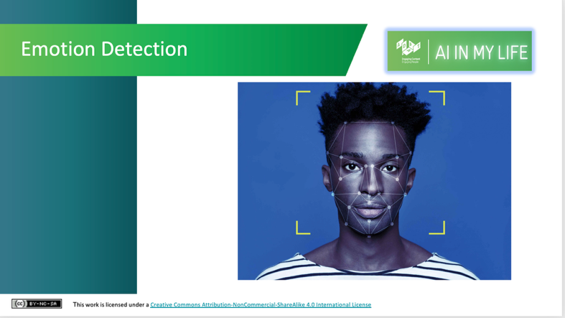 | Lecture (~1 min.)  One of the things that machines find hardest to deal with accurately is emotion – a truly human characteristic.  However, just as a child learns to read emotions through years of experience, so too can machines learn to read our emotions. But how effective are they at doing so?
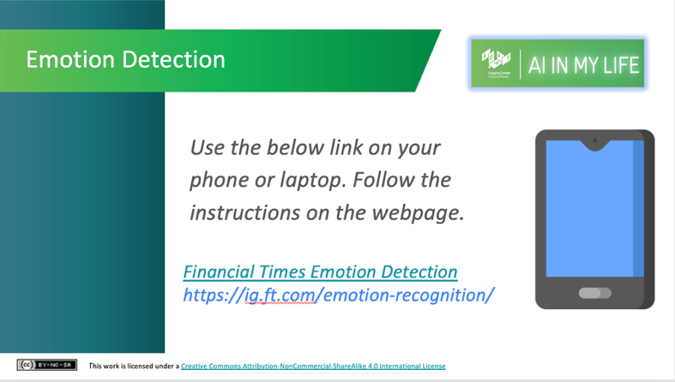 | Activity (~7 mins.)  Let’s try out a short game that helps demonstrate how difficult it is for machines to accurately interpret emotions from human faces.  Instruct students to use the link on the screen to access an interactive game and follow the instructions on the web page to play the game. Note: This game takes about 5 mins. to complete. It doesn’t store facial images, but if students don’t have a camera built into their device or they don’t wish to allow the game access their camera, they can instead watch the explainer video when prompted.  After playing/watching the game, using a Think-Pair-Share approach, ask students why they think machines are better at recognising some faces (and emotions) than others.  Essentially, this comes down to bias and lack of diversity in the data used to train the system (i.e. the examples given to it to help it learn). Often these systems are built using predominantly white adult male examples/data and so they become good at recognising white adult male faces. They are typically less accurate at identifying the faces of people of other ethnicities, women, children and older adults because they’ve been trained on fewer examples of such faces. Eradicating bias from AI systems is a key ethical concern of AI development and use.

AI for Good vs. Unethical AI Use (~7 mins.)

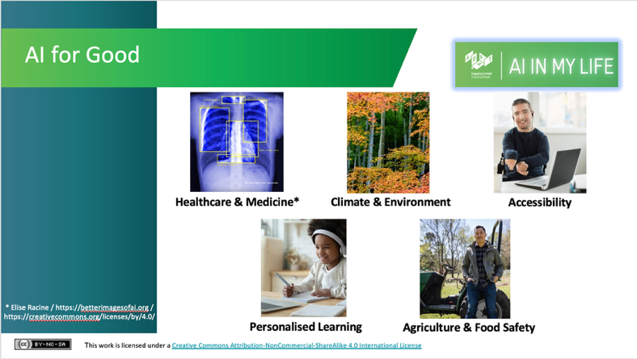 | Lecture (~2 mins.)  This slide introduces five practical areas where AI creates positive societal impact:  Healthcare: Catches diseases early in medical scans and speeds up drug development.  Climate & Energy: Monitors deforestation and predicts climate emergencies (but running AI data centres itself consumes significant energy).  Accessibility: Provides real-time subtitles, screen descriptions, and voice tools to help people with disabilities navigate daily life independently.  Education: Acts as a personalised tutor, adapting lessons to each student's learning style and pace.  Agriculture: Scans crops to target water and pesticide use precise where needed, reducing chemical runoff and waste.  These are just a few examples of ways in which AI Is being used for good.
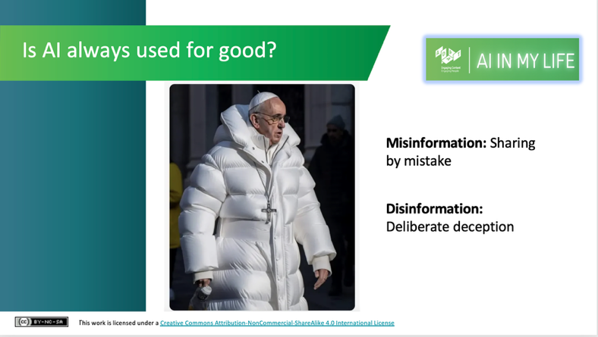 | Lecture (~1 min.)  But is AI always used for good?  Has anyone seen this image before? If so, what do you know about it?  This image, which has been referred to as the Balenciaga Pope, is actually fake. It was generated by AI image generator Midjourney.  While such images can be seen as harmless fun, AI-generated images like this could be used in unethical ways.  The following video explains the dangers of “deepfakes”, which are video and audio content generated by AI.
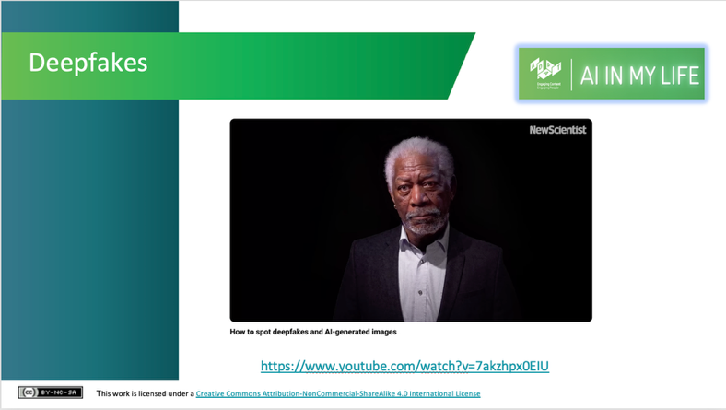 | Activity (~4 mins.)  Play this short video (3 mins 17 secs):  This video from New Scientist introduces students to “deepfakes” – a video, image, or piece of audio in which a person’s face, body, or voice has been digitally altered so that they appear to be someone else. Deepfakes are typically used maliciously or to spread false information. Leading deepfake experts discuss the rising threat from AI-created content and what we can do about it.
Spotting AI: Art or AI? Quiz & Detection Tips (~12 mins.)
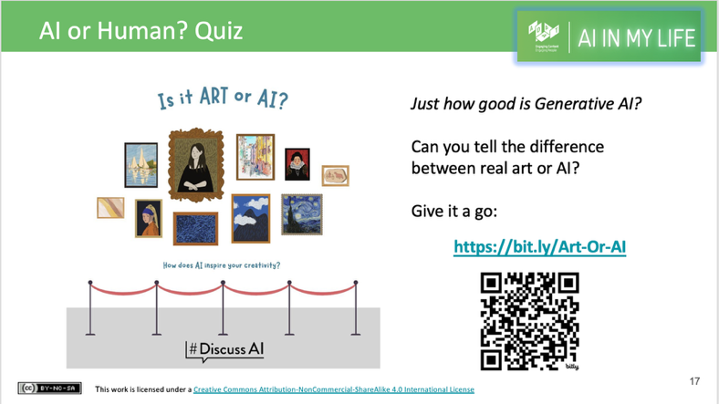 | Activity (~8 min.)  This slide facilitates an interactive, 5-minute image recognition quiz where students attempt to distinguish human-made art from Generative AI images using their phones or iPads.  Students scan an on-screen QR code, evaluate a series of images, submit their guesses, and view their final scores.  Ask volunteers for their scores and prompt them on what "tell-tale signs" helped them decide whether an image was AI-generated or human-made. Highlight that most people only score around 6/10 because identifying synthetic media is inherently difficult –  even for experts – setting up the need for critical evaluation tools.
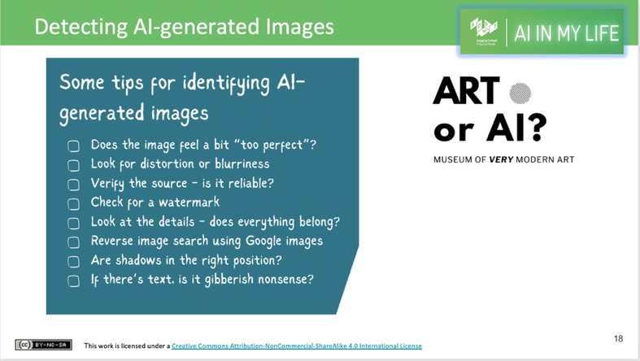 | Lecture (1 min.)  This slide equips students with practical techniques to critically evaluate and identify synthetic media:  Visual Cues: Advise students to look for common AI artifacts, such as uncanny "perfection," blurry background distortions, unreadable/gibberish text, and mismatched or physically impossible shadows.  Verification Steps: Outline actionable ways to double-check suspicious images:  - Check for AI platform watermarks.  - Trace the original publisher/source to verify credibility.  - Perform a reverse Google Image search to check the context and history of the image.
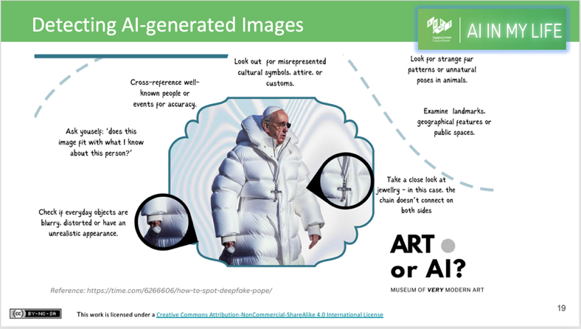 | Lecture (1 min.)  This slide provides a concrete, real-world case study using the viral "Balenciaga Pope" image to teach students how to analyse visual flaws and context, including:  Zooming In on Flaws: Demonstrates how to spot subtle rendering errors, such as the Pope's cross chain disappearing into his coat or his coffee cup appearing distorted and blurry.  Contextual Reality Check: Encourages students to apply common-sense reasoning, asking whether the context makes physical or cultural sense (e.g., Would the Pope realistically wear a designer puffa coat?).  [For more tips on how to spot AI-generated images, see the short Art or AI? Guide in the workshop Google Drive folder at: www.adaptcentre.ie/courses/ai-in-my-life-taster-lesson/
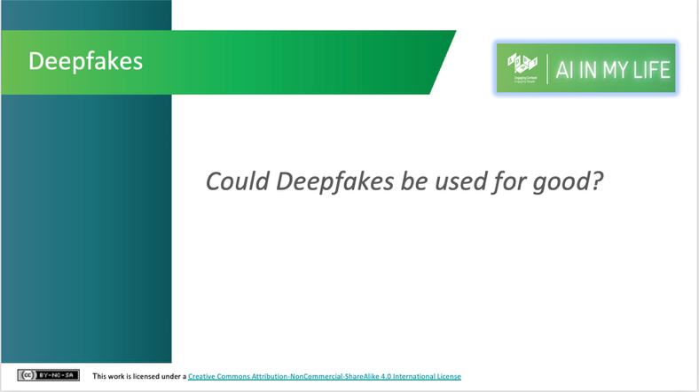 | Discussion (~2 mins.)  Can students think of any ways in which deepfakes could be used for good? How about using them to make learning more engaging?  In Shanghai, for example, Associate Professor Jiang Fei used an anime version of himself to make his online lessons more fun and engaging during the Covid lockdown. He said “The enthusiasm of the students in class, and the improvement of the quality of homework have made obvious progress.”  Irish company Marino Software worked with former RTÉ TV presenter Charlie Bird to develop a custom solution to preserve and clone the voices of people with motor neuron disease before they lose their ability to speak.  Again, this shows that AI-powered technologies aren’t inherently good or bad; what matters is how they’re used and who governs their use.
Data Privacy & Protecting Your Data (~11 mins.)

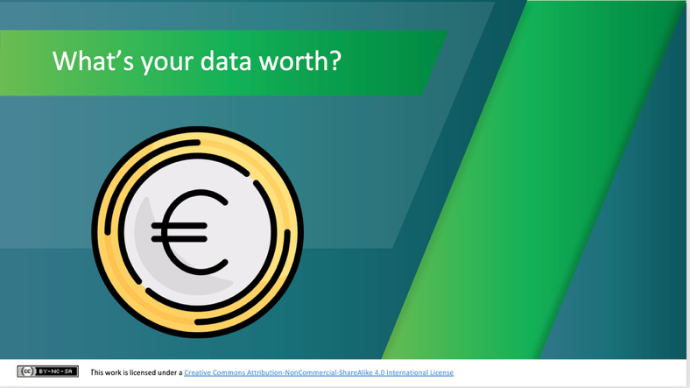 | Lecture (~1 min.)  We’ve seen that Machine Learning systems need data to improve their accuracy. From where do they get this data?  When it comes to digital apps, it’s often said that if you’re not paying for the product, then you ARE the product! This is because the technology we use in our daily lives collects huge amounts of data from and about us.  The reason your data matters to businesses so much is what it’s used for. Not only is it used to target you with personalised ads, but it also tailors online experiences for you, tracks how you use websites, monitors the kind of products you spend time looking at, and helps brands try and sell more to you.
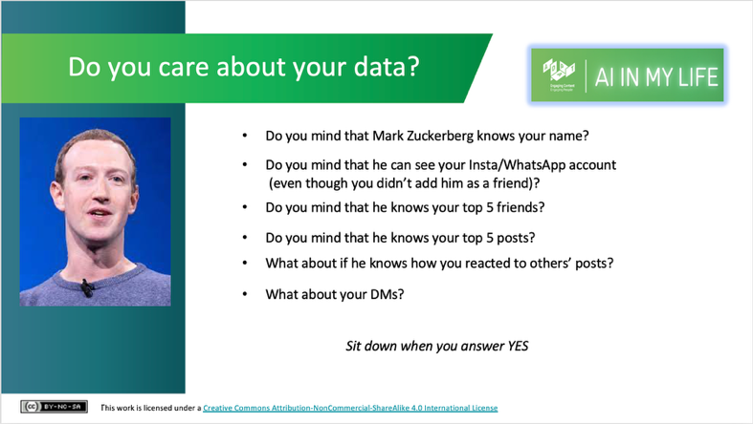 | Activity (~3 mins.)  Do you care about your data and keeping it safe and private?  Anyone know who this guy is? He’s Mark Zuckerberg, billionaire co-founder of Facebook and its parent company Meta.  [Walk through the questions with the students, asking them to stand up initially, and sit down as soon as they answer “yes” to a question. Observe how reluctant students are to share their data]
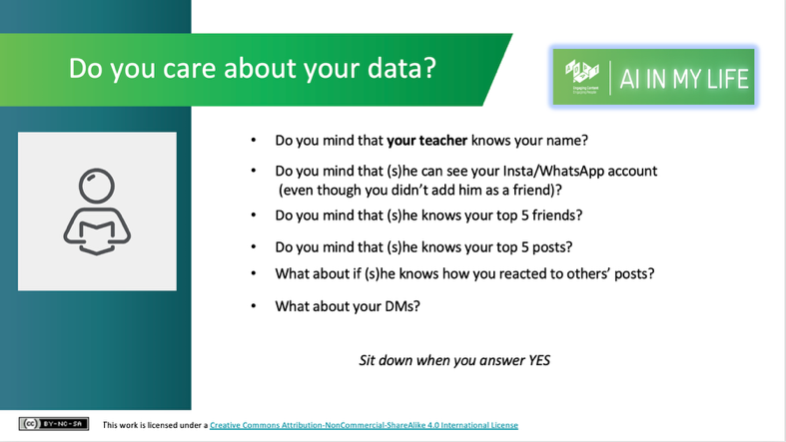 | Activity (~3 mins.)  Repeat the exercise, asking this time about a teacher in the school accessing their data. If there are differences in their attitudes in sharing between Mark Zuckerberg and their teacher, ask students to reflect on why this is the case. What does that say about their attitudes to data and privacy?
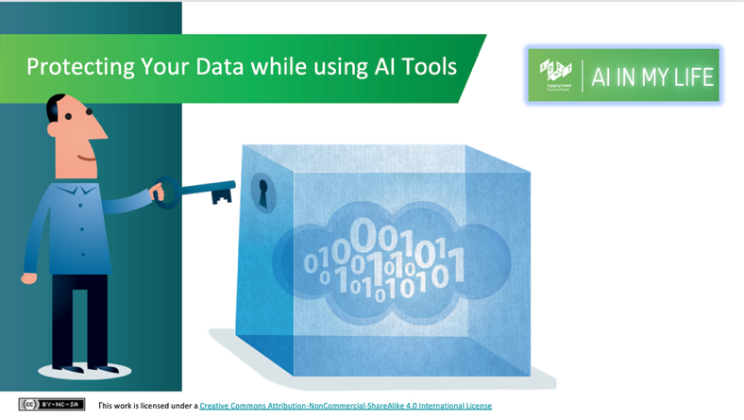 | Lecture (~1 min.)  Using digital apps and services, including those powered by AI, brings potentially significant implications for your privacy. As you would take steps to protect your privacy in the real world, you should do likewise when using digital apps.
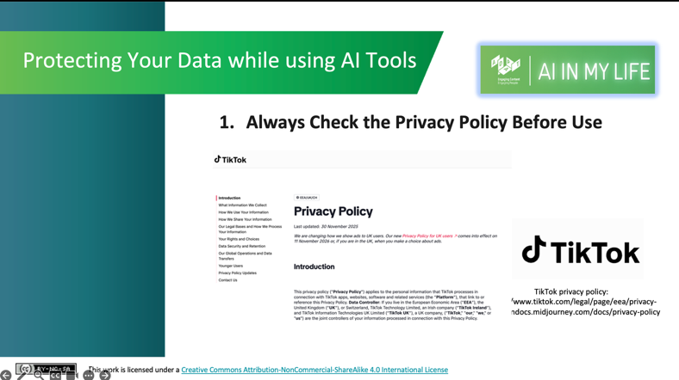 | Lecture (~1 min.)  The first tip is to always check the privacy policy of the service you’re about to use. Will it access and keep your location data, your camera or your microphone? Will it share your data with advertisers?  Checking the terms and conditions of apps before using them is a chore but worth the effort. You want to know what you're agreeing to.  Reading the privacy statement in full will help you understand what data is being collected from/about you and how it might be used. If that’s not realistic (Meta’s policy can take an hour to read in full!), make sure to scan or search for key terms like "sell," "share," "location," or "third party.
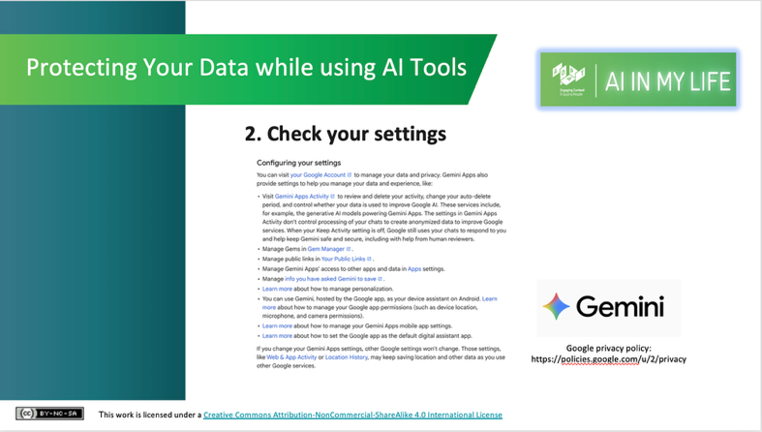 | Lecture (~1 min.)  Explore and use the privacy and security controls you get with your AI tools of choice. Most companies make these controls relatively visible and easy to operate.  When you go to use the Google Gemini chat-based AI tool, for example, you can configure (or adjust) your privacy settings in order to minimise the amount of data from you that Google will share, store and use. It is worth it to take a few minutes to check and change your settings. You can indicate that you don’t want the tool to use your data (i.e., your chats) to train/improve their model, and you can set your chats to autodelete after a certain time.
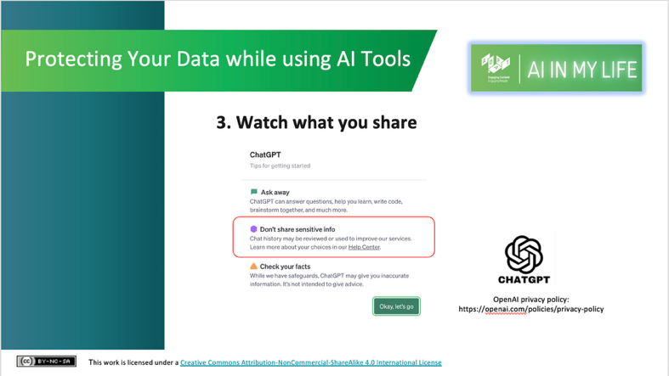 | Lecture (~1 min.)  Watch what you share with AI tools. Services like ChatGPT, for example, warn you not to share sensitive data (e.g., name, address, school name, passwords, date of birth) about yourself or others, as it may store and use such data to improve its service.  Essentially, anything you input into or produce with an AI tool is liable to be used to further refine the AI and then to be used as the developer sees fit, so don’t share anything that you wouldn’t be comfortable potentially showing up publicly somewhere!
AI, Bias and Ethics (~15 mins.)

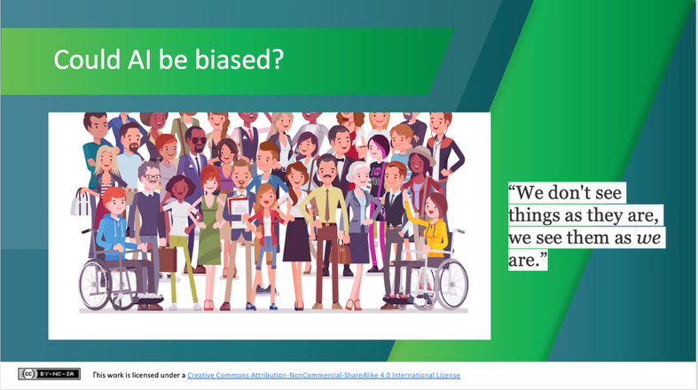 | Lecture (~3 mins.)  Just like the humans who built them, AI systems can be biased (or prejudiced) – favouring or prioritising the needs of certain people over others.  What kinds of bias can students name?  For example:  A criminal justice algorithm used in Florida, USA mislabelled African-American defendants as “high risk” at nearly twice the rate it mislabelled white defendants.  Amazon stopped using a hiring algorithm that favoured CVs received from male job applicants.  It’s important to highlight, however, that AI could also contribute to reducing bias. AI itself is indifferent to colour, gender, age, and other biases. The only reason we see bias in AI at all is because of assumptions and biased data that humans sometimes use to train it. Some AI-based tools have proved successful in reducing bias. For example, traditionally we’ve seen very low portions of investment in start-up (i.e., new) companies going to companies led by women. AI tools to automatically and objectively review company funding proposals (which remove all reference to the gender of applicants) have resulted in a much larger share of funding going to women.
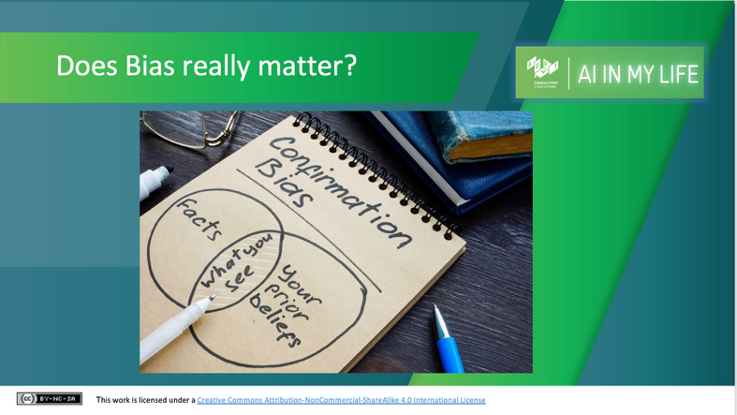 | Discussion (~4 mins.)  Do students think it matters that AI can reinforce bias? Why/why not? How might we overcome this issue? [Potential solutions include ensuring more diversity in the backgrounds of people who develop AI systems, and researchers and companies making a concerted effort to build more diverse data sets).
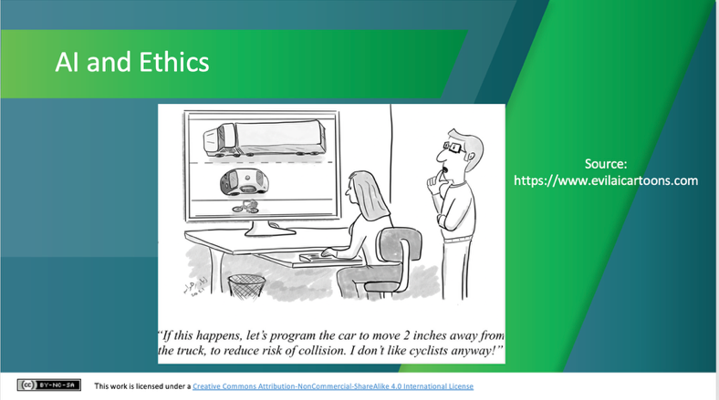 | Lecture (~1 min.)  There are many ethical concerns associated with AI development and use. These include its potential to exacerbate bias (which we’ve seen already), lack of transparency on how AI makes recommendations or decisions, and the potential of AI to replace some jobs.  The case of driverless cars highlights some of the ethical dilemmas faced by those developing AI systems.
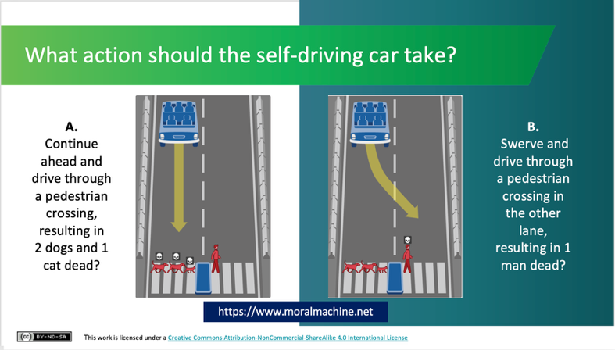 | Activity (~6 mins.)  Imagine yourself as an AI developer building a self-driving car. In the event of an impending unavoidable accident, how would you programme the car to decide what action it should take? Which of these two possible scenarios, in your mind, is the lesser of two evils?  Researchers in the USA have built a platform for gathering a human perspective on moral decisions made by machine intelligence, such as self-driving cars. They call the platform ”The Moral Machine”.  This is what ethicists refer to as an “edge case” or an extreme scenario, but it highlights the kind of ethical issues that AI can raise.  [Separate students into small groups and ask them to discuss and come to an agreement on which is their preferred course of action for the car. Ask them to report back to the whole class on their decision and the rationale for it. Then ask students how they found the activity: did they come to agreement quickly or were there different opinions in the group. Did they ever think about how AI systems like this must make ethical decisions?]  There are hundreds of these scenarios on the Moral Machine website. You can view and “judge” them yourself. You can also submit your own scenarios.
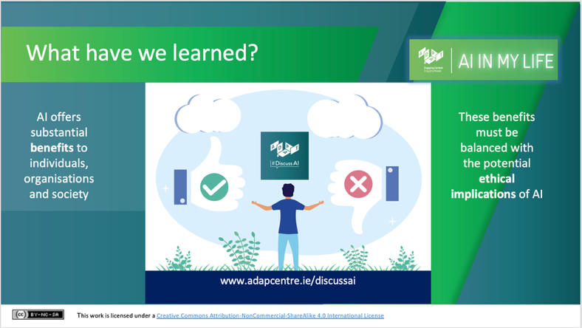 | Lecture (~1 min.)  The key message here is that AI offers substantial benefits to individuals and society – from more accurate cancer screening and fraud prevention, to automating repetitive tasks and maybe even safer car journeys. These benefits must be balanced with the potential ethical implications of AI, however, in order to ensure a safer and fairer ‘Age of AI’ for all.

Recap and Evaluation (~5 mins.)

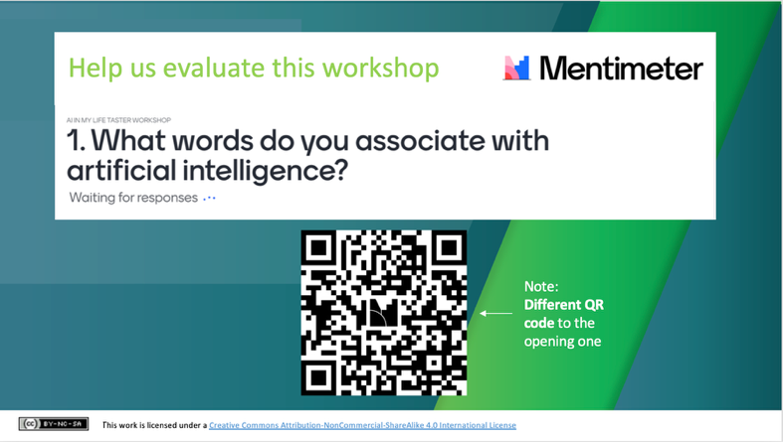 | Activity (~4 mins.)  We’re going to finish by repeating the Mentimeter survey – with a NEW QR code. This will take about 5 mins.  Tell students that the survey will ask them if (or how) their knowledge of or attitude to AI has changed by doing the module, and what they thought of it.  Again, their answers will be anonymous and will only be used to help the AI in My Life team to evaluate and improve this module.  Advised students to access and complete the survey on their phone or tablet by scanning the QR code.  Thank students for their answers – they’ll be valuable in helping us understand what they thought of the module!
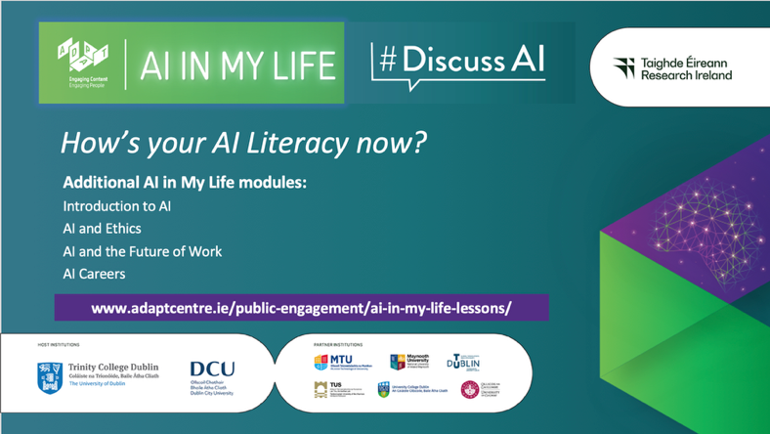 | Lecture (1 min.)  That’s it for the AI in My Life taster module!  Wrap up by highlighting to students that ‘AI literacy’ is the set of skills, knowledge, and critical thinking needed to understand, use, and evaluate artificial intelligence tools effectively and ethically.  It involves knowing how AI systems work, recognising where they are used, evaluating their output for accuracy or bias, and understanding their social and ethical impacts.  Nobody has perfect AI literacy, but today students have enhanced theirs.  (Tell students that they’ll learn more in subsequent modules, if you plan to do them – see the web link for resources)

Additional Free Resources
- ADAPT Centre / DCU – AI Literacy in the Classroom, supported by Google Course
A 90-minute self-led online course designed by ADAPT, DCU, and Irish post-primary teachers. It equips post-primary educators with foundational AI concepts, AI ethics, and practical strategies to guide students in using AI safely and critically. www.adaptcentre.ie/ai-literacy-in-the-classroom
- ADAPT Centre / DCU and Wove – Who Do They Think You Are? Quiz
A short online game and follow-on resource pack that highlights the hidden role of data brokers, i.e., companies that aggregate personal information from public records, web tracking, and commercial transactions to build and sell detailed consumer profiles to third parties. https://hidden-selves.wove.co/

- ADAPT Centre / DCU – Art or AI? Guide to Spotting Fake Images
A short guide that provides a visual checklist of physical, contextual, and digital clues to help users detect AI-generated images. Access via the Google Drive folder at www.adaptcentre.ie/courses/ai-in-my-life-taster-lesson/
- Oide Technology in Education – AI Hub
Provides official Department of Education guidance, the RASE Prompting Framework, and short online courses to help teachers understand generative AI, policy considerations, and ethical use in classroom settings. https://www.oidetechnologyineducation.ie/ai-hub/

- Webwise – School & Parent Resources on AI
Offers dedicated post-primary lessons on Generative AI, online safety, digital citizenship, and data privacy. Its A Parents' Guide to Generative AI (developed with ADAPT and the National Parents Council) provides useful discussion prompts on digital footprints and algorithmic influence. https://www.webwise.ie/teachers/resources/

Reusing & Sharing These Workshop Resources
We want to ensure our resources are used as widely as possible and that they suit your needs. These materials are open to use under a CC BY-NC-SA 4.0 licence:
- Use, Adapt & Share: Free to copy, edit, present, and distribute for educational use.
- Attribution (BY): Give credit to the original author when sharing or adapting (e.g., "Adapted from AI in My Life ‘Introduction to AI’ Module by ADAPT/Dublin City University (CC BY-NC-SA 4.0)”).
- NonCommercial (NC): Not for sale or commercial gain.
- ShareAlike (SA): If you tweak, remix, or build upon these resources, you must share your modified version under the same CC BY-NC-SA 4.0 licence.

