AI and Ethics
Teacher Guide
Version 2.1 | Last Updated: 31st August 2026
This guide accompanies the ‘AI and Ethics presentation slide deck of the AI in My Life workshop series, which is available at https://www.adaptcentre.ie/courses/ai-and-ethics/
The programme was developed by the Education and Public Engagement team and subject experts at the Research Ireland ADAPT Centre at Dublin City University.
Through interactive activities and real-world scenarios, this lesson explores how AI affects citizens and society, and what kind of ethical and privacy issues we might consider when developing or using such technologies. Understanding the ethical implications of AI elevates AI literacy from basic technical fluency to critical engagement.
Learning Intentions
By the end of this workshop, students will be able to:
- Define AI and give everyday examples of its use
- Outline key ethical and privacy implications of AI systems
- Evaluate the role AI plays in their lives and in society

Overview & Setup
- Target Audience: Primary audience is Transition Year (TY) students, but content is suited all Second Level students with a little tweaking.
- Module Duration: 60 Minutes (with guidance for shortened 40-minute class periods).
- Curriculum & Competency Alignment: Includes Media & Information Literacy, Being Personally Effective, Ethical Education, and Digital Citizenship (see details on Pages 2-3).
- Materials Needed: Laptop with Google Slides or PowerPoint with audio, screen, WiFi access, student devices (for interactive quizzes). If devices are limited, activities can be done in pairs / small groups.
- Prerequisites: While there are no prerequisites for this workshop and students do not need any previous knowledge of AI, the AI in My Life ‘Introduction to AI’ module sets students up for more informed conversations.
- Key Vocabulary: Artificial Intelligence, Training Data, Pattern Recognition, Bias, Hallucination, Human-in-the-Loop.

Curriculum Links
This module aligns with the overarching mission of Transition Year in Ireland: to promote personal, social, educational, and vocational development, preparing students to become autonomous, participative, and responsible members of society.
1. Senior Cycle Key Skills Alignment (NCCA)
- Being Literate: Students critically analyse AI issues, media reports and ethical debates. (Slides 5, 9, 15, 17, 23, 25)
- Managing Information and Thinking: Students evaluate evidence, explore ethical dilemmas, and make informed judgements about AI. (Slides 8-10, 16, 18-20, 23)
- Communicating: Pair-share activities, debates and class discussions develop students' ability to express and justify viewpoints. (Slides 6, 12, 16, 18, 20)
- Working with Others: Collaborative tasks require teamwork, discussion and consensus-building. (Slides 6, 12, 16, 18)
- Being Creative: Students design ethical rules, propose solutions and consider alternative perspectives on AI challenges. (Slides 12, 16, 19, 23)
- Being an Active Citizen: Students examine issues of fairness, privacy, regulation and societal responsibility in AI. (Slides 9, 14, 18, 21-24)
- Managing Myself/Being Personally Effective: Students reflect on responsible AI use, personal choices and their role as informed digital citizens. (Slides 16, 23-25)
- Staying Well: Students consider the impact of AI on wellbeing, privacy, employment and society. (Slides 10-11, 21-22)

2. Core Leaving Certificate Subject Alignment
- English: Analysing media, evaluating arguments, and participating in discussion and debate. (Slides 5, 9, 16, 23).
- Politics and Society: Exploring ethics, rights, regulation, citizenship, and the societal impact of technology. (Slides 8-14, 18, 23).
- Computer Science: Understanding AI systems, their applications, limitations, and responsible development. (Slides 3-4, 8, 13-14).
- Business: Examining AI's impact on work, decision-making, innovation, and the economy. (Slides 21, 23).
- Geography: Investigating the environmental impacts of AI, including energy, water use, and resource extraction. (Slide 22).
- SPHE: Reflecting on ethical decision-making, personal responsibility, wellbeing, and digital citizenship. (Slides 16, 23-25).

3. Cross-Curricular Themes
- Digital Citizenship: Students explore responsible, ethical and informed use of AI technologies. (Slides 8-14, 16, 23-25).
- Sustainability: Students examine the environmental impact of AI, including energy use, water consumption and resource extraction. (Slides 14, 22).
- Global Citizenship: Students consider how AI affects societies worldwide through issues such as fairness, privacy, regulation and social responsibility. (Slides 9-23)
- Media and Information Literacy: Students critically evaluate media reports, case studies and evidence relating to AI and its societal impacts. (Slides 5, 9, 15, 17).
- Ethical Education: Students engage with moral dilemmas, ethical frameworks and decision-making in real-world AI contexts. (Slides 6-14, 16, 19, 23-24).
- Future of Work and Enterprise: Students explore the impact of AI on employment, skills and the changing world of work. (Slide 21).

Suggested Lesson Timing Matrix
60 MINUTES (Recommended)
Complete the full workshop, allowing time for discussion and activities.
40 MINUTES (Possible)
Follow the same sequence, but skip slides marked OMIT and shorten overall discussion time.
Activity / Topic | 40-Min Workshop | 60-Min Workshop | Slide No.
Intro. & learning intentions | 3 mins | 3 mins | 1-3
What is AI? (recap) | 2 mins | 2 mins | 4
Ethics and AI video | 3 mins | 4 mins | 5
What do we mean by ethics? | 4 mins | 10 mins | 6-7
AI ethics: fairness, transparency, privacy and safety | 4 mins | 3 mins | 8
Why does ethics matter for AI? | 3 mins | 6 mins | 9-11
Create your own AI rules | 4 mins | 8 mins | 12
Trustworthy AI principles | 3 mins | 4 mins | 13-14
Scenarios | 8 mins (one of B or C) | 12 mins (select one)
Scenario A: GenAI and school projects | OMIT | (12 mins) | 15-16
Scenario B: Social Credit System | (8 mins) | (12 mins) | 17-18
Optional Scenario C: Self-driving cars | (8 mins) | (12 mins) | 19-20
AI, jobs and the environment | 3 mins | 5 mins | 21-22
Reflection and key takeaways | 3 mins | 3 mins | 23-25
Total | 40 mins | 60 mins

Teacher Notes & Scripting
Important Note for Teachers: Detailed suggested presenter scripts are built directly into the Presenter Notes section of the slide deck for your convenience.
- If you want a ready-to-read script: Feel free to use or adapt the built-in slide notes directly during your delivery. Best for teachers with limited existing knowledge of AI.
- If you prefer a conversational approach: Use the key concepts and talking points outlined in this guide to lead the discussion naturally in your own voice.
Tip: To view the built-in scripts while presenting, use Presenter View
in PowerPoint or Google Slides.

Slide Deck Walkthrough (timing based on 60-min. lesson – adjust for 40-min. class as necessary)
Introduction & Learning Intentions (~3 mins.)
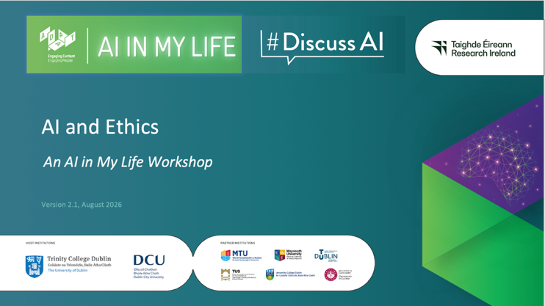 | Lecture (~1 min) (Slide 1)  Welcome students and tell them we’ll be addressing one of the most critical topics of our time: AI ethics.  We’ll explore how artificial intelligence impacts our daily lives, where human values fit into AI system design, and the key principles guiding safe technology.
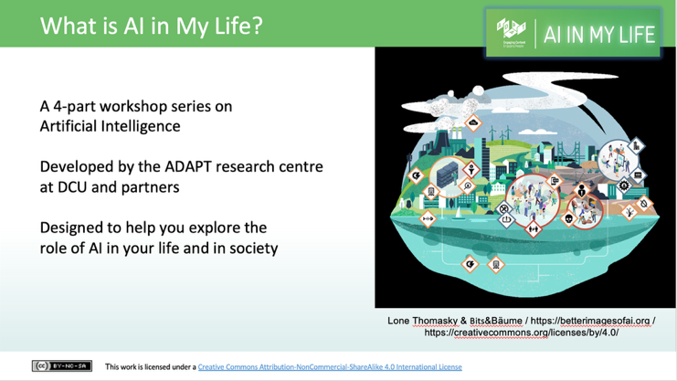 | Lecture (~1 min) (Slide 2)  Tell students that AI in My Life is a modular workshop series on Artificial Intelligence (AI). It was developed by the Research Ireland ADAPT Centre. ADAPT is a major academia-industry research centre with more than 300 researchers from 8 Irish universities (led by Trinity College Dublin and co-hosted by Dublin City University) producing research and innovations in many aspects of AI. AI in My Life is a 4-part series designed to help young people explore the role of AI in their lives.
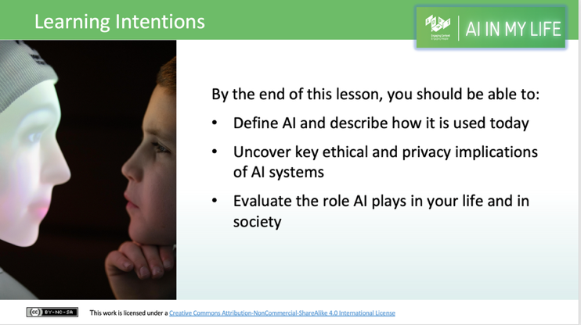 | Lecture (~1 min)(Slide 3)  Outline to students what they’ll be able to do by the end of this module:  - Define AI and give examples of how AI is used  - State some of the ethical and privacy implications of AI  - Evaluate the role of AI in their lives and in society
What is AI? (~2 mins)
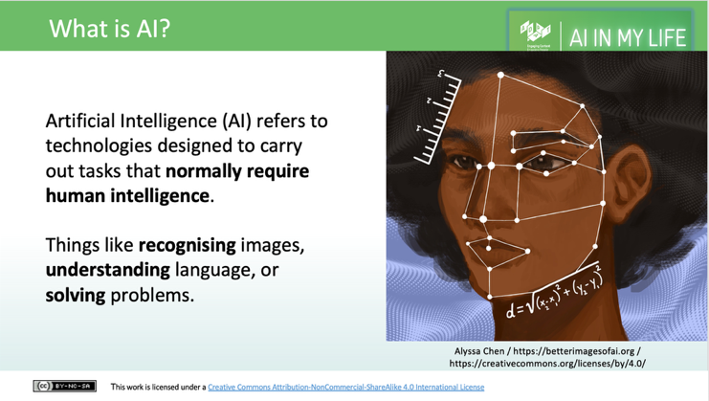 | Lecture (~2 mins) (Slide 4)  Go through the following definition, checking that students understand:  Artificial intelligence refers to many different technologies that are designed to accomplish tasks that can otherwise be only carried out by human minds, for example identifying patterns, recognising images, understanding languages or solving problems. This will be a recap for students who have completed the Introduction to AI module or the taster module.

AI and Ethics (~23 mins.)
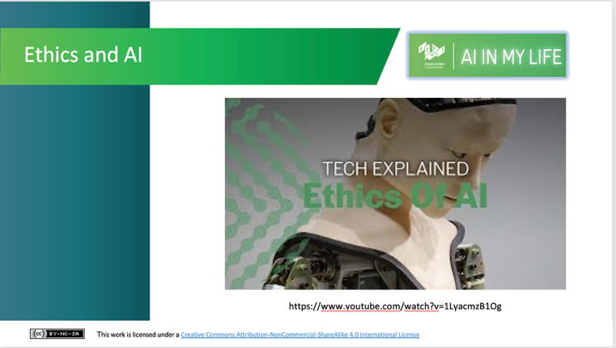 | Activity (~4 mins) (Slide 5)  Watch this short video (which lasts 2 minutes 51 seconds) which outlines some key aspects of the AI and Ethics debate.  Ask students to note what are the 3 key ethical questions this video throws up?  (Answer: What is AI used for?, who has access to AI?, and AI doesn’t share our values (thereby potentially amplifying bias))
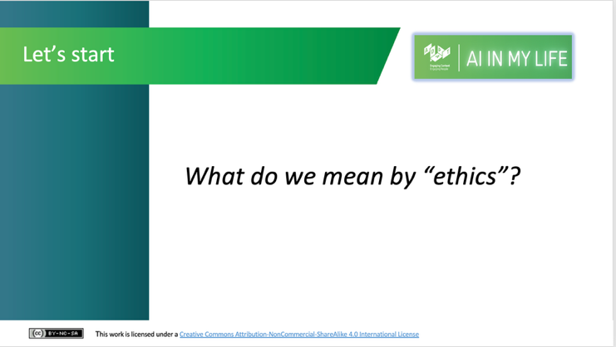 | Activity (Think, Pair & Share) (~7mins)(Slide 6)  Students individually identify three words they associate with ethics, discuss their ideas with a partner, and then contribute to a whole-class discussion to develop a shared definition of ethics.
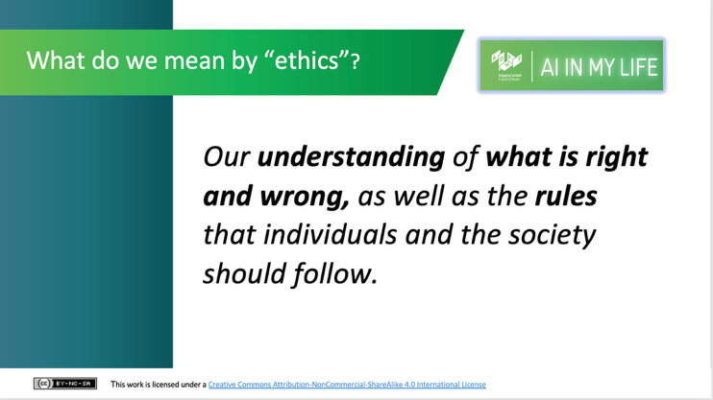 | Lecture (~3 mins)(Slide 7)  Provide a definition for what we mean by ethics: “Our understanding of what is right and wrong, as well as the rules that individuals and the society should follow.”  How does this compare with the class’s definition?  If asked about the difference between morals and ethics, you can say that ethics is more about the rules and codes and the discussion about what is right and wrong, whereas morality is about an individual’s/group’s sense of what is right and wrong. Morality is what we have internally, whereas ethics is the branch of knowledge (or discussion) that studies this. However, these terms are also often used interchangeably.
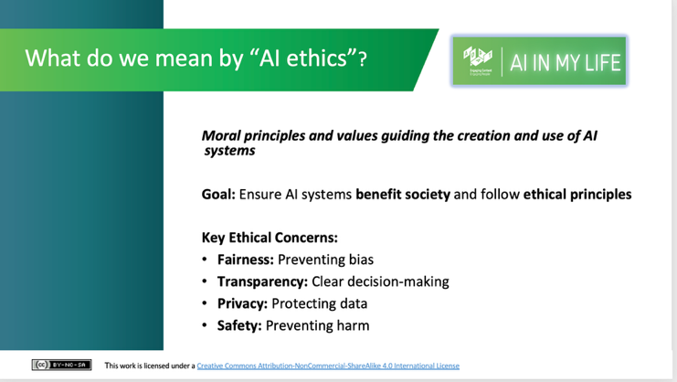 | Lecture (~3 mins) (Slide 8)  Proceed by explaining what we mean by “AI ethics”:  - AI ethics refers to the moral principles and values that should guide the development and use of artificial intelligence systems.  - AI systems should be designed and used in a way that benefits society and follows ethical principles.  - Issues like fairness, transparency, privacy and safety are important ethical considerations.
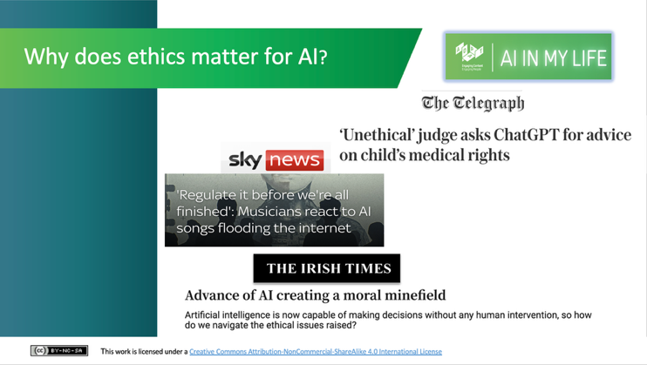 | Lecture (~2 mins) (Slide 9)  Why does ethics matter?  Show examples of media excerpts which indicate how this debate has been increasingly present in public awareness. They are examples of headlines from:  - The Telegraph article about ChatGPT use by a judge  - The Irish Times article about AI’s decision making capability  - Sky News article about musicians feeling threatened by AI-generated music  What other AI controversies or ethical debates have students seen online or in the news?  (Thinks like deepfakes and voice cloning scams, facial recognition and privacy, AI-generated homework and cheating, environmental impacts of running massive AI data centres)
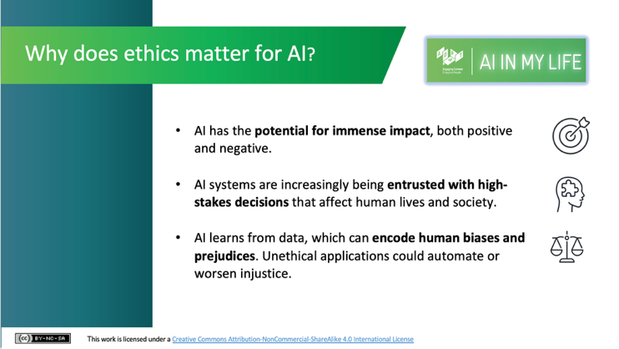 | Lecture (~2 mins) (Slide 10)  - Explain that AI has the potential for both positive and negative impact.  - However, as AI systems improve, it appears that they are being entrusted with more decision-making capabilities that affect humans and society.  - Ultimately, AI learns from the data on which it is trained. The origin of this training data is therefore very important, as it may lead systems to make judgements that are biased or prejudiced.
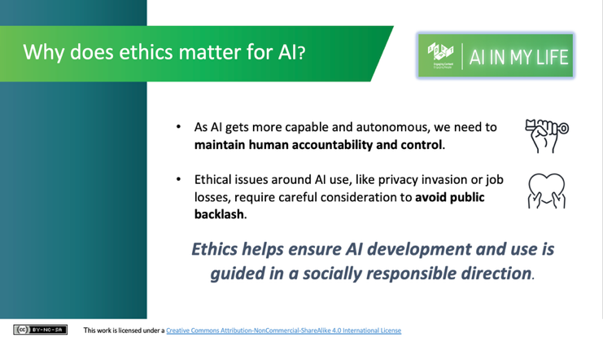 | Lecture (~2 mins) (Slide 11)  - As AI capability becomes more powerful, we need to make sure that there is human accountability and control.  - Ethical issues around AI use require careful consideration and discussion. Ethical consideration needs to be central to AI development in order to ensure it is guided in a socially responsible direction.  - Ethics is not just about technical solutions; it’s also about the values that we want reflected in the AI systems/tools we create e.g., corporate profit v social solidarity - we must actively decide what we want to achieve as a final outcome.
Responsible AI Development (~12 mins.)
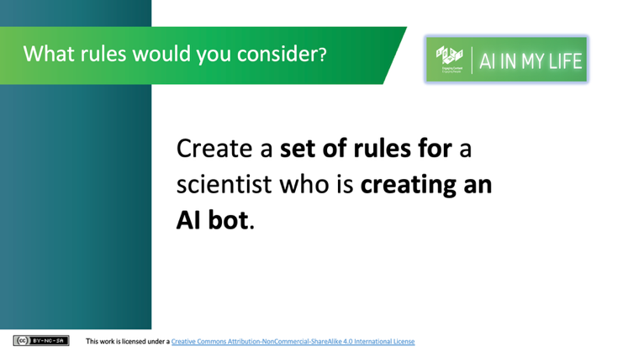 | Activity (Pair & Share) (~8 mins) (Slide 12)  We will now look at what developers may have to consider when developing AI systems e.g. not to cause harm, listening to humans as the final decision maker, etc.  If you were governing AI development, what kind of rules would you give a scientist who is creating an AI bot?  Prompting Questions:  Should the bot always have to obey a human, or can it make final decisions?  What rules prevent it from causing harm, leaking private data, or acting unfairly?  Pairs should identify and share their 2 top rules.  Make a note of 6-8 responses, ideally on a board that you can refer back to.
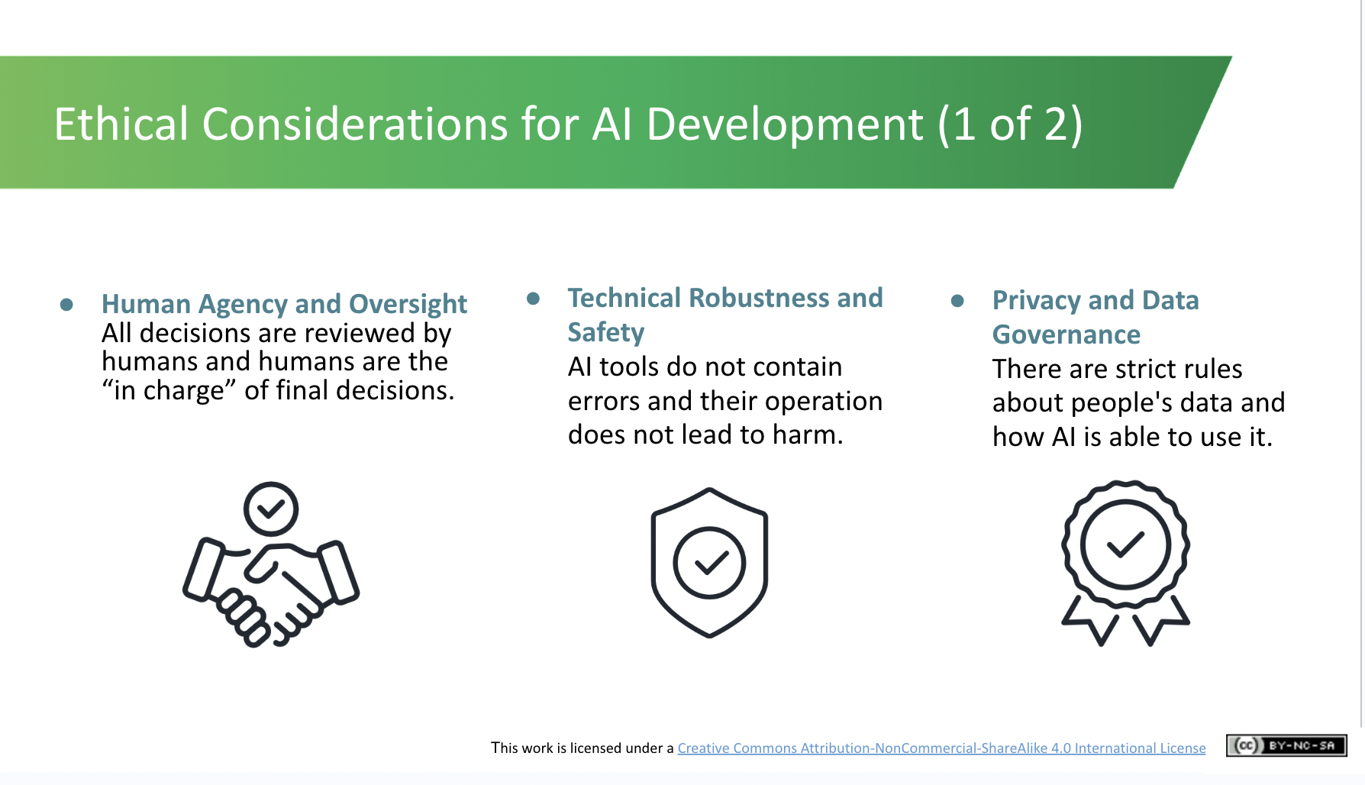 | Lecture (~2 mins) (Slide 13)  We will now look at the seven ethical considerations which should be taken into account during the development of AI systems. These are the EU’s 7 guidelines for Trustworthy AI. It is not the only possible list, but these guidelines are now law under the EU AI Act.  The first three are:  - Human Agency and Oversight - making sure all decisions are made by humans and humans are in charge of the final decision  - Technical Robustness and Safety - making sure that AI systems/tools do not have any errors (bugs) and that their operation would not lead to harm  - Privacy and Data Governance - the rules associated with how people’s data is used
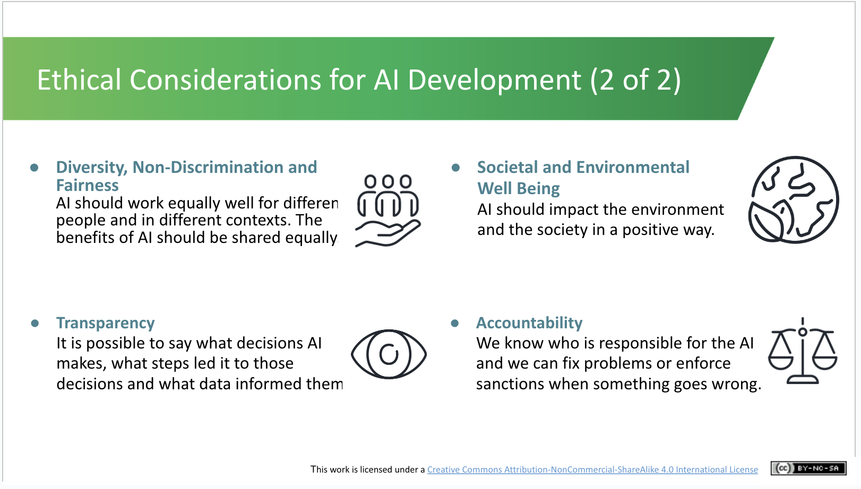 | Lecture (~2 mins) (Slide 14)  The final four ethical considerations for AI development are:  - Diversity, Non-Discrimination and Fairness - making sure that AI works equally for different people in different2contexts and there should be no bias related to gender, ethnicity etc.  - Transparency - it should be possible to see what AI decisions are made, the steps along this decision making process and the data that informed them  - Societal and Environmental Well Being - AI should positively impact the environment and society  - Accountability - it should be obvious as to who is responsible for the AI so that problems can be fixed or sanctions can be imposed.

SCENARIOS: Ethical Use of AI (~12 mins)
**For the Scenarios that follow, you should select the ONE that you think will resonate most with your class – or outline them briefly and invite the class to select one. If your class has already completed the AI in My Life taster module, you’ll already have covered the Moral Machine scenario, albeit with a slightly different example.
If you have a 40-min. class, we recommend taking Scenario B or C, as Scenario A requires the full 12 mins.
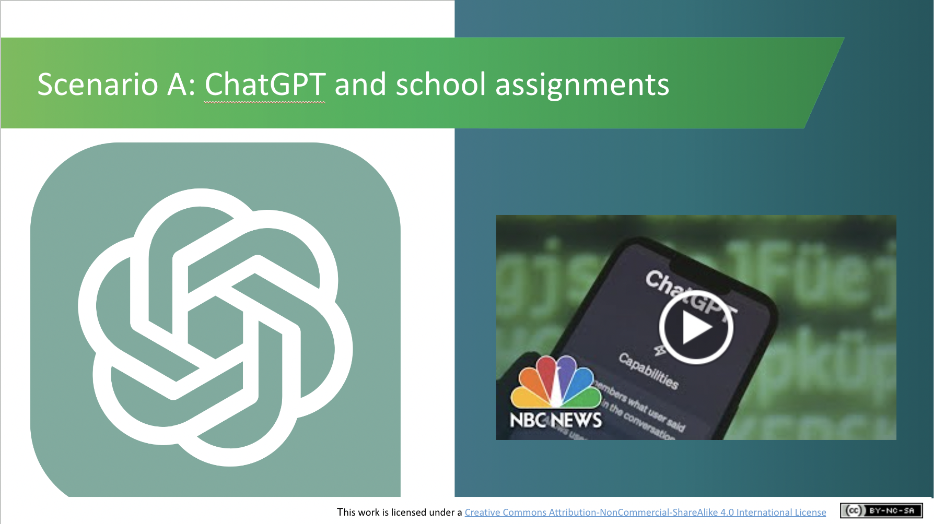 | Scenario A  Activity (~3 mins) (Slide 15)  This video (length 2 minutes and 4 seconds) explores whether it’s ethical to use generative AI systems like ChatGPT for school assignments.  If you have difficulty accessing the video, play the first 2 mins. of the full-length version on YouTube: https://www.youtube.com/watch?v=Fn8jDanbf0c
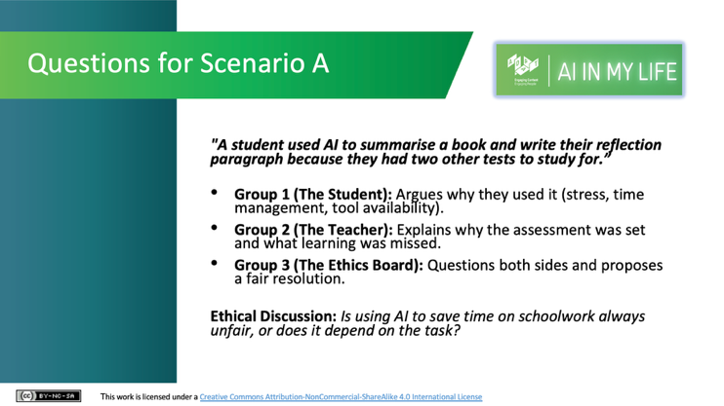 | Scenario A  Scenario Discussion (~9 mins) (Slide 16)  A student, Alex, was stressed as he ran out of time, and used ChatGPT for his assignment – summarising a book and writing his reflection paragraph.  Split students into 3 groups and debate the case (3 mins in-group prep, 5 mins debate). If you’ve too many students for each group, double up – 2 each of Group 1, Group 2, and Group 3 below.  Group 1 (Alex): Argue why using AI under pressure was understandable and not malicious.  Group 2 (The Teacher): Argue why it was dishonest and what learning was missed.  Group 3 (The Ethics Board): Listen, ask 1 question to each side, and decide a fair consequence and rule.  Take 2 mins then to discuss the key question: “Is using AI to save time on schoolwork always unfair, or does it depend on the task?”
OR
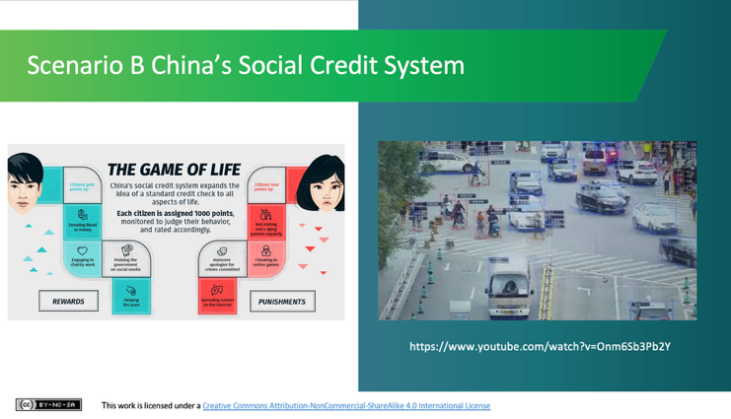 | Scenario B: Social Credit System  Activity (~3 mins) (Slide 17)  Next play the video about the Social Credit System in China (Length: 2 minutes and 36 seconds).  This ‘Game of Life’ concept means that members of society could earn points for performing certain altruistic tasks such as donating blood or helping the poor but simultaneously could lose points when caught engaging in morally offensive activities such as cheating on video games or not visiting elderly family members.
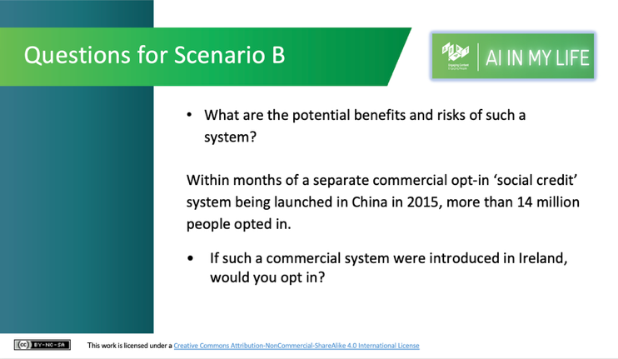 | Scenario B: Social Credit System  Discussion (~9 mins) (Slide 18)  China’s State-run Social Credit System exists as a patchwork of regional trials run by local city governments. Participation is mandatory. Citizens don’t opt in, consent to data collection, or have a way to opt out.  After watching the video, divide the class in two: one side identifies potential benefits of a social credit system, while the other identifies potential risks. Students discuss in pairs or small groups for 3 minutes and report back.  Suggested points:  - Benefits: Public safety, accountability, rewards for positive behaviour.  - Risks: Surveillance, loss of privacy, restricted freedoms, social stigma, errors leading to unfair penalties.  Conclude by asking whether Ireland's ban on AI-powered social scoring under the EU AI Act is a positive development. Use the discussion to explore how different cultures may view the trade-off between privacy, societal benefits, and the use of AI.

OR
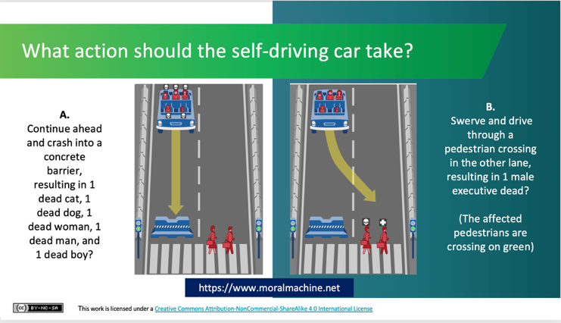 | Scenario C: The Moral Machine  Discussion (~9 mins) (Slide 19)  (Note: This is a different scenario to the one in the AI in My Life taster module. However, if you’ve completed that module, we recommend you skip this activity and spend more time on the other scenarios).  This activity challenges students to imagine themselves as an AI developer of a self-driving car. In the event of an impending unavoidable accident, how would they programme the car to decide what action it should take? Which of these two possible scenarios, in their minds, is the lesser of two evils?  Researchers in the USA have built a platform for gathering a human perspective on moral decisions made by machine intelligence, such as self-driving cars. They call the platform ”The Moral Machine”. Explain to students that this is an “edge case” or extreme scenario as, in reality, there are lots of other actions, such as braking, that a car could take and there is more to making ethical decisions than choosing who gets harmed.  Separate students into small groups and ask them to discuss and come to an agreement on which is their “least undesirable” course of action for the car. Ask them to report back to the whole class on their decision and the rationale for it. Then ask students how they found the activity, did they come to agreement quickly or were there different opinions in the group. Did they ever think about the kind of ethical decisions that AI developers face?  There are hundreds of these scenarios on the Moral Machine website. You can view and “judge” them yourself. You can also submit your own scenarios.
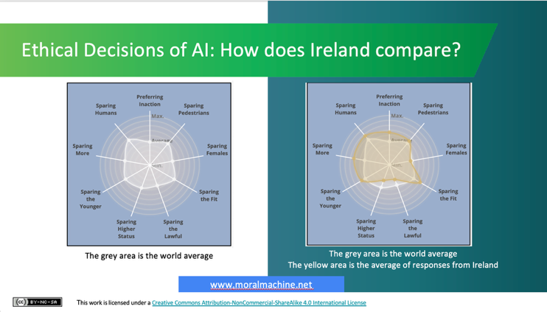 | Lecture (~3 mins) (Slide 20)  In the previous discussions about the cultural aspects to ethics, you would have touched on how different cultures can treat different cohorts of society as more or less important. The class may be interested in seeing how Irish preferences compare to people across the world.  The Moral Machine shows results from people judging scenarios on its website.  1st image: We can see the world average here. The further to the outside of the circle a dot is, the more people preferred that course of action.  2nd image: How does Ireland compare? The yellow area shows that people in Ireland generally show a greater preference for sparing humans, preferring inaction, and sparing the fit, and they are less inclined to spare those with higher social status and those obeying the law. What do you think this tells us about people in Ireland?
AI, Jobs and the Environment (~5 mins)
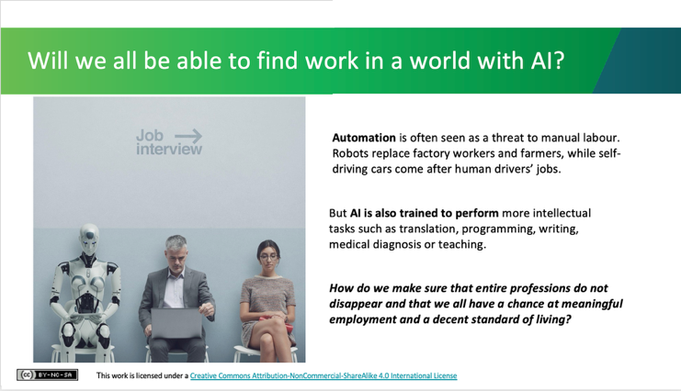 | Lecture (~2 mins) (Slide 21)  - Automation has been seen as a threat to manual labour in the past. Could robots replace factory workers and farmers, or self-driving cars come after human drivers’ jobs?  - AI can also be trained to do more intellectual tasks such as translation, programming, writing, medical diagnosis or teaching.  - The ethics of AI also involves the discussion of wider impacts of the technology. How do we distribute the benefits created by automation fairly? How to ensure that entire communities are not left behind? AI has the potential to transform the world’s economy and we have an ethical obligation to make this transformation fair.
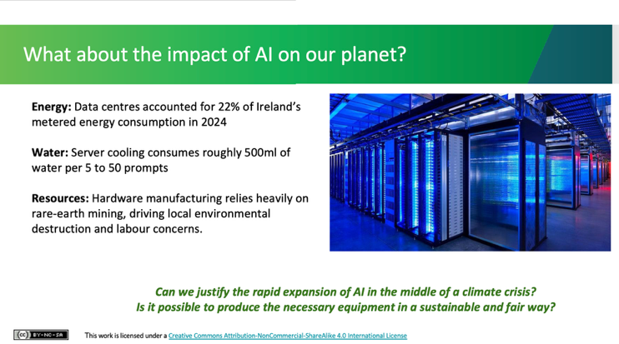 | Lecture (~3 mins) (Slide 22)  - AI is not magic. Each operation made by AI consumes energy and resources, which has a large impact on the environment and we should be mindful of this as we find ourselves in the middle of a climate crisis. Data used by AI is stored and processed in enormous data centres comprising millions of servers and computers.  - Data centres accounted for 22% of Irish energy consumption, it is worth stressing that these are all data centres and not only AI.  - As the servers require cooling, it is estimated that ChatGPT uses half a litre of water for every 5 to 50 prompts it answers! While ChatGPT is being lauded as a revolutionary tool, there has been little discussion about the computing power required to train such a system i.e. the training of GPT-3 was estimated to generate 85,000 kg of CO2, or the equivalent of driving a new car to the Moon and back: https://www.theregister.com/2020/11/04/gpt3_carbon_footprint_estimate  - Moreover, the material costs of AI should not be underestimated, especially as many of the resources are imported from developing countries and are not sourced in an ethical or sustainable way  - Can we justify such energy use today? Will the benefits outweigh the drain on resources?

Reflection and Key Takeaways (3 mins)
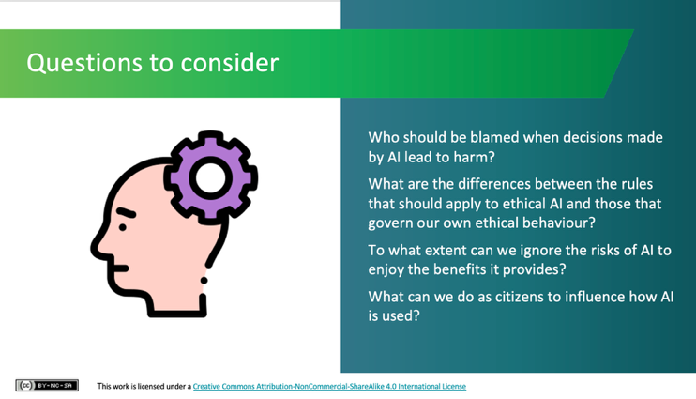 | Lecture (~1 min) (Slide 23)  Show the slide with the following questions:  - Who should be blamed when decisions made by AI lead to harm?  - What are the differences between the rules that should apply to ethical AI and those that govern our own ethical behaviour?  - To what extent can we ignore the risks of AI to enjoy the benefits it provides?  - What can we do as citizens to influence how AI is used?  We don't have to provide answers but rather can leave students with these questions to consider. The intention is to encourage students to ponder some of the many ethical considerations of AI.
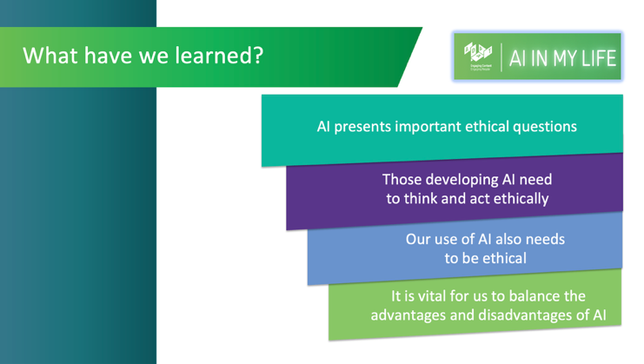 | Lecture (~1 min) (Slide 24)  What have we learned?  We revisit the three learning outcomes outlined at the start of the session:  - We know what AI is and how its use can present ethical questions  - We have uncovered some of the ethical and privacy implications of AI - those developing AI AND those using AI need to act ethically  - We have looked at the role of AI in our lives and in society and understand the importance of striking the right balance as there are negative and positive impacts
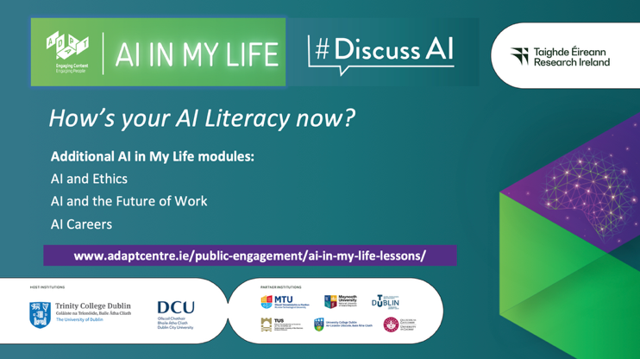 | Lecture (~1 min) (Slide 25)  Final slide which explains that a key element of being AI literate is knowing how AI systems work, where their limits lie, and critically, recognising the ethical choices built into them. Hopefully students feel better informed and more confident in what it means to use AI ethically and responsibly.  (Tell students that they’ll learn more in subsequent modules, if you plan to do them – see the web link for resources).

Additional Resources
- ADAPT Centre / DCU – AI Literacy in the Classroom Course
A 90-minute self-led online course designed by ADAPT, DCU, and Irish post-primary teachers (supported by Google). It equips post-primary educators with foundational AI concepts, AI ethics, and practical strategies to guide students in using AI safely and critically. www.adaptcentre.ie/ai-literacy-in-the-classroom
- Oide Technology in Education (AI Hub)
Provides official Department of Education guidance, the RASE Prompting Framework, and short online courses to help teachers understand generative AI, policy considerations, and ethical use in classroom settings. www.oidetechnologyineducation.ie/ai-hub/
- Webwise Post-Primary Resources
Provides dedicated post-primary lesson plans and resources addressing safe, ethical, and responsible Generative AI use, alongside A Parents' Guide to Generative AI (developed with ADAPT and NPC) to support home-school alignment on AI literacy. www.webwise.ie/teachers/resources/#post-primary
Reusing & Sharing These Workshop Resources
We want to ensure our resources are used as widely as possible and that they suit your needs. These materials are open to use under a CC BY-NC-SA 4.0 license:
- Use, Adapt & Share: Free to copy, edit, present, and distribute for educational use.
- Attribution (BY): Give credit to the original author when sharing or adapting (e.g., "Adapted from AI in My Life ‘Introduction to AI’ Module by ADAPT Centre, Dublin City University (CC BY-NC-SA 4.0)”).
- NonCommercial (NC): Not for sale or commercial gain.
- ShareAlike (SA): If you tweak, remix, or build upon these resources, you must share your modified version under the same CC BY-NC-SA 4.0 license.

