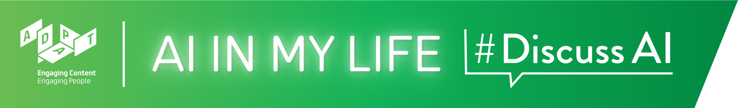

Introduction to AI Teacher Guide

Introduction to AI
AI is playing an ever-greater role in society. This Introduction to AI lesson gives students an understanding of AI and some of its characteristics.

Time: ~1 hour*

*If your classes are 40 mins. long rather than 1 hour, we recommend that you select the topics you feel are most important and/or shorten some of the interactive activities.

Background
There are no prerequisites for this module as it provides a very basic introduction to what AI is and what it can be used for.

Curriculum Links
The interactive and reflective nature of AI in My Life ensures that students will hone the five key skills central to teaching and learning across the Transition Year curriculum:
- Information processing
- Critical and creative thinking
- Communicating
- Working with others
- Being personally effective

An outline of links to the Leaving Certificate curriculum is provided after the module walkthrough.

Materials Needed: PowerPoint presentation, Laptop, Screen, Internet Access, Timer

Module Overview

Introduction (~3 mins.)
A quick introduction to the overall course - AI in My Life - followed by an overview of this specific module, outlining learning goals for this session over the next 60 mins.

What is AI? (~19 mins.)
Starts with a definition and video of AI. The class is then asked to list AI they use in their daily lives and complete a quiz on what they know about AI. Please note that the quiz link will require students to use their phones; otherwise it could be done as a group exercise.

AI in Use (~10 mins.)
Short videos about how researchers are using AI in their work. Discuss the pros and cons of using AI.

Human v AI Capability (~26 mins)
Explores what intelligence means using The Intelligent Piece of Paper activity. Computing is about making intelligent machines but how do we do this? Explore the concept of an algorithm as a set of instructions. Outlines recent advances in Generative AI – more commonly referred to as tools such as ChatGPT. Challenges students to complete the Art v AI quiz to see if they can tell the difference between Art produced by humans v Art produced by AI.

Recap (~2 mins.)
A brief recap on what students have learned in this module and an opportunity to ask questions about topics they would like to explore more.

Introduction to AI
Module Walkthrough
Learning Intentions
By the end of this workshop, students will be able to:
- Understand what AI is
- Explain what we mean by “intelligent”
- Be able to cite examples of the uses of AI

Introduction (~3 mins.)

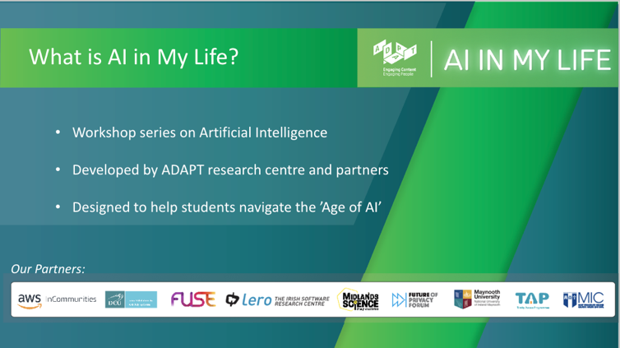 | Lecture  Tell students that Introduction to AI is the first session in a modular workshop series on Artificial Intelligence (AI). It was developed by the Science Foundation Ireland ADAPT Research Centre.  ADAPT is a major academia-industry research centre with more than 300 researchers from 8 Irish universities (led by Trinity College Dublin and co-hosted by Dublin City University) producing research and innovations in many aspects of AI.
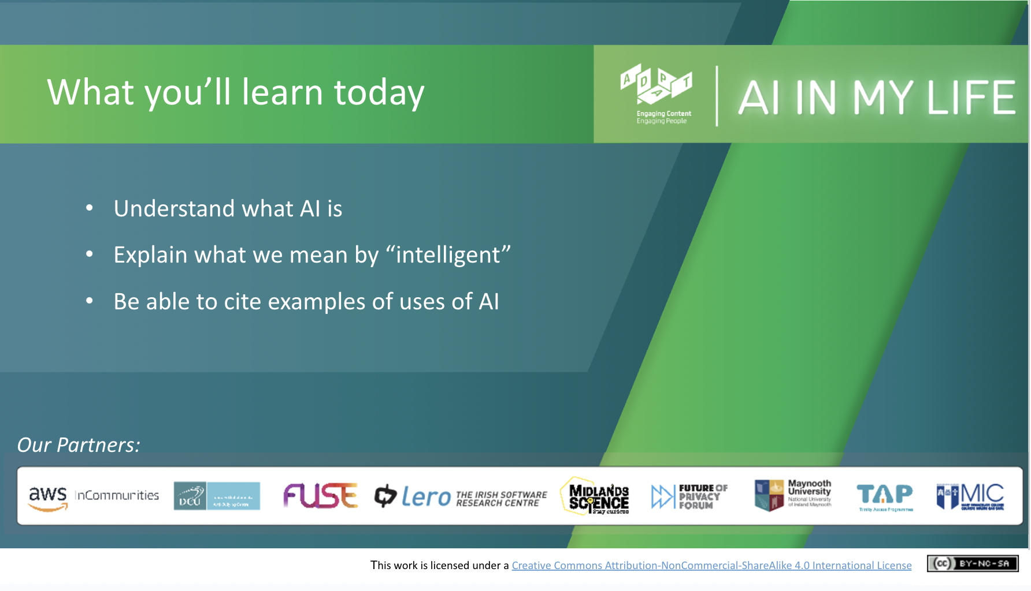 | Lecture  Outline to students what they’ll be able to do by the end of this module:  - Understand what AI is  - Explain what we mean by “intelligent”  - Cite examples of uses of AI
What is AI? (~19 mins)
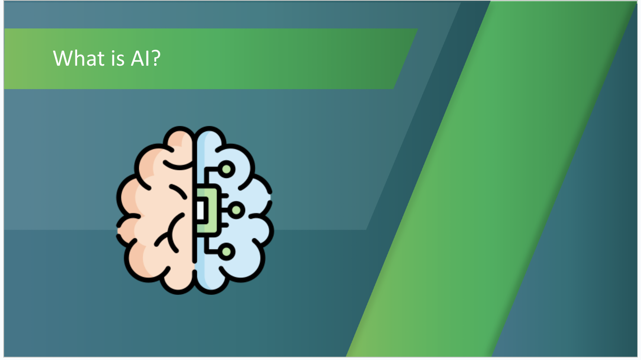 | Activity (5 mins)  What does AI stand for?  Using an interactive participation tool such as Sli.do, Mentimeter or Kahoot, ask students to indicate what they think AI is and show a word cloud with their responses.  Alternatively, you can simply ask the class to shout their answers.
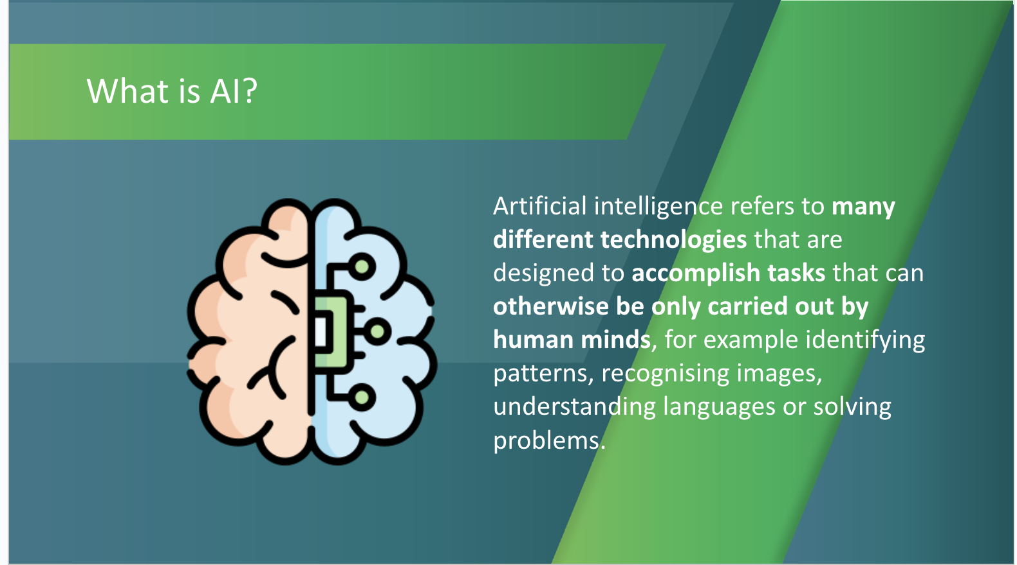 | Lecture (2 mins)  Go through the following definition, checking that students understand:  Artificial intelligence refers to many different technologies that are designed to accomplish tasks that can otherwise be only carried out by human minds, for example identifying patterns, recognising images, understanding languages or solving problems.
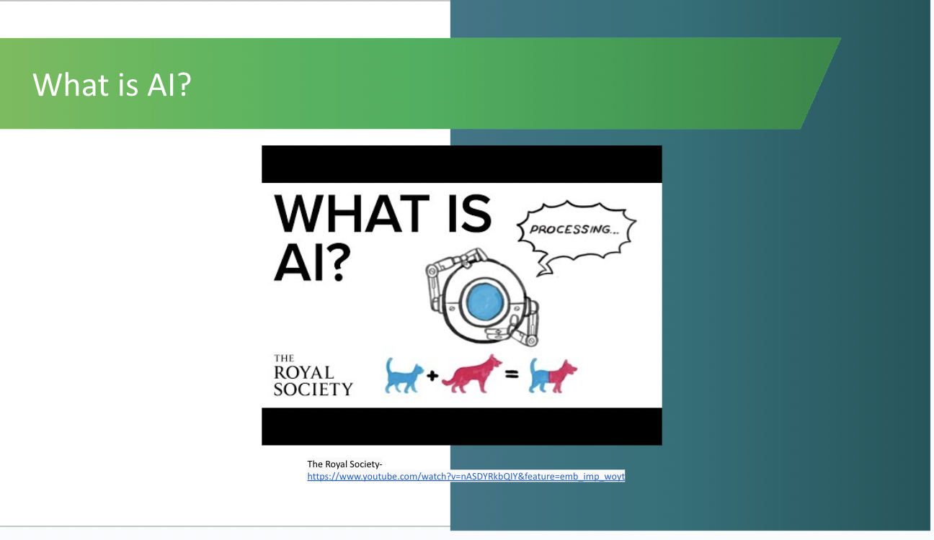 | Activity (3 mins)  This 2.5-minute video from the Royal Society in the UK explains some of the benefits of AI and ways in which it’s being used currently. It also encourages us to reflect on whether AI development and use can have potentially negative effects on individuals and society and what we can do to address this issue. Show the video to the students.
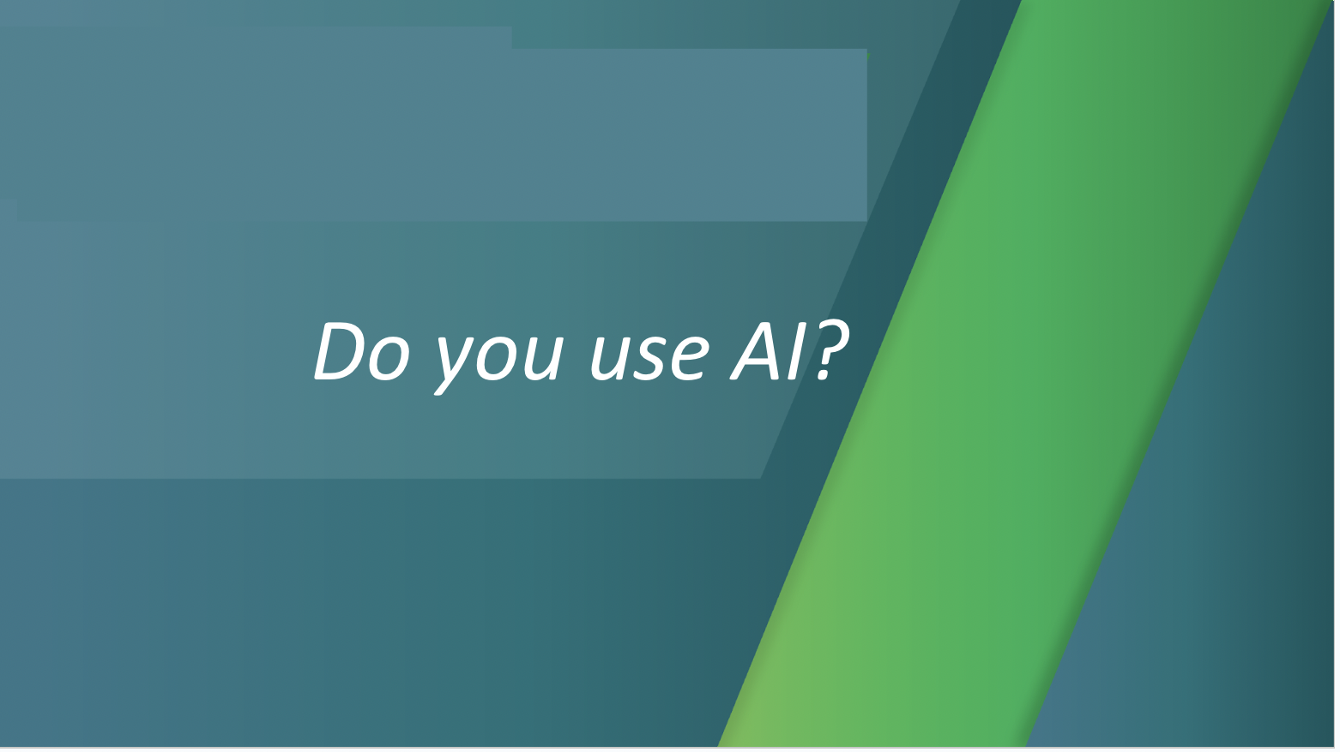 | Discussion (5 mins)  Ask the students to consider whether they think they use AI.  Again, you could use an interactive word cloud generator for this, or ask the class to shout examples of where they use AI in their everyday lives.
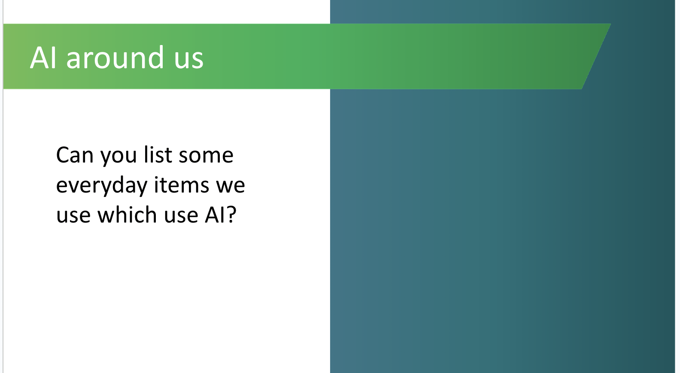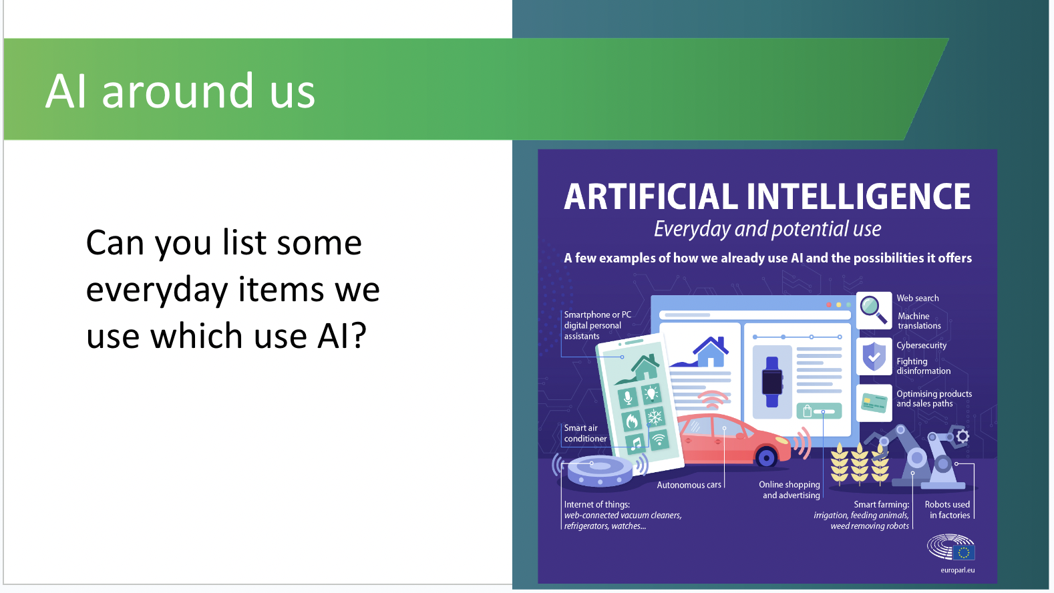 | Activity (4 mins)  List items that the students list/call out and then show the image of AI "everyday and potential use”.  Discuss areas which they may not have thought of.
AI in Use (~10 mins.)
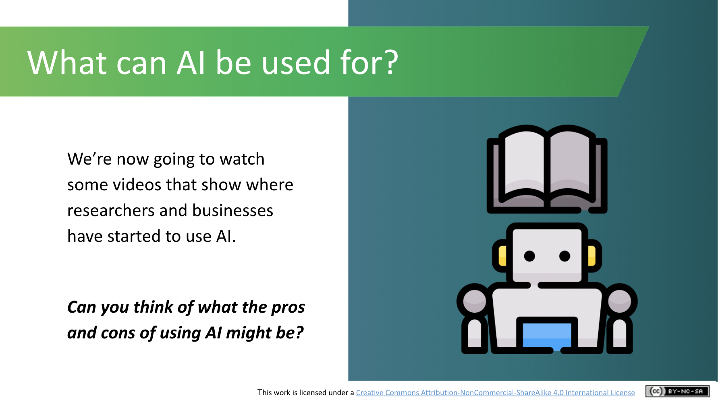 | Lecture (1 mins)  Tell students that we’re about to watch two videos that show how AI is being used in very different ways to enhance the world around us.
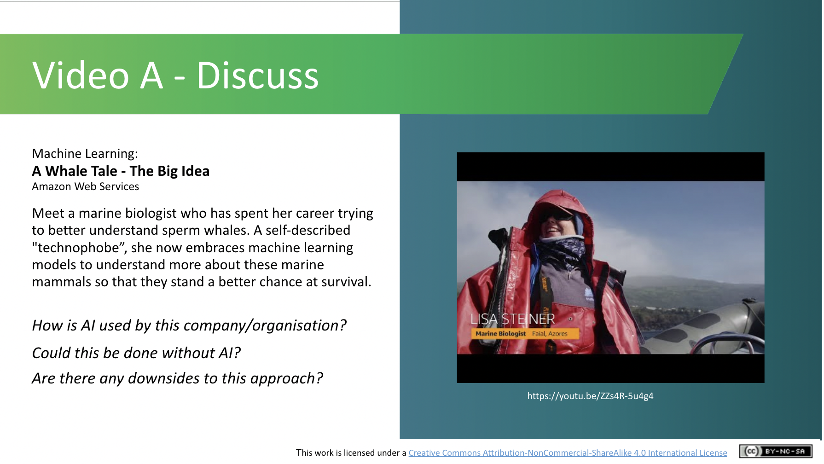 | Activity (5 mins)  Watch the video (which is 3 mins. 30 secs. long) and have the students note:  How is AI used by this organisation?  Could this be done without AI?  Are there downsides to this approach?
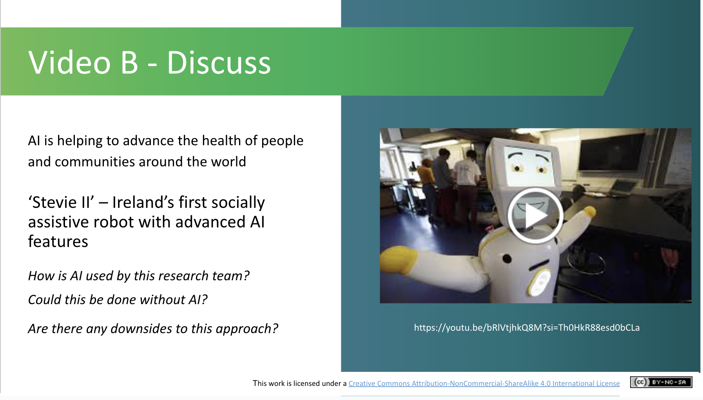 | Activity (4 mins)  AI is being used to transform healthcare practice in Ireland and beyond, from enabling “precision” (or personalised) medicine tailored to an individual’s genes and lifestyle, to cancer risk prediction, and identifying abnormalities in medical scans.  Stevie II is Ireland’s first assistive robot built with advanced AI features.  Watch the video (which is 2 mins. long) and have students note:  How is AI used by this research team?  Could this be done without AI?  Are there downsides to this approach?
AI v Human Capabilities (~26 mins)
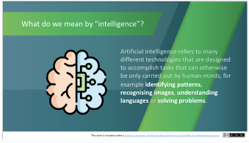 | Lecture (2 mins)  Looking back at our definition of Artificial intelligence, we see that it refers to many different technologies that are designed to accomplish tasks that can otherwise be only carried out by human minds. Some programmable functions of AI systems include identifying patterns, recognising images, understanding languages or solving problems. Over the next few slides we will discuss what makes a computer seem intelligent and what is involved in making this happen.
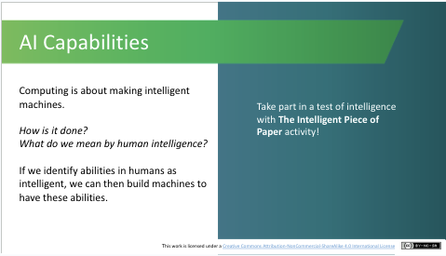 | Activity (11 mins)  This is an interactive activity showing how to create a very basic algorithm for a computer to play Noughts and Crosses.  ***You will need to print out this document to give to one volunteer.  Please watch the video (rather than showing it to the class) to see how it can be played - video length is 8 minutes 10 seconds https://youtu.be/BBIXO1_JLeg  Instructions to play The Intelligent Piece of Paper activity:  - Draw a Noughts and Crosses board on the whiteboard.  - Select two volunteers. One will play with the sheet of paper (you have printed out), the other will play for humankind. Remind the player for humankind that they can take suggestions from the audience.  - The player with the piece of paper will always go first.  - Over to the humankind player. Engage with the audience. If the person is unsure, encourage them to go where they think best of the options shouted.  - Continue like this, making sure the reader reads out and follows the exact instructions. You might need to help them understand where they are being told to go.  - Continue the game until the volunteer with the paper inevitably wins.  The aim of this exercise is that while the outcomes are similar i.e. a player wins a game, the process by which this was achieved was very different. Using this intelligent piece of paper, the player can seem to be a master player without any knowledge of the game. You can come back to this example when discussing Generative AI, i.e., AI doesn’t understand how to make Art but it can seem like it does based on the finished product.
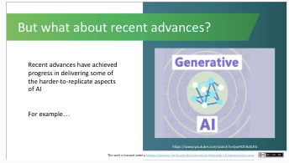 | Lecture (2 mins)  Recently there has been a lot of focus on Generative AI, with the most obvious example being ChatGPT. This video (which is 1 minute and 16 seconds long) explains what Generative AI is and how it works.
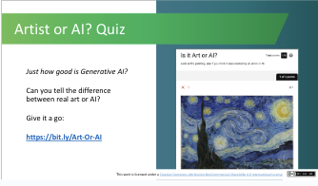 | Activity (3 mins)  ***Students will need to do this quiz on their smartphones/ipads or if the preference is to do the quiz as a group exercise, on a whiteboard.***  The Generative AI video explained how new images can be created by AI. Is it easy to tell the difference between what has been created by a human or by AI?  Take the following quiz (which takes about a minute) to see if you can tell the difference and discuss why some works were easier to predict than others.  As per the intelligent paper activity, while the end product may appear similar, the process to get there is indeed very different.
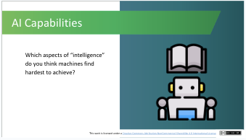 | Activity (3 mins)  Now the class has worked out how a computer or machine can be instructed to appear intelligent, the discussion can turn to what a computer/machine may find difficult to achieve. What aspects of “intelligence” do students think are hard to emulate?”  This video (https://www.youtube.com/watch?v=piYnd_wYlT8) is also a good example demonstrating that even with image recognition, AI looks at completely different things (i.e., colour and shape patterns) than human beings. It shows how AI is easy fooled by subtly changing the look of an object.
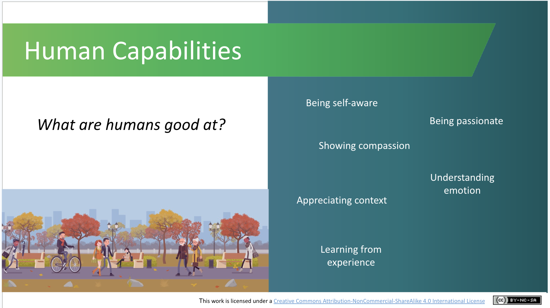 | Activity (5 mins)  What are Humans good at? Ask students to name some attributes that they consider to be inherently human. You might need to prompt them with an example or two:  Humans have the capability to be self aware (i.e., having conscious knowledge of one's own character and feelings). Do students think that machines have the capacity to do this also?  Continue the discussion by showing some human capabilities and ask whether the students think a machine can simulate these attributes?  You can also introduce the concept of emotional intelligence i.e., to have the ability to recognise social cues, etc.  Some different ways in which humans practice emotional intelligence include:  - Being able to accept criticism and responsibility.  - Being able to move on after making a mistake.  - Being able to say no when you need to.  - Being able to share your feelings with others.  - Being able to solve problems in ways that work for everyone.  Can a machine do this? [The answer is that although machine intelligence is progressing at a rapid pace, machines don’t quite have the ability to perform these human qualities yet!]
Recap and Conclusions (~2 mins)
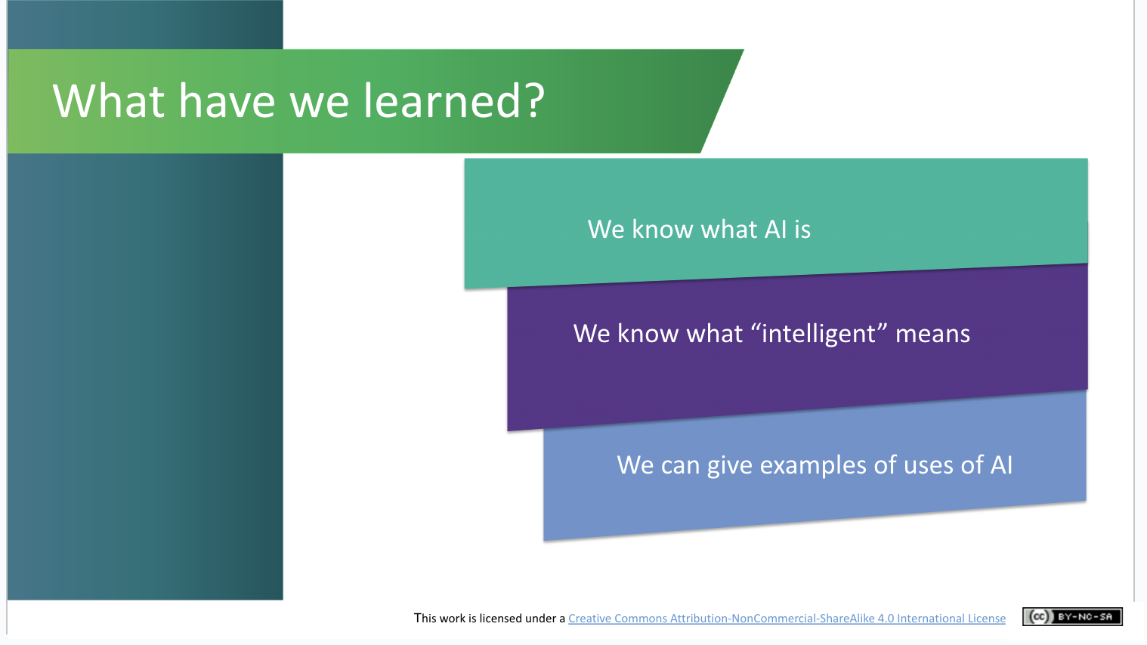 | Lecture (1.5 mins)  What have we learned?  We revisit the three learning outcomes outlined at the start of the session.  - We know what AI is  - We know what “intelligent” means and how machines can be instructed to appear intelligent  - We can give examples of AI use in everyday life
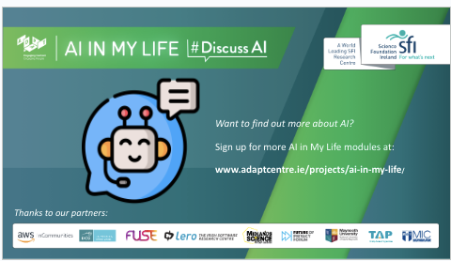 | Lecture (.5 mins)  Final slide which explains that there are more AI in My Life modules available if the students would be interested.

Curriculum Links

In addition to its relevance to honing the key skills central to teaching and learning across the Transition Year curriculum, the STEAM focus makes the AI in My Life content relevant to the following subjects:

Leaving Certificate:
Technology
Politics and Society
Computer Science
Design and Communication
Business
Economics

Applied Leaving Certificate:
Engineering
Technology
Social Education
Science
Information and Communication Technology – Specialism

Additional Resources
If you have longer than an hour for this module, you might like to include the following activity early in the module as a fun way to engage students with the topic:

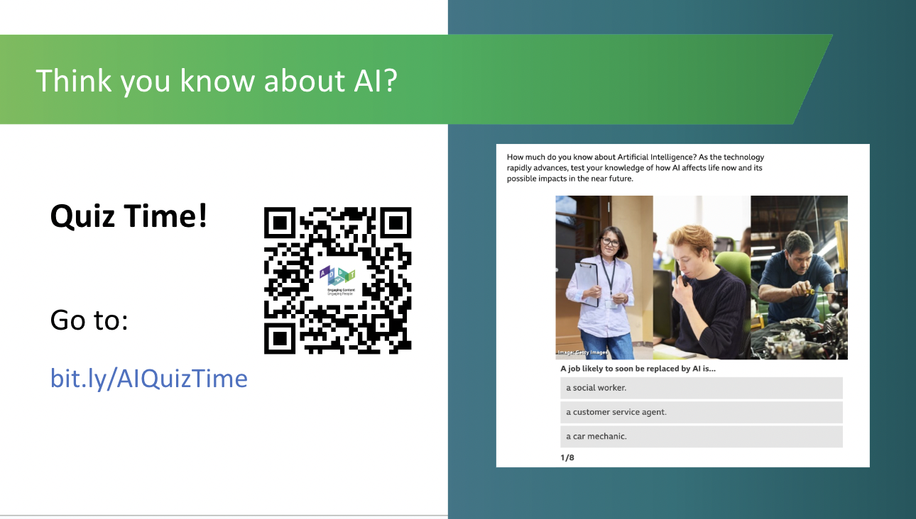 | Activity (5 mins)  How much do students think they know about AI? This fun quiz, (which takes about 5 mins. to complete), will help them assess their current knowledge levels.

If you have questions or comments about this lesson,
please contact us at education@adaptcentre.ie

