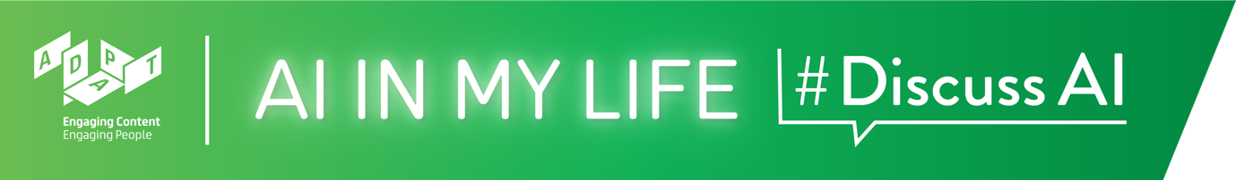

AI in My Life Taster Teacher Guide

AI in My Life Taster
The AI in My Life taster module provides an introduction to some of the key topics covered in the broader ADAPT AI in My Life workshop series.

Suggested Time: ~1.5 hours

Background
There are no prerequisites for this module. The module provides a condensed version of the course for teachers and students who do not have time to undertake multiple AI in My Life modules. Note that some of the content and activities feature in the full modules.

Curriculum Links
The interactive and reflective nature of AI in My Life ensures that students will hone the five key skills central to teaching and learning across the Transition Year curriculum:
- Information processing
- Critical and creative thinking
- Communicating
- Working with others
- Being personally effective

An outline of links to the Leaving Certificate curriculum is provided after the module walkthrough.

Materials Needed: PowerPoint presentation, Laptop, Screen, Internet Access, Timer. Students will need access to mobile phones or tablets for some of the interactive activities.

Module Overview

Introduction (~3 mins.)
A quick introduction to the module and outline of the learning goals.

What is AI (~12 mins.)
Starts with students completing a short questionnaire on their current familiarity with AI and its uses, then defines what AI is and features a video highlighting some of the benefits and potential drawbacks of AI research, development and use.

Machine Learning (~18 mins.)
Many AI applications are based on Machine Learning (ML). This section looks at what ML is and some examples of how it's used in our everyday lives. Students try out Google’s Thing Translator and discuss some uses of facial recognition technology.

AI and Bias (~16 mins.)
Considers the potential of AI to either exacerbate or eradicate human bias. A short emotion detection game encourages students to reflect on why the tool they use is better at recognising some faces and emotions than others.

Is AI always used for good? (~14 mins.)
AI offers tremendous potential for good at both the individual and societal level. Recent AI-enabled advancements such as Deepfakes are posing serious questions about the use of AI for negative purposes. Students will learn to spot Deepfakes and will reflect on whether this technology could also be used for good.

The Importance of Data (~12 mins.)
A closer look at the value of data, followed by a short activity on students’ attitudes to safeguarding the privacy of their data, and key tips for how students can take some control of their data while using AI tools and apps.

AI and Ethics (~9 mins.)
Highlights some of the ethical implications of AI development and use, and puts students in the role of a driverless car developer – what value would the student assign to different categories of road user in an unavoidable crash scenario?

Recap and Evaluation (~6 mins.)
A brief recap on what students have learned in this module and an opportunity to ask questions about topics they would like to explore more.

AI in My Life Taster
Module Walkthrough
Learning Intentions
By the end of this workshop, students will be able to:
- Give examples of how AI is used
- State some of the ethical and privacy implications of AI
- Evaluate the role of AI in their lives and in society

Introduction (~3 mins.)

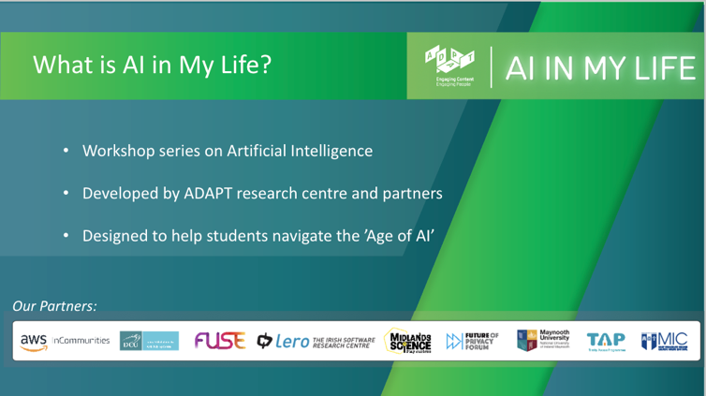 | Lecture (~2 mins.)  AI in My Life is a modular workshop series on Artificial Intelligence (AI). It was developed by the Science Foundation Ireland funded ADAPT Research Centre. ADAPT is a major academia-industry research centre with more than 300 researchers from 8 Irish universities producing research and innovations in many aspects of AI. Partners on the project include, for example, DCU Access, Amazon Web Services and the Lero software research centre.  AI is transforming life as we know it. While AI offers substantial benefits to individuals and society, it has major implications for privacy, ethics and security. AI in My Life aims to help students navigate this so-called ‘Age of AI’ safely and successfully.
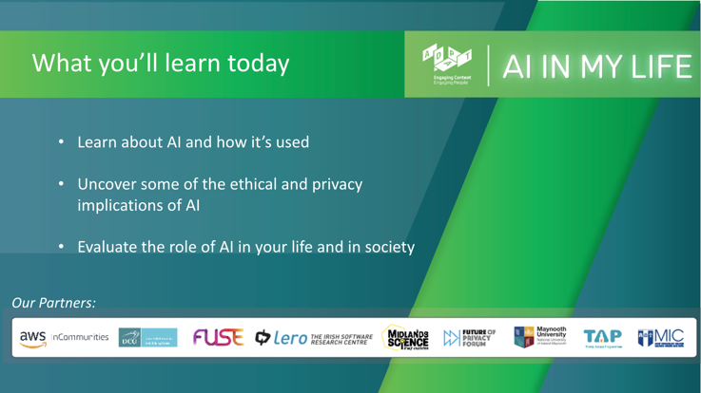 | Lecture (~1 min.)  Outline to students what they’ll be able to do by the end of this module:  - Learn about AI and how it’s used  - Uncover some of the ethical and privacy implications of AI  - Evaluate the role of AI in your life and in society.
What is AI? (~12 mins.)
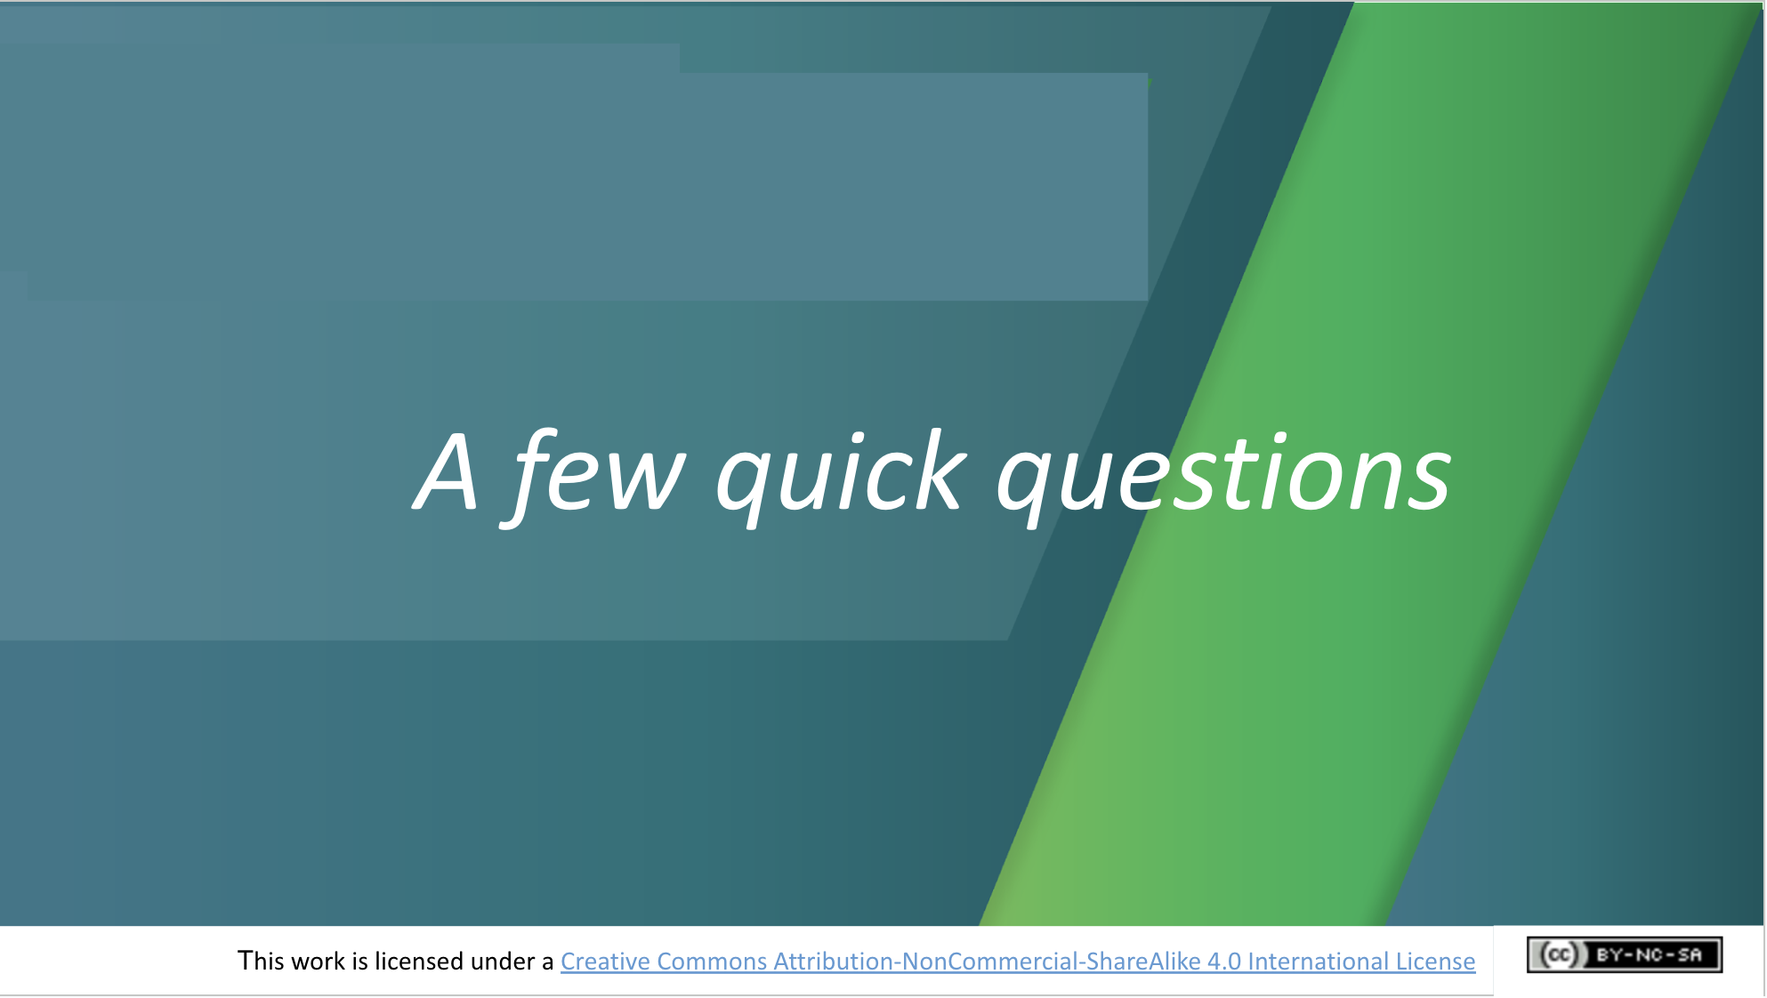 | Activity (~5 mins. for 4-question survey)  We’ll start by asking students 4 short questions designed to help us understand their current level of understanding and interest in AI. The survey is anonymous and the answers will help us to evaluate the course and improve it.  Explain to students that their answers will not appear on screen (we’ve decided on this approach so that students won’t be swayed by answers they see others give).
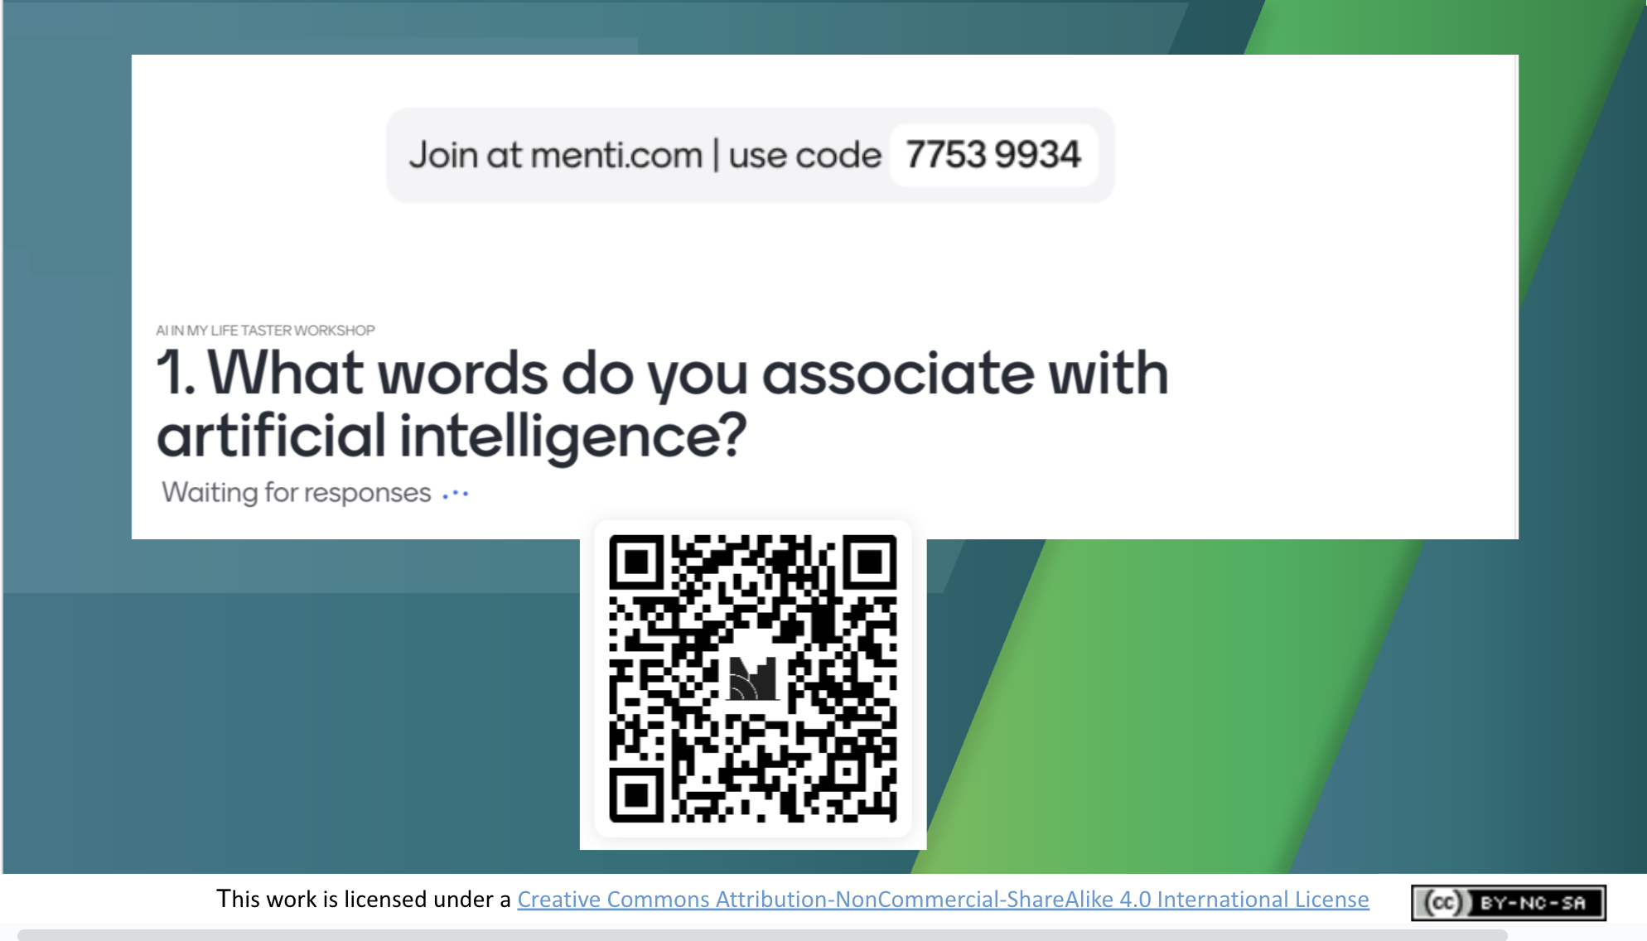 | Ask students to use their mobile phones or tablets to access the short survey on Mentimeter.  Highlight that their answers will go (anonymously) to the AI in My Life evaluation team and will only be used to help us evaluate and improve the course.  Students can access the quiz by scanning the QR code on screen or by visiting menti.com and entering the code at the top of this slide.
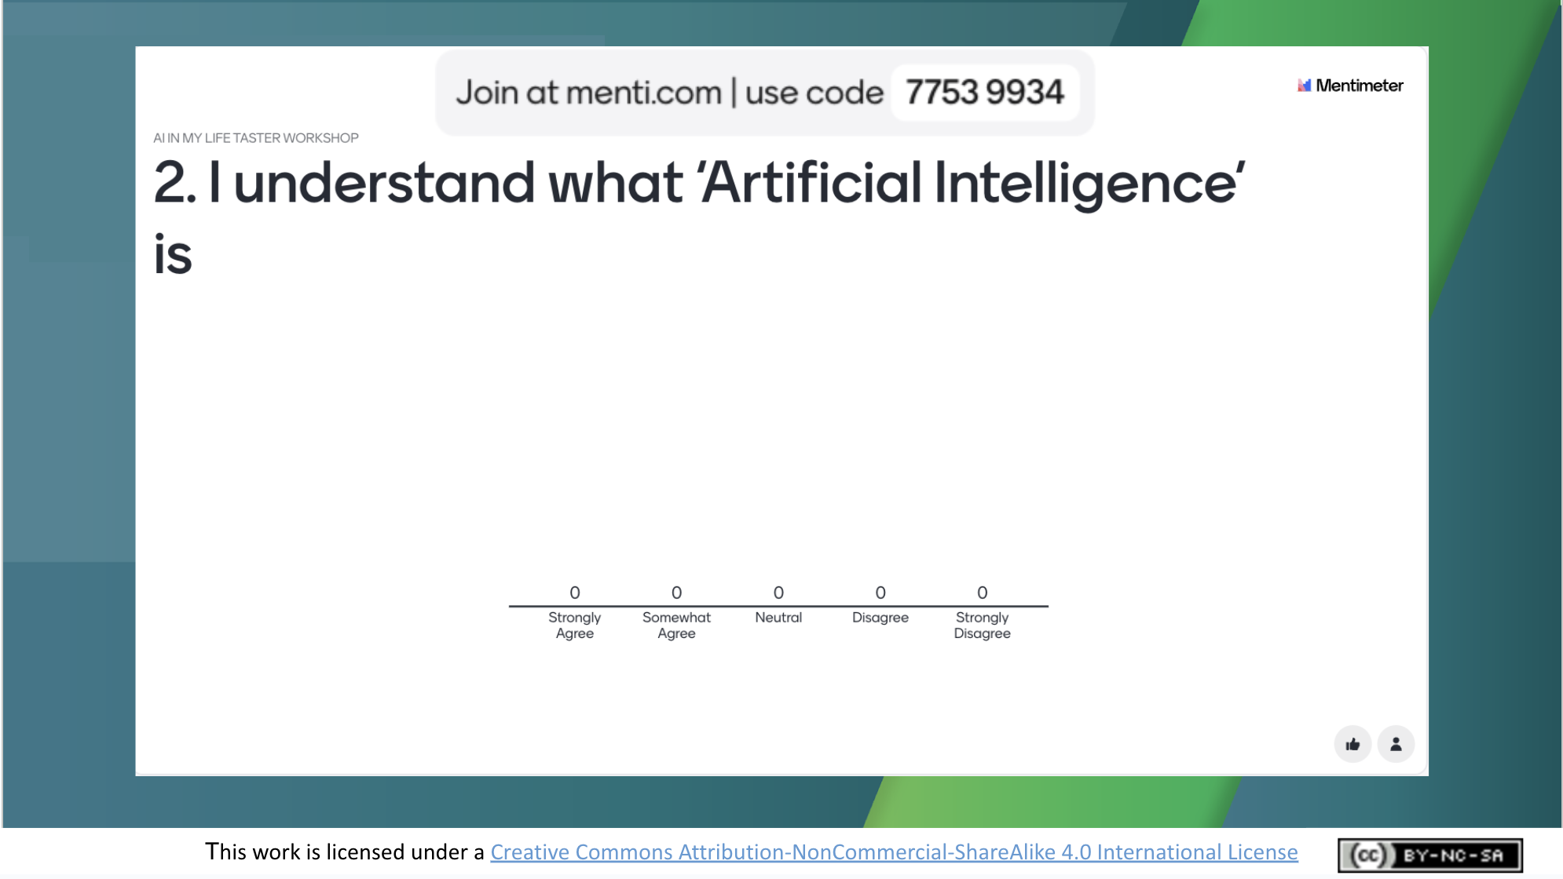 | Encourage students to proceed to answer question 2.
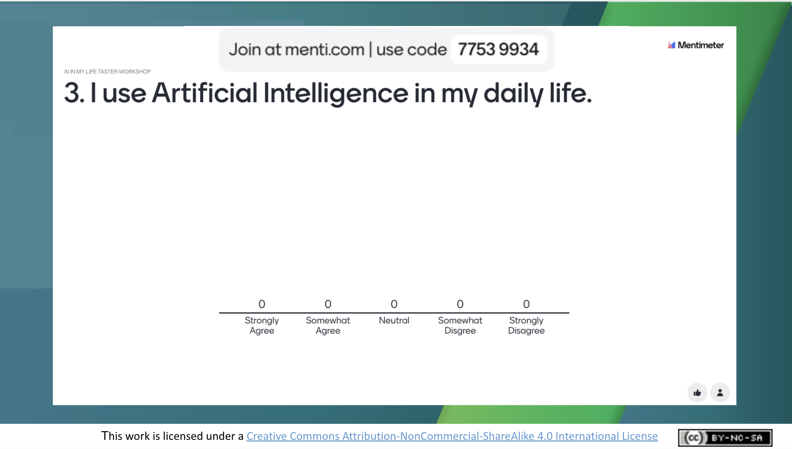 | Encourage students to proceed to answer question 3.
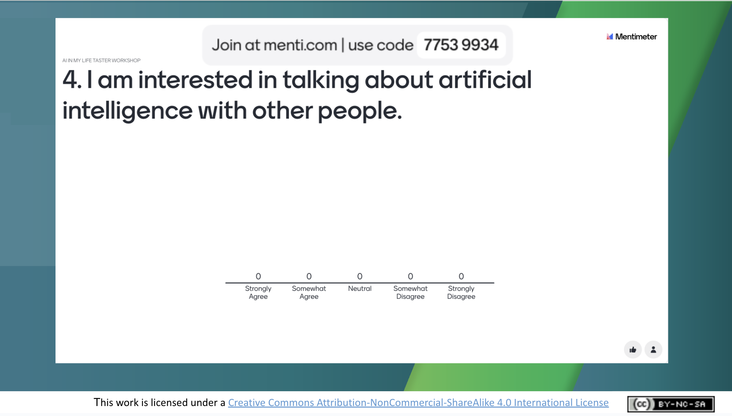 | Encourage students to proceed to answer question 4, which is the final question.
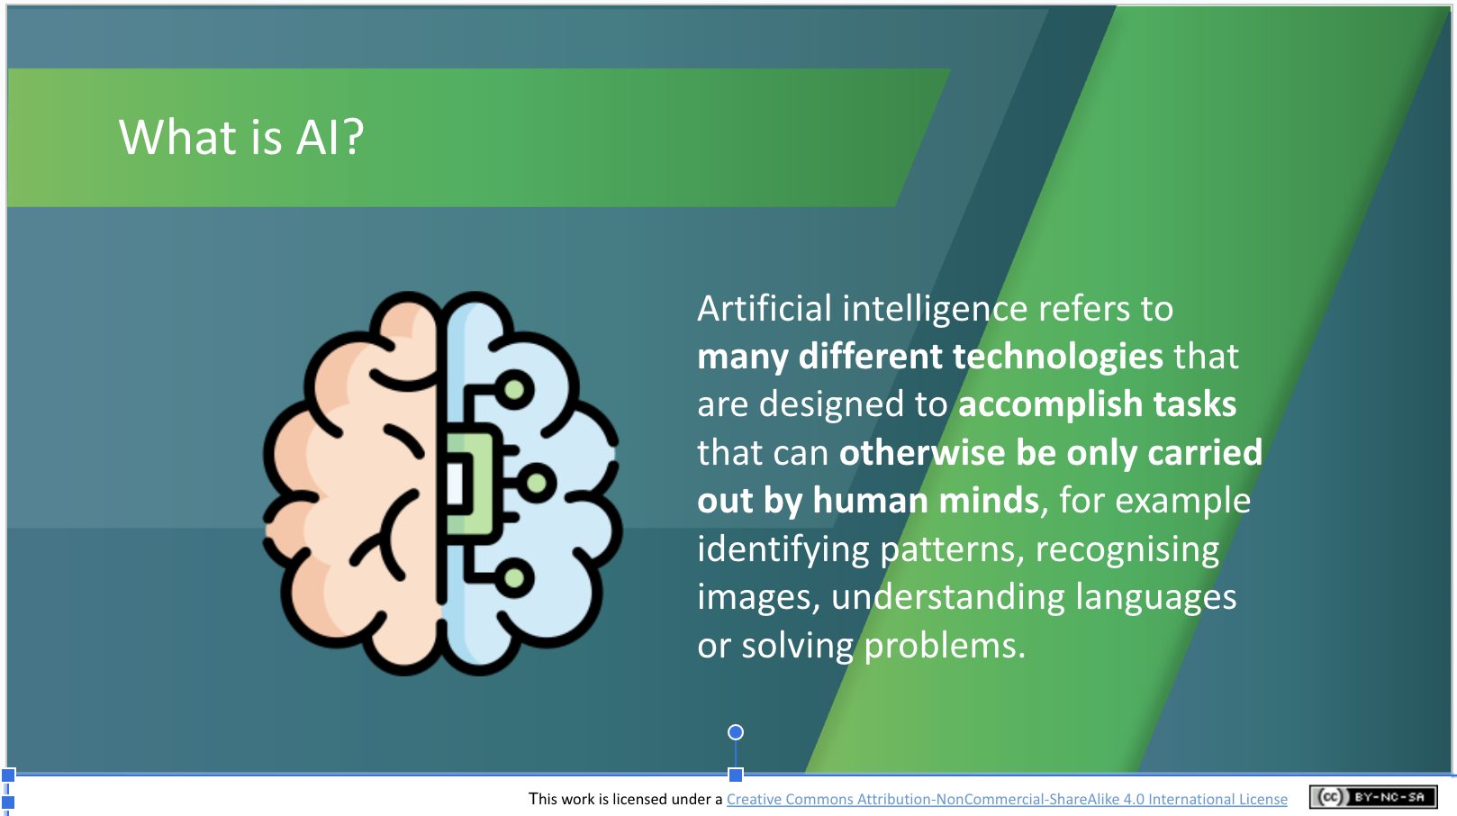 | Lecture (~2 mins.)  Explain what AI is. Go through the following definition, checking that students understand:  Artificial intelligence refers to many different technologies that are designed to accomplish tasks that can otherwise be only carried out by human minds, for example identifying patterns, recognising images, understanding languages or solving problems.
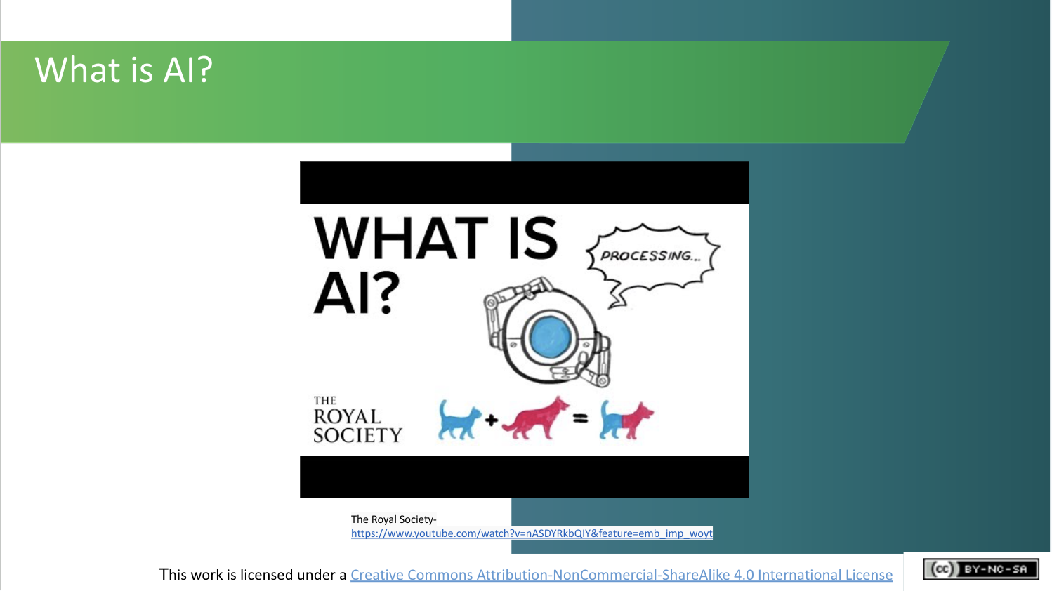 | Activity (~5 mins.)  This 2.5 minute video from the Royal Society in the UK explains some of the benefits of AI and ways in which it’s being used currently.  It also encourages us to reflect on whether AI development and use can have potentially negative effects on individuals and society and what we can do to address this issue.  Let’s take a look.  Ask students to note some of the beneficial uses of AI that the video mentions.
Machine Learning (~18 mins.)

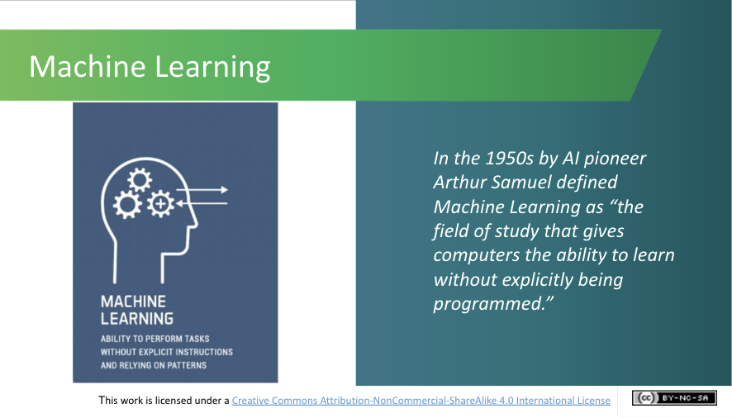 | Lecture (~1 min.)  Many AI applications are based on Machine Learning – so much so, that the terms AI and Machine Learning are often used interchangeably.  Machine Learning is an application (or subset) of AI that focuses on developing computer programmes that can access data and use it to learn and improve from experience.  In the 1950s AI pioneer Arthur Samuel defined Machine Learning as “the field of study that gives computers the ability to learn without explicitly being programmed.”
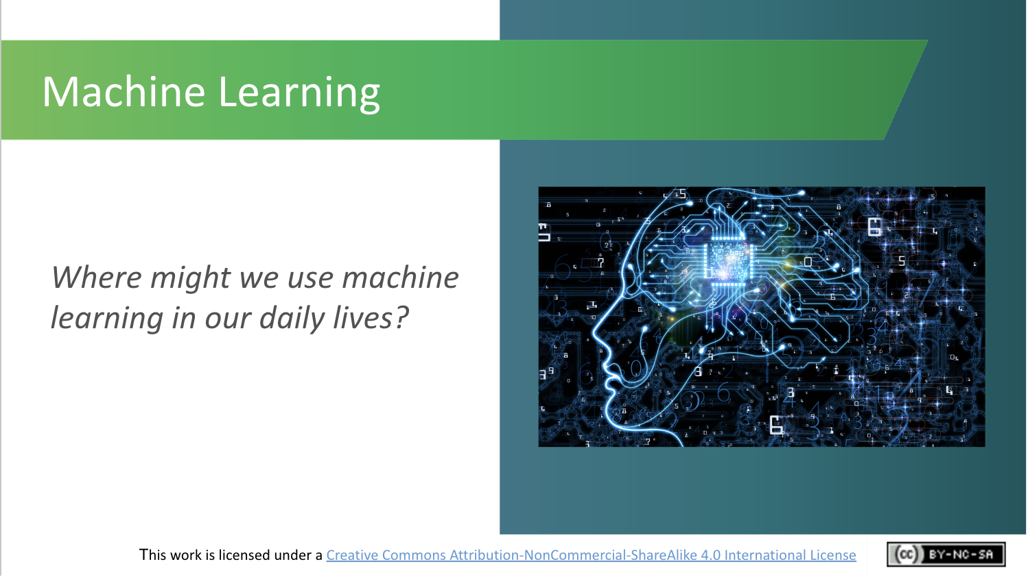 | Activity (~3 mins.)  Where might we use Machine Learning in our everyday lives?  Ask students to call out some examples.  - Netflix, for example, learns from your browsing and watching history in order to present you with recommended content based on what it has learned about you and your preferences.  - Email accounts classify spam into a separate folder from inbox.  - Personal assistants such as Siri or Alexa also use Machine Learning to function.
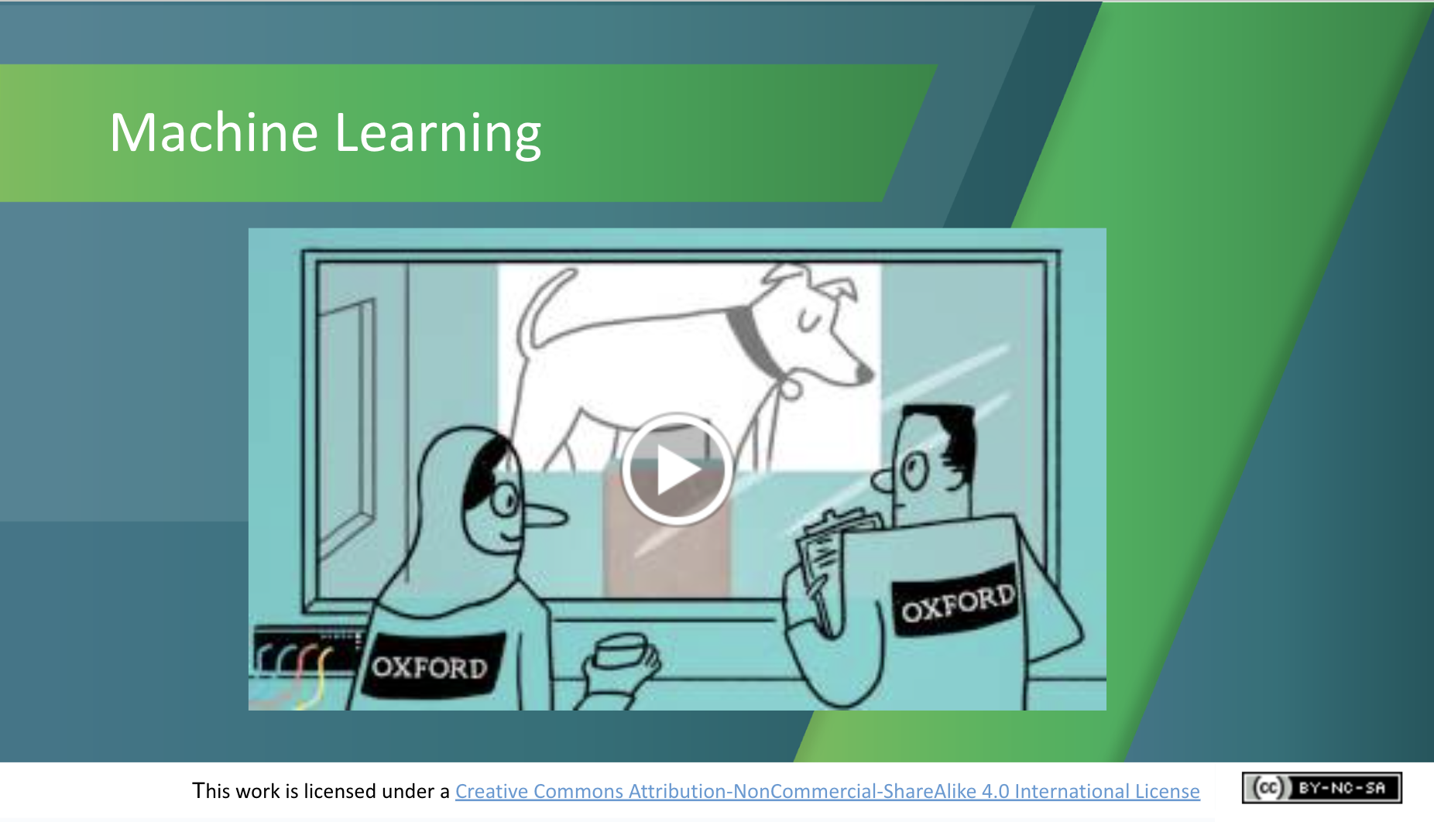 | Activity (~4 mins.)  Watch the short video (2.41 mins) from the University of Oxford, U.K. (https://www.youtube.com/watch?v=f_uwKZIAeM0) and ask students to note additional examples of Machine Learning applications.
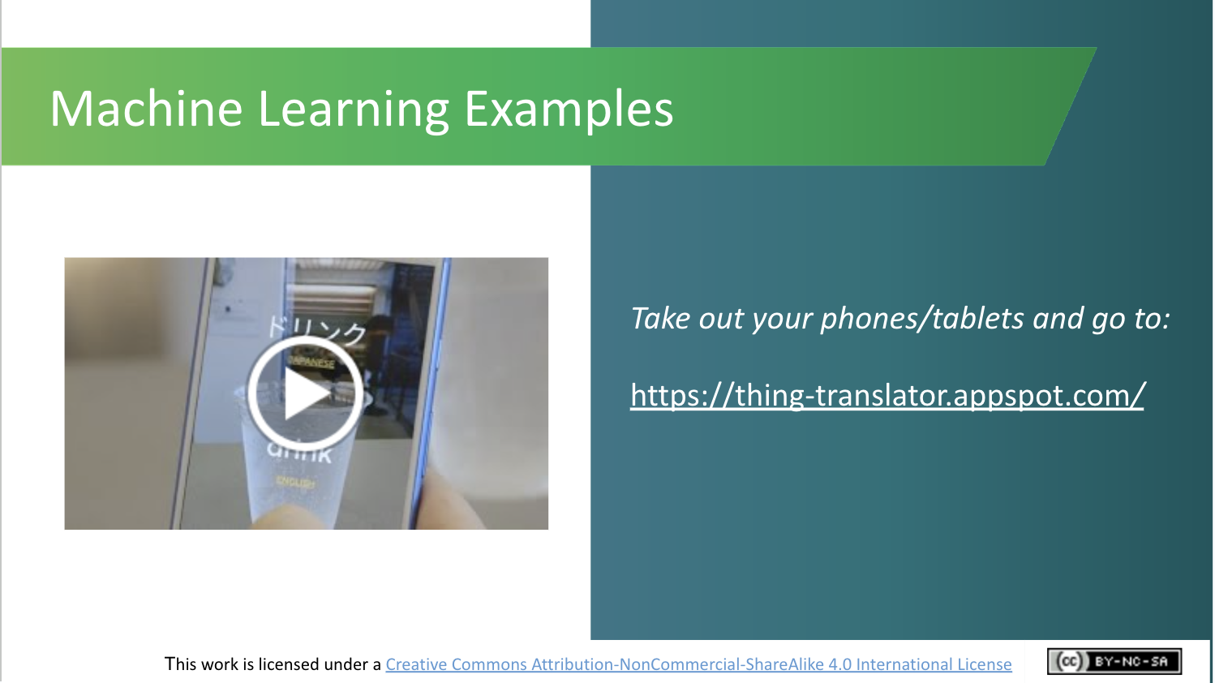 | Activity (~5 mins.)  Let’s try out an app that uses Machine Learning.  This one, called Thing Translator, is being developed by Google to recognise objects and translate the names of them into foreign languages. It has learned from huge amounts of data and the more data it gets, the more accurate the translations become. Try it out for yourself.  [Ask students to visit the link on their mobile phone or laptop (if the latter has a functioning camera). If students are unable to access the app, show them how it works via the short video (57 seconds) at https://www.youtube.com/watch?v=bH5sU7ew5V4]
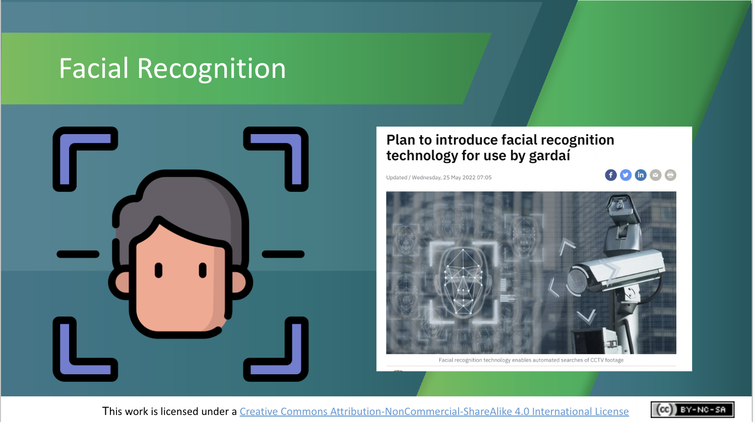 | Lecture (~1 min.)  Facial recognition systems are also built on Machine Learning and trained with large amounts of data. The more data they are provided with, the more accurate they become at recognising faces.  Discussion (~3 mins.)  Ask students if they can think of useful ways in which they’ve seen facial recognition used. Some examples are:  - To unlock your mobile phone  - For passport control at the airport  - For surveillance in shops or other business premises  Lecture (~1 min.)  The Irish Government has proposed allowing Gardaí to use facial recognition technology but its introduction has been postponed due to objections by legal experts and human rights advocates. This highlights that the benefits of facial recognition technology need to be weighed up with their potential effects on the privacy and human rights of individuals.
AI and Bias (~16 mins.)

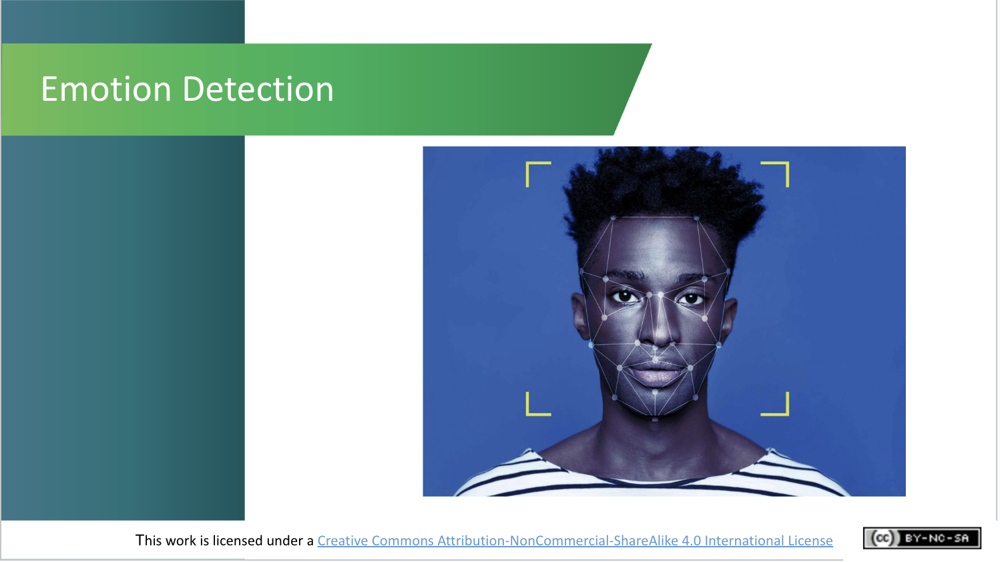 | Lecture (~1 mins.)  One of the things that machines find hardest to deal with accurately is emotion – a truly human characteristic.  However, just as a child learns to read emotions through years of experience, so too can machines learn to read our emotions. But how effective are they at doing so?
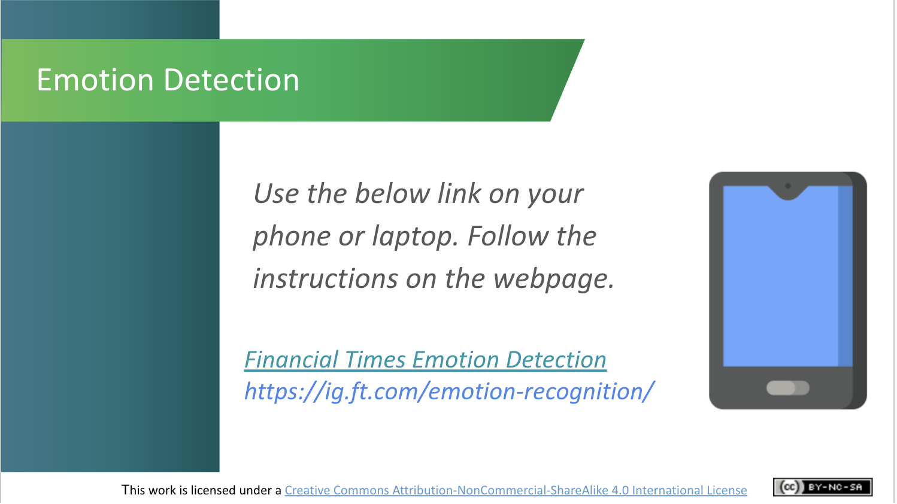 | Activity (~7 mins.)  Let’s try out a short game on this topic.  Use the link on the screen to access an interactive game and follow the instructions on the web page to play the game. Note: This game takes about 5 mins. to complete  After playing the game, ask students why they think machines are better at recognising some faces (and emotions) than others.  Essentially, this comes down to bias and lack of diversity in the data used to train the system (i.e. the examples given to it to help it learn). Often these systems are built using predominantly white (i.e., Caucasian) adult male examples/data and so they become good at recognising white adult male faces. They are typically less accurate at identifying the faces of people of other ethnicities, women, children and the elderly because they’ve been trained on few examples of such faces. Eradicating such bias from AI systems is a key ethical concern of AI development and use.
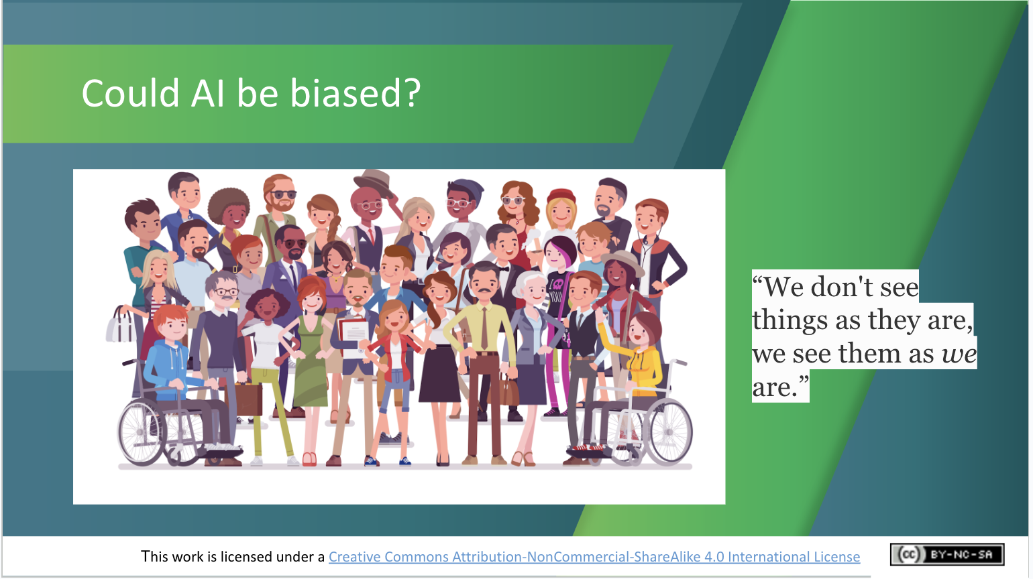 | Lecture (~3 mins.)  Just like the humans who built them, AI systems can be biased (or prejudiced) – favouring or prioritising the needs of certain people over others.  For example:  A criminal justice algorithm used in Florida, USA mislabelled African-American defendants as “high risk” at nearly twice the rate it mislabelled white defendants.  Amazon stopped using a hiring algorithm that favoured CVs received from male job applicants.  It’s important to highlight, however, that AI could also contribute to reducing bias. AI itself is indifferent to colour, gender, age, and other biases. The only reason we see bias in AI at all is because of assumptions and biased data that humans sometimes use to train it. Some AI-based tools have proved successful in reducing bias. For example, traditionally we’ve seen very low portions of investment in start-up (i.e., new) companies going to companies led by women. AI tools to automatically and objectively review company funding proposals (which remove all reference to the gender of applicants) have resulted in a much larger share of funding going to women.
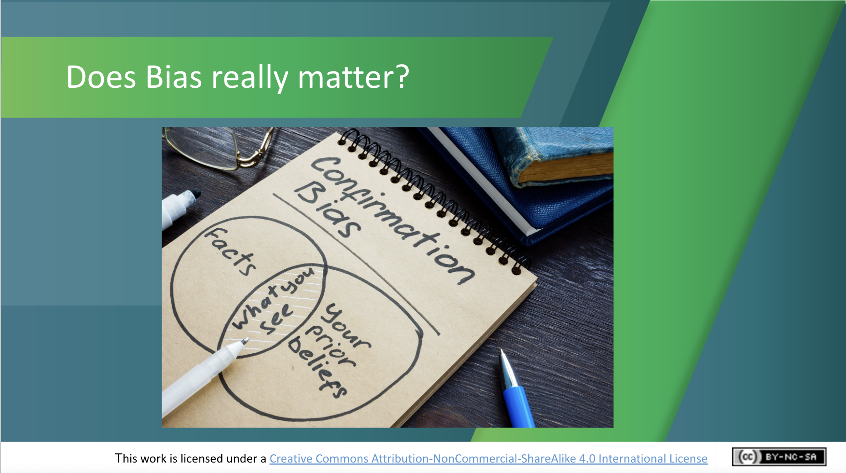 | Discussion (~5 mins.)  Do students think it matters that AI can reinforce bias? Why/why not? How might we overcome this issue? [Potential solutions include ensuring more diversity in the backgrounds of people who develop AI systems, and researchers and companies making a concerted effort to build more diverse data sets).
Is AI always used for good? (~14 mins.)

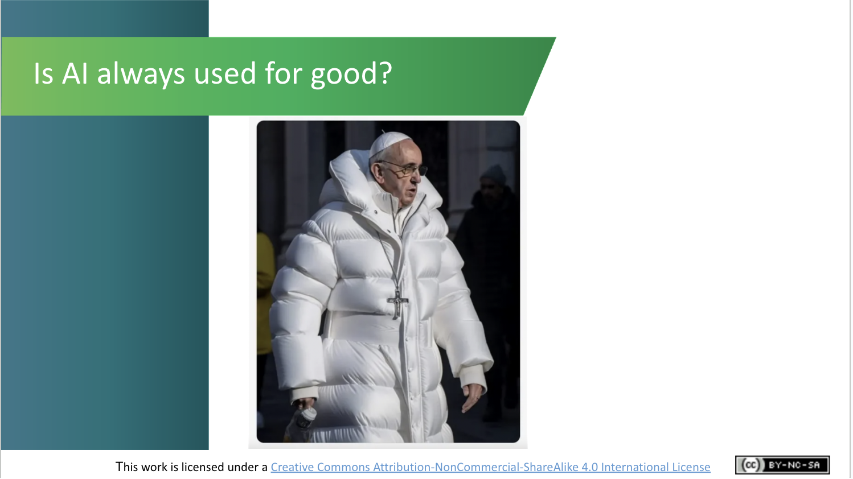 | Lecture (~1 min.)  Speaking of ethical concerns, is AI always used for good?  Has anyone seen this image before? If so, what do you know about it?  This image, which has been referred to as the Balenciaga Pope – is actually fake. It was generated by AI image generator Midjourney.  While such images can be seen as harmless fun, AI-generated images like this could be used in unethical ways.  The following video explains the dangers of “deepfakes”, which are video and audio content generated by AI.
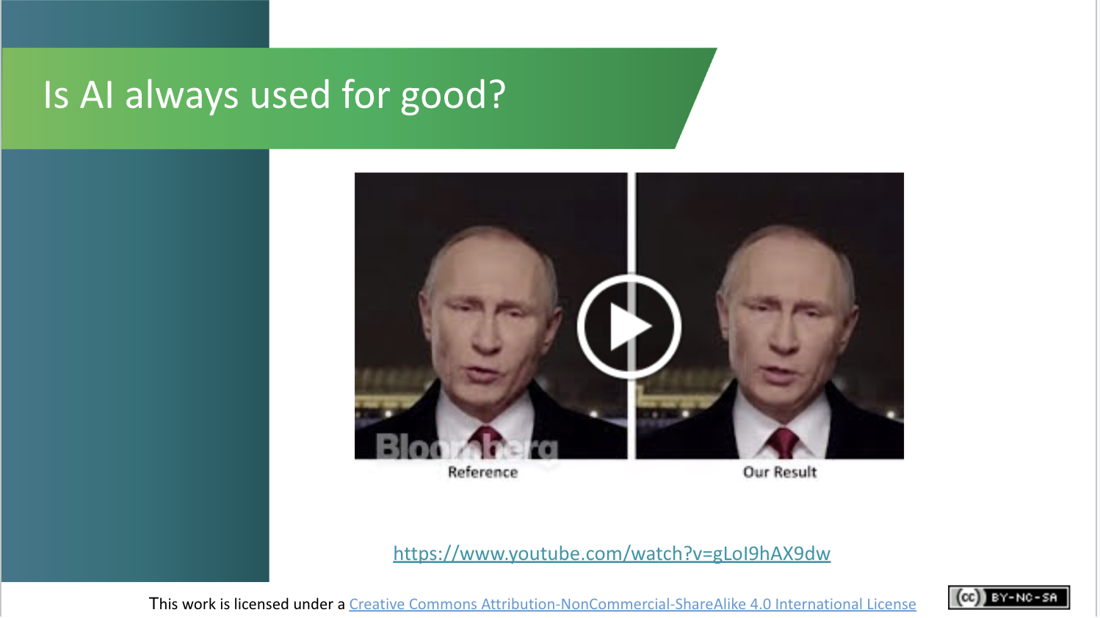 | Activity (~3 mins.)  Play this short video (2.59 mins): https://www.youtube.com/watch?v=gLoI9hAX9dw  Believe it or not, this video is 5 years old! Deepfake technology has advanced further in recent times, so the risks and need for ways to detect and stop unethical uses of AI have intensified.
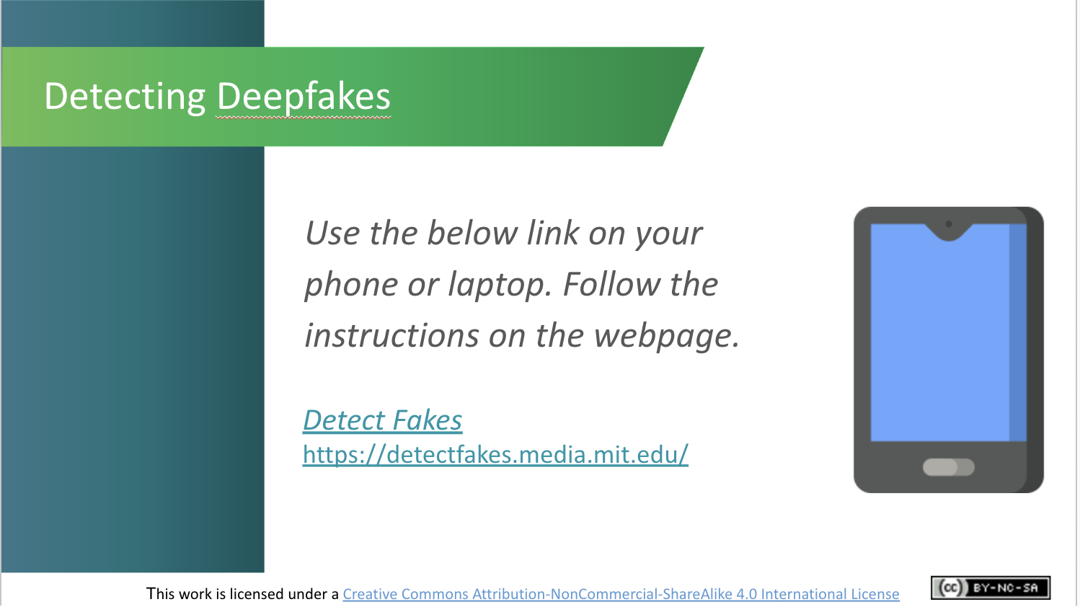 | Activity (~7 min.)  Note: This game allows students to test how good they are at spotting deepfakes. It is based on research by Massachusetts Institute of Technology (MIT).  There are 20 clips for students to rate as real or fake. In the interests of time, we suggest you encourage them to try out 4 or 5 clips and to note down the link if they wish to try out more examples after class.  **When selecting whether the clip is real or fake,  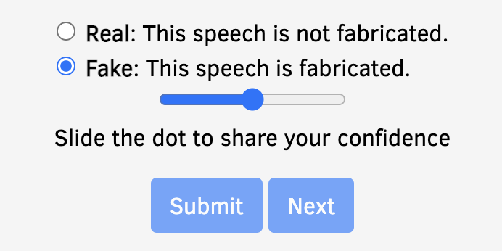  you must slide the dot to “Completely confident” first and then adjust downwards if this is what you feel i.e if you feel “Fairly confident” you must slide the dot to “Completely confident” first  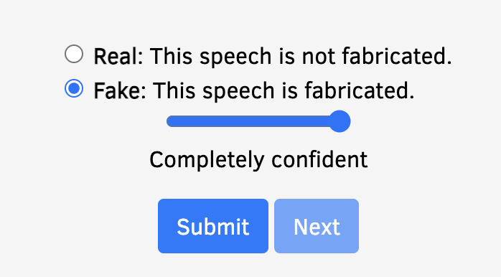  and slide left to bring the dot to “Fairly confident” before the Submit button allows you to click on it. 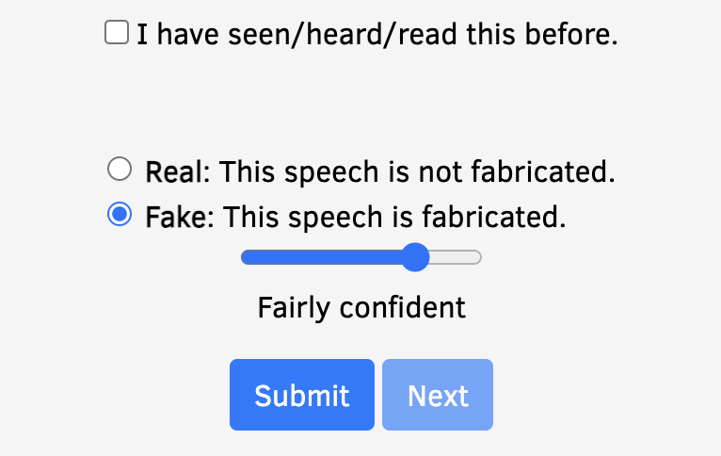  You will not be allowed to Submit if you don’t slide the dot to “Completely confident” first.
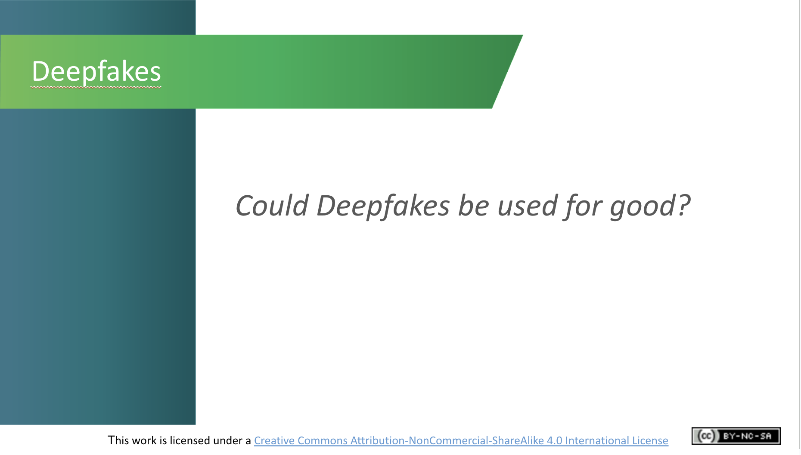 | Discussion (~3 mins.)  Can students think of any ways in which deepfakes and AI characters could be used for good? How about using them to make learning more engaging?  In Shanghai, for example, Associate Professor Jiang Fei used an anime version of himself to make his online lessons more fun and engaging during lockdown. He said “The enthusiasm of the students in class, and the improvement of the quality of homework have made obvious progress.”  Irish company Marino Software has worked with former RTÉ TV presenter Charlie Bird to develop a custom solution to preserve and clone the voices of people with motor neuron disease before they lose their ability to speak.
The Importance of Data (~12 mins.)

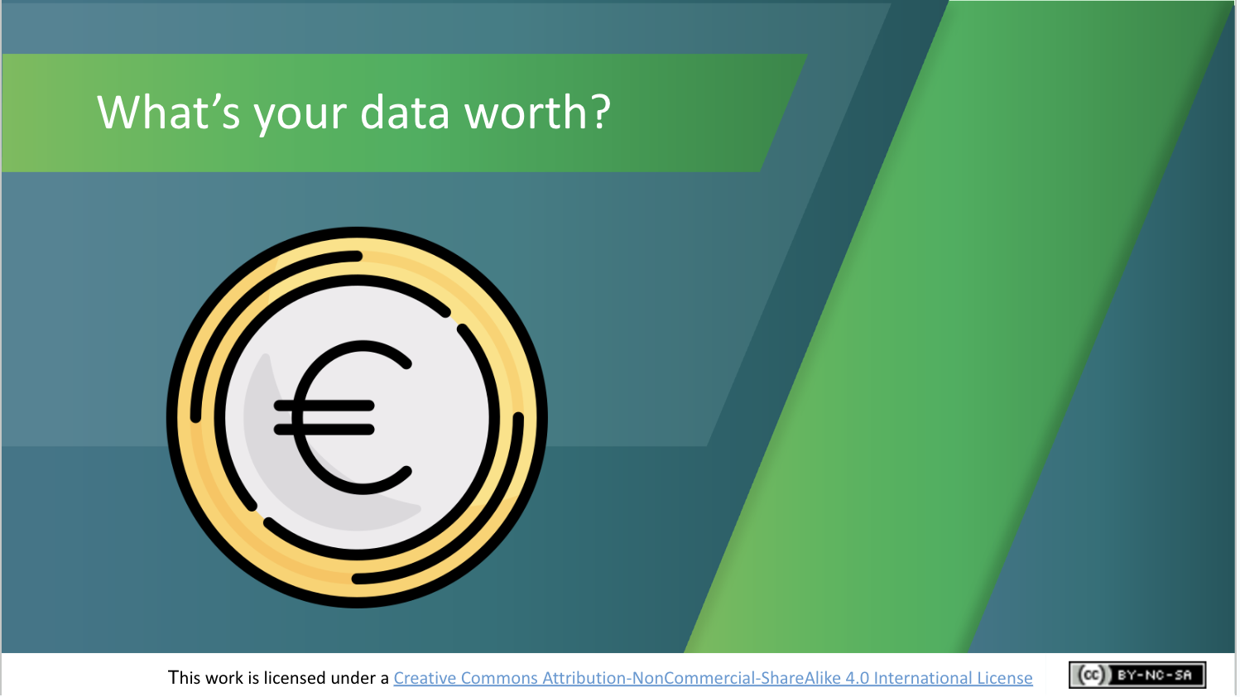 | Lecture (~1 min.)  We’ve seen that Machine Learning systems need data to improve their accuracy.  From where do they get this data? When it comes to digital apps, it’s often said that if you’re not paying for the product, then you ARE the product! This is because the technology we use in our daily lives collects huge amounts of data from and about us.  The reason your data matters to businesses so much is what it’s used for. Not only is it used to target you with personalised ads, but it also tailors online experiences for you, tracks how you use websites, monitors the kind of products you spend time looking at, and helps brands try and sell more to you.
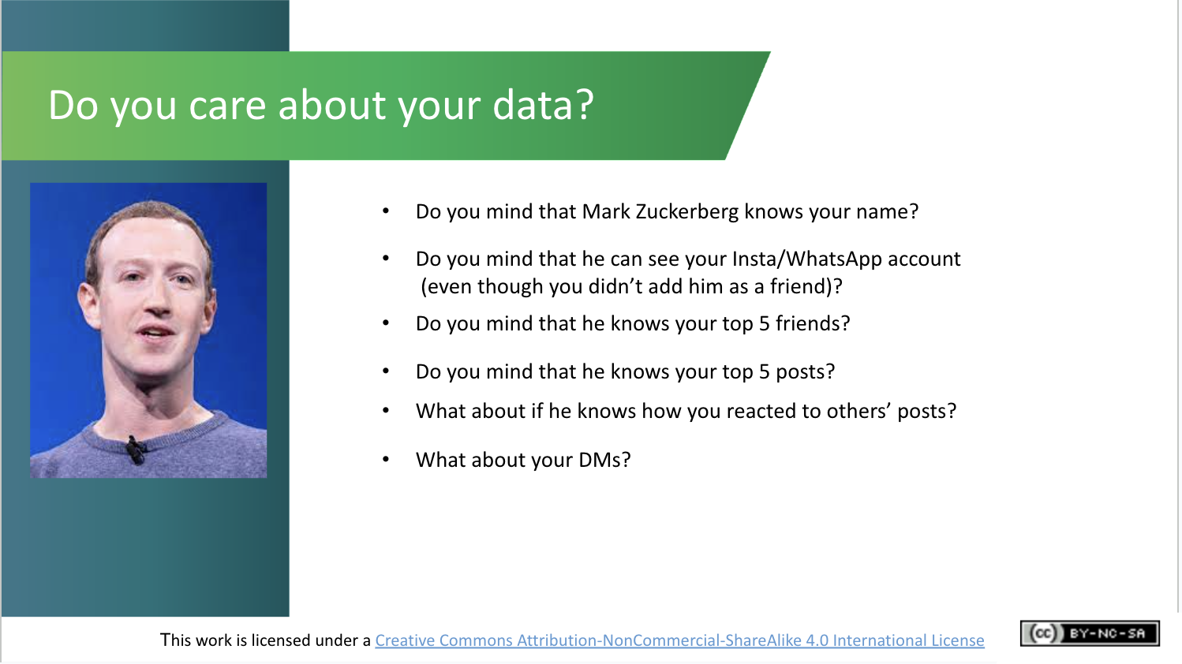 | Activity (~4 mins.)  Do you care about your data and keeping it safe and private?  Anyone know who this guy is? He’s Mark Zuckerberg, billionaire co-founder of Facebook and its parent company Meta.  [Walk through the questions with the students, asking them to stand up initially, and sit down as soon as they answer “yes” to a question. Observe how reluctant students are to share their data]
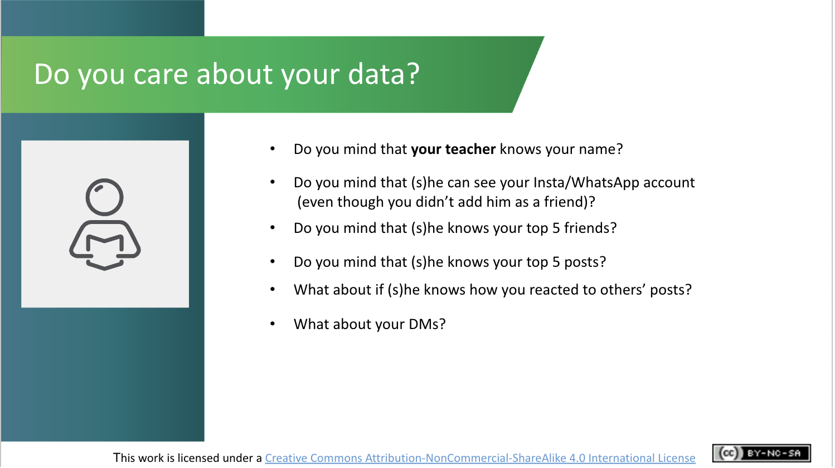 | Activity (~3 mins.)  Repeat the exercise, asking this time about their teacher accessing their data. If there are differences in their attitudes in sharing between Mark Zuckerberg and their teacher, ask students to reflect on why this is the case. What does that say about their attitudes to data and privacy?
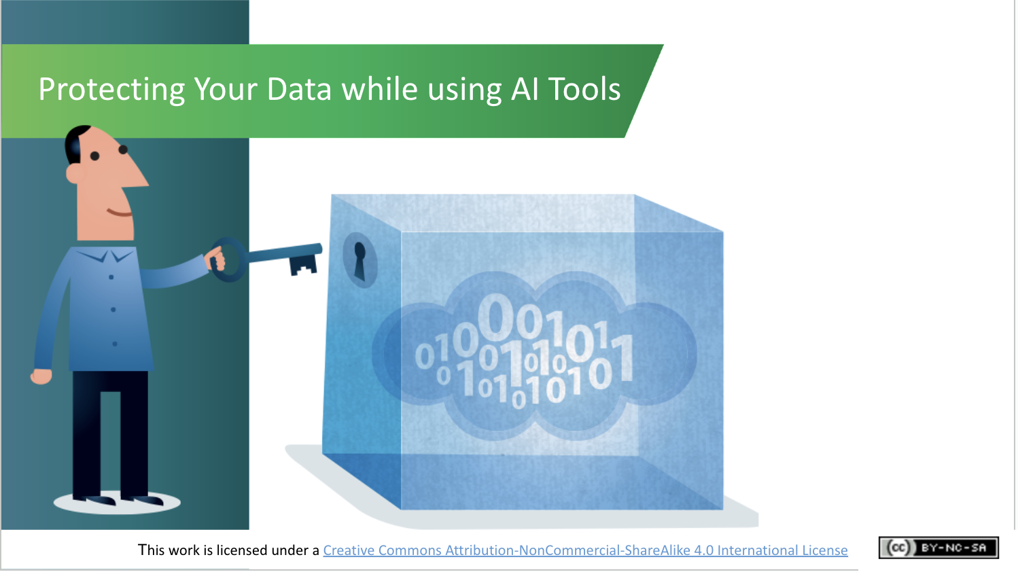 | Lecture (~1 min.)  Using digital apps and services, including those powered by AI, brings potentially significant implications for your privacy. As you would take steps to protect your privacy in the real world, you should do likewise when using digital apps.
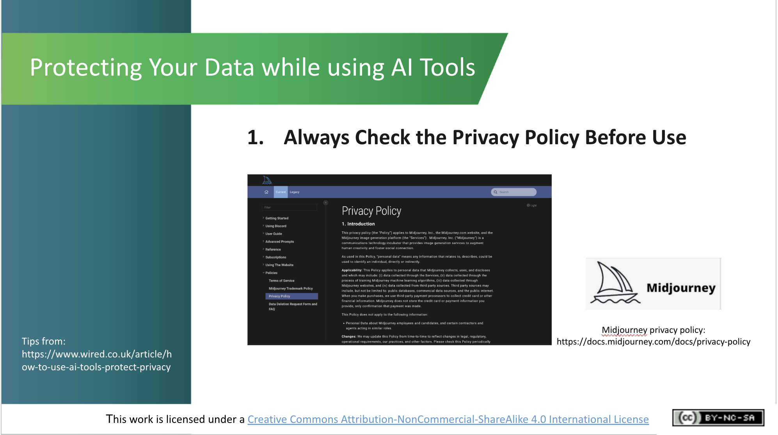 | Lecture (~1 min.)  Technology news website Wired provides 3 key tips for taking some control of your data while using AI tools and apps.  The first tip is to always check the privacy policy of the service you’re about to use. Checking the terms and conditions of apps before using them is a chore but worth the effort—you want to know what you're agreeing to.  Midjourney’s privacy statement, for example, states that while interacting with its AI image generator, you are providing certain personally identifiable information that could be used to contact or identify you, including text or image prompts you input, your location data, or public chats you maintain on Midjourney. Reading the privacy statement in full will help you understand what data is being collected from/about you and how it might be used.
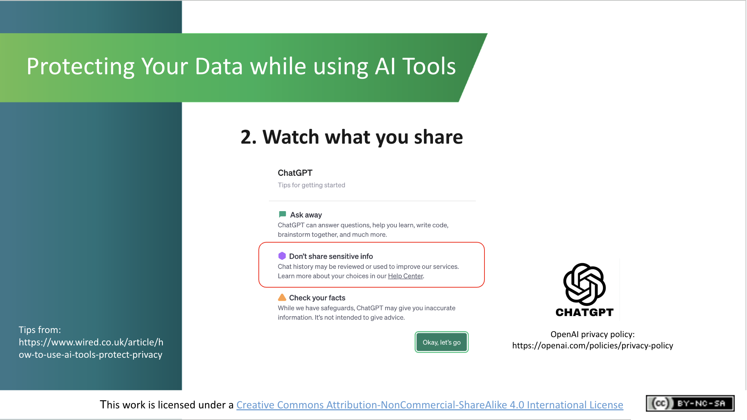 | Lecture (~1 min.)  Tip no. 2 is to watch what you share. Services like ChatGPT, for example, warn you not to share sensitive data (e.g., text or image prompts) about yourself or others, as it may store and use such data to improve its service.  Essentially, anything you input into or produce with an AI tool is likely to be used to further refine the AI and then to be used as the developer sees fit, so don’t share anything that you wouldn’t be comfortable potentially showing up publicly somewhere!
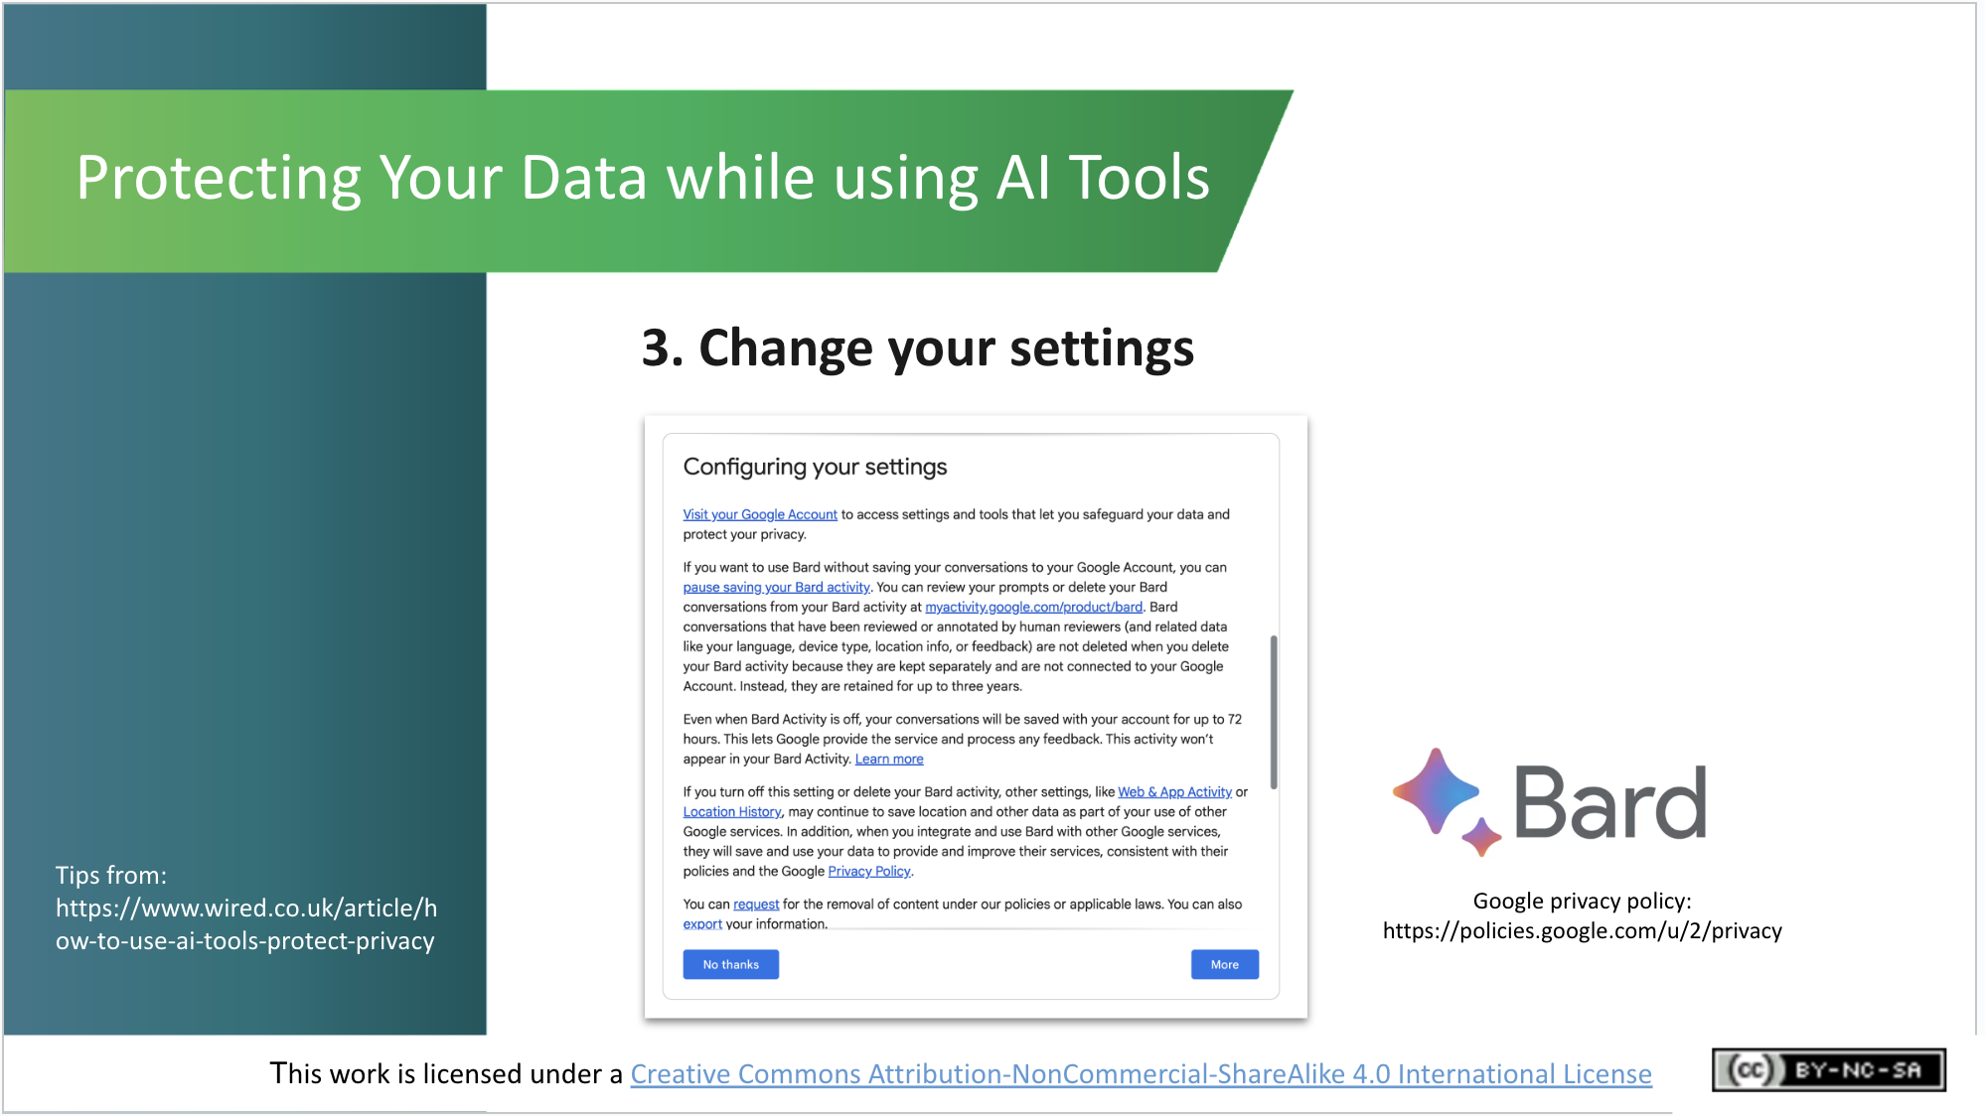 | Lecture (~1 min.)  The final tip is to explore and use the privacy and security controls you get inside your AI tools of choice. Most companies make these controls relatively visible and easy to operate.  When you go to use the Google Bard chat-based AI tool, for example, a pop-up window tells you how you can configure (or adjust) your privacy settings in order to minimise the amount of data from you that Google will share, store and use. It is worth it to take a few minutes to check and change your settings.
AI and Ethics (~9 mins.)

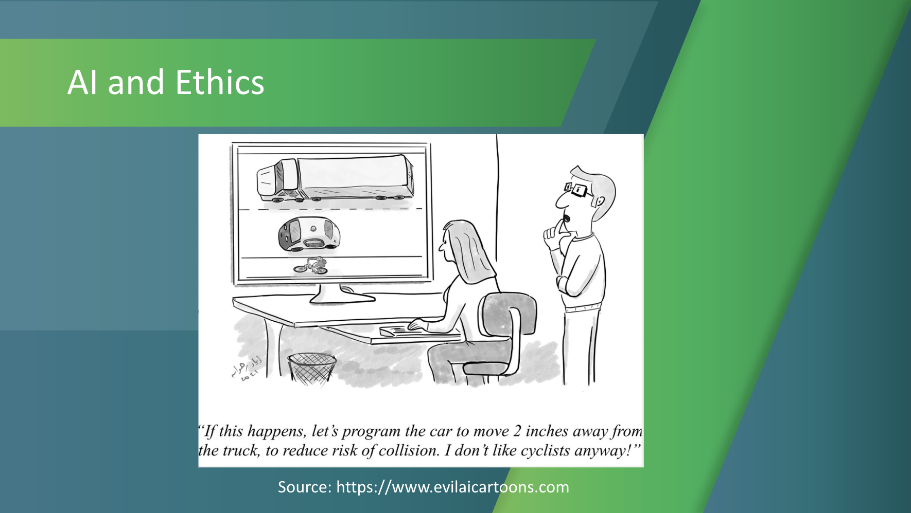 | Lecture (~1 min.)  There are many ethical concerns associated with AI development and use. These include its potential to exacerbate bias (which we’ve seen already), lack of transparency on how AI makes recommendations or decisions, and the potential of AI to replace some jobs.  The case of driverless cars highlights some of the ethical dilemmas faced by those developing AI systems.
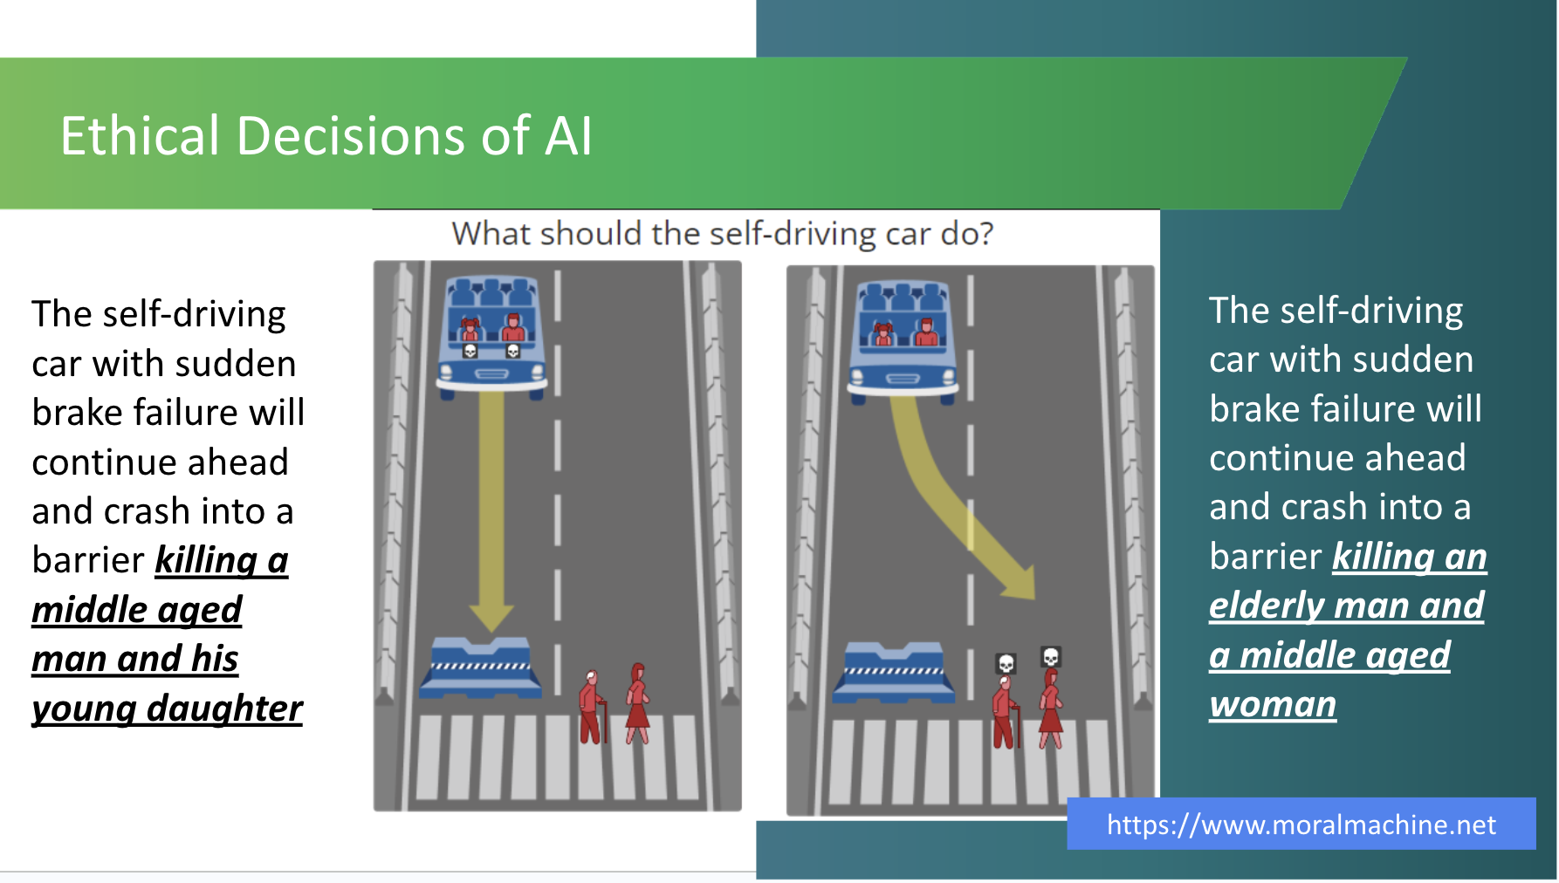 | Activity (~7 mins.)  Imagine yourself as an AI developer building a self-driving car. In the event of an impending unavoidable accident, how would you programme the car to decide what action it should take? Which of these two possible scenarios, in your mind, is the lesser of two evils?  Researchers in the USA have built a platform for gathering a human perspective on moral decisions made by machine intelligence, such as self-driving cars. They call the platform ”The Moral Machine”.  This is what ethicists refer to as an “edge case” or an extreme scenario, but it highlights the kind of ethical issues that AI can raise.  [Separate students into small groups and ask them to discuss and come to an agreement on which is their preferred course of action for the car. Ask them to report back to the whole class on their decision and the rationale for it. Then ask students how they found the activity: did they come to agreement quickly or were there different opinions in the group. Did they ever think about how AI systems like this must make ethical decisions?]  There are hundreds of these scenarios on the Moral Machine website. You can view and “judge” them yourself. You can also submit your own scenarios.
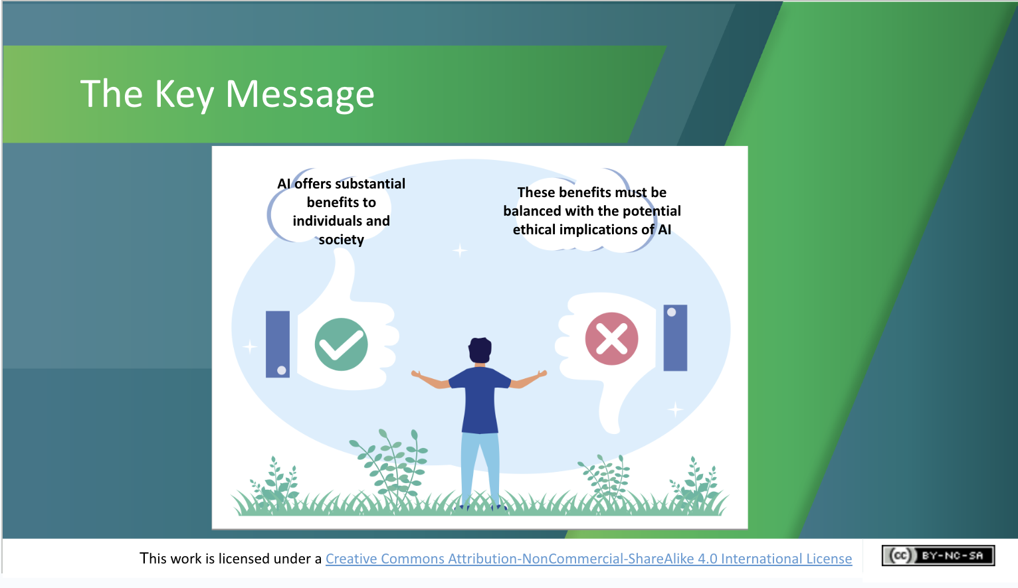 | Lecture (~1 min.)  The key message here is that AI offers substantial benefits to individuals and society – from more accurate cancer screening and fraud prevention, to automating repetitive tasks and maybe even safer car journeys. These benefits must be balanced with the potential ethical implications of AI, however, in order to ensure a safer and fairer ‘Age of AI’ for all.
Recap and Evaluation (~6 mins.)
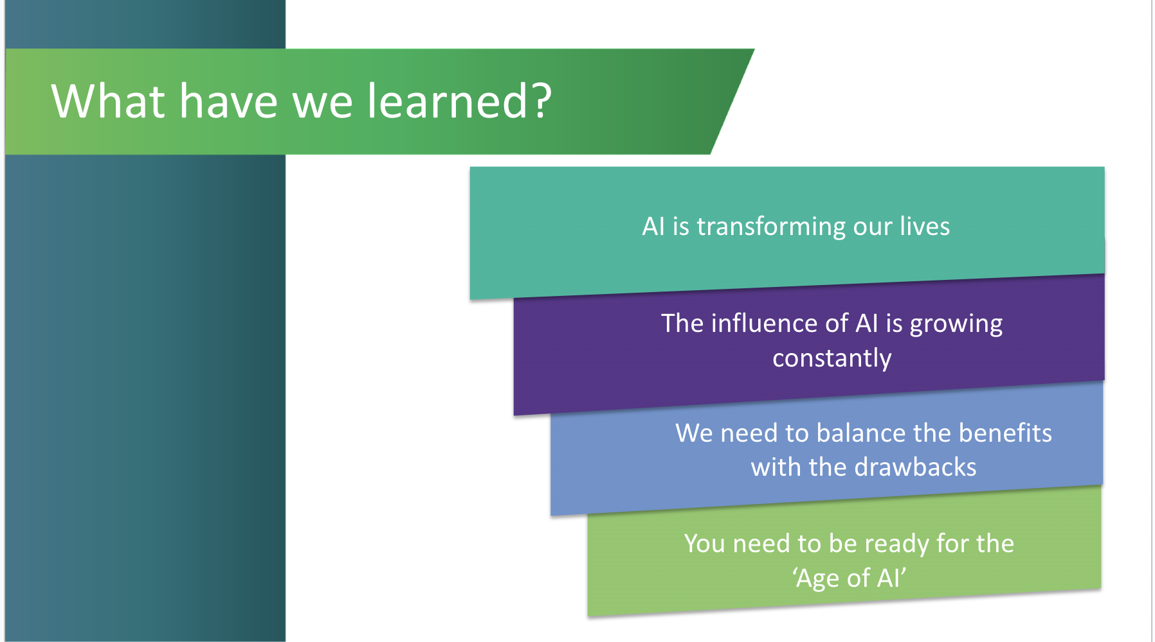 | Lecture (~1 min.)  A brief recap on what students have learned in this module and an opportunity to ask questions about topics they would like to explore more.  - AI is transforming our lives  - The influence of AI is growing constantly  - We need to balance the benefits with the drawbacks  - You need to be ready for the ‘Age of AI’
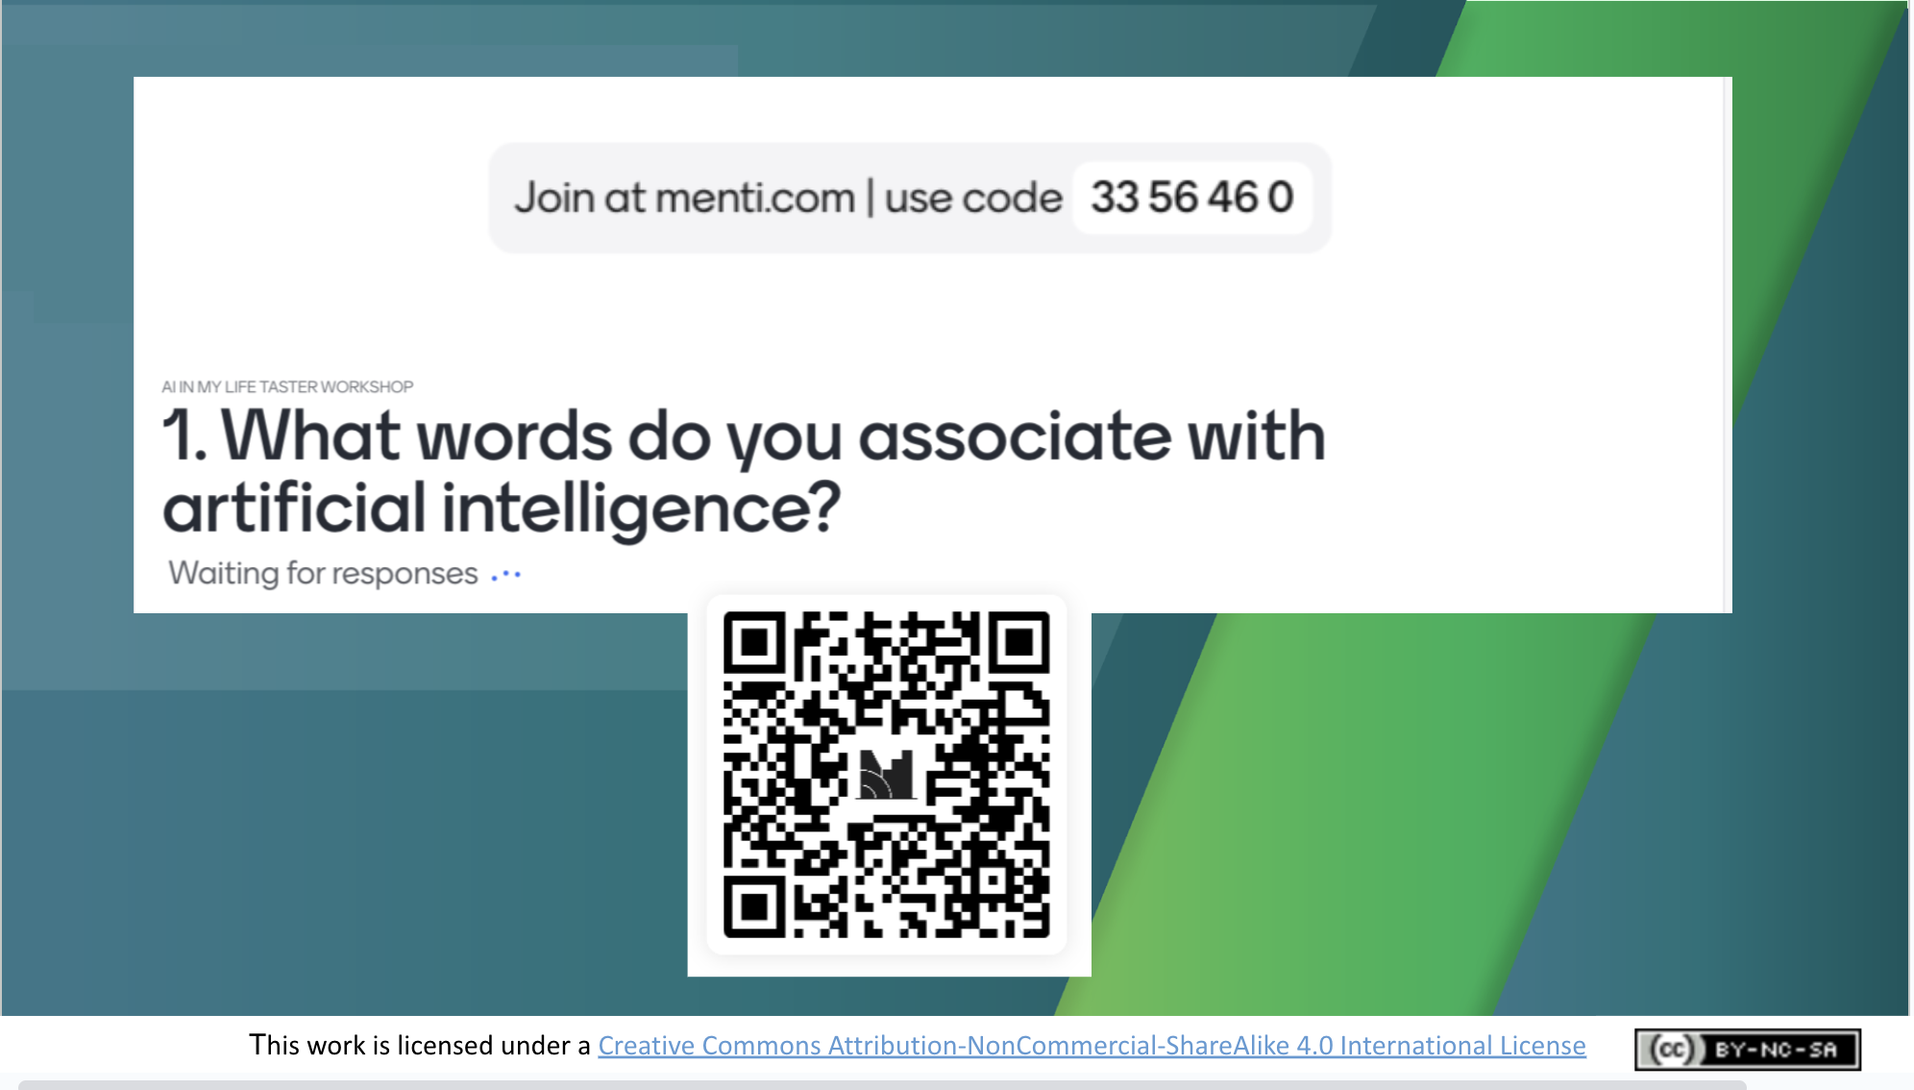 | Activity (~5 mins. total)  We’re going to finish by repeating the Mentimeter survey. This will take about 5 mins.  The survey will ask you if (or how) your knowledge of or attitude to AI has changed by doing the module, and what you thought of it.  Again, your answers will be anonymous and will only be used to help the AI in My Life evaluation team to evaluate and improve this module.  Access the survey on your phone or tablet by scanning the QR code or by visiting menti.com and entering the code at the top of this slide.
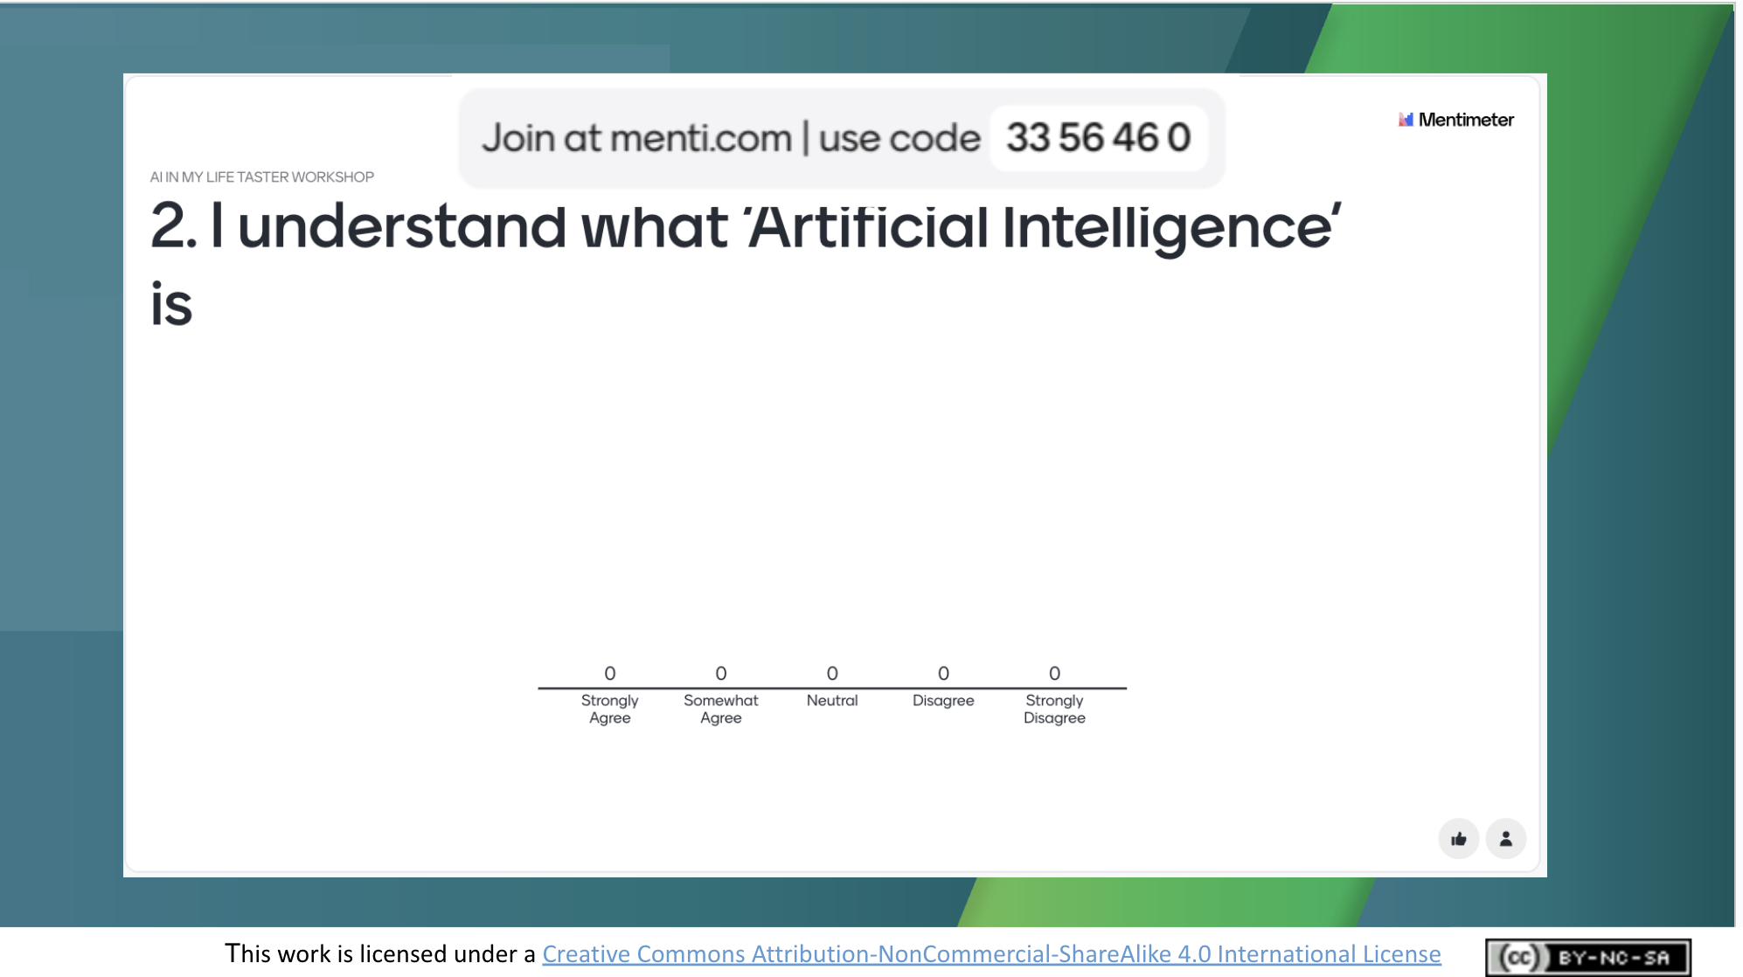 | Activity  Proceed to answer Question 2 as quickly as you can.
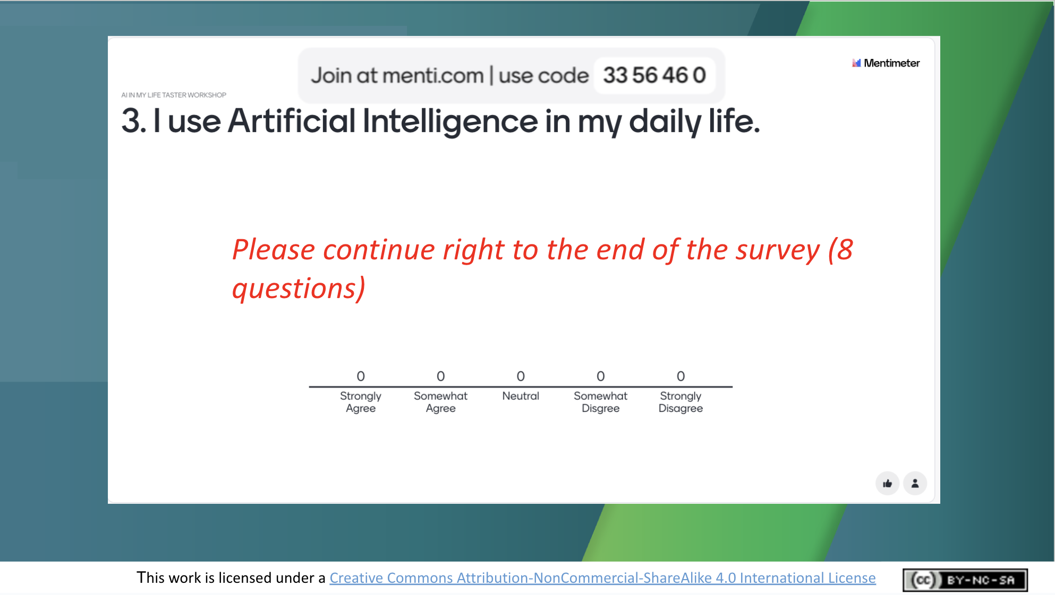 | Activity  Proceed to answer Question 3 as quickly as you can, and then work through to the end of the survey. There are 8 short questions in total.  Thank students for their answers – they’ll be valuable in helping us understand what they thought of the module!
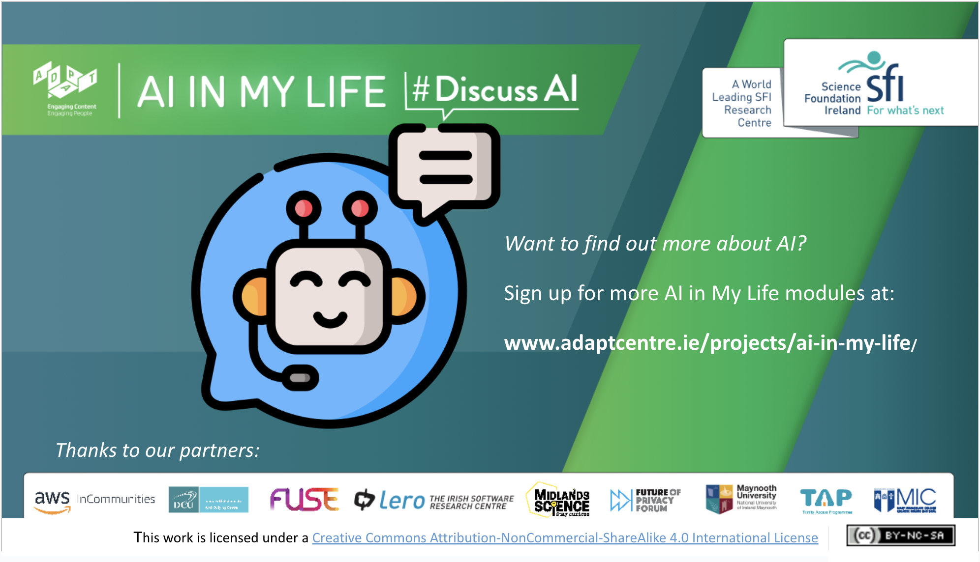 | That’s it for the AI in My Life taster module.  We hoped you enjoyed this workshop.  Don’t hesitate to contact us if you’d like to try out more modules.

Curriculum Links

In addition to its relevance to honing the key skills central to teaching and learning across the Transition Year curriculum, the STEAM focus makes the AI in My Life content relevant to the following subjects:

Leaving Certificate:
Technology
Politics and Society
Computer Science
Design and Communication
Business
Economics

Applied Leaving Certificate:
Engineering
Technology
Social Education
Science
Information and Communication Technology – Specialism

Additional Resources
The following resources provide additional background on the topics covered in this module:

- How to Spot a Deepfake
https://time.com/6266606/how-to-spot-deepfake-pope/

- Why are Women Beautiful and Men Intelligent? [Video featuring Eva Vanmassenhove’s work on detecting and combatting gender bias in machine translation systems. Eva was formerly a researcher with the ADAPT research centre at Dublin City University]
https://www.universiteitvannederland.nl/colleges-en/why-are-women-beautiful-and-men-intelligent

- New ‘voice banking’ technology to help Charlie Bird and other MND sufferers [Irish Times article]
https://www.irishtimes.com/news/ireland/irish-news/new-voice-banking-technology-to-help-charlie-bird-and-other-mnd-sufferers-1.4776786

If you have questions or comments about this lesson,
please contact us at education@adaptcentre.ie

