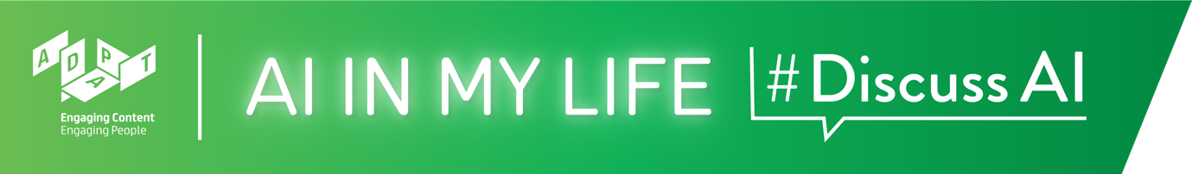

AI and the Future of Work Teacher Guide

AI and the Future of Work
This module will introduce students to how Artificial Intelligence (AI) is transforming the world of work. They will learn how AI will disrupt some jobs while replacing others, and they’ll explore the multidisciplinary nature of AI.

Time: ~1 hour*

*If your classes are 40 mins. long rather than 1 hour, we recommend that you select the topics you feel are most important and/or shorten some of the interactive activities.

Background
This module focuses on the prevalence and transformative nature of AI across almost all sectors of industry. The Careers in AI module highlights the varied job opportunities for those interested in AI, as well as relevant options for further study related to the field of AI. Although there are no prerequisites for this module, it would be useful to cover the Introduction to AI module with students first, so that they already understand AI and its increasing role in society.

Curriculum Links
The interactive and reflective nature of AI in My Life ensures that students will hone the five key skills central to teaching and learning across the Transition Year curriculum:
- Information processing
- Critical and creative thinking
- Communicating
- Working with others
- Being personally effective

An outline of links to the Leaving Certificate curriculum is provided after the module walkthrough.

Materials Needed: PowerPoint presentation, Laptop, Screen, Internet Access, Timer

Module Overview

Introduction (~4 mins.)
A quick introduction to the module, outlining learning goals and what is Artificial Intelligence

AI and the World of Work (~11 mins.)
A brief look (through video examples) at how AI is being used across many industries and how it’s transforming the world of work.

Will a robot take my job? (~25 mins.)
Interactive polls will assess students’ attitudes/fears around the increasing impact of AI on jobs. We will also consider what kind of jobs are most likely to be displaced by AI.

AI: A Multidisciplinary Field (~12 mins.)
Explores what we mean by “multidisciplinarity”, providing a short video example. Students will discuss in teams a scenario that highlights the range of expertise required to develop and employ AI systems effectively.

Futureproof Yourself (~5 mins.)
Outlines some ways in which students can prepare themselves for the ever-changing world of work in this Age of AI.

Recap (~3 mins.)
A brief recap on what students have learned in this module and an opportunity to ask questions about topics they would like to explore more.

AI and the Future of Work
Module Walkthrough
Learning Intentions
- Understand the role that AI plays in many industries
- Describe how AI is transforming the world of work
- Explain why AI requires expertise of people from many fields

Introduction (~4 mins.)

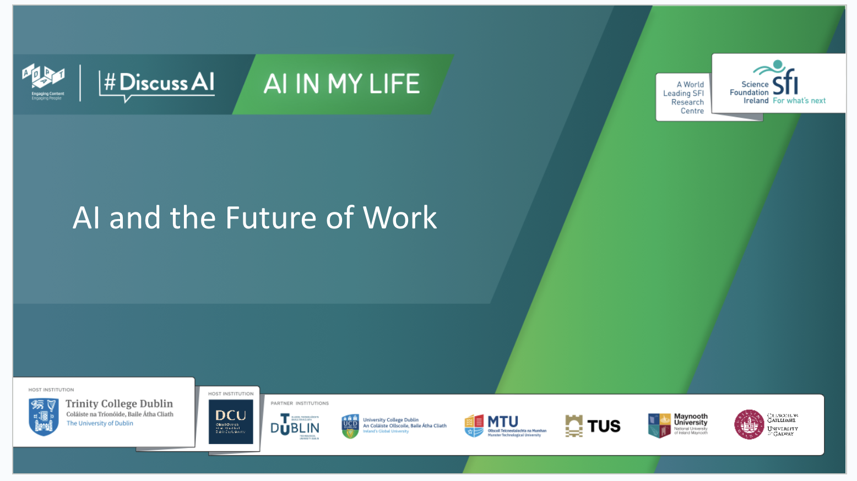 | Lecture (2 mins)  Tell students that AI in My Life is a modular workshop series on Artificial Intelligence (AI). It was developed by the Science Foundation Ireland ADAPT Research Centre.  ADAPT is a major academia-industry research centre with more than 300 researchers from 8 Irish universities (hosted by Trinity College Dublin and Dublin City University) producing research and innovations in many aspects of AI.
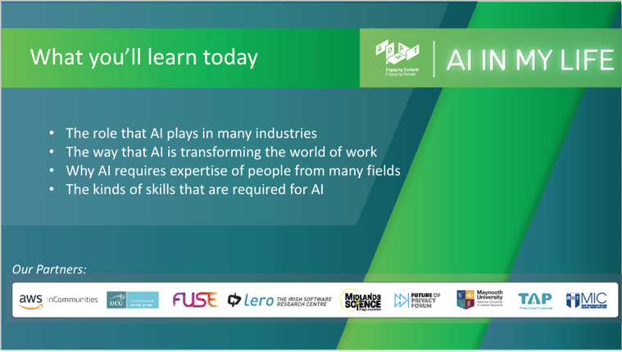 | Lecture (1 mins)  Outline to students what they should be able to do by the end of this module.
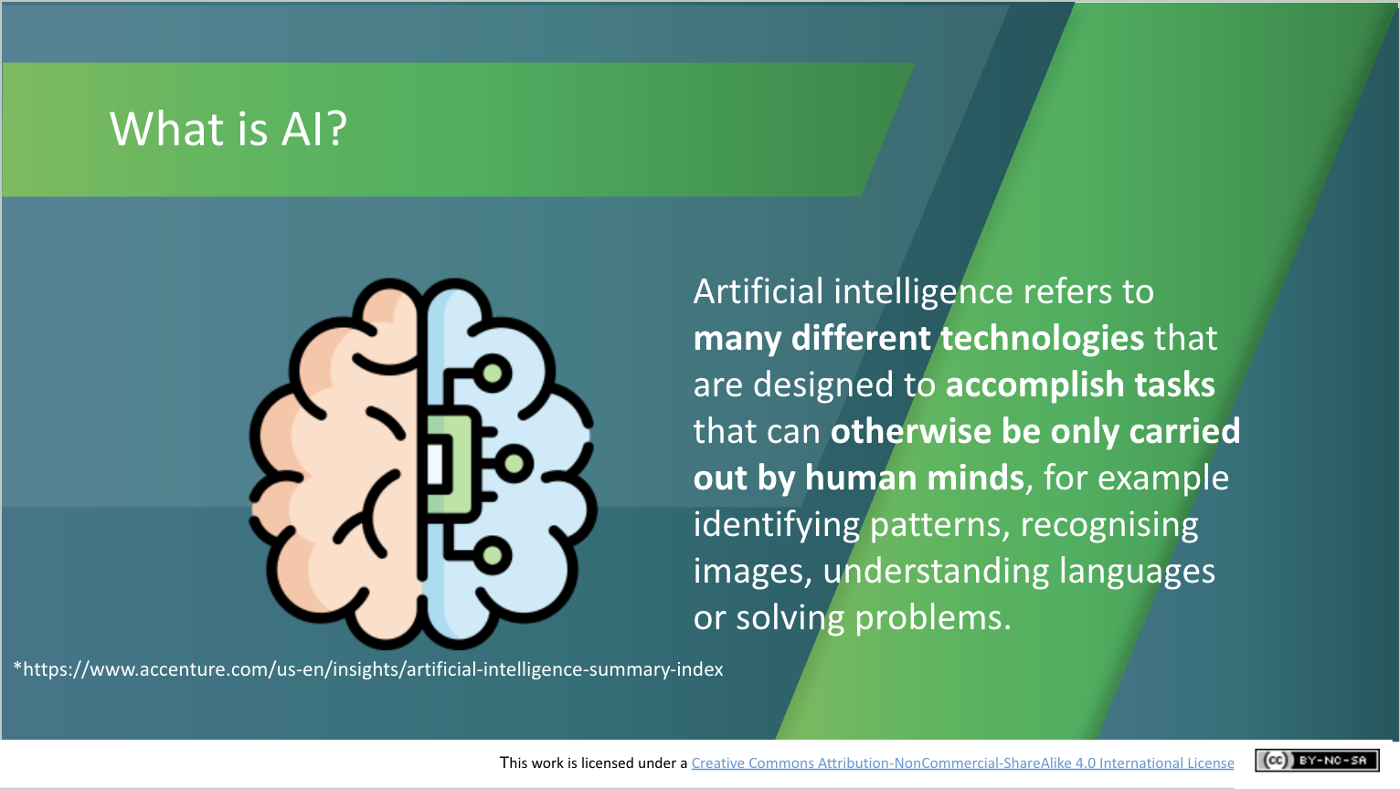 | Lecture (1 min)  Go through the following definition, checking that students understand:  Artificial intelligence refers to many different technologies that are designed to accomplish tasks that can otherwise be only carried out by human minds, for example identifying patterns, recognising images, understanding languages or solving problems.
AI and the World of Work (~11 mins.)
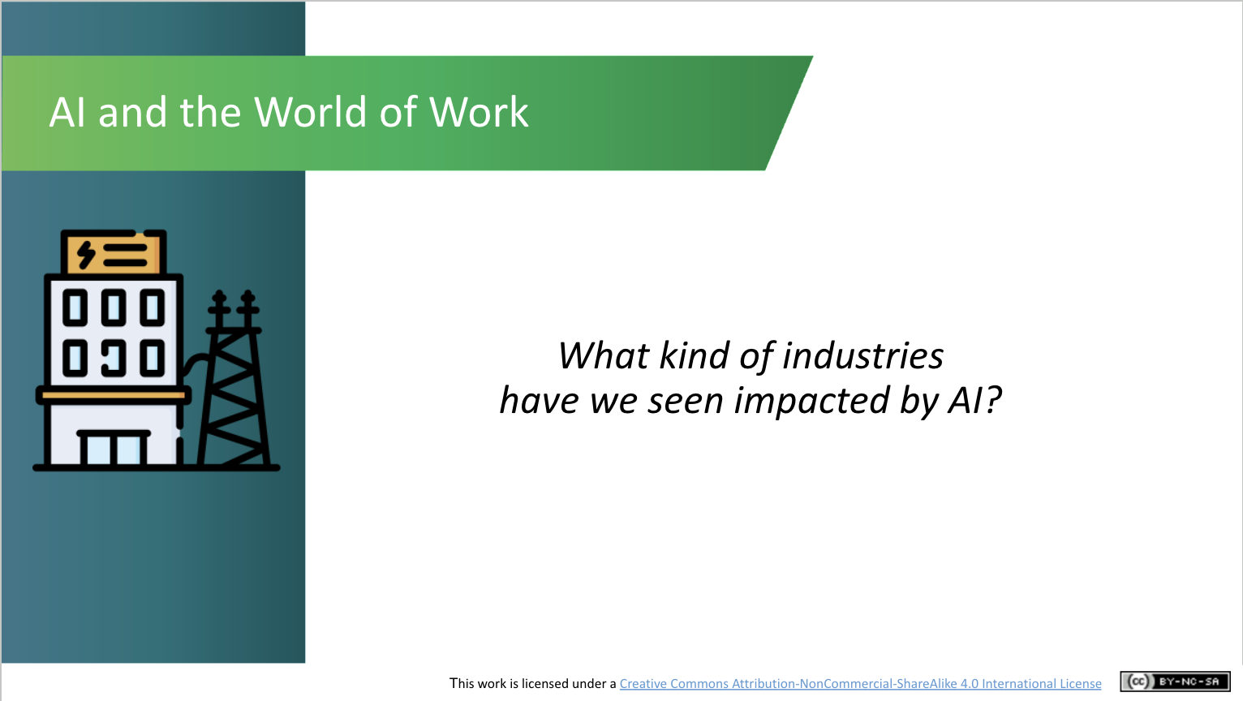 | Discussion (2 mins)  If students have taken other AI in My Life modules, ask students to reflect on what industries we have seen impacted by AI.  If students are new to the course, ask them if they can think of or imagine examples of industries where jobs are/might be changed or replaced by AI.  Are there any industries or jobs that they think couldn’t be replaced by AI? Why?
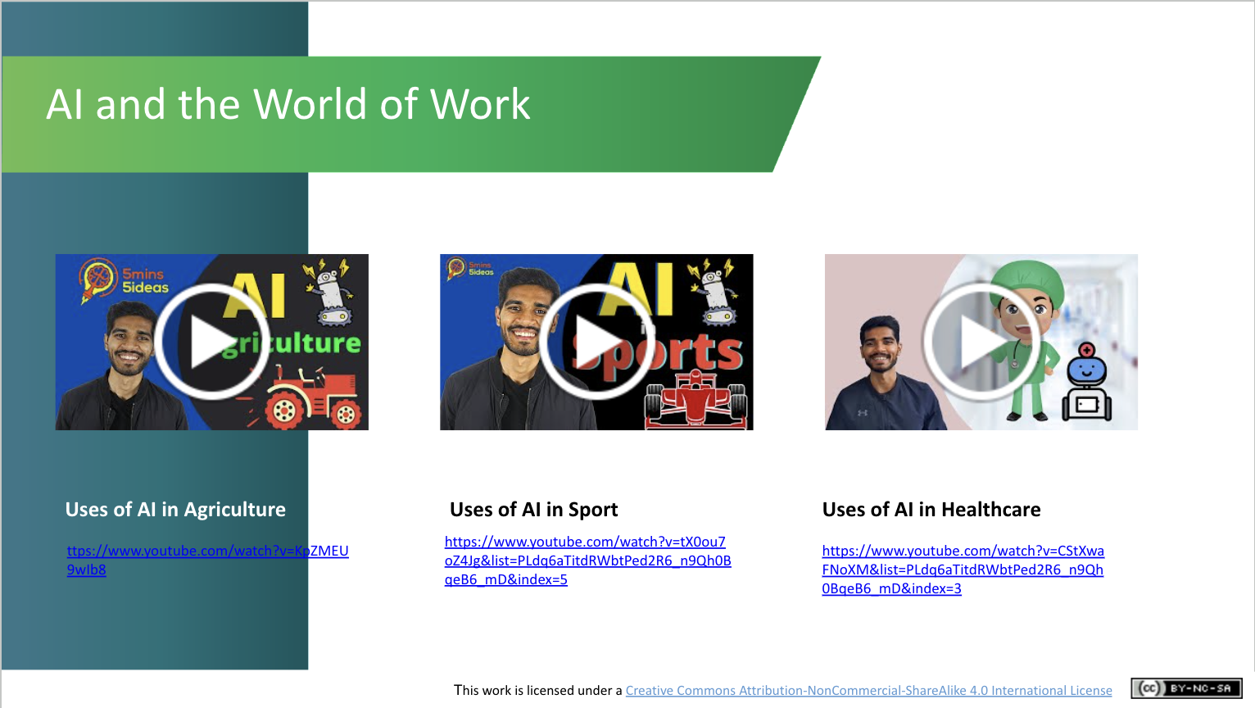 | Activity (4 mins)  In these “5 minutes, 5 uses of AI” videos,  Samanvay Karambhe explains 5 ways in which AI are transforming an industry: Agriculture (3 min video), Sport (4.06 mins), or Healthcare (3.15 mins).  Ask students to select the one in which they are most interested in and view that video.  Discussion (3 mins)  What kind of advantages does AI make in these fields (e.g., cost reductions, greater efficiencies, more accurate performance of tasks)? Can students see themselves working in any of these industries? Had they ever considered how AI might change the kind of work they do?
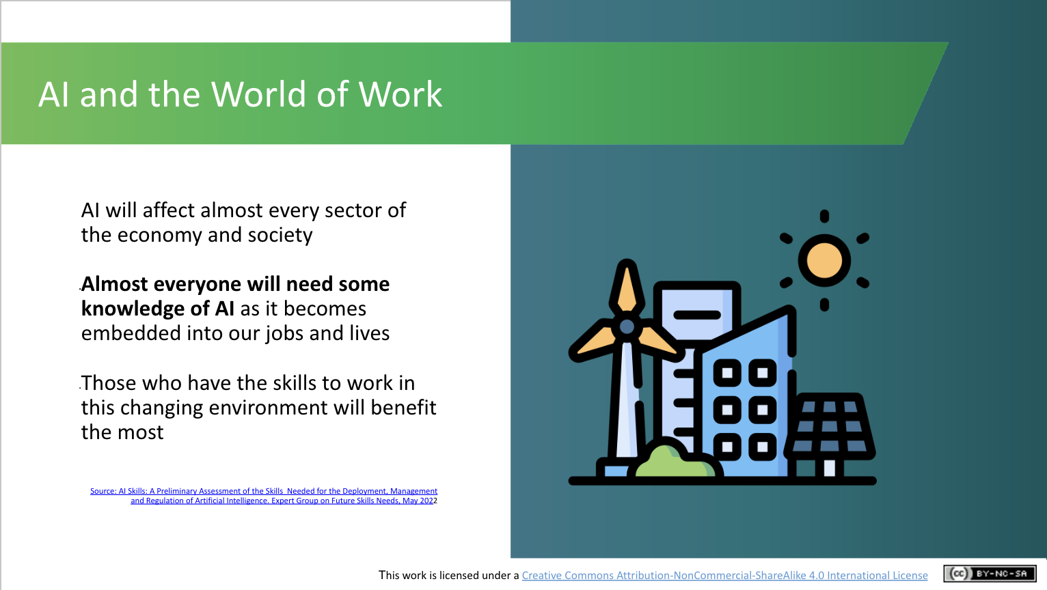 | Lecture (2 mins)  AI will affect almost every sector of the economy and society into the future.  As a result, almost everyone will need some knowledge of AI.  Those with the skills to work in this changing environment will benefit most, so get yourself ready!
Will a Robot take my Job? (~25 mins.)

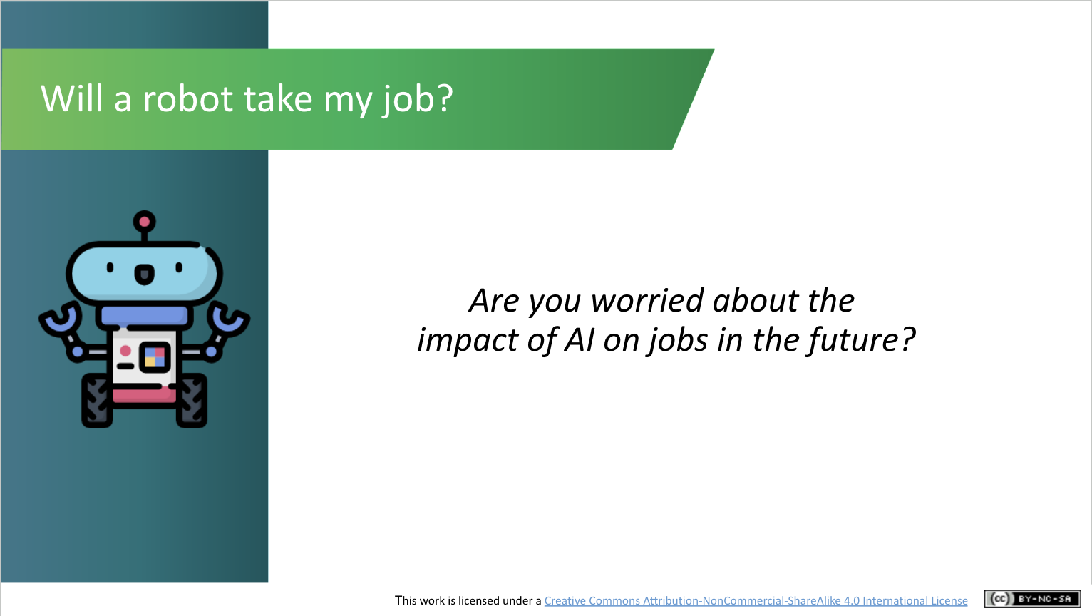 | Activity (3 mins)  Ask students if they are worried about the impact of AI on jobs in the future. You could do this by simply asking them for a show of hands (i.e., are you worried about robots replacing the job you’d like to do?) or invite their thoughts via a word cloud around their emotions when they think of this issue.
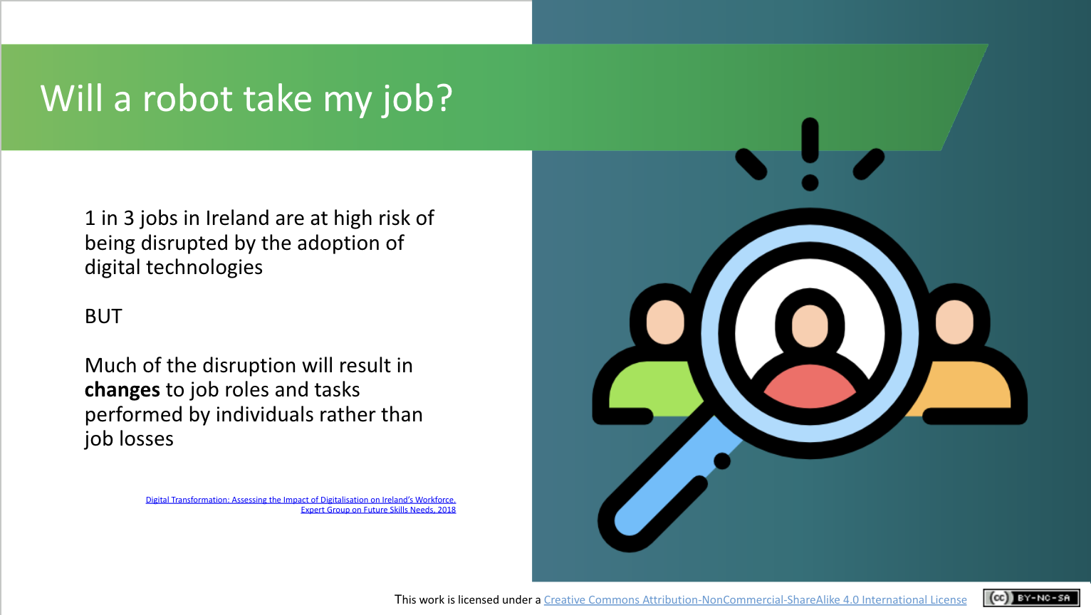 | Lecture (2 mins)  Research published recently by an expert group set up by the Irish Government reported that 1 in 3 jobs in Ireland are at high risk of being disrupted by the adoption of digital technologies, but much of the disruption will result in changes to job roles and tasks rather than job losses.  In theory, AI should improve productivity by assisting workers in carrying out tedious or physically demanding tasks, while allowing workers to leverage their own uniquely human abilities.
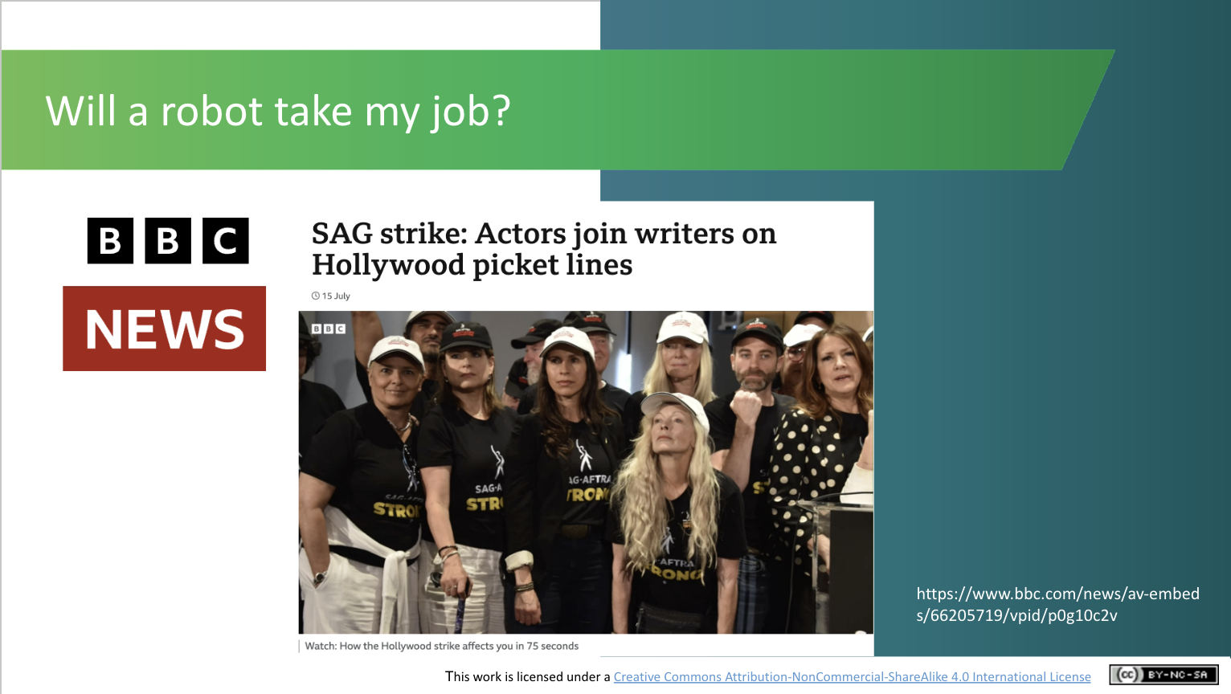 | Activity (5 mins)  For much of 2023, more than 11,000 film and TV writers in the U.S. have been on strike, protesting in part against the increasing role AI is playing in their industry. They’ve been joined by actors, including many famous  Hollywood names.  Until relatively recently, it was thought jobs in the creative industries, including journalism, writing and acting, were immune to being replaced by AI, but recent advances mean this may no longer be the case.  This video (1.15 mins) from the BBC News website [click on the main image to open it] gives a good synopsis of what has been happening. As of 12th October, 2023 talks between actors and studios had broken down again and so it would be wise to check on the current situation before discussing this topic.  However, this is a good, recent and highly publicised example showing the fear around the impact of AI on jobs. The following slides will explore whether this fear is warranted.
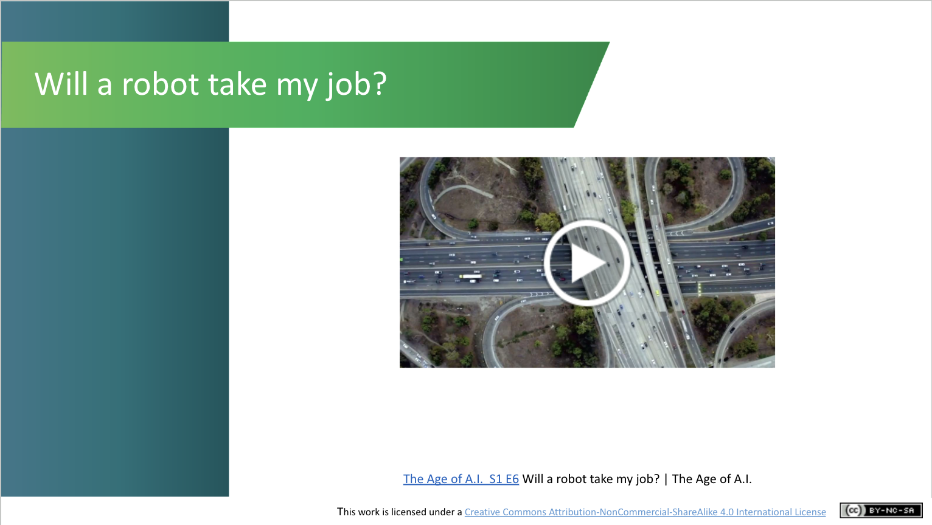 | Activity (8 mins)  Play the video (7 min.s) asking ‘Will AI take my Job?’  This is a snippet from one episode of ‘The Age of AI’, a fascinating YouTube series, presented by the actor Robert Downey Jr., covering many aspects of AI and its (real or potential) impact on our lives. It’s rather long but we think it explains excellently the impact of AI on work.
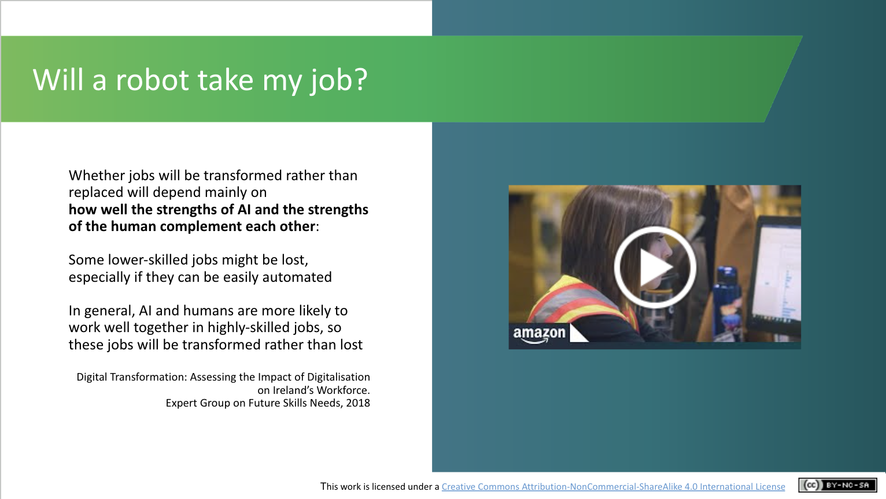 | Lecture (3 mins)  What will determine whether a job is likely to be replaced by AI?  An expert group which produced a report on Digital Transformation in 2018, stated that the reasons for transforming jobs rather than replacing them will depend largely on how well the strengths of AI and the strengths of the human complement each other.  Some lower-skilled jobs might be lost, especially if they can be easily automated.  In general, AI and humans are more likely to work well together in highly-skilled jobs, so these jobs will be transformed rather than lost.  The video (1.26 mins) from the Amazon warehouse provides a good example of this.
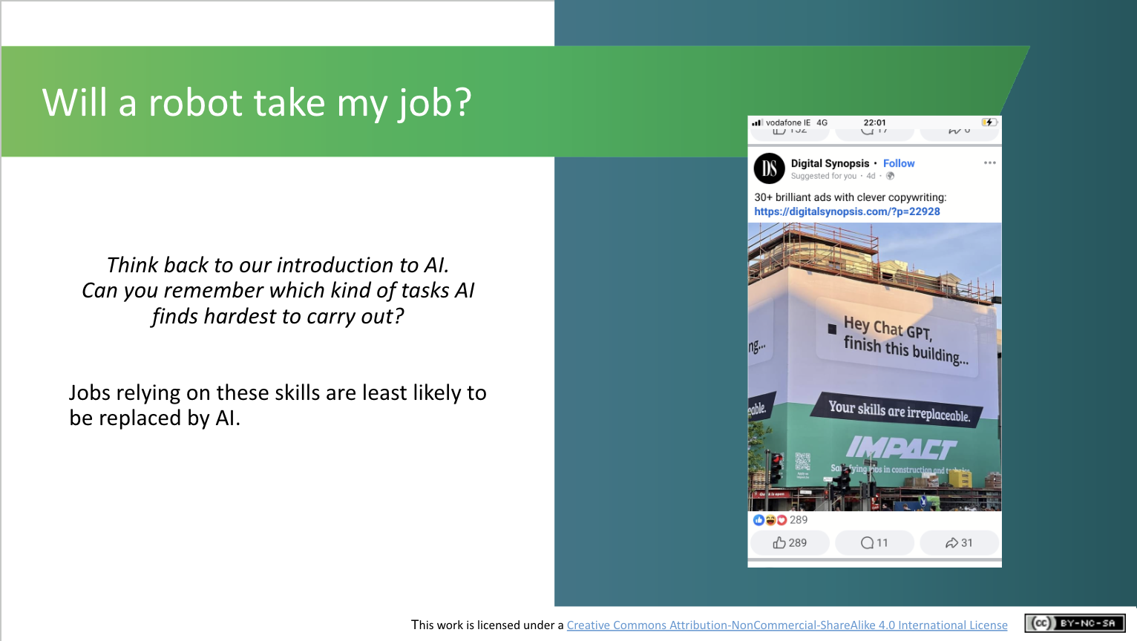 | Discussion (1 min)  Ask students to think back to the Introduction to AI workshop when they discussed the different tasks AI finds it hardest to do.  The image of a construction site provides a tongue-and-cheek comment to the physical tasks that AI can carry out.
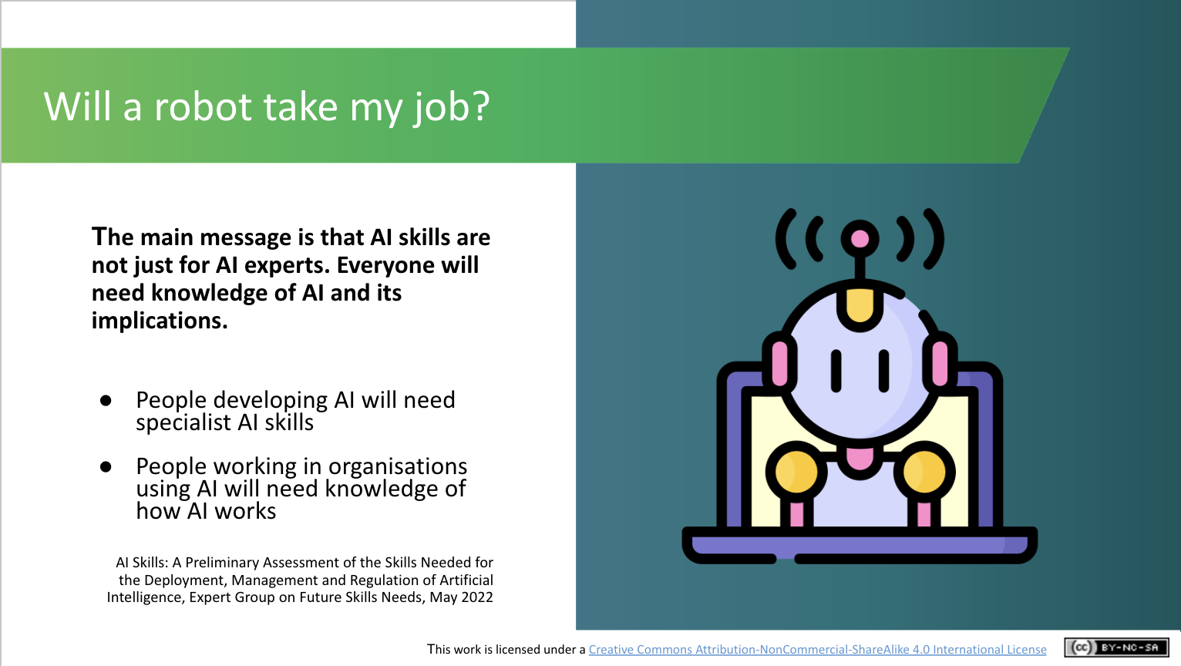 | Lecture (1 min)  The main message is that, whether you see yourself working developing systems or not, everyone will need AI skills.  People developing AI will obviously need AI skills, but people working in organisations using AI (which is an increasing phenomenon) will also need knowledge of how AI works.
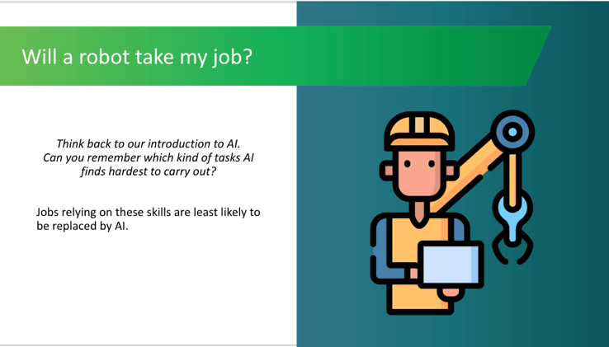 | Discussion (2 mins)  If your students have taken the Introduction to AI module, ask them if they can remember what kind of tasks AI finds most challenging. (2 slides from the Introduction to AI module have been added to the end of presentation if you would like to revisit them)  Jobs based on these skills are least likely to be replaced by AI.  If your students did not complete the Introduction to AI module, you can explain that it’s usually considered that roles requiring creativity and empathy (i.e., the ability to understand and share the feelings of another) are more difficult to replace by AI. In theory, AI should improve productivity by assisting workers in the execution of tedious or physically demanding tasks, while allowing workers to leverage their own uniquely human abilities.
AI: A Multidisciplinary Field (~12 mins.)

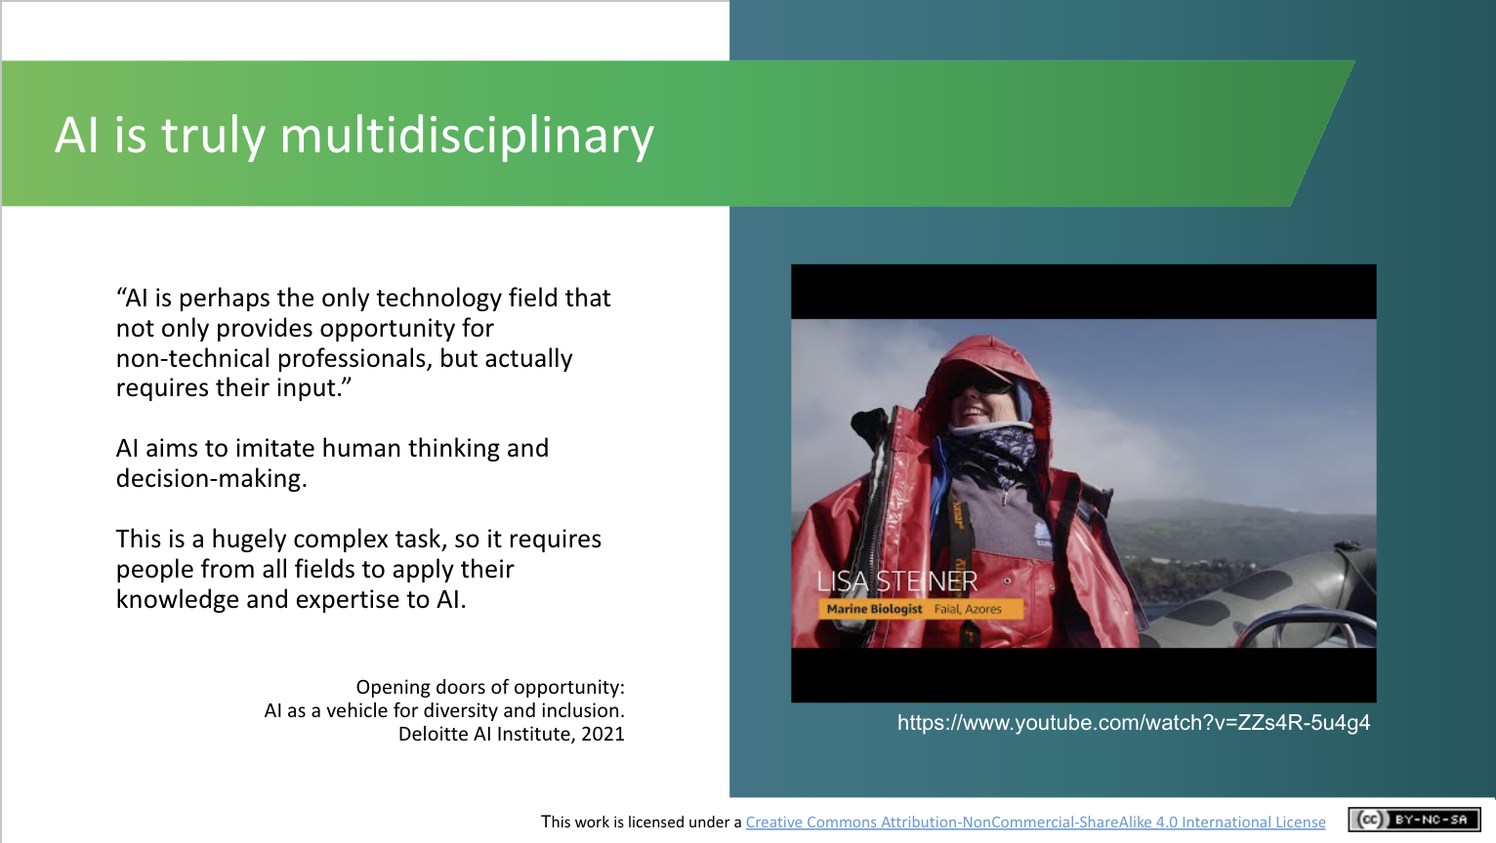 | Lecture (1 mins)  Explain this quote from the Deloitte AI Institute.  Discussion (2 mins)  What do students understand “multidisciplinary” to mean? What kind of disciplines do they think combine to build AI?  Activity (2 mins)  Students who've done the Intro. to AI will have seen this video (Machine Learning: A Whale Tale https://youtu.be/ZZs4R-5u4g4 - 3.30 mins) already, so if you have completed this module just recap briefly on what the video covered i.e. how AI/machine learning is transforming the work of marine biologists.  This is an example of the multidisciplinary nature of AI. Machine learning experts are collaborating with marine biologists to use the analytical strengths of AI to replace the most cumbersome aspects of marine biologists’ work.
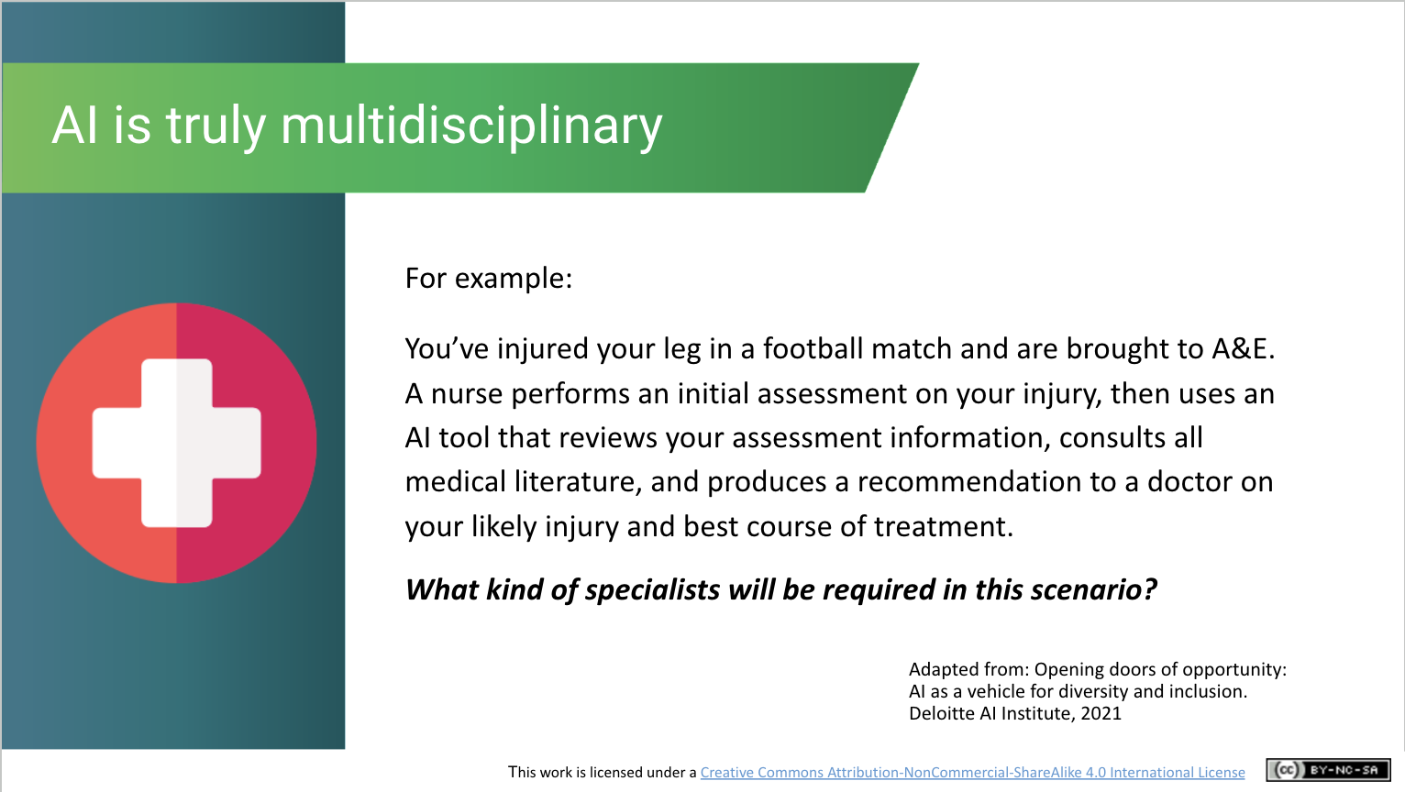 | Discussion (2 mins)  Read out this healthcare admissions scenario, then ask students to consider what kind of expertise will be needed. You might need to explain briefly what we mean by “medical literature”.  We need technical experts to build AI systems. AI also requires dual skilling, where subject matter experts (such as healthcare professionals in this scenario) understand how to use AI to enhance their jobs.
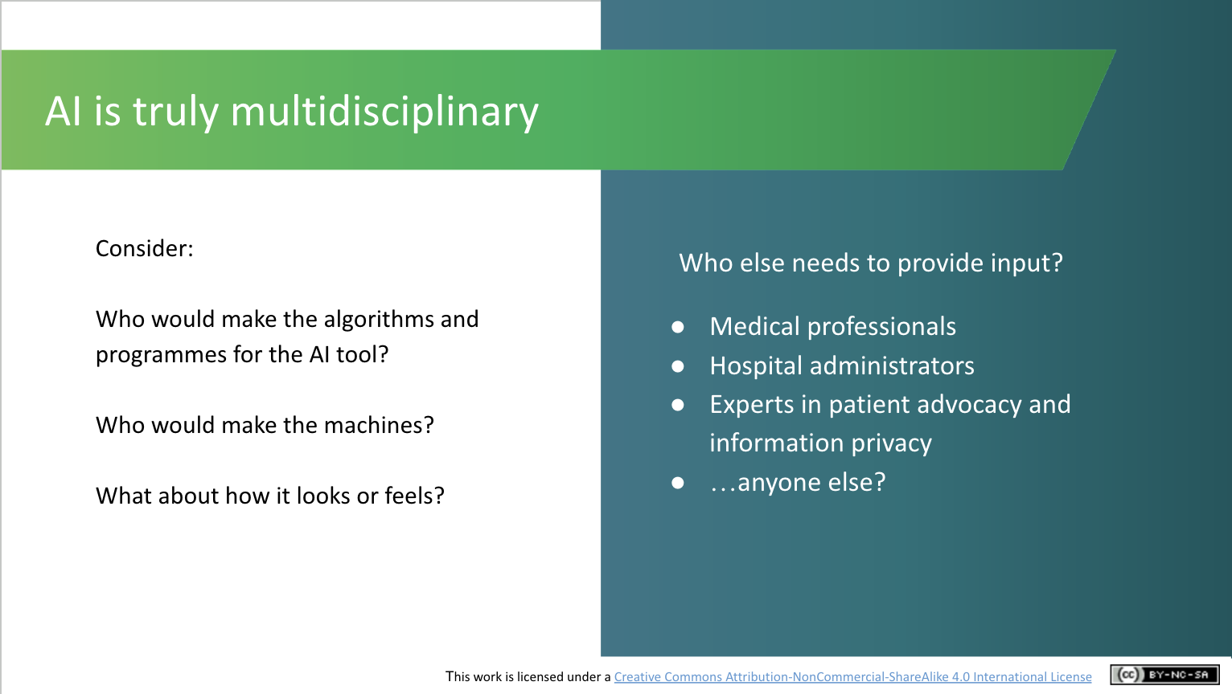 | Discussion (3 mins)  With the time you have remaining in this section, ask students to consider:  Who would programme this AI tool? [answer e.g., a computer scientist]  Who would make the physical machines? [answer e.g., an engineer]  Who would decide how it should look or feel? [answer e.g., a psychologist or graphic designer]  The word algorithm is provided on the slide. Ask the students what they understand an algorithm to be.  An algorithm is a set of instructions for solving a problem or accomplishing a task. Computer algorithms work via input and output. When data is entered, the system analyses the information given and executes the correct commands to produce the desired result.
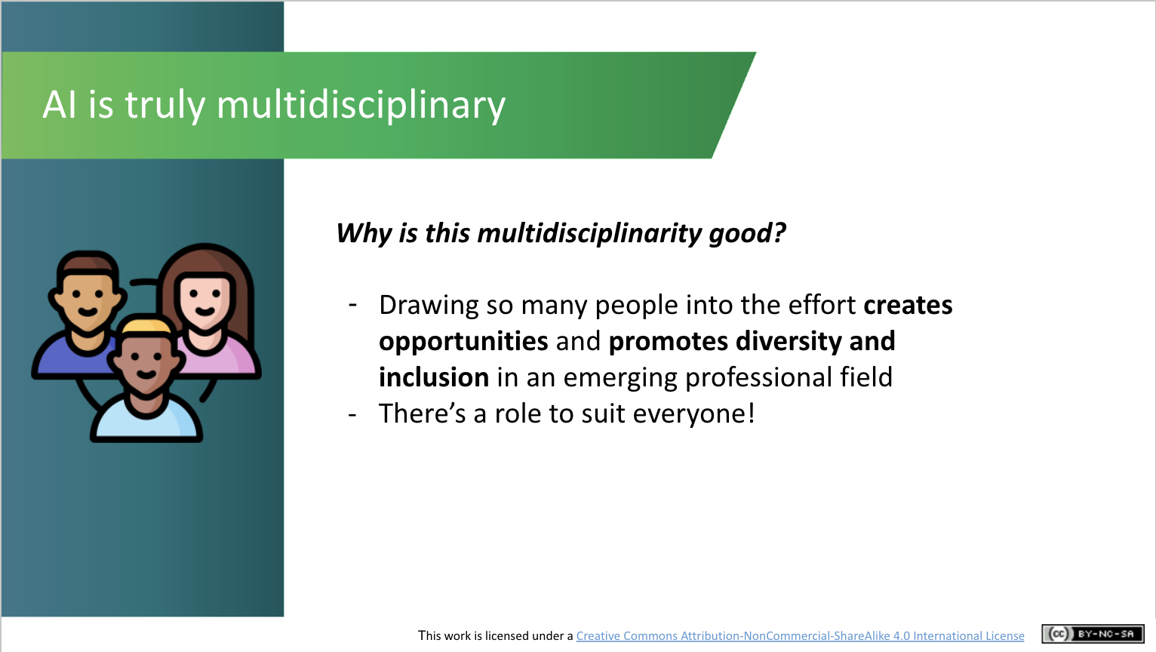 | Lecture (2 mins)  Explain that the multidisciplinary effort required for AI development can help promote diversity and inclusion in this new professional field, i.e., it can attract people from very different backgrounds with very different life experiences. This means there’s potentially a role for everyone.
Futureproof Yourself (5 mins.)

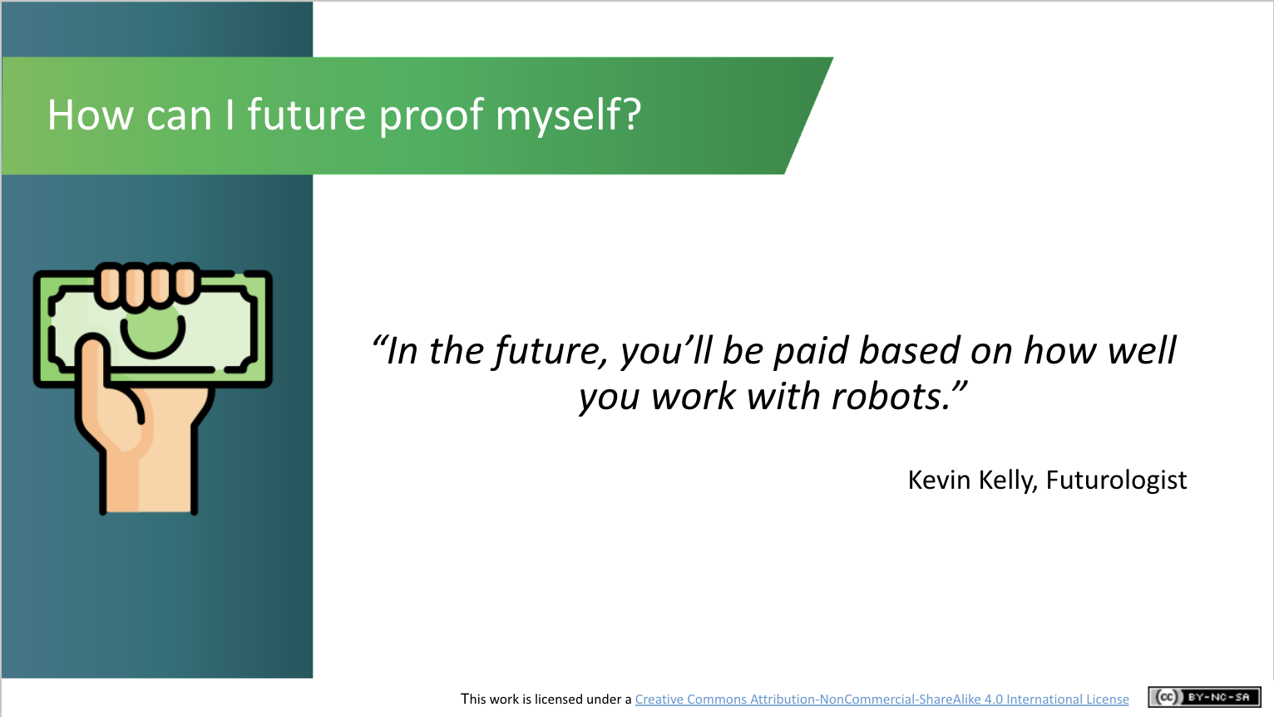 | Lecture (2 mins)  Futurologist Kevin Kelly (who makes educated predictions about future trends) has predicted that “In the future, you’ll be paid based on how well you work with robots”.  While this might not be true for all jobs, it certainly hints at the extent of impact that AI will have on the future of work. How can you get yourself ready for this continuing revolution?
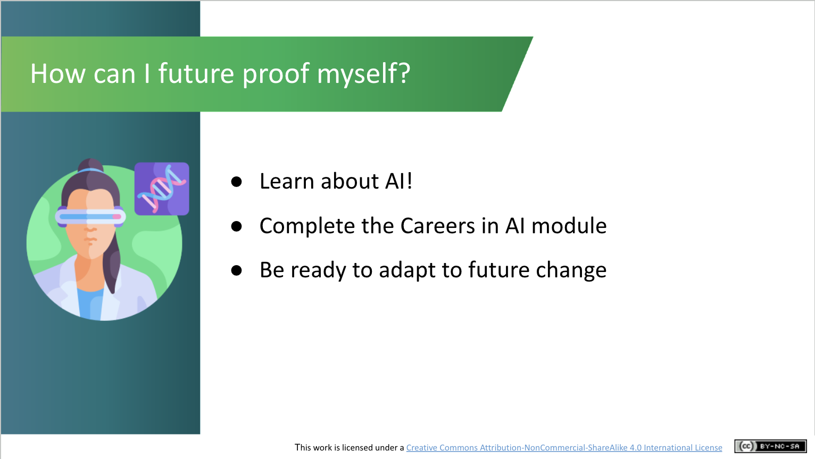 | Lecture (3 mins)  Advise students they can prepare themselves to fare best in the Age of AI by learning about AI, completing the AI in My Life Careers in AI module, and stay flexible so that you can adapt successfully to future changes in the world of work.
Recap and Closing (3 mins)
Activity (2 mins)
Ask students again if they are worried about the impact of AI on jobs in the future. Again, you could do this by simply asking them for a show of hands (i.e., are you worried about robots replacing the job you’d like to do?) or invite their thoughts via a word cloud (generated by interacting with Kahoot, Sli.do, Mentimeter or similar tool) around their emotions when they think of this issue. Note if there are any changes in the class’s aggregated response. Hopefully they’re less fearful now that they know more about AI and its impact on the world of work!
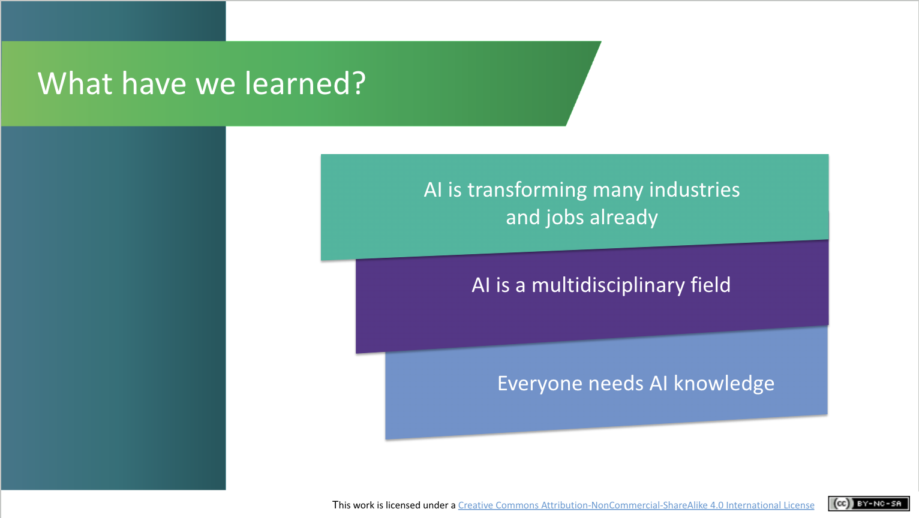 | Lecture (1 mins)  Give a brief recap on what students have learned in this module. If time allows, invite them to ask questions about topics they would like to explore more.
Curriculum Links

In addition to its relevance to honing the key skills central to teaching and learning across the Transition Year curriculum, the STEAM focus makes the AI in My Life content relevant to the following subjects:

Leaving Certificate:
Technology
Politics and Society
Computer Science
Design and Communication
Business
Economics

Applied Leaving Certificate:
Engineering
Technology
Social Education
Science
Information and Communication Technology – Specialism

Additional Resources
The following resources provide additional background on the topics covered in this module:

- The Hollywood Writer’s Fight is Everyone’s Fight
Article from Spanish newspaper El País on the Hollywood Writers’ Association strike, which in part is due to fears over AI replacing writers’ jobs: https://english.elpais.com/opinion/2023-08-25/the-hollywood-writers-ai-fight-is-everyones-fight.html

- How AI is changing the Face of Hollywood
2-min. video from US-based CBS News on how generative AI is transforming the TV and movie industry: https://youtu.be/7IfkamIf_IM
- AI Skills: A Preliminary Assessment of the Skills Needed for the Deployment, Management and Regulation of Artificial Intelligence
Report of the Irish Government’s Expert Group on Future Skills Needs (2022)
https://www.skillsireland.ie/all-publications/2022/ai-skills-report.html

If you have questions or comments about this lesson,
please contact us at education@adaptcentre.ie

