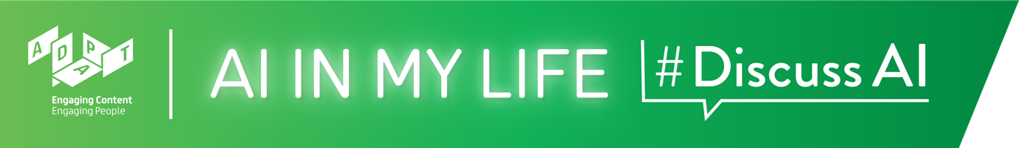

AI Careers Teacher Guide

AI Careers
This lesson will highlight to students the wide variety of careers and future study options available to those interested in working with AI. Students will hear from AI professionals about their work and learn how to find out about relevant options for further study.

Time: ~1 hour*

*If your classes are 40 mins. long rather than 1 hour, we recommend that you select the topics you feel are most important and/or shorten some of the interactive activities.

Background
AI is transforming the world of work. This lesson highlights the varied job opportunities for those interested in AI, as well as relevant options for further study related to the field of AI.
The AI and Future of Work module explores the impact of AI on working life, highlighting the prevalence and transformative nature of AI across almost all sectors of industry. Although there are no pre-requisites for this module, it would be useful to cover the Introduction to AI module with students first, so that they already understand what AI is and its impact on society and industry.

Curriculum Links
The interactive and reflective nature of AI in My Life (AIML) ensures that students will hone the five key skills central to teaching and learning across the Transition Year curriculum:
- Information processing
- Critical and creative thinking
- Communicating
- Working with others
- Being personally effective

An outline of links to the Leaving Certificate curriculum is provided after the module walkthrough.

Materials Needed: PowerPoint presentation, Laptop, Screen, Internet Access, Timer

Module Overview

Introduction (~5 mins)
A quick introduction to the module, outlining learning goals and what is Artificial Intelligence, and asking students to ponder “does a career in AI appeal to me?”

Careers and AI (~8 mins)
Students will contemplate what characteristics they look for in a career and ask them if a career in AI appeals to them.

Reasons to consider a Career in AI (~5 mins)
Ask students why they might consider a career in AI, from the ability to work in a variety of fields and with life-changing technology, to the strong enjoyment prospects and the chance to work at the forefront of an exciting emerging field.

What could a Career in AI look like? (~19 mins.)
Through short video profiles, students will hear from AI professionals in industry and academia about their work. They’ll then reflect on the study and career paths the AI professionals took. An interactive quiz will then highlight that many of the careers of the future are not yet known.

AI Careers: What we do know now (~9 mins.)
Reiterates that future advances in technology are hard to predict, but that AI’s influence will certainly grow. Everyone will need AI knowledge, and resilience and adaptability will be key. Explores what we mean by “dual skilling” and why it makes people highly employable.

AI Study Options (~11 mins.)
Although the multidisciplinary nature of AI means there are innumerable study options, we take Dublin City University as a case study and highlight examples of relevant course options. We then outline how students can find course information themselves and where they should go for advice.

Recap and Conclusions (~3 mins.)
A brief recap on what students have learned in this module and an opportunity to ask questions about topics they would like to explore more. Students again answer the question “does a career in AI appeal to me?” and are encouraged to note if there is a difference to the class’s aggregated response to the same question at the start of the lesson.

AI Careers
Module Walkthrough
Learning Intentions
By the end of this workshop, students will be able to:
- Give examples of the broad range of careers available to those with an interest in AI
- Explain what we mean by “multidisciplinary” and “dual skilling” in the context of AI careers
- Conduct an initial search for third-level courses relating to AI

Introduction (~5 mins.)

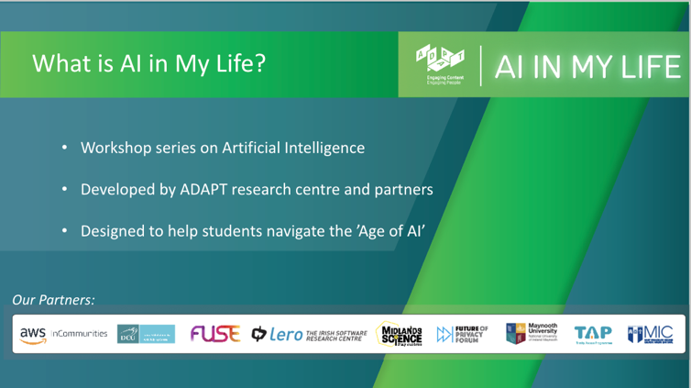 | Lecture (2 mins)  Tell students that AI in My Life is a modular workshop series on Artificial Intelligence (AI). It was developed by the Science Foundation Ireland ADAPT Research Centre.  ADAPT is a major academia-industry research centre with more than 300 researchers from 8 Irish universities (led by Trinity College Dublin and co-hosted by Dublin City University) producing research and innovations in many aspects of AI.
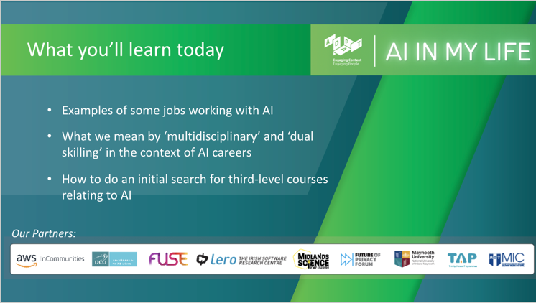 | Lecture (2 mins)  - Outline to students what they should be able to do by the end of this module:  - Give some examples of careers available to those with an interest in AI.  - Explain what we mean by “multidisciplinary” and “dual skilling” when we talk about AI careers  - Know how to search for further study options related to AI
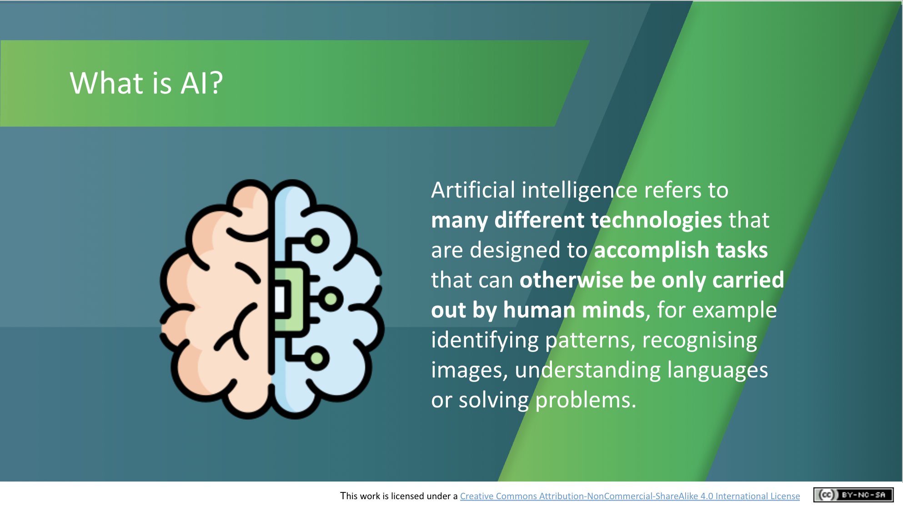 | Lecture (1 mins)  Go through the following definition, checking that students understand:  Artificial intelligence refers to many different technologies that are designed to accomplish tasks that can otherwise be only carried out by human minds, for example identifying patterns, recognising images, understanding languages or solving problems.  This definition will be a recap for those who have already taken an AIML module.
Careers and AI (~8 mins)

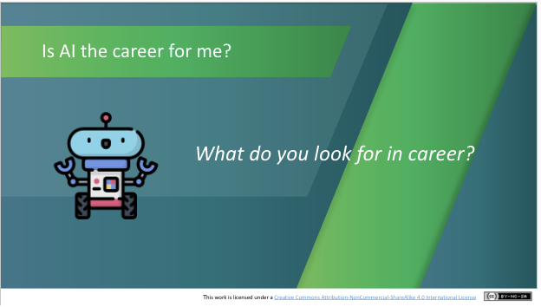 | Discussion (3 mins)  We’ve all got different priorities. Thinking about what’s most important to students will help determine what kind of career will appeal to them most. Ask students what factors they think are most important to them when selecting a future career. You might like to do this via an online tool like Kahoot or Sli.do.  For example:  - The opportunity to travel  - Working with people from different backgrounds  - The opportunity to make a difference  - Being able to solve problems  - Making a good salary  - Working in a fast-changing area  - Using my existing skills and talents  - Availability of jobs  - Something else?
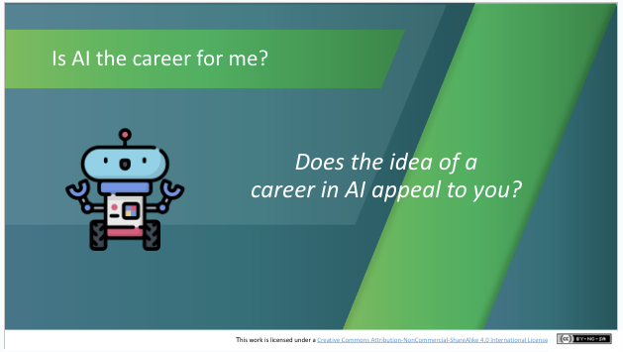 | Activity (3 mins)  Ask students if the idea of a career in AI appeals to them. You could do so by means of a show of hands or (preferably) you can use an online platform such as Kahoot, Mentimeter or Sli.do to generate a class poll. Note/save the results as we’ll use them later.  Discussion (2 mins)  Why does a career in AI appeal to you (or not)?
Reasons to Consider an AI Career (~5 mins.)
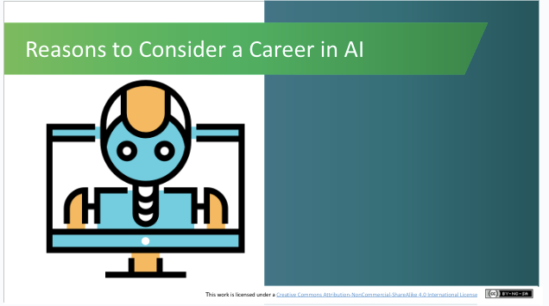 | Lecture (1 min)  The broad range of career options for those with an interest in AI means that there is significant flexibility to forge a career path that matches a student's priorities.  We’ll look now at some of the reasons why an AI career would suit many people. As we go through them, ask students to think about whether they match the career priorities they’ve just identified.
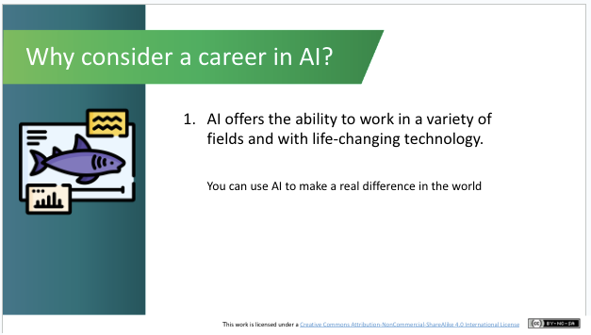 | Lecture (1 min)  AI offers the ability to work in a variety of fields and with life-changing technology.  Our global societal issues are complex. AI provides us with a valuable tool to enhance human efforts to come up with solutions to difficult problems, ranging from wildlife conservation and climate change, to improved cancer screening and predicting virus behaviour. In a few mins. we’ll see some profiles of people working with AI and how they’re using it to make a real difference in the world.
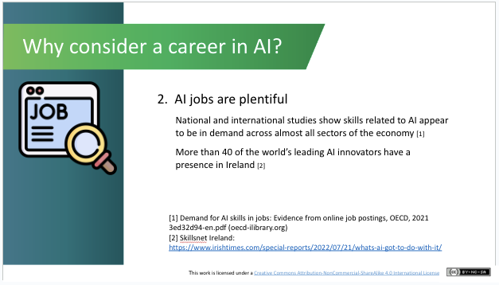 | Lecture (1 min)  There are lots of jobs in AI. National and international studies show skills in AI appear to be in demand across all sectors of the economy.  In addition, more than 40 of the world’s top companies developing AI solutions are now located in Ireland.
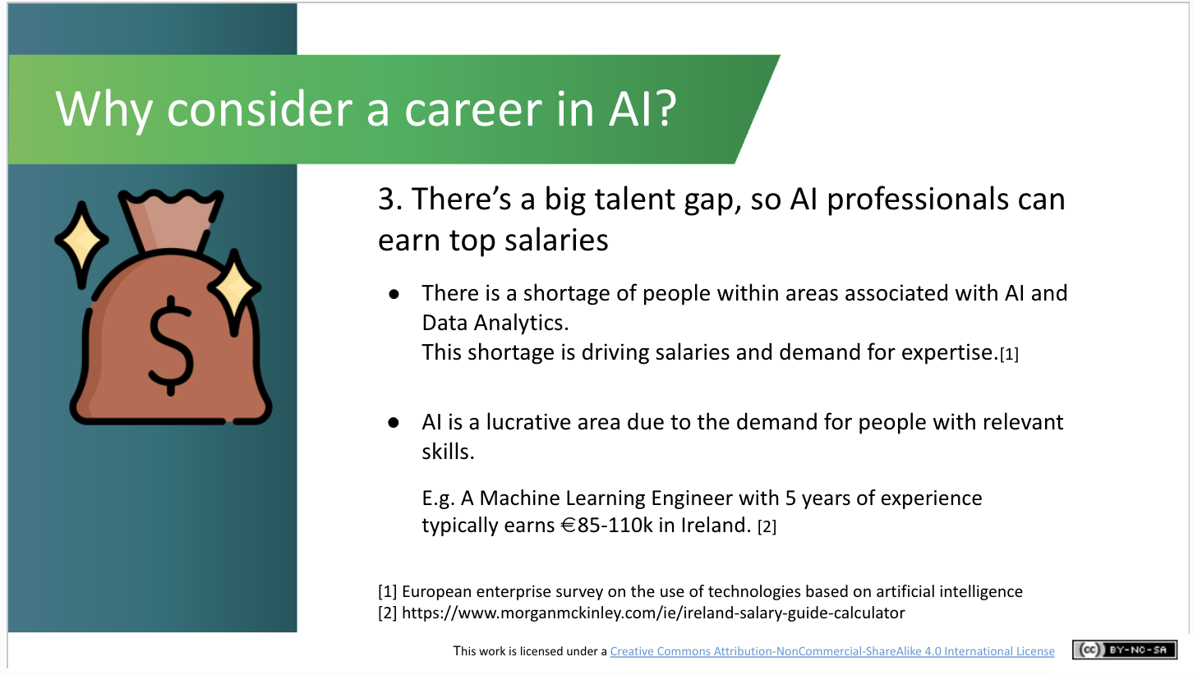 | Lecture (1 min)  There’s a shortage of people with the skills required to meet demand for people to work with AI. This means that AI professionals can earn top salaries.
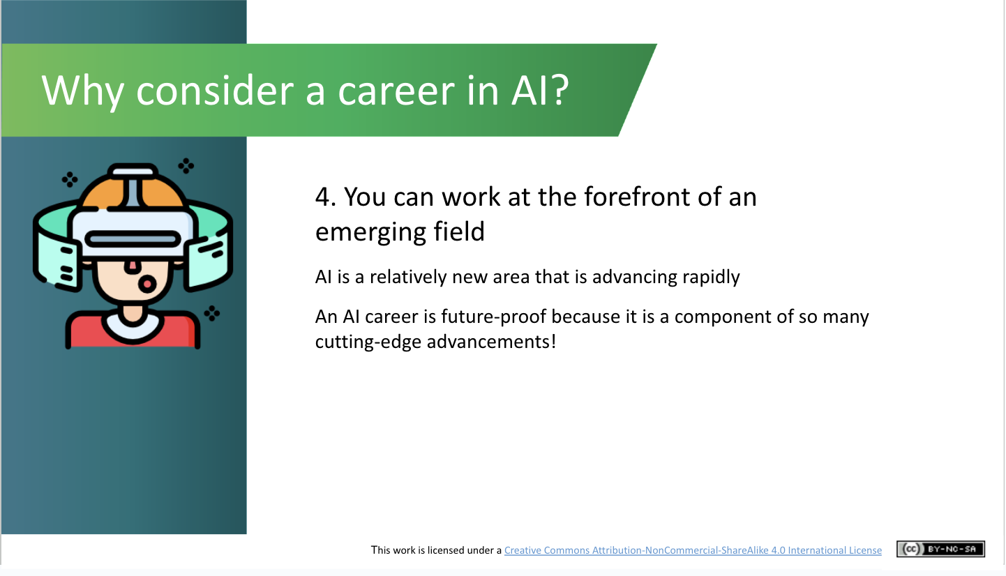 | Lecture (1 min)  AI is a relatively new area that is advancing rapidly and is here to stay.  An AI career is future-proof because it is a component of so many cutting-edge advancements!
What could a career in AI look like? (~19 mins.)

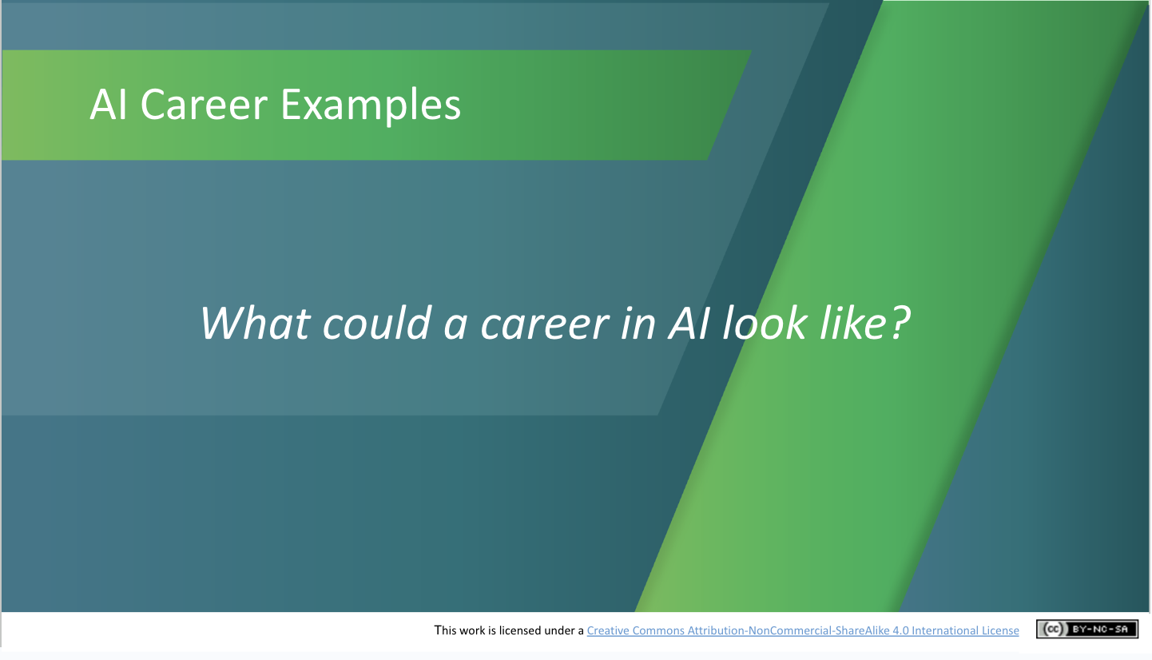 | Lecture (1 mins)  Now that you’ve some idea of why an AI career might be appealing, let’s look at some profiles of people already working in or with AI.
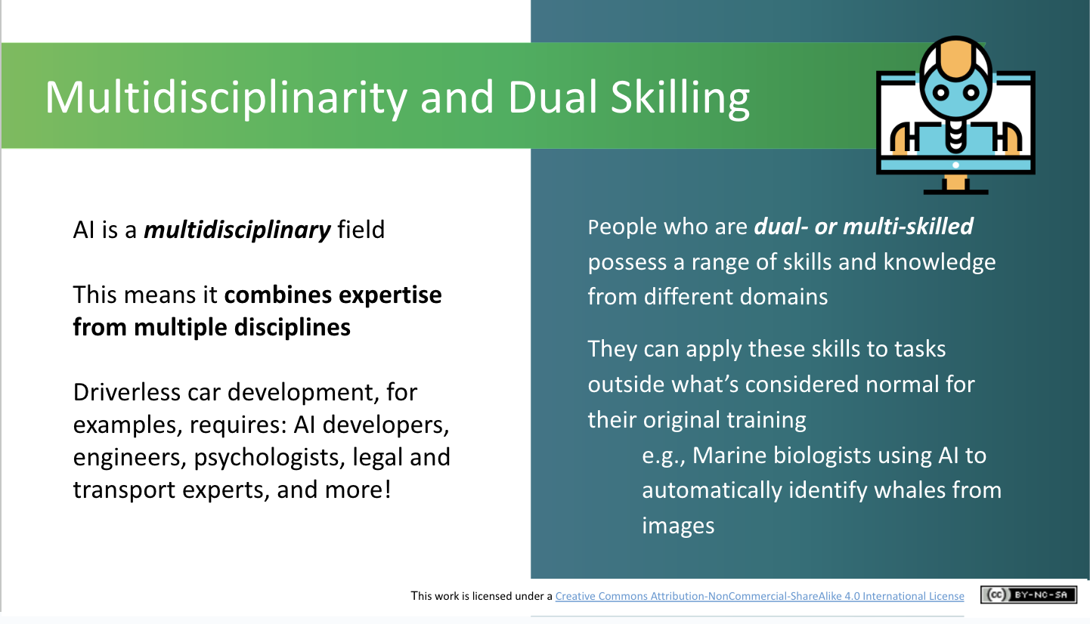 | Lecture (2 mins)  Introduce students to the concepts of “multidisciplinarity” and “dual skilling”.  AI is very much a multidisciplinary field, meaning it requires and combines expertise from multiple disciplines or areas. Driverless car development, for example, requires AI developers (to develop the computer programmes to help the cars’ AI systems to learn and adapt), engineers to build the physical elements of the car, psychologists to consider driver behaviour, legal experts to figure out the legal implications if things go wrong on the road, and transport experts who understand roads and traffic flows.  Dual skilling means learning other skills in addition to one’s main area of expertise. In previous workshops we’ve already seen examples of non-AI specialists applying AI in their work. Can students remember any of their areas of work? (e.g. marine biologists using AI in transformational ways in their jobs).  Having dual skills like this can make you very attractive to employers – plus you get to learn about more than one discipline!
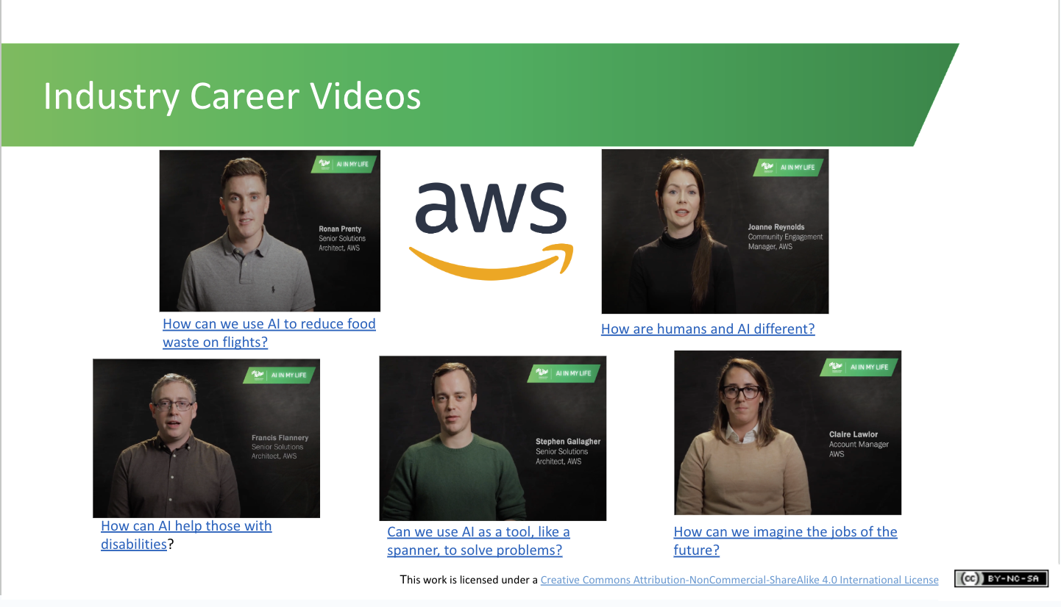 | Lecture (2 mins)  Amazon Web Services (AWS) is a part of Amazon that provides infrastructure services to businesses in the form of web services. These career profiles, recorded in their offices in Dundalk, Co. Louth, explain how their workers are using AI to deliver value for customers.  Activity (4 mins.)  Ask students to select one video and to note what the person profiled studied in college. Are they dual skilling, combining expertise from an area other than AI?  The video grid below this PowerPoint walkthrough will give you a better idea of what each video covers
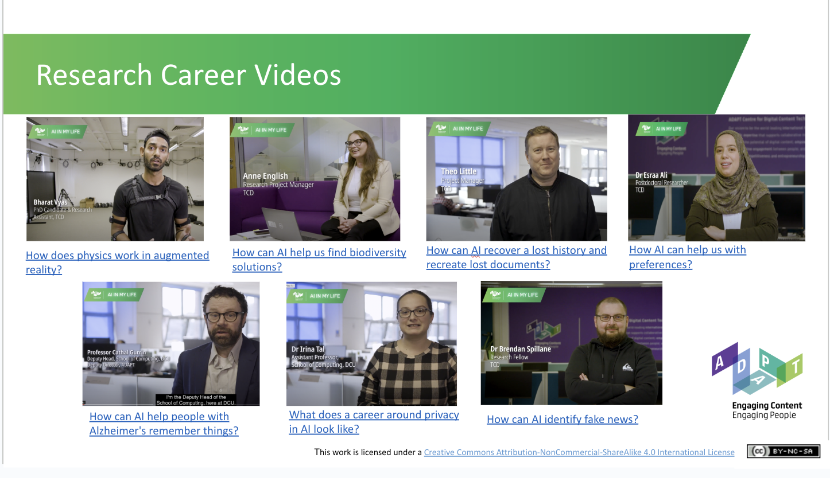 | Lecture (1 min)  ADAPT is a major Science Foundation Ireland research centre dedicated to AI research and innovation. AIML visited Trinity College Dublin and Dublin City University to hear about the career paths of some of their researchers and management staff.  Activity (4 mins)  Ask students to select one video and to note what the person profiled studied in college. Are they dual skilling, combining expertise from an area other than AI?  The video grid below this PowerPoint walkthrough will give you a better idea of what each video covers.
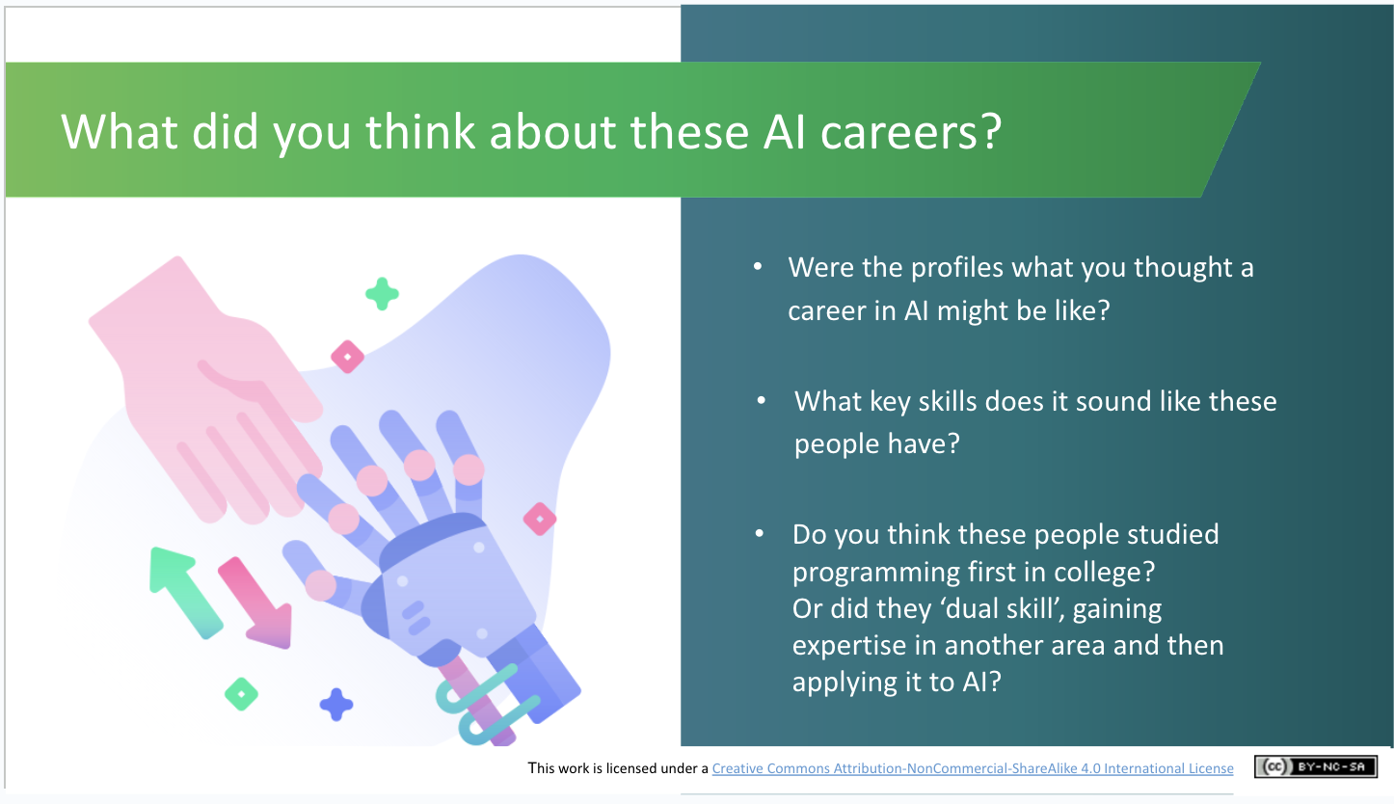 | Discussion (5 mins)  You’ve seen a range of careers within AI.  - Were they what you thought a career in AI might be? Or look like what you expected?  - What key skills does it sound like those people had? They mightn’t say them directly, but have a guess. (Example answers: problem-solving, people skills, technical skills, research skills, communication skills, analytical skills, the ability to figure out how things work and identify improvements, collaboration skills, etc).  - Did these people study programming in school or university? Or did they ‘dual skill’, gaining expertise in another area and then applying it to AI?
AI Careers: What we do know now (~8 mins.)

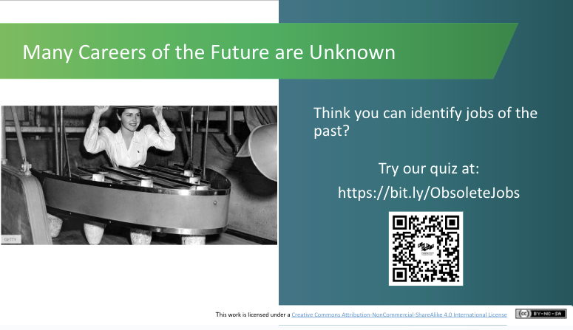 | Lecture (1 min)  Technology is advancing at such a rate, it’s impossible to predict how the jobs or careers of the future will look. History tells us, however, that things definitely will change and so people need to be open to changing and adapting.  Activity (4 mins)  Using their phones or tablets, ask students to complete the short quiz at https://bit.ly/ObsoleteJobs  How did they score? Were they surprised by some of these jobs?
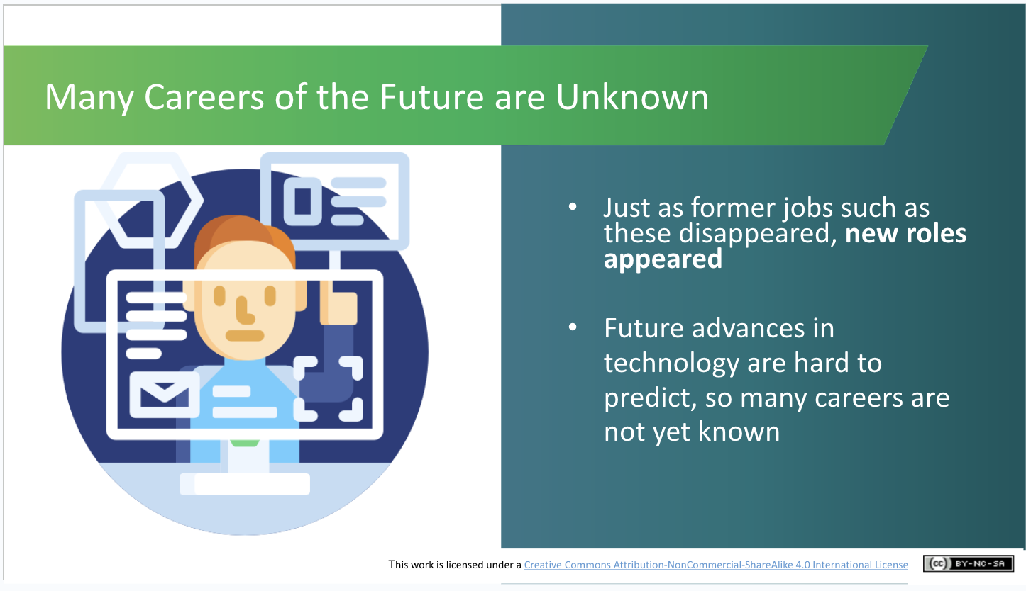 | Lecture (1 mins)  The main message is just as former jobs such as these disappeared in the past, new roles appeared.  Future advances in technology are hard to predict, so many careers are not yet known.
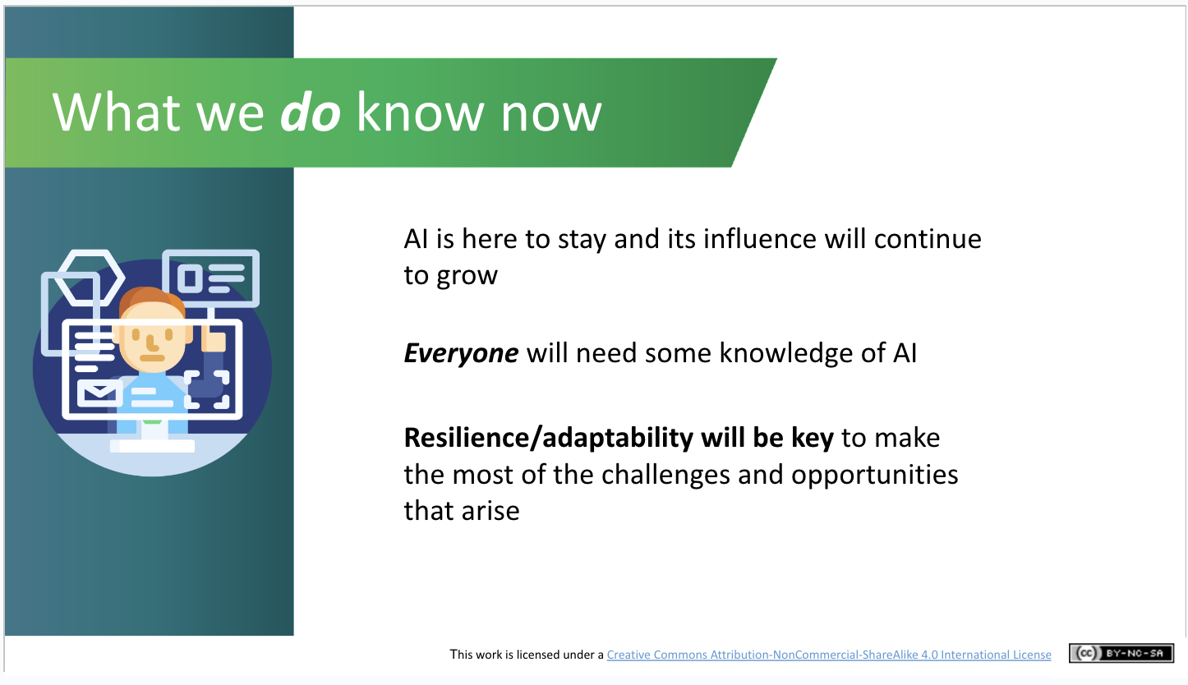 | Lecture (2 mins)  What we do know is that AI is here to stay and its influence will continue to grow across all industries.  Everyone will need some knowledge of AI to perform their jobs.  Resilience and adaptability will be key if you want to make the most of the challenges and opportunities that will arise as jobs evolve.
AI Study Options (~11 mins.)

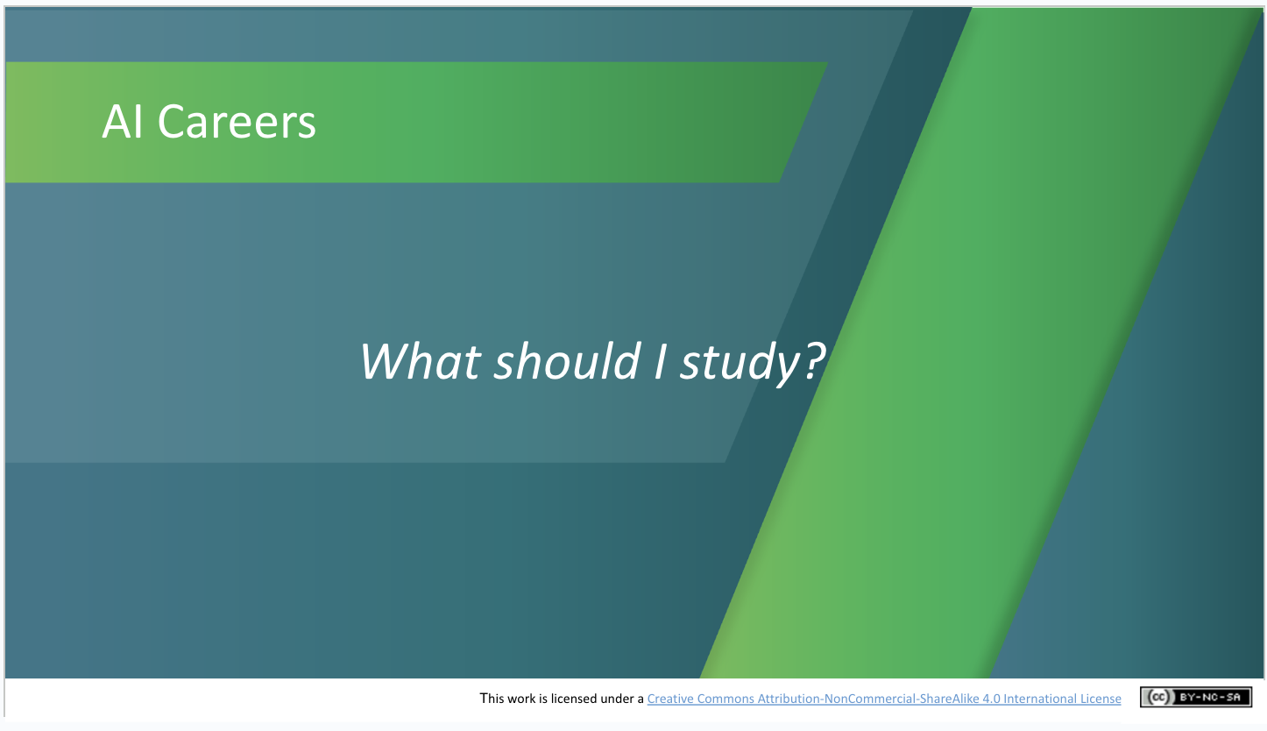 | Lecture (1 mins)  You might well be asking “what should I study?” Let’s take a look at some relevant study routes you could take.
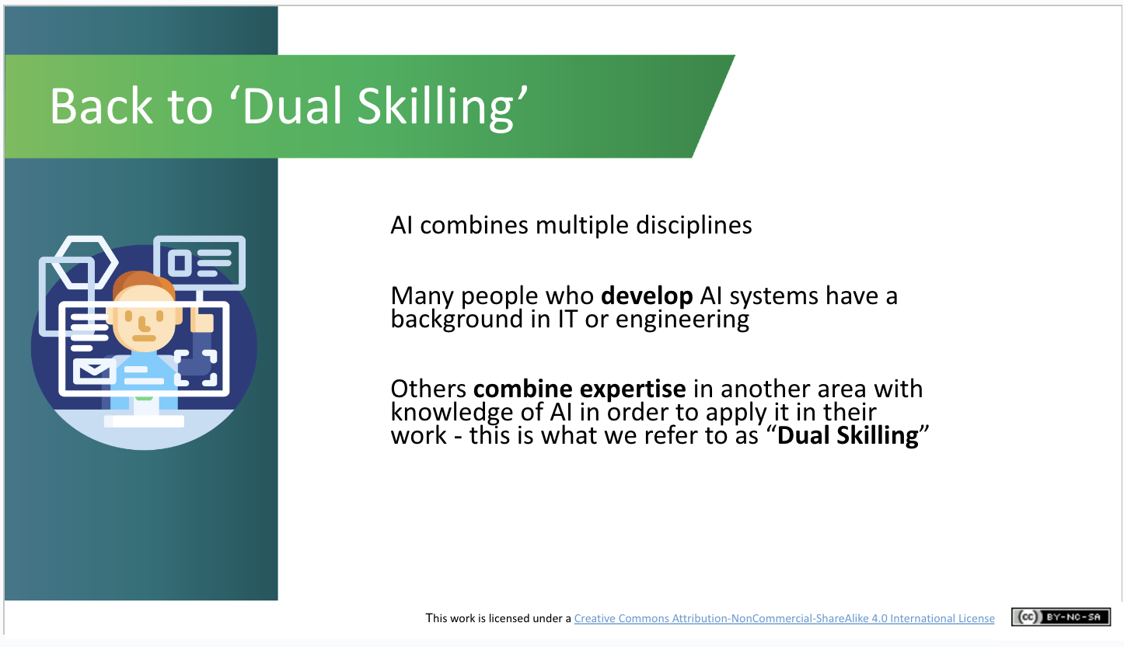 | Lecture (2 mins)  We’ve seen that AI combines multiple disciplines, so AI skills will be needed by a broad range of people, not just by AI experts and specialists.  How closely a person works with AI systems will determine the kinds of AI skills they will require and how they will need to prepare:  AI specialists (i.e. those who want to develop AI systems) will need specific education and training. Many of those developing AI systems will initially start out by studying computing, IT or engineering. Both Ronan Prenty and Stephen Gallagher in AWS are examples of this.  Those working in roles that use AI systems will need to be dual-skilled, i.e. with digital and AI skills alongside other their core areas of expertise. This is like in the AWS videos where people discussed how they use AI as tools to help provide solutions for their customers. Claire from AWS started working in finance and then took on a role with AWS where she uses that background and AI tools to help her customers.
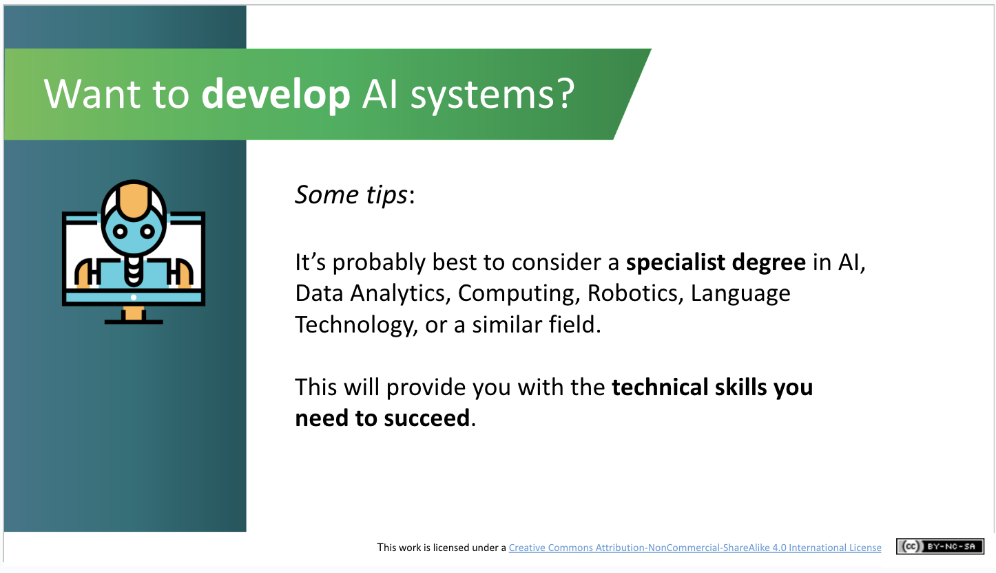 | Lecture (1 mins)  For students who are interested in researching or developing AI systems, it’s probably best to consider a specialist degree in AI, Data Analytics, Computing, Robotics, Language Technology, or a similar field. This will provide them with the technical skills they need to succeed.
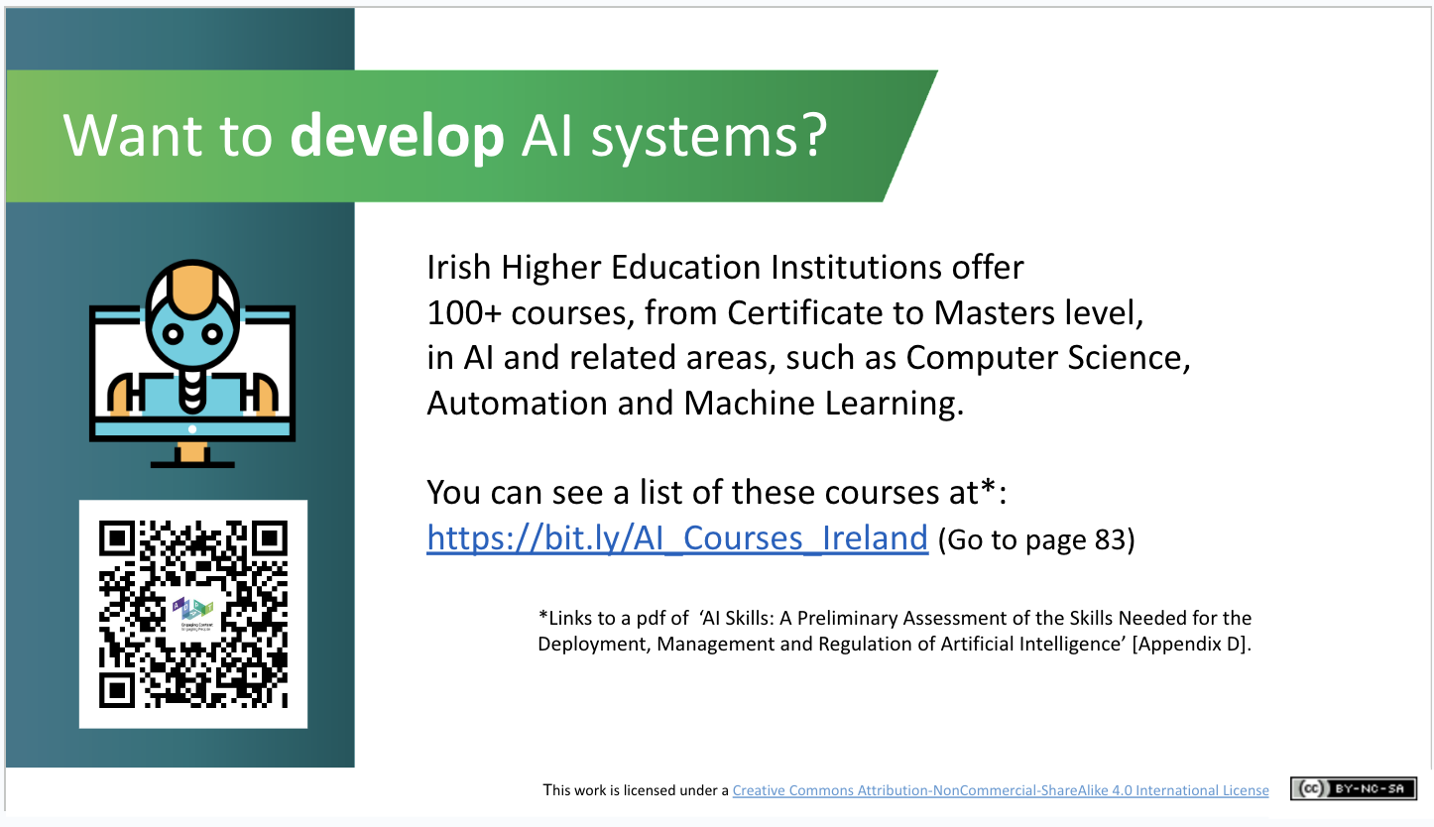 | Lecture (2 mins)  The HEIs [you might need to explain what these are] currently provide more than 105 courses, from Certificate to Masters level, in AI and related areas, such as Computer Science and Machine Learning.  You can see a list of these courses in the AI Skills report published last year.  If you’ve time, you can encourage students to view this course list (on page 83 of the pdf report linked to here) and/or save the link and check it out later.
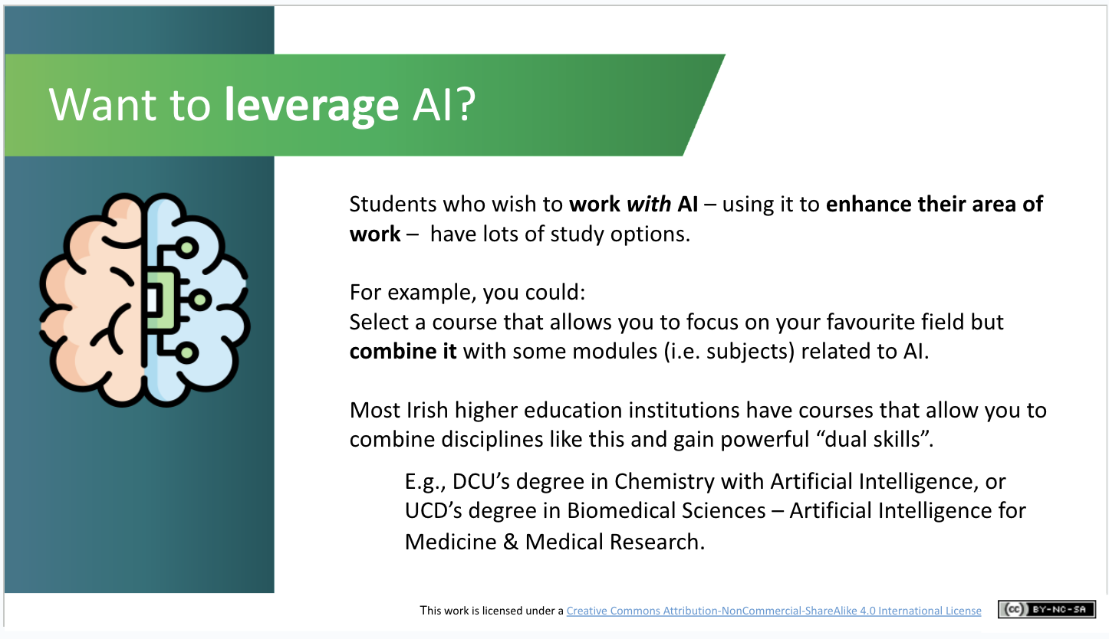 | Lecture (2 mins)  Students who wish to work with AI – using it to enhance their area of work rather than developing new AI innovations – have lots of study options. For example, they could:  Select a course that allows them to focus on their chosen field but combine it with some modules (i.e. subjects) related to AI. There were examples of this in the videos in this lesson, such as those who studied linguistics, engineers, finance and then moved into a role where they work more with AI.  There are excellent courses across all Irish higher education institutions that allow students to gain powerful “dual skills” in this way.  Examples are DCU’s degrees in Chemistry with Artificial Intelligence or UCD’s Biomedical Sciences – Artificial Intelligence for Medicine & Medical Research. Most universities have courses that allow you to combine disciplines like this.
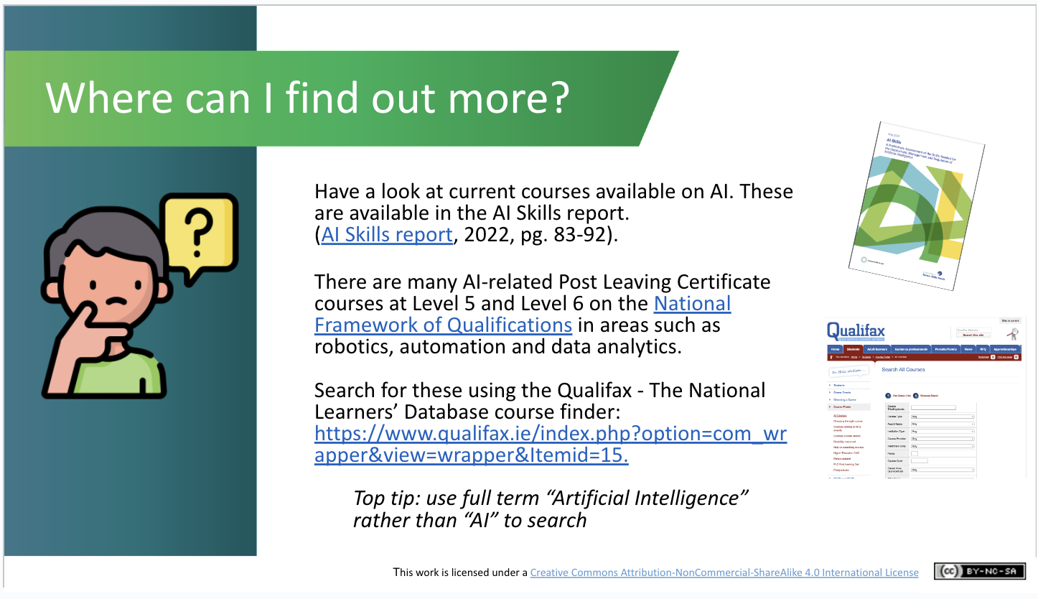 | Lecture (2 mins)  To find out more, have a look through the list of current courses available in Irish colleges and universities in the AI Skills report.  There are many AI-related Post Leaving Certificate courses at Level 5 and Level 6 in areas such as Robotics, Automation and Data Analytics.  The best place to search for courses is Qualifax, the National Learners’ Database. This will show you a list of courses by level, location and duration.  Just make sure you search by “artificial intelligence” rather than “AI” as it’ll give you a better list of results.
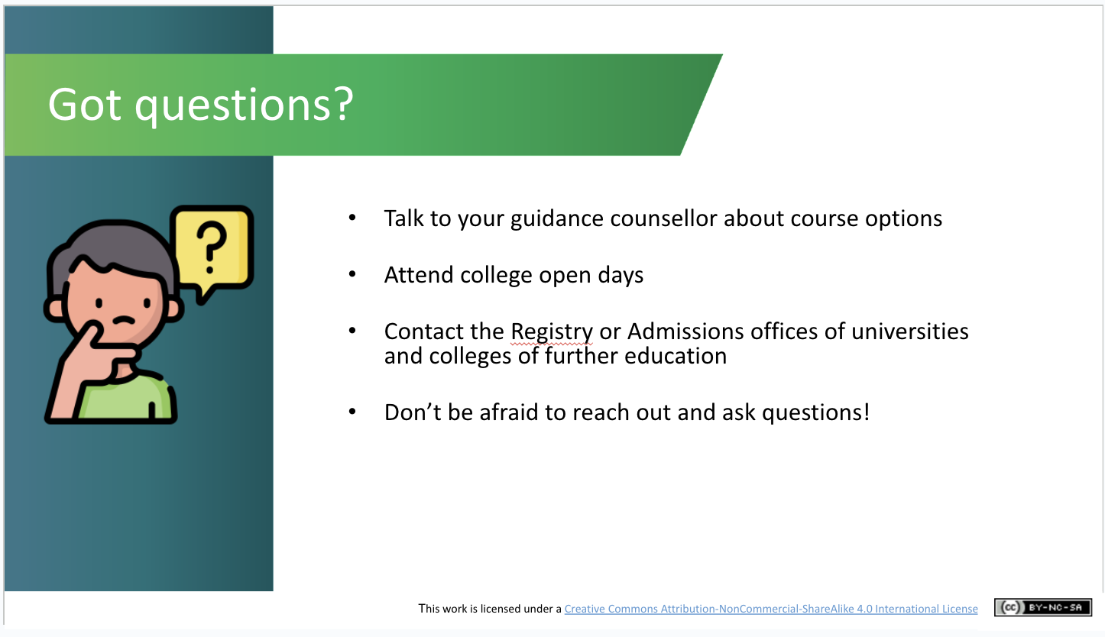 | Lecture (1 mins)  If you’ve questions, talk to your guidance counsellor about course options, attend college open days, contact the admissions offices of the education institutions you’re interested in attending, and don’t be afraid to ask questions!
Recap and Conclusions (3 mins.)
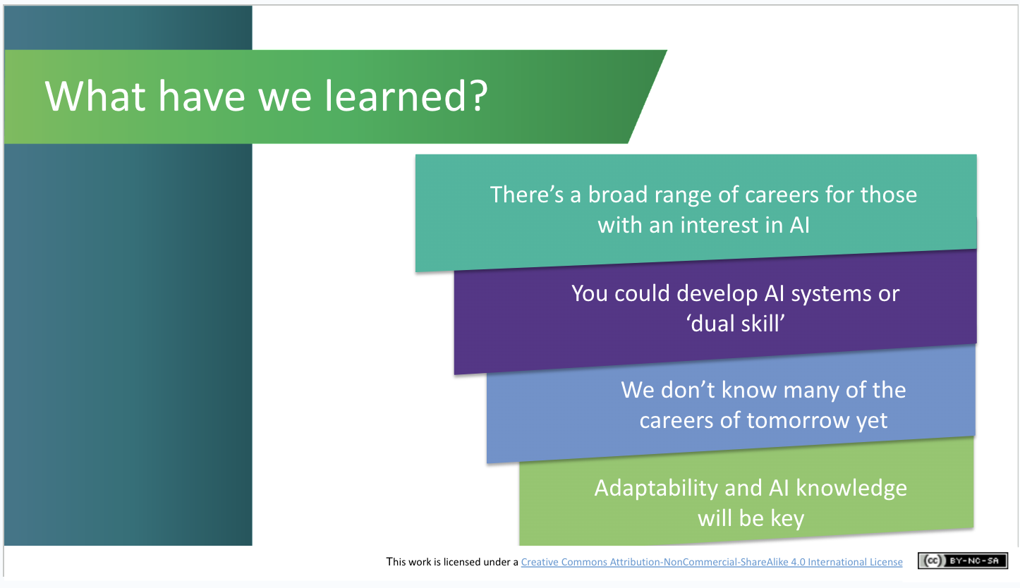 | Lecture (1 mins)  Recap briefly on what students have learned in this module and an opportunity to ask questions about topics they would like to explore more.
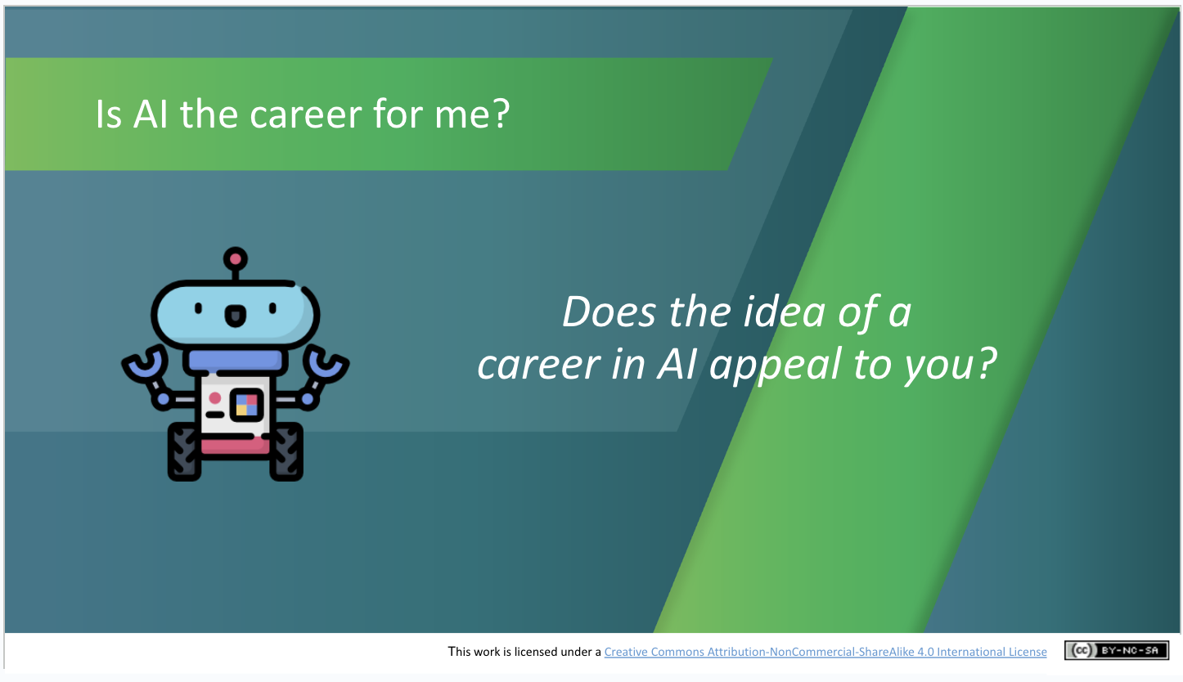 | Activity (1.5 mins)  Students again answer the question “does a career in AI appeal to me?” and are encouraged to note if there is a difference to the class’s aggregated response to the same question at the start of the lesson. What, if anything, has changed in their views?
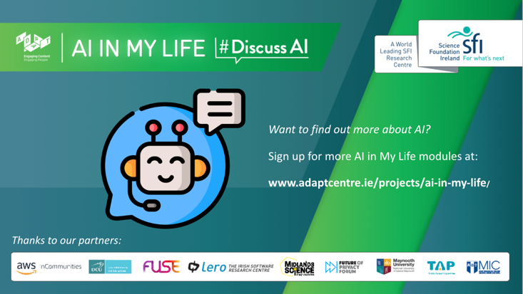 | Lecture (.5 min)  That’s it for this AI Careers module. I hope you enjoyed it!

Curriculum Links

In addition to its relevance to honing the key skills central to teaching and learning across the Transition Year curriculum, the STEAM focus makes the AI in My Life content relevant to the following subjects:

Leaving Certificate:
Technology
Politics and Society
Computer Science
Design and Communication
Business
Economics

Applied Leaving Certificate:
Engineering
Technology
Social Education
Science
Information and Communication Technology – Specialism

AI Career Profile Videos

Industry career videos - developed with Amazon Web Services

Speaker Name | Position | Organisation | Topic
Ronan Prenty | Senior Solutions Architect | Amazon Web Services | How can we use AI to reduce food waste on flights? Looking at how AI can help businesses improve how function
Francis Flannery | Senior Solutions Architect | Amazon Web Services | How can AI help those with disabilities?  Can AI be used to help make the world more accessible?
Stephen Gallagher | Senior Solutions, Architect | Amazon Web Services | Can we use AI as a tool, like a spanner, to solve problems? You don't have to know how to code instead you can use AI like a tool to perform other tasks
Claire Lawlor | Account Manager | Amazon Web Services | How can we imagine the jobs of the future? What will business owners need to support the work they do in the future? How might jobs change?
Joanne Reynolds | Community Engagement Manager | Amazon Web Services | How are humans and AI different? AI will play a bigger role in our lives, but there will always be a need for humans in the workplace. What’s the best way for AI and humans to work together in the future?

Research career videos - developed with the Science Foundation Ireland ADAPT Centre

Esraa Ali | Postdoctoral Researcher | ADAPT, Trinity College Dublin | Discusses how data can be used to teach algorithms about user preferences, but highlights that it’s important to understand that the data we share should be protected. Also discusses having a family and a research career.
Brendan Spillane | Research Fellow | ADAPT, University College Dublin | How can AI be used to help us detect and remove fake news? It’s getting hard to tell what’s fake or real news, but what if AI could help warn you if something doesn't look to be true?
Anne English | Research Project Manager | ADAPT, Trinity College Dublin | How can AI help us find solutions to biodiversity challenges?  Discusses what it’s like to manage research projects. Studied languages which then led to a career in the private sector and then led to academia.
Bharat Vyas | PhD Candidate and Research Assistant | ADAPT, Trinity College Dublin | How does Physics have a role in augmented reality? Works with virtual and augmented reality. Has a background in Physics and Engineering and now gets to apply this knowledge to augmented reality.
Theo Little | Project Manager | ADAPT, Trinity College Dublin | How can AI recover a lost history and recreate lost documents? Has a background in history and digital history. Works with AI developers to recreate the Virtual Record Treasury of Ireland which re-imagines and reconstructs through digital technologies the Public Record Office of Ireland. A magnificent archive destroyed on June 30th, 1922, in the opening engagement of the Civil War.
Cathal Gurrin | Deputy Head, School of Computing, and Deputy Director, ADAPT | ADAPT, Dublin City University | How can AI research help people with Alzheimer's remember things? Or help us document our lives and memories?
Irina Tal | Assistant Professor | ADAPT, School of Computing, Dublin City University, | Privacy is vital to ensure that the rights of individuals are protected. What’s it like to research privacy in AI within an Irish university? What does a career around privacy in AI look like?

Additional Resources

AI-related Study Options: Some Examples from Dublin City University

If you have a little time to spare and students are interested in specific examples of AI-related study options, these examples from Dublin City University might be useful to get students really thinking.

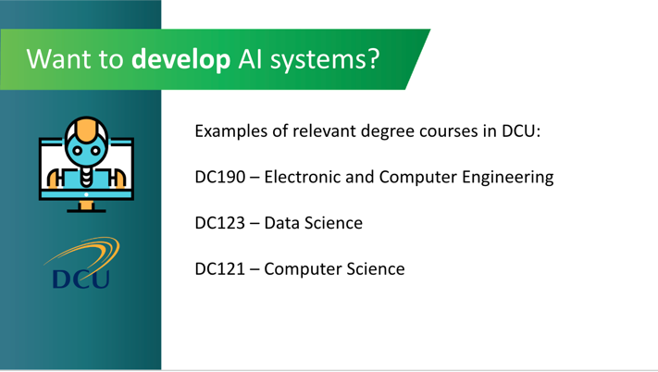 | Lecture  If you want to develop AI systems:  With Electronic and Computer Engineering, you’ll be able to build devices and processes to solve real-world problems using cutting-edge technology like augmented reality and virtual reality.  Data Science will equip you to analyse and find trends in real world data, as well as the communication skills to share these insights to audiences who’ll appreciate the value of your analysis.  Computer Science has a strong emphasis on software engineering, which is writing, modifying and maintaining software systems.
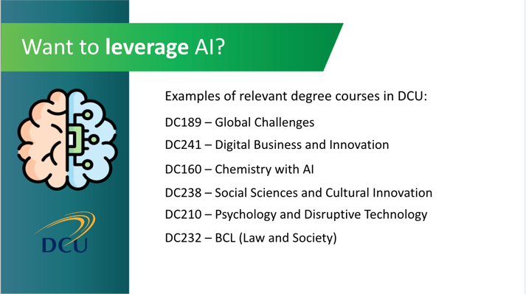 | Lecture  Want to work with AI but combine it with another field? These are a few examples of options available at DCU:  Global Challenges covers emerging technologies from a social perspective, examining issues such as fake news.  Digital Business & Innovation looks at how companies can use digital technologies to innovate and transform.  Chemistry with AI explore AI applications in chemistry using large set of data e.g. drug development  Cultural Innovation focuses on the role of technology in society & innovation adoption.  Psychology and Disruptive Technology examines behaviour change and technology.  BCL (Law and Society) will equip you to regulate social systems and AI.  Other colleges and universities will have similar study options relevant to the development or application of AI.  The key message is this: There are many routes to a career in AI, so pick the one that appeals to you most!

Useful Links

These resources will help teachers and students to understand more about career and further study options for those with an interest in AI:
- National learners’ database: https://www.qualifax.ie/
- Careers portal on STEM careers: https://www.smartfutures.ie/
- Handy career planning self-assessment tool: https://careersportal.ie/school/index.php
- AI Here for Good: A National Strategy on Artificial Intelligence for Ireland: https://enterprise.gov.ie/en/publications/publication-files/national-ai-strategy.pdf
- AI skills report of Expert Group on Future Skills Needs: http://www.skillsireland.ie/all-publications/2022/ai-skills-report.pdf
- Blog post explaining dual skilling: https://www.northeastern.edu/graduate/blog/career-in-artificial-intelligence/
- Article on top skills required for AI careers:
https://www.ictskillnet.ie/news/top-skills-to-know-for-a-career-in-ai/
- Blog post on AI career prospects and key jobs: https://www.springboard.com/blog/data-science/careers-in-ai/
- Article on AI and the world of work: https://www.irishtimes.com/special-reports/2022/07/21/whats-ai-got-to-do-with-it/
- British Council, Skills for the 21st Century Exercise https://learnenglishteens.britishcouncil.org/skills/reading/b1-reading/skills-for-the-21st-century-workplace

If you have questions or comments about this lesson,
please contact us at education@adaptcentre.ie

